**MINISTRY OF EDUCATION AND TRAINING**

|  |
| --- |
| **FPT UNIVERSITY** |
| **Capstone Project Document** |
| **TrendyPlus** |
|  |
| |  |  | | --- | --- | | **TrendyPlus Team** | | | **Group Member** | Đặng Mạnh Cường – SE02679  Nguyễn Đức Nam – SE02613  Vũ Tuấn Nghĩa – SE02603  Lê Trung Anh – SE02828  Đỗ Thành Luân – SE02899 | | **Supervisor** | Lecturer : Nguyễn Tất Trung | | **Capstone Project code** | TrendyPlus |   Hanoi, 24/4/2015 |

**Contents**

Acknowledgements 5

Definitions and Acronyms 6

CHAPTER 1: INTRODUCTION 7

1.1. Purpose 7

1.2. Project Information 7

1.3. The People 7

1.3.1. Supervisor 7

1.3.2. Team members 7

1.4. Background 8

1.5. Literature Review 9

1.6. Ideas 10

1.7. Proposal of System 10

1.7.1. Our proposal system 10

1.7.2. Introduction about our proposal system 11

CHAPTER 2: PROJECT MANAGEMENT 12

2.1. Purpose 12

2.2. Project Organization 12

2.2.1. Our proposal system 12

2.2.2. Roles and Responsibilities 13

2.3. Project Management Plan 15

2.3.1. Task 15

2.3.2. Meeting Minutes 16

2.3.3. Coding Conventions 16

2.3.4. Risk Management Plan 16

2.3.5. Communication Plan 18

CHAPTER 3: SOFTWARE REQUIREMENT SPECIFICATION 19

3.1. Purpose 19

3.2. Functional Requirements 19

3.2.1. Use Case Diagram 19

3.2.2. Use Case List 20

3.2.3. Business Rules 22

3.2.4. Use Cases 23

3.3. Non-functional Requirement 75

3.3.1. Security 75

3.3.2. Maintainability & Extensibility 77

3.3.3. Performance 77

3.4. Entity Relationship Diagram 77

CHAPTER 4: SOFTWARE DESIGN 79

4.1. Purpose 79

4.2. Architecture Overview 79

4.2.1. System Architecture 79

4.2.2. System Architecture Explanation 82

4.3. Design of TrendyPlus system 84

4.3.1. Architecture Layers Design 84

4.3.2. Database Design 89

4.3.3. Common Design 98

4.3.4. Detail Design 110

CHAPTER 5: SOFTWARE TESTING DOCUMENTATION 289

5.1. Introduction 290

5.1.1. Purpose 290

5.1.2. Scope of testing 290

5.2. Test Plan 291

5.2.1. Testing tool and environment 291

5.2.2. Resources and responsibilities 293

5.2.3. Test strategy 293

5.2.4. Feature to be tested 297

5.2.5. Feature not to be tested 299

5.3. Test Approach 299

5.3.1. Unit Test 299

5.3.2. Integration and System Test 301

5.3.3. Acceptance Test 302

5.3.4. Defect Log 302

5.4. Test Report 302

5.4.1. Version 1.0 302

5.4.2. Version 2.0 303

5.4.3. Version 10.0 305

5.4.4. Bug list report 305

CHAPTER 6: INSTALLATION GUIDE & USER MANUAL 306

6.1. Purpose 306

6.2. Deployment Guidelines 306

6.1.1. Environment 306

6.1.2. Deployment 306

6.3. User Guidelines 310

Login 310

View Trendy 310

View Newsfeed 311

Around here 311

My Location 312

Create Post 312

Create Shop 313

User Page 314

Shop Page 317

Notification 321

Admin Login 322

Manage User 323

Manage Post 323

Manage Shop 323

Show Report 324

# Acknowledgements

*The success and final outcome of this project required a lot of guidance and assistance from many people and wish to express our deepest gratitude to them. Without them, this project would have been done with much more obstacles than it was.*

*First, we want to say thanks to Mr. Nguyen Tat Trung for his continuously sharing and motivating throughout the project. Mr. Nguyen Tat Trung has always been very responsive in providing necessary information, and without his generous support project would lack in accurate information on current developments. Under the instructions of Mr. Nguyen, the project team has always felt comfortable and confident. Apart from all the technologies and methodologies, Mr. Nguyen shared with us the philosophy of keeping the right attitude towards problems.*

*Second, we would like to say thanks to the instructors at FPT University for all the classes. Without the knowledge that university teaches us through each class, semester, we cannot finish this project.*

*Third, we truly appreciate the random fellows on the internet who has discussed with us. Every our tiny problem was answered clearly.*

*Finally, we want to thank our family for their help, inspiring during this project.*

# Definitions and Acronyms

|  |  |  |
| --- | --- | --- |
| **Acronym** | **Definition** | **Note** |
| SRS | Software Requirement Specification |  |
| API | Application Programming Interface |  |
| HTML | Hypertext Markup Language |  |
| CSS | Cascading Style Sheets |  |
| IDE | Integrated Development Environment |  |
| DBMS | Database Management System |  |
| UML | Unified Modeling Language |  |
| PM | Project Manager |  |
| UC | Use Case |  |
| N/A | Not Available |  |
| ORM | Object Relational Mapping |  |
| GUI | Graphical User Interface |  |
| HTTP | Hypertext Transfer Protocol |  |
| PHP | Hypertext Preprocessor |  |
| REST | Representational State Transfer |  |
| RAM | Random Access Memory |  |
| URL | Uniform Resource Locator |  |

# CHAPTER 1: INTRODUCTION

## Purpose

This chapter provides an overview of project include background information, literature review of existing system and raising a proposal for ideas of improvement.

## 1.2. Project Information

* Project name: **Trendy Plus**
* Project code: **Trendy Plus**
* Project group name **: N-CLAN**
* Product type: **Website Application**
* Timeline: **From 5th Jan 2015 to 28thApr 2015**

## 1.3. The People

### 1.3.1. Supervisor

|  |  |  |  |  |
| --- | --- | --- | --- | --- |
|  | **Full name** | **Phone** | **E-Mail** | **Title** |
| Supervisor | Nguyễn Tất Trung | 0904399139 | [trungnt@fpt.edu.vn](mailto:trungnt@fpt.edu.vn) | Lecturer |

*Table 1.1: Supervisor information*

### 1.3.2. Team members

|  |  |  |  |  |  |
| --- | --- | --- | --- | --- | --- |
|  | **Full name** | **Student code** | **Phone** | **E-mail** | **Role in Group** |
| 1 | Đặng Mạnh Cường | SE02679 | 01696234558 | [cuongdmse02679@fpt.edu.vn](mailto:cuongdmse02679@fpt.edu.vn) | Leader |
| 2 | Nguyễn Đức Nam | SE02613 | 01649608433 | [namndse02613@fpt.edu.vn](mailto:namndse02613@fpt.edu.vn) | Member |
| 3 | Vũ Tuấn Nghĩa | SE02603 | 01673833970 | [nghiavtse02603@fpt.edu.vn](mailto:nghiavtse02603@fpt.edu.vn) | Member |
| 4 | Lê Trung Anh | SE02828 | 01687388281 | [anhltse02828@fpt.edu.vn](mailto:anhltse02828@fpt.edu.vn) | Member |
| 5 | Đỗ Thành Luân | SE02899 | 01696986680 | [luandtse02899@fpt.edu.vn](mailto:luandtse02899@fpt.edu.vn) | Member |

*Table 1-2: Team member’s information*

## 1.4. Background

Social network penetration worldwide is ever – increasing. In 2012, 63.1 percent of internet users were also social network users and these figures are expected to grow. Social networking is one of the most popular online activities with high user engagement rates. Overall, US users spent more than 121.8 billion monthly minutes on social media. According to Statista[1], there are already about 1.79 billion users in social media in 2014. And it is projected to reach about 2.44 billion by 2018. This is surely going to give a large market for Information Technology.

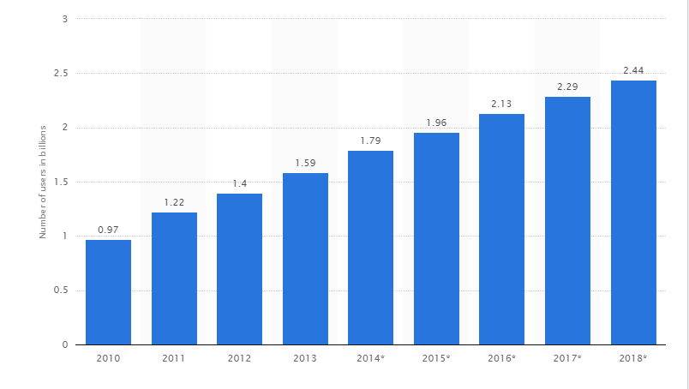

*Figure 1-1: Number of social network users worldwide from 2010 to 2018 (in billions)*

Besides, the use of images and Real-time are two of top 7 Anticipated Social Media Trends in 2015[2]. Because *“a picture surely speaks a thousand words”,* it is a known fact that visual contents are easier to comprehend, especially with fashion. However, the fashion tendency changes gradually over times. The clothes you wore yesterday could be outdated today. Be aware of the problems, we created a social network to support people in following the contemporary fashion trends. We call it *“TrendyPlus”* (Trendy+).

Trendy+ is a social network for sharing and discovering trendy fashion. You can share your owns photos, tag products used, and follow other users. It also has a dedicated feed for shoppable items, which provides you with links to see, to purchase articles of clothing shared by other users.

## 1.5. Literature Review

Facebook is one of the most famous social networking with a great number of tools what related to photos and albums serving more than 1.4 billions user. Instagram is another famous photo sharing social network with more than 300 millions users.



*Figure 1-2: Facebook and Instagram*

However these two social – networks have not highlighted yet and cannot highlight the current fashion trends. This is problem that followers of fashion, youth and women always interested daily, hourly. Besides, apart from using the websites for normal sales, the customers will get hardly difficulties during finding the places come up with the hottest fashion trends on social networks.

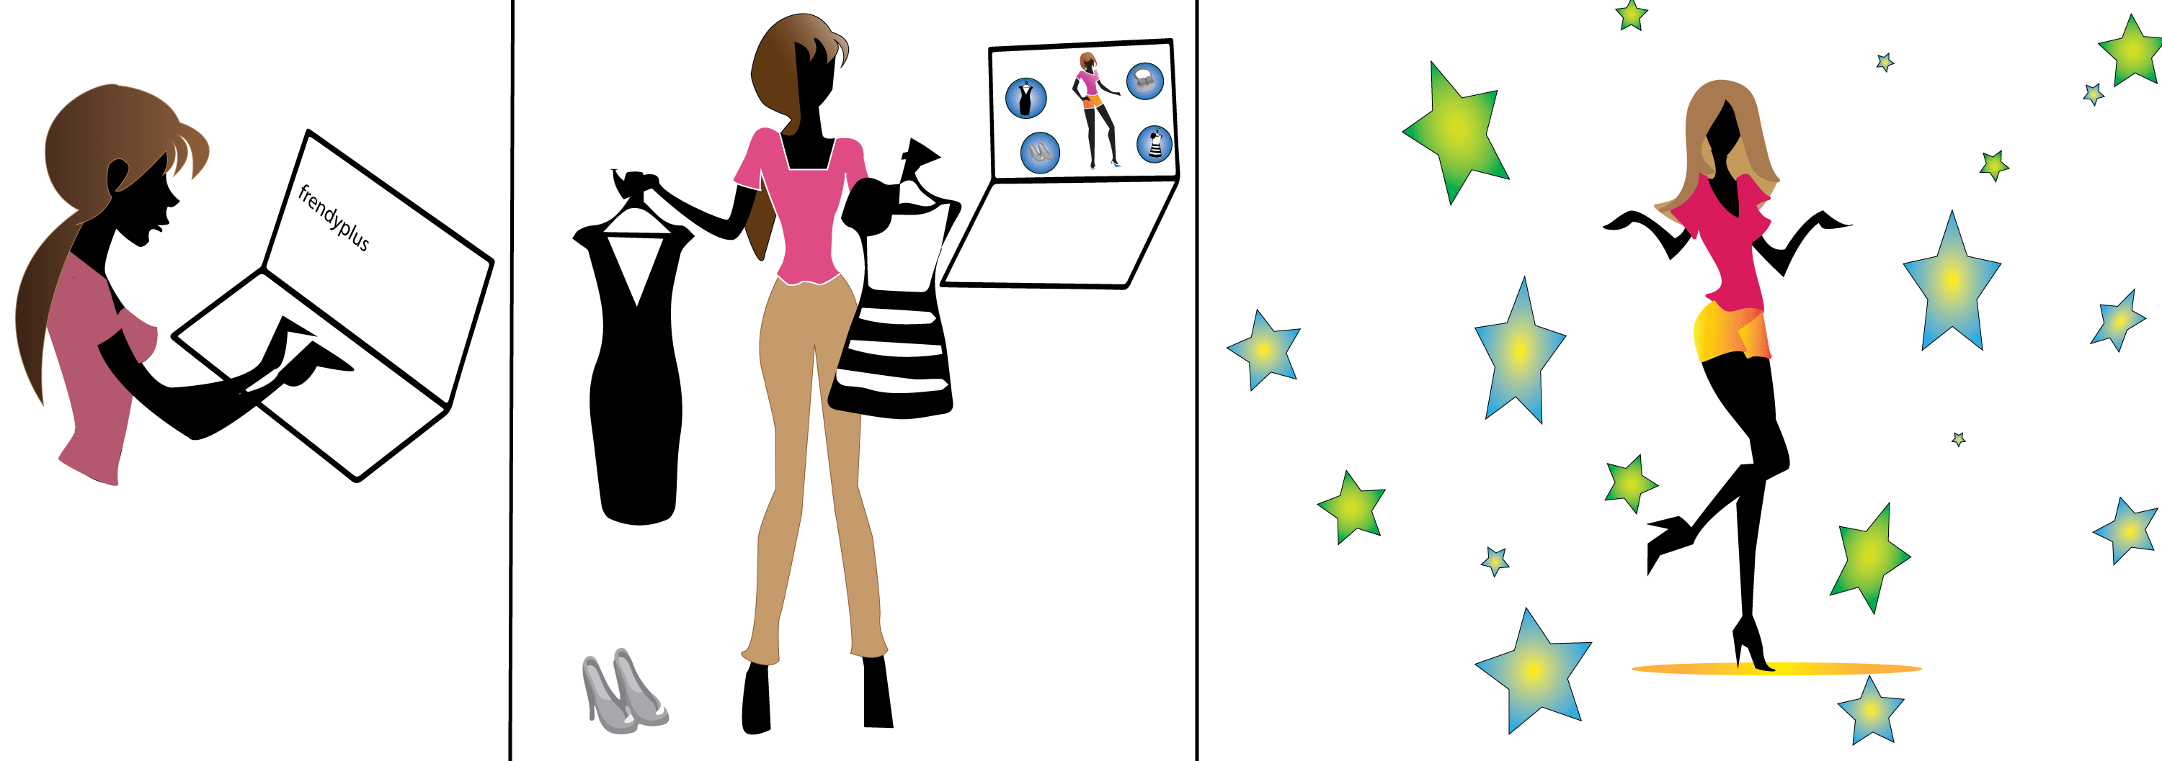

*Figure 1-3: TrendyPlus*

## 1.6. Ideas

Overlooking the limitations of the existing systems, our project with the aim of developing social networks *"TrendyPlus"* to change the way people share personal fashion style, search the store. Specially, it is easy to update fashion trends quickly as possible.

## 1.7. Proposal of System

### 1.7.1. Our proposal system

After review those characteristics of websites, they have their own advantages and disadvantages, so we came to an agreement about which functions our website should support to inherit their strong points and reduce their limitations:

BASIC FUNCTIONS:

* Allow user to post *“My style”* to their personal page. Their posts will also appear on the News Feed real-time. Each *“My style”* is a collection of their image tag, image caption.
* Allow user to edit their image with many beautiful filter.
* Allow user to tag their clothes in image.
* Allow user to add image caption to describe about image.
* Allow user to create album to keep their image.
* Allow user to delete image tag if they tag incorrect.
* Allow user to see most like *“My style”* with many filter.
* Allow user to view trendy at a time.
* Allow user to receive notification real – time when other user interactive.
* Allow user to connect to another social network account (Facebook, Google+ and Twitter).
* Allow user to like a *“My style”* or a comment.
* Allow user to unlike a *“My style”.*
* Allow user to share a *“My style”* to their Facebook.
* Allow user to add *“My style”* to favorite.
* Allow user to view their personal information page.
* Allow user to manage their personal information page.
* Allow user to edit or delete album image.
* Allow user to edit or delete post.
* Allow user to change cover.
* Allow user to follow another user.
* Allow user to manage process their following.
* Allow user to remove follow another user.
* Allow user to view all person who they are following.
* Allow user to view shop information.
* Allow user to view shop on map.
* Allow user to like shop that they are viewing.
* Allow user to unlike shop that they liked.
* Allow user to comment shop that they are viewing.
* Allow user to update shop information.
* Allow user to edit or delete comment.
* Allow all to search for a *“User”* or *“Shop”* by keywords.
* Allow all to search address by keywords on map.
* Allow display user’s address on map.
* Visualize user’s *“My style”* on map, display *“My style”* around user.
* Suggestion for following and shop.

However, due to the limitation of team’s effort, we will not implement these following functions, although we are aware that they are also important to a social network.

OUT OF SCOPE FUNCTIONS:

* Instant Messages.
* Videos Upload.

Finally, we use some new approaches to solve the problems stated. Having aware of the emergence of new technologies, we aim at applying them to our project.

SPECIAL FUNCTIONS:

* Using AngularJS + Server – Send Events technology for real-time application.
* Using Google Map API for helping user finding useful information easier.
* Using Cloudinary Web Services feature for image storage.

### 1.7.2. Introduction about our proposal system

The core idea of the system is the collection of the best information about fashion trends. The information are completely made by admin and user. Therefore users are no longer wasting their time to search information about clothing or items related to fashion on Internet.

System will display four tabs: *“Trendy”, “Newsfeed”, “Favorite”, “Around here”.* With *“Trendy”*, user will view trendy of system. Each post has a lifetime and it will become convenient for user. A post will become trendy if it has the number of likes and comments reach a large number. With *“Newsfeed”*, user will see all activity of other user that they are following (while viewing any other user, system will display *“Follow”* button and user wills click it to follow). With *“Around here”*, system display a map. Map will display user’s location if they use positioning function and map display all shop. Bellow map will display images that user posted order by address. With *“Favorite”*, user can see all posts that they added to favorite.

# CHAPTER 2: PROJECT MANAGEMENT

## 2.1. Purpose

The purpose of this chapter is to describe the organization and plan of the project. All team members must use this chapter as a guideline for tracking assigned tasks and deadlines. This chapter also included an overview of this project and team member. This is a document for daily meeting and meeting minute.

*Figure 2-1: Iterative and Incremental Software Process Model*

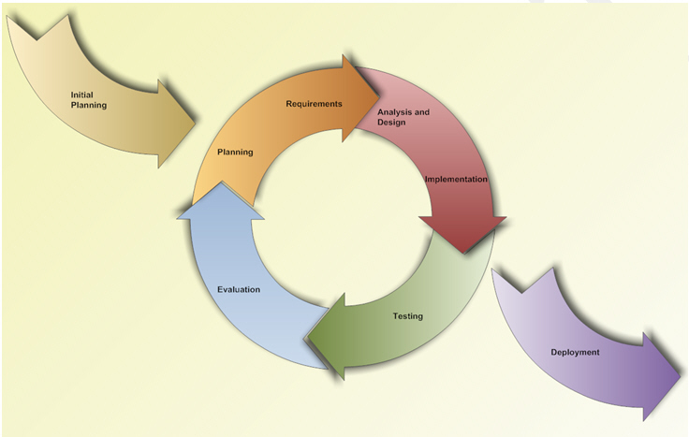

## 2.2. Project Organization

### 2.2.1. Our proposal system

This figure above describes the information and products flow lifecycle process model. TrendyPlus project uses the Iterative and Incremental Software Process Model.

*Figure 2-1: Iterative and Incremental Software Process Model*

The Iterative and Incremental Software Process Model is most use when the scope of the project is big, the major requirements were defined clearly, some more detail will be added in time, and for the newbie group in software development. By using this software process model, we break down the developing system task into series of smaller tasks which be completed separately, evaluated, and subsequently re-worked until the system’s performance adequately. In addition, the iterative model is easier than other models when the issues are discovered. They are fed back to the team, and solutions found while the project is still in development.

### 2.2.2. Roles and Responsibilities

#### 2.2.2.1. Organization Structure

*Table 2-1: Organization Structure*

|  |  |
| --- | --- |
| **Role** | **Responsibility** |
| Project Manager | Planning and defining scope, developing schedules, allocating resources, coordinating communication, generally responsible for keeping the team’s focus on main goal, and tries to keep the project team focused on the right goal at a time. |
| Technical Leader | Responsible for the underlying architecture for the software program, assigning tasks, mentoring people, reporting and updating regular associates RAG status. Also technical leader is a reference book for other software programmers. |
| Business Analyst | Eliciting requirement, analyzing and documenting requirements, communicate requirements, identifying solution and verifying solution meets the requirements, leads and coordinates use-case modeling. Outline the system’s functionality. |
| Developer | Involve to code product. |
| Test Leader | Responsible for test execution, including test set-up and test run, evaluation of test run and error recovery, defect logging and test results recording. |
| Designer | Involve to design product. |

#### 2.2.2.2. Project Team Member

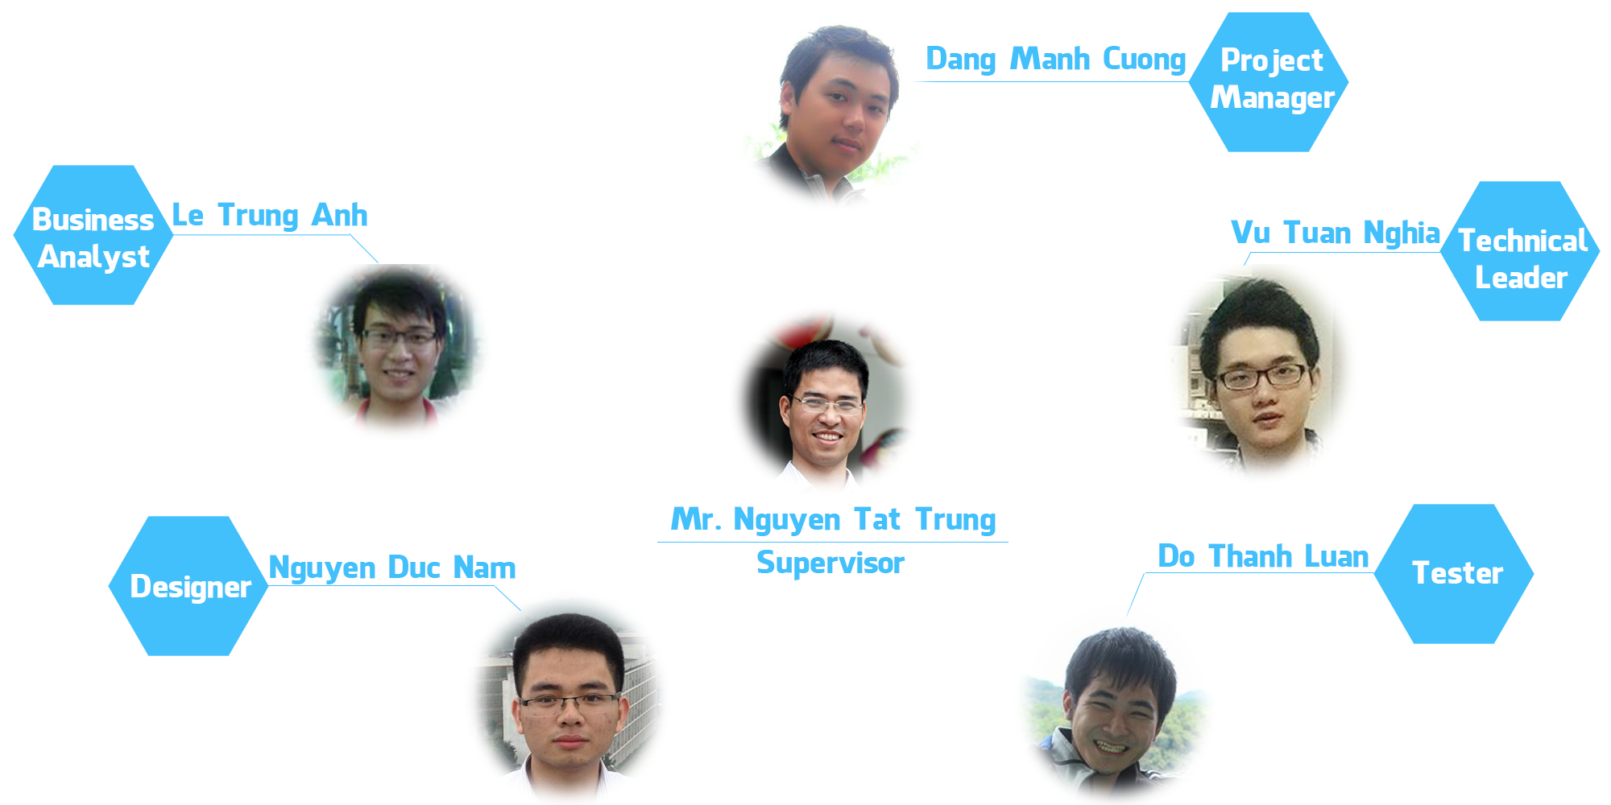

*Figure 2-2: Project Team Members*

#### 2.2.2.3. Tools and Techniques

* Programming languages:
* PHP v5.6, Node JS v0.12.1, HTML5, CSS3.
* Framework:
* Laravel v4.3 (PHP), Express v3.20 (Node JS), AngularJS v1.2.22 (JavaScript)
* Software Architecture:
* Web Service (REST architecture).
* Process Model:
* Iterative and Incremental Software Process Model.
* Version Control:
* Github.
* IDEs:
* PHPStorm v8.0.
* DBMS:
* MySQL v5.5, Redis v3.0, MySQL Workbench v6.2.
* UML tools:
* Enterprise Architect v12, Astah Professional v6.9.0
* Manage tools:
* Microsoft Project Professional 2013.
* Web server:
* Apache2.0.

## 2.3. Project Management Plan

### 2.3.1. Task

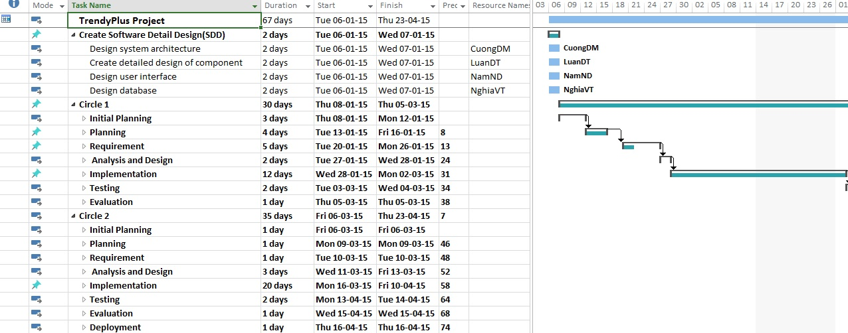

*Figure 2-3: Work Breakdown Structure*

### 2.3.2. Meeting Minutes

All meeting minutes will be written follow this template:

| ***Meeting/Project Name:*** | *TrendyPlus.* | | | | |
| --- | --- | --- | --- | --- | --- |
| ***Date of Meeting:*** | *10/03/2015* | | ***Time: (Type)*** | *3 hours* | |
| ***Facilitator:*** | *CuongDM* | | ***Location:*** | *FPT University* | |
| ***Note Taker:*** | *AnhLT* | | ***Time Keeper:*** | *NamND* | |
| 1. Meeting Objective: | | | | | |
| Brainstorming all functions of systems | | | | | |
| 2. Attendance | | | | | |
| ***Name*** | ***Roles*** | ***E-mail*** | | | ***Phone*** |
| Dang Manh Cuong | Project Manager | [cuongdmse02679@fpt.edu.vn](mailto:cuongdmse02679@fpt.edu.vn) | | | 01696234558 |
| Le Trung Anh | Business Analyst | [anhltse02828@fpt.edu.vn](mailto:anhltse02828@fpt.edu.vn) | | | 01638985195 |
| Do Thanh Luan | Test Leader | [luandtse02899@fpt.edu.vn](mailto:luandtse02899@fpt.edu.vn) | | | 0978332970 |
| 3. Content: | | | | | |
|  | | | | | |

*Table 2-2: Meeting Minutes Template*

### 2.3.3. Coding Conventions

Follow PHP coding convention. See the reference for detail: <http://www.php-fig.org/psr/psr-2/>.

### 2.3.4. Risk Management Plan

|  |  |  |  |  |  |
| --- | --- | --- | --- | --- | --- |
| **No** | **Description** | **Root Cause** | **Avoidance plan** | **Contingency plan** | **Status** |
| 1 | Team members can miss some important information. | - Don’t use common tool to communicate.  - Members are too busy to check notifications or messages. | - Come to agreement of which is the main communication tool all members use.  - Use phone call in case of important situations.  - Use reminder web service to assign task and tracking work schedule. | - Review all information and tasks in the end of the wrap-up meeting. | Close |
| 2 | The project is not on time. | - Underestimate time of project.  - The scope of project is too big for team.  - Spend too much time to research and study but don’t start coding. | - Keep track with capstone’s deadline.  - Ask supervisor for advice to define suitable scope.  - Put high priority on main functions.  - Start coding as early as possible. | - Work together for tracking schedule. | Close |
| 3 | Poor experience of evaluation make miss scope. | - This project to need some new technique to meet scope.  - Some team members do not work in web development function.  - Team member do not have experience about this domain knowledge. | - List tasks and check continuously.  - Evaluate quality and progress weekly. | - Training some new technique like: Github and how to use, Ubuntu Linux, web remind…  - Assign one member to research about domain knowledge and create business annalistic. | Close |
| 4 | Conflict between team members | - Opinion disagreements  - Some team members don’t get along with others. | - Organize some team buildings to bond members together. | - Talk with each member to find the solution. | Close |
| 5 | Productivity is low | - Some members spend too little time to do project.  - New technique required a lot of time to research and study. | - Set rule with money penalty for who doesn’t finish job on time.  - Set minimum working time for every team members. | - Tell team members to rearrange their working time.  - Work overtime to study new technique. | Close |
| 6 | Requirement Changing | - Not cover all possible cases  - Change the requirement regularly to optimize system | - Carefully brainstorm system’s features among team members  - Regularly hold meeting to define and discuss all features of systems  - Design system carefully. Calculate all the possible cases to minimize the change. | - Team meetings with supervisor to determine whether new feature should be implemented or not  - Team leaders create implementation plan for implemented features and send to team members. | Close |
| 7 | Data lost | - Lost data because do not backup the data.  - Someone merge code make lost another one code. | - Define a schedule to back up project’s data | - Restore project’s data.  - Using Github repository to back- up data. | Close |

*Table 2-3: Risk Management Plan*

### 2.3.5. Communication Plan

*Weekly meeting schedule:* By using Iterative and Incremental Process Model, TrendyPlus Project system will be divided into a series of small tasks, each task will be assigned to team members by Technical Leader and depend on difficulty, and Technical Leader will assign deadlines for each task. We will have a meeting every day from 20h00 to 21h00 to review together all task and problem in project. Any member who doesn’t finish his/her task (without reasonable explanation) will be fined. The issues which we are having, we will discuss and find solution together. If it is too difficult and can’t be solved by ourselves, we will ask our supervisor for advises*.*

*Unscheduled meeting:* If someone has an important problem want to be solved immediately, he proposes to PM and we will have a meeting for discussion*.*

*Communication channel:* Our main communication channels are face – to – face meeting, Email and Facebook. However, we sometimes can make a phone call or instant message if someone has problem.

# CHAPTER 3: SOFTWARE REQUIREMENT SPECIFICATION

## 3.1. Purpose

This chapter outlines functional and non – functional requirements of our website. It also provides some format constraints in common requirements and project success criteria. All members will work (design, code, test) based on the information provided in this chapter.

## 3.2. Functional Requirements

### 3.2.1. Use Case Diagram

*Figure 3-1: Use case diagram of TrendyPlus system*

*Figure 3-1: Use case diagram of TrendyPlus system*

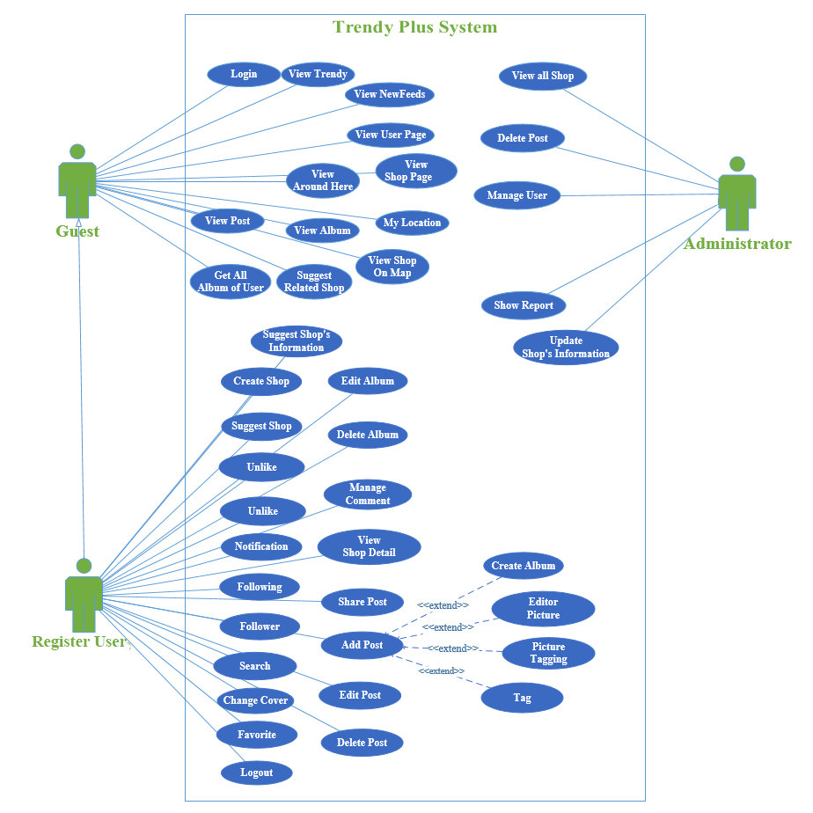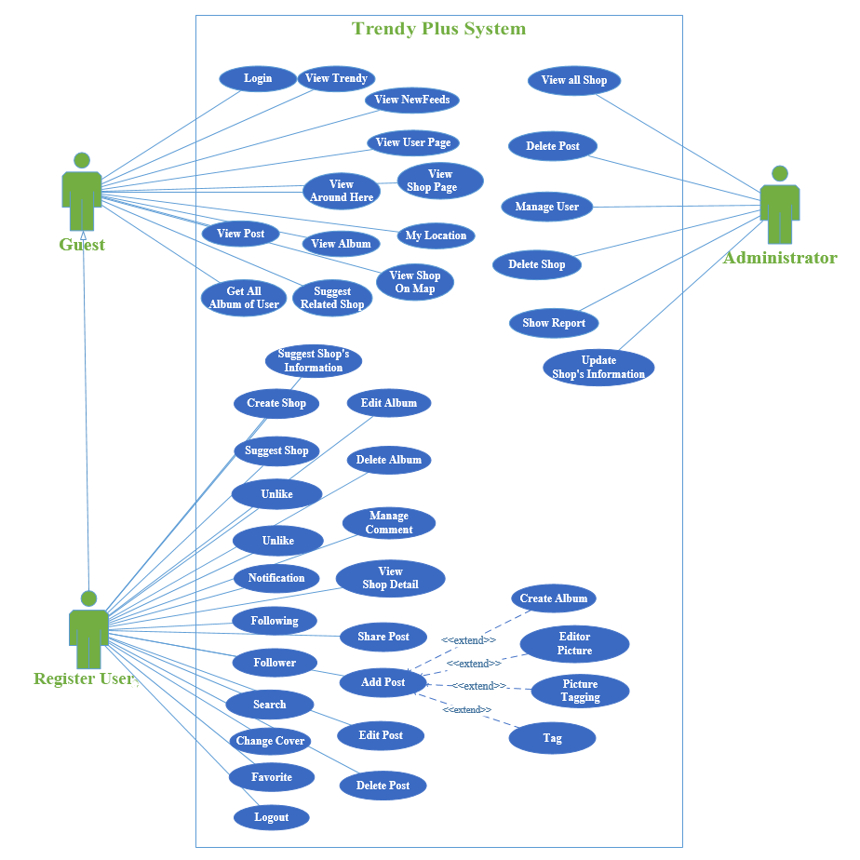

### 3.2.2. Use Case List

|  |  |
| --- | --- |
| Primary Actor | Use Cases |
| Guest, Register User | UC-1.0: Login |
| Guest, Register User | UC-2.0: View Trendy |
| Guest, Register User | UC-3.0: View Newsfeed |
| Guest, Register User | UC-4.0: View User page |
| Guest, Register User | UC-5.0: View Shop page |
| Guest, Register User | UC-6.0: View Around Here |
| Guest, Register User | UC-7.0: My Location |
| Guest, Register User | UC-8.0: View Album |
| Guest, Register User | UC-9.0: View Post |
| Guest, Register User | UC-10.0: View Shop on map |
| Guest, Register User | UC-11.0: Get all Album of user |
| Guest, Register User | UC-12.0: Suggest related user |
| Register User | UC-13.0: Create Album |
| Register User | UC-14.0: Delete Album |
| Register User | UC-15.0: Edit Album |
| Register User | UC-16.0: Add Post’s comment |
| Register User | UC-17.0: Edit Post’s comment |
| Register User | UC-18.0: Delete Post’s comment |
| Guest, Register User | UC-19.0: View Post’s comment |
| Register User | UC-20.0: Add Shop’s comment |
| Register User | UC-21.0: Edit Shop’s comment |
| Register User | UC-22.0: Delete Shop’s comment |
| Guest, Register User | UC-23.0: View Shop’s comment |
| Register User | UC-24.0: Add Post |
| Register User | UC-25.0: Editor Image |
| Register User | UC-26.0: Image tagging |
| Register User | UC-27.0: Content tagging |
| Register User | UC-28.0: Delete Post |
| Register User | UC-29.0: Edit Post |
| Register User | UC-30.0: Like Post |
| Register User | UC-31.0: Unlike Post |
| Register User | UC-32.0: Share Post |
| Register User | UC-33.0: Create Shop |
| Guest, Register User | UC-34.0: Suggest Shop |
| Register User | UC-35.0: Suggest Shop’s Information |
| Register User | UC-36.0: View Shop Detail |
| Register User | UC-37.0: Like Shop |
| Register User | UC-38.0: Unlike Shop |
| Register User | UC-39.0: View Following |
| Register User | UC-40.0: View Follower |
| Register User | UC-41.0: Add Follow |
| Register User | UC-42.0: Remove Follow |
| Register User | UC-43.0: Add Favorite |
| Register User | UC-44.0: Remove Favorite |
| Register User | UC-45.0: Subscribe Notification |
| Register User | UC-46.0: View Notification |
| Register User | UC-47.0: Change Cover |
| Register User | UC-48.0: Logout |
| Guest, Register User, Administrator | UC-49.0: General Search |
| Administrator | UC-50.0: Search User |
| Administrator | UC-51.0: Search Shop |
| Guest, Register User, Administrator | UC-52.0: Search on Map |
| Administrator | UC-53.0: View All User |
| Administrator | UC-54.0: Delete Post |
| Administrator | UC-55.0: View All Shop |
| Administrator | UC-56.0: Update Information Shop |
| Administrator | UC-57.0: Ban User |
| Administrator | UC-58.0: Unban User |
| Administrator | UC-59.0: Show Report |

*Table 3-1: Use case list*

*Table 3-1: Business Rule*

### 3.2.3. Business Rules

This is the business rules table for system‘s use cases

|  |  |
| --- | --- |
| **No** | **Description** |
| **B1** | The banned account can’t log in the system. |
| **B2** | The text length must be less than 255 characters. |
| **B3** | The maximum time out for a post is 120s. |
| **B4** | The file upload extension name must be “*.PNG”* or *“.JPG*”. |
| **B5** | The target user must exist, not banned. |
| **B6** | Information of each item in follower (or following) list includes: avatar, user name. |
| **B7** | If search result is empty then TrendyPlus system displays message *“No result for* ***[abcd]****”* with abcd is content that actor inputs*.* |
| **B8** | Editing information confirmation dialog includes: *“Do you want to save your changes?”* message, *“Yes”* button, *“No”* button. |
| **B9** | If user currently failed to communicate with TrendyPlus server then TrendyPlus system display error message dialog *“Cannot connect to server”.* |
| **B10** | Error message dialog includes: error message text, *“Ok”* button. |
| **B11** | Administrator must enter at least one search criteria before clicking *“Delete”* button. |
| **B12** | User has two states, includes: *“Active”* – active, *“Banned”* – banned. |
| **B13** | Post lazy loading technique displays at most 8 posts more each time. |
| **B14** | If user accesses to nonexistent address in the system then TrendyPlus displays error message *“Page not found”.* |
| **B15** | Searched text must be not empty. |
| **B16** | User is the owner of this Post/Album/Comment/Like. |
| **B17** | After user hit the like button or icon, TrendyPlus replaces it with unlike button and change icon's color from default to blue. |
| **B18** | After user hit the favorite button or favorite icon, TrendyPlus replaces it with “*favorited*” button and change icon's color from default to red. |
| **B19** | After user hit the unlike button or icon, TrendyPlus replaces it with like button and change icon's color from blue to default. |
| **B20** | After user hit the *“favorited”* button or icon, TrendyPlus replaces it with favorite button and change icon's color from red to default.  *Table 3-2: Business Rule*  *Table 3-1: Business Rule* |

### 3.2.4. Use Cases

#### 3.2.4.1. Guest

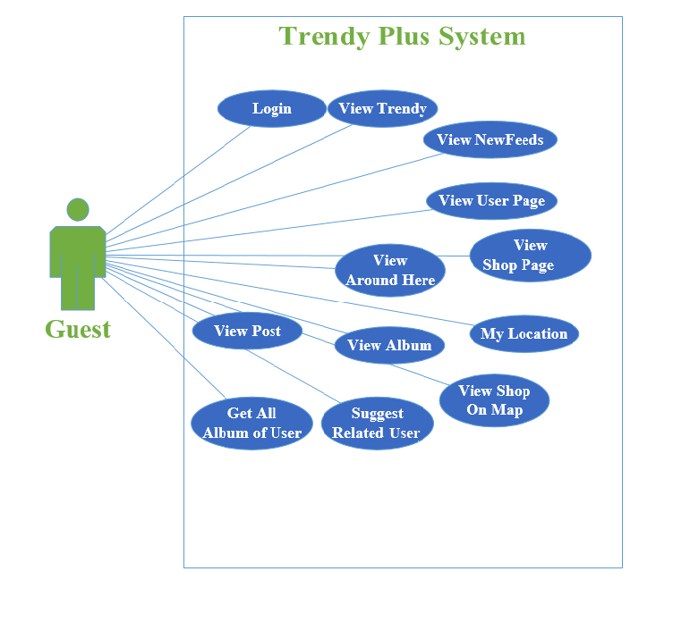

*Figure 3-2: Use case of Guest*

*Figure 3-2: Use case of Guest*

##### 3.2.4.1.1. Login

*Use Case specification*

|  |  |  |  |
| --- | --- | --- | --- |
| UC ID and Name: | **UC-1.0: Login** | | |
| Created By: | **NghiaVT** | Date Created: | **17/03/2015** |
| Primary Actor: | **Guest** | Secondary Actors: | N/A |
| Trigger: | Actor want to login to TrendyPlus | | |
| Description: | Actor logins to website to access full function. Actor can login by many way:   * Click “*Login*” button on Homepage * Input text field *“Comment”* * Click on *“Like”*, *“Favorite”* button * Click on *“Newsfeed”* Tab | | |
| Preconditions: | **PRE-1.1.** Actor accesses website on browser via Internet  **PRE-1.2.** Actor has one of 3 social network account (Facebook, Google+ and Twitter) | | |
| Postconditions: | **POST-1.1.** Actor logins the system successfully. | | |
| Normal Flow: | 1. **Login** 2. Actor clicks on “*Login*” button. 3. If it is first time Actor logins to website go to step 3, if not go to step 4. 4. A dialog *“Login”* display on actor’s screen, ask for permission about TrendyPlus app. 5. Actor clicks on “*Join using your Facebook Account*” or “*Join using your Google Account*” or “*Join using your Twitter Account*” button. 6. System indicates this account is valid or not. | | |
| Alternative Flows: | N/A | | |
| Exceptions: | **1.0-E1 – Banned Account (Step 4)**   1. System indicates that account has been banned 2. A message *“Your account is banned. Please contact to administrator”* is displayed. 3. Actor clicks on *“Ok”* button and TrendyPlus reload this page. | | |
| Priority: | High. | | |
| Frequency of Use: | Low. | | |
| Business Rules: | N/A | | |
| Other Information: | N/A | | |
| Assumptions: | N/A | | |

##### 3.2.4.1.2. View Trendy

*Use Case specification*

|  |  |  |  |
| --- | --- | --- | --- |
| UC ID and Name: | **UC-2.0: View Trendy** | | |
| Created By: | **NghiaVT** | Date Created: | **17/03/2015** |
| Primary Actor: | **Guest, Registered User** | Secondary Actors: | N/A |
| Trigger: | Actor want to see trendy fashion post in TrendyPlus. | | |
| Description: | Actor views fashion Trendy in website. | | |
| Preconditions: | **PRE-2.1.** Actor accesses website on browser via Internet | | |
| Postconditions: | N/A | | |
| Normal Flow: | **2.0 View Trendy**   1. Actor accesses to TrendyPlus on browser via Internet. 2. TrendyPlus displays most and more Trendy Post result. 3. Actor scrolls to view more post. | | |
| Alternative Flows: | N/A | | |
| Exceptions: | **2.0-E1 – Cannot communicate with the application server**   1. TrendyPlus displays error: *“Cannot connect to server”.* | | |
| Priority: | High. | | |
| Frequency of Use: | High. | | |
| Business Rules: | N/A | | |
| Other Information: | N/A | | |
| Assumptions: | N/A | | |

##### 3.2.4.1.3. View Newsfeed

*Use Case specification*

|  |  |  |  |
| --- | --- | --- | --- |
| UC ID and Name: | **UC-3.0: View Newsfeed** | | |
| Created By: | **NghiaVT** | Date Created: | **17/03/2015** |
| Primary Actor: | **Registered User** | Secondary Actors: | N/A |
| Trigger: | Actor want to see news posts which actor’s following posting in TrendyPlus. | | |
| Description: | Actor views Newsfeed in website. | | |
| Preconditions: | **PRE-3.1** - Actor accesses website on browser via Internet.  **PRE-3.2 -** Actor is not existed on banned user list. | | |
| Postconditions: | N/A | | |
| Normal Flow: | **3.0 View Newsfeed**   1. Actor accesses to TrendyPlus on browser via Internet. 2. Actor clicks on *“Newsfeed”* tab. 3. Website displays most Newsfeed post result. 4. Actor scrolls to view more post. | | |
| Alternative Flows: | N/A | | |
| Exceptions: | **3.0-E1** – Actor doesn’t following anyone   * 1. Website will display some most popular user to actor following. | | |
| Priority: | High | | |
| Frequency of Use: | High | | |
| Business Rules: | N/A | | |
| Other Information: | N/A | | |
| Assumptions: | N/A | | |

##### 3.2.4.1.4. View User page

*Use Case specification*

|  |  |  |  |
| --- | --- | --- | --- |
| UC ID and Name: | **UC-4.0: View User Page** | | |
| Created By: | **LuanDT** | Date Created: | **17/03/2015** |
| Primary Actor: | **Guest, Registered Users** | Secondary Actors: | **TrendyPlus System** |
| Trigger: | N/A | | |
| Description: | Actor can view all Post and Album of actor or another user | | |
| Preconditions: | **PRE–4.1.** Actor accesses TrendyPlus on browser via Internet. | | |
| Postconditions: | N/A | | |
| Normal Flow: | **4.0 View user profile page of Actor**   1. Actor accesses TrendyPlus on browser via Internet. 2. Actor clicks user avatar 3. Actor clicks *“Profile”* in header | | |
| Alternative Flows: | **4.0 View user profile page of another user**   1. Actor accesses to TrendyPlus 2. Actor searches one user by using search box *“Search friend or shop”* 3. Actor accesses to user page of this user. | | |
| Exceptions: | **4.0-E1 – Cannot communicate with the application server**   1. TrendyPlus displays error: *“Cannot connect to server”*. | | |
| Priority: | Medium | | |
| Frequency of Use: | High | | |
| Business Rules: | N/A | | |
| Other Information: | If actor is lost network connectivity in process, system doesn’t anything. | | |
| Assumptions: | N/A | | |

##### 3.2.4.1.5. View Shop page

*Use Case specification*

|  |  |  |  |
| --- | --- | --- | --- |
| UC ID and Name: | **UC-5.0: View shop page** | | |
| Created By: | **NamND** | Date Created: | **15/03/2015** |
| Primary Actor: | **Guest, Registered User** | Secondary Actors: | **TrendyPlus System** |
| Trigger: | The actor indicates that he wants to view shop page. | | |
| Description: | The Actor accesses this function on shop page via Internet. The Actor accesses to the target shop page. | | |
| Preconditions: | **PRE-5.1.** The actor is logged into Trendy Plus.  **PRE-5.2.** If actor is registered user, actor is not existed on banned user list. | | |
| Postconditions: | **POST-5.1.** TrendyPlus displays target shop page. | | |
| Normal Flow: | **5.0 View shop page**   1. Actor on Post popup. 2. The actor clicks on the shop’s address of tagging image information. | | |
| Alternative Flows: | **5.1 View shop page**   1. Actor searches shop on search bar. 2. Actor clicks on shop to access to target shop. | | |
| Exceptions: | **5.0-E1 –** **Target shop page was deleted before user accesses to shop.**   1. TrendyPlus displays message *“No result for* ***[abcd]****”* with abcd is content that actor inputs. | | |
| Priority: | Medium | | |
| Frequency of Use: | Medium | | |
| Business Rules: | **B13, B14** | | |
| Other Information: | N/A | | |
| Assumptions: | N/A | | |

##### 3.2.4.1.6. View around Here

*Use Case specification*

|  |  |  |  |
| --- | --- | --- | --- |
| UC ID and Name: | **UC-6.0: View around here** | | |
| Created By: | **NghiaVT** | Date Created: | **17/03/2015** |
| Primary Actor: | **Registered User, Guest** | Secondary Actors: | N/A |
| Trigger | Actor want to see some posts in TrendyPlus around actor’s location. | | |
| Description: | Actor views posts around actor’s location. | | |
| Preconditions: | **PRE-6.1.** Actor accesses website on browser via Internet. | | |
| Postconditions: | N/A | | |
| Normal Flow: | **6.0 View Around here**   1. Actor accesses TrendyPlus on browser via Internet 2. Actor clicks on *“Around here”* tab. 3. TrendyPlus will display all shop on map and get position of post order by near to far. | | |
| Alternative Flows: | N/A | | |
| Exception | **6.0-E1 – Cannot communicate with the application server**   * 1. TrendyPlus displays error message *“Cannot connect to server”.*   2. Actor clicks on *“Ok”* button and TrendyPlus reload this page. | | |
| Priority: | Medium. | | |
| Frequency of Use: | Medium. | | |
| Business Rules: | **B14** | | |
| Other Information: | N/A | | |
| Assumptions: | N/A | | |

##### 3.2.4.1.7. My Location

*Use Case specification*

|  |  |  |  |
| --- | --- | --- | --- |
| UC ID and Name: | **UC-7.0: My Location** | | |
| Created By: | **LuanDT** | Date Created: | **17/03/2015** |
| Primary Actor: | **Guest, Registered User** | Secondary Actors: | **TrendyPlus System** |
| Trigger: | N/A | | |
| Description: | Actor can find out actor‘s location. | | |
| Preconditions: | **PRE–7.1**. Actor accesses TrendyPlus on browser via Internet. | | |
| Postconditions: | N/A | | |
| Normal Flow: | **7.0 Get My location**   1. Actor accesses TrendyPlus on browser via Internet. 2. Actor clicks tab “*Around here*”. 3. Trendy Plus displays around here page. 4. Actor clicks on to C:\Users\Anh\Downloads\Capture.PNG button. 5. Brower displays pop up confirm “*Google Chrome wants to use your location information*”. 6. Actor clicks “*Allow*”. 7. The Map changes center to actor’s location. | | |
| Alternative Flows: | **7.1 Block get location** (Step 6)   1. Actor clicks “*Block*” button. 2. TrendyPlus doesn’t anything. | | |
| Exceptions: | **7.0-E1 – Cannot communicate with the application server**   1. TrendyPlus displays error: *“Cannot connect to server”*. | | |
| Priority: | Medium | | |
| Frequency of Use: | Medium | | |
| Business Rules: | N/A | | |
| Other Information: | If actor is lost network connectivity in process, system doesn’t anything. | | |
| Assumptions: | N/A | | |

##### 3.2.4.1.8. View Album

*Use Case specification*

|  |  |  |  |
| --- | --- | --- | --- |
| UC ID and Name: | **UC-8.0: View Album** | | |
| Created By: | **CuongDM** | Date Created: | **10/03/2015** |
| Primary Actor: | **Guest, Registered User** | Secondary Actors: | N/A |
| Trigger: | N/A | | |
| Description: | The actor views about Posts of Album. | | |
| Preconditions: | **PRE-8.1.** Actor visits TrendyPlus on browser via Internet.  **PRE-8.2.** If actor is registered user, actor is not existed on banned user list. | | |
| Postconditions: | **POST-8.1.** TrendyPlus show all of Post in Album. | | |
| Normal Flow: | **8.0 View Album**   1. Actor visits owner user page on browser via Internet. 2. Actor chooses tab “*Albums*”. 3. TrendyPlus displays all Albums of actor. 4. Actor clicks on Album which wants to view. 5. TrendyPlus shows all Posts in the Album. | | |
| Alternative Flows: | N/A | | |
| Exceptions: | **8.0-E1 – Cannot communicate with the application server**   1. TrendyPlus displays error message *“Cannot connect to server”*. 2. Actor clicks on *“Ok”* button and TrendyPlus reload this page. | | |
| Priority: | Medium | | |
| Frequency of Use: | Medium | | |
| Business Rules: | **B16** | | |
| Other Information: | N/A | | |
| Assumptions: | N/A | | |

##### 3.2.4.1.9. View Post

*Use Case specification*

|  |  |  |  |
| --- | --- | --- | --- |
| UC ID and Name: | **UC-9.0: View Post** | | |
| Created By: | **CuongDM** | Date Created: | **10/03/2015** |
| Primary Actor: | **Guest, Registered User** | Secondary Actors: | N/A |
| Trigger: | N/A | | |
| Description: | Actor accesses to 1 in 4 tabs *“Trendy”, “Newsfeed”, “Around here”, “Favorite”* or User page and selects a Post to view. | | |
| Preconditions: | **PRE-9.1.** Actor visits TrendyPlus on browser via Internet.  **PRE-9.2.** If actor is registered user, actor is not existed on banned user list. | | |
| Postconditions: | **POST-9.1.** All information about clicked Post is displayed. | | |
| Normal Flow: | **9.0 View Post:**   1. With any tab on TrendyPlus or user page, actor clicks to a container of a Post (such as a cover photo of this Post). 2. TrendyPlus redirect actor to Post’s pop up. | | |
| Alternative Flows: | N/A | | |
| Exceptions: | **9.0-E1 – Cannot communicate with the application server.**   1. TrendyPlus displays error message *“Cannot connect to server”*. 2. Actor clicks on *“Ok”* button and TrendyPlus reload this page. | | |
| Priority: | High. | | |
| Frequency of Use: | High. | | |
| Business Rules: | N/A | | |
| Other Information: | If actor is lost network connectivity during processing to redirect to Post’s pop up, pop up cannot be displayed. | | |
| Assumptions: | N/A | | |

##### 3.2.4.1.10. View Shop on map

*Use Case specification*

|  |  |  |  |
| --- | --- | --- | --- |
| UC ID and Name: | **UC-10.0: View Shop on map** | | |
| Created By: | **NamND** | Date Created: | **16/03/2015** |
| Primary Actor: | **Guest, Registered Users** | Secondary Actors: | **TrendyPlus System** |
| Trigger | Actor indicates that he wants to view shop on map. | | |
| Description: | Actor accesses this function on shop page via Internet. The actor view shop’s position on map. | | |
| Preconditions: | **PRE-10.1.** The actor is logged into Trendy Plus.  **PRE-10.2.** If actor is registered user, actor is not existed on banned user list. | | |
| Postconditions: | **POST-10.1.** The shop position show on map. | | |
| Normal Flow: | **10.0 View Shop on map**   * 1. The Actor on Post popup.   2. The actor clicks on the shop’s address of tagging image information.   3. The actor views shop on map with map is displayed on shop page. | | |
| Alternative Flow: | **10.1 View Shop on map**   * 1. The Actor searches shop on search bar.   2. Actor clicks on shop to access to target shop.   3. Return to step 3. | | |
| Exception | **10.0-E1 – Target shop page was deleted before the Actor accesses to shop.**   * 1. TrendyPlus displays message *“No result for* ***[abcd]****”* with abcd is content that actor inputs*.* | | |
| Priority: | High. | | |
| Frequency of Use: | High. | | |
| Business Rules: | N/A | | |
| Other Information: | N/A | | |
| Assumptions: | N/A | | |

##### 3.2.4.1.11. Get all Album of user

*Use Case specification*

|  |  |  |  |
| --- | --- | --- | --- |
| UC ID and Name: | **UC-11.0: Get all Album of User** | | |
| Created By: | **CuongDM** | Date Created: | **10/03/2015** |
| Primary Actor: | **Guest, Registered User** | Secondary Actors: | N/A |
| Trigger: | The actor indicates that he want to get all album of user. | | |
| Description: | The actor want to see all Album of user. | | |
| Preconditions: | **PRE-11.1.** Actor visits TrendyPlus on browser via Internet.  **PRE-11.2.** If actor is registered user, actor is not existed on banned user list. | | |
| Postconditions: | **POST-11.1.** TrendyPlus displays all album of user. | | |
| Normal Flow: | **11.0 Get all Album of User**   1. Actor visits any user page on browser via Internet. 2. Actor chooses tab “*Albums*”. 3. TrendyPlus displays all albums of user. | | |
| Alternative Flows: | N/A | | |
| Exceptions: | **11.0-E1 – Cannot communicate with the application server**   1. TrendyPlus displays error message *“Cannot connect to server”*. 2. Actor clicks on *“Ok”* button and TrendyPlus reload this page. | | |
| Priority: | Medium | | |
| Frequency of Use: | Medium | | |
| Business Rules: | **B16** | | |
| Other Information: | If actor is lost network connectivity during editing Album, the Album will not be changed. There is nothing affected to the system. | | |
| Assumptions: | N/A | | |

##### 3.2.4.1.12. Suggest related user

*Use Case specification*

|  |  |  |  |
| --- | --- | --- | --- |
| UC ID and Name: | **UC-12.0: Suggest related User** | | |
| Created By: | **NghiaVT** | Date Created: | **17/03/2015** |
| Primary Actor: | **Guest, Registered User** | Secondary Actors: | N/A |
| Trigger: | N/A | | |
| Description: | Actor sees related user to following. | | |
| Preconditions: | **PRE-12.1.** Actor accesses website on browser via Internet | | |
| Postconditions: | N/A | | |
| Normal Flow: | **12.0 Suggest related User – Registered User**   1. Actor accesses any user’s page on browser via Internet. 2. On the right, actor can see 3 related suggestion users to follow. 3. Actor clicks on “*Follow*” button which under User’s name who actor want to follow. 4. Followed user in step 3 will be disappeared and website update new list related suggestion user. | | |
| Alternative Flows: | **12.1 Suggest related User – Guest**   1. Actor accesses any user’s page on browser via Internet 2. On the right, actor can see 3 related suggestion user to follow. 3. Actor clicks on “*Follow*” button under User’s name who actor want to follow. 4. Pop-up login display and require actor to login. | | |
| Exceptions: | **12.0-E1 – User of user’s page which Actor accesses has none related**   1. Tab Suggestion related User will be disappeared.   **12.0-E2 – Cannot communicate with the application server**   1. TrendyPlus displays error: *“Cannot connect to server”*. | | |
| Priority: | Medium. | | |
| Frequency of Use: | Medium. | | |
| Business Rules: | N/A | | |
| Other Information: | N/A | | |
| Assumptions: | N/A | | |

#### 3.2.4.2. Register User

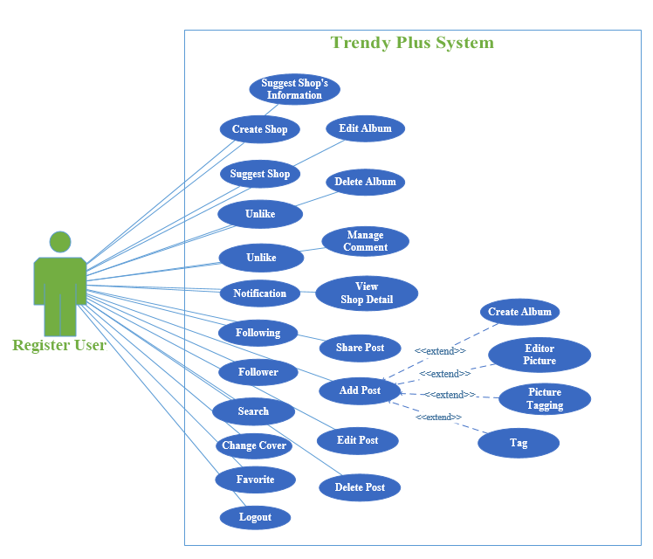

*Figure 3-3: Use case of Register User*

*Figure 3-3: Use case of Register User*

##### 3.2.4.2.1. Create Album

*Use Case specification*

|  |  |  |  |
| --- | --- | --- | --- |
| UC ID and Name: | **UC-13.0: Create Album** | | |
| Created By: | **AnhLT** | Date Created: | **17/03/2015** |
| Primary Actor: | **Register User** | Secondary Actors: | N/A |
| Trigger: | The Actor selects to create album image to the database. | | |
| Description: | Actor uses this function to create album image. All of image that actor posted will be saved in album. | | |
| Preconditions: | **PRE – 13.1.** Actor is logged into TrendyPlus  **PRE – 13.2.** Actor is not existed on banned user list | | |
| Postconditions: | **POST – 13.1.** Album after creating will be displayed on album image and it will save image of actor. | | |
| Normal Flow: | **13.0 Create album**   1. Actor clicks to *"Upload image"* button on TrendyPlus after logging. 2. A dialog box will be displayed and actor will choose image that they want to post. 3. A message dialog will be displayed with question *"Do you want to editor image"*. If actor want edit their image, they will click button *"Yes"* unless, they will click button *"No"* 4. Actor clicks to button *“Yes”* on message dialog. 5. Edit image page will be displayed. 6. Actor will edit their photos as they like with the tools made available. 7. After editing complete, actor can choose save or doesn’t save their image. If they want to save their image, they will click button “*Save”* on the top of edit image page unless they will click button *“Close”* on the top of edit image page. 8. Actor clicks to *“Save”* button*.* 9. TrendyPlus handle and move to create post page. 10. In Create post page, and at text field “*Add album*” is displayed on the bottom of the image actor will write name of album that they want create and add image to this album. 11. Actor clicks *“Submit”* button of the create post page after finishing. 12. TrendyPlus handling and create album that actor wrote. | | |
| Alternative Flows: | **13.1 Choose *“No”* (Step 3)**   1. Actor clicks *“No”* button on message dialog. 2. Create post page will be displayed. 3. Return to step 10.   **13.2 Choose *“Close”* (Step 7)**   1. Actor clicks *“Close”* button*.* 2. After clicking to button *“Close”,* TrendyPlus handle and move to Homepage. | | |
| Exceptions: | **13.0-E1 – Cannot communicate with the application server**   1. TrendyPlus displays error message *“Cannot connect to server”*. 2. TrendyPlus not handle save album that actor want create to the database. 3. TrendyPlus not handle display actor’s album in album image. | | |
| Priority: | High | | |
| Frequency of Use: | High | | |
| Business Rules: | **B2, B4, B9, B14, B15** | | |
| Other Information: | If actor is lost network connectivity in process to create album, actor's album won’t be created. | | |
| Assumptions: | N/A | | |

##### 3.2.4.2.2. Delete Album

*Use Case specification*

|  |  |  |  |
| --- | --- | --- | --- |
| UC ID and Name: | **UC-14.0: Delete Album** | | |
| Created By: | **CuongDM** | Date Created: | **10/03/2015** |
| Primary Actor: | **Registered User & Album Owner** | Secondary Actors: | N/A |
| Trigger: | N/A | | |
| Description: | When created successfully Album, the actor want to delete this Album. User will no longer see this Album anymore. | | |
| Preconditions: | **PRE-14.1.** Actor is logged into TrendyPlus on browser via Internet.  **PRE-14.2.** Actor is not existed on banned user list.  **PRE-14.3.** Actor is owner of this Album. | | |
| Postconditions: | **POST-14.1.** Album is deleted successfully, information and all Post of Album is erased from database. | | |
| Normal Flow: | **14.0 Delete Album**   1. Actor visits owner actor’s page. 2. Actor chooses tab “*Albums*” 3. TrendyPlus displays all Albums of actor. 4. Actor hovers edit icon bottom right of Album which wants to delete. 5. TrendyPlus shows the pop up “*Edit Album*”. 6. Actor clicks *“Delete Album”*. 7. TrendyPlus show a pop up with question “*Are you sure?*” with two options *“Yes”* or *“No”*. 8. Actor chooses *“Yes”.* 9. The Album will be deleted from database and no longer being displayed. | | |
| Alternative Flows: | **14.1 Choose *“No”* (Step 7)**   1. Actor chooses *“No”* instead of *“Yes”*. 2. Album is not deleted. | | |
| Exceptions: | **14.0-E1 – Cannot communicate with the application server.**   1. TrendyPlus displays error message *“Cannot connect to server”*. 2. Actor clicks on *“Ok”* button and TrendyPlus reload this page. | | |
| Priority: | Medium. | | |
| Frequency of Use: | Medium. | | |
| Business Rules: | **B16** | | |
| Other Information: | If actor is lost network connectivity during deleting Album, the Album will not be changed. There is nothing affected to the system. | | |
| Assumptions: | N/A | | |

##### 3.2.4.2.3. Edit Album

*Use Case specification*

|  |  |  |  |
| --- | --- | --- | --- |
| UC ID and Name: | **UC-15.0: Edit Album** | | |
| Created By: | **CuongDM** | Date Created: | **10/03/2015** |
| Primary Actor: | **Registered User & Album Owner** | Secondary Actors: | N/A |
| Trigger: | The actor views detail about Album, indicates something wrong and wants to update information. | | |
| Description: | When created successfully Album, the actor want to edit this Album. | | |
| Preconditions: | **PRE-15.1.** Actor is logged into TrendyPlus on browser via Internet.  **PRE-15.2.** Actor is not existed on banned user list.  **PRE-15.3.** Actor is owner of this Album. | | |
| Postconditions: | **POST-15.1.** TrendyPlus show alter message *“Congratulation”,* a name of Album is updated successfully and information of Album is saved. | | |
| Normal Flow: | **15.0 Edit Album**   1. Actor visits owner user page on browser via Internet. 2. Actor chooses tab “*Albums*”. 3. TrendyPlus displays all Albums of actor. 4. Actor hovers edit icon bottom right of this Album which wants to edit. 5. TrendyPlus shows the pop up “*Edit Album*”. 6. Actor renames this Album and click “*Save*”. 7. TrendyPlus shows alert congratulation message *“You have editted album name.”* 8. Album’s name will be changed from database and return user page. | | |
| Alternative Flows: | **15.1 Choose *“No”* (Step 7)**   1. Actor chooses *“No”* instead of *“Yes”*. 2. Album’s name won’t be unchanged. | | |
| Exceptions: | **15.0-E1 – Cannot communicate with the application server.**   1. TrendyPlus displays error message *“Cannot connect to server”*. 2. Actor clicks on *“Ok”* button and TrendyPlus reload this page. | | |
| Priority: | Low | | |
| Frequency of Use: | Low | | |
| Business Rules: | **B16** | | |
| Other Information: | If actor is lost network connectivity during editing album, album will not be changed. There is nothing affected to the system. | | |
| Assumptions: | N/A | | |

##### 3.2.4.2.4. Add Post’s comment

*Use Case specification*

|  |  |  |  |
| --- | --- | --- | --- |
| UC ID and Name: | **UC-16.0: Add Post’s comment** | | |
| Created By: | **AnhLT** | Date Created: | **17/03/2015** |
| Primary Actor: | **Register User** | Secondary Actors: | N/A |
| Trigger: | The Actor selects to add new post’s comment to the database. | | |
| Description: | Actor uses this function on post is displayed at 1 in 4 tabs *“Trendy”, “Newsfeed”, “Around here”, “Favorite”* via Internet. Actor will write content that they want comment to a text field is displayed on the right and bottom of the image of post. | | |
| Preconditions: | **PRE – 16.1.** Actor is logged into TrendyPlus.  **PRE – 16.2.** Actor is not existed on banned user list. | | |
| Postconditions: | **POST – 16.1.** Comment which is written will be displayed on the right of actor’s image of post. | | |
| Normal Flow: | **16.0 Add Post’s comment**   1. Actor scrolls the mouse to search post is displayed at 1 in 4 tabs *“Trendy”, “Newsfeed”, “Around here”, “Favorite”*. 2. Actor clicks any post that they like. 3. TrendyPlus handling and show post that actor want after they click. 4. Actor writes content that they want comment to a text field is displayed on the right and bottom of the image. 5. Actor presses *“Enter”* on keyboard after finishing comment. 6. TrendyPlus handling and show actor’s comment on the right and bottom of the image of post. | | |
| Alternative Flows: | N/A | | |
| Exceptions: | **16.0-E1 – Cannot communicate with the application server**   1. TrendyPlus displays error message *“Cannot connect to server”*. 2. TrendyPlus not handle display actor’s comment on the right and bottom of the image of post. | | |
| Priority: | High | | |
| Frequency of Use: | High | | |
| Business Rules: | **B9** | | |
| Other Information: | If actor is lost network connectivity in process to post content of comment, actor's comment won't be displayed. | | |
| Assumptions: | N/A | | |

##### 3.2.4.2.5. Edit Post’s comment

*Use Case specification*

|  |  |  |  |
| --- | --- | --- | --- |
| UC ID and Name: | **UC-17.0: Edit Post’s comment** | | |
| Created By: | **AnhLT** | Date Created: | **17/03/2015** |
| Primary Actor: | **Register User** | Secondary Actors: | N/A |
| Trigger: | The Actor selects to edit post’s comment to the database. | | |
| Description: | Actor uses this function on post is displayed at 1 in 4 tabs *“Trendy”, “Newsfeed”, “Around here”, “Favorite”* via Internet. Actor will write content that they want edit in comment text field is displayed on the right and bottom of the image of post. | | |
| Preconditions: | **PRE – 17.1.** Actor is logged into TrendyPlus.  **PRE – 17.2.** Actor commented in post.  **PRE – 17.3.** Actor is not existed on banned user list. | | |
| Postconditions: | **POST – 17.1.** Comment is edited will be displayed on the right and bottom of the image of post on newsfeed. | | |
| Normal Flow: | **17.0 Edit Post’s comment**   1. Actor scrolls the mouse to search post is displayed at 1 in 4 tabs *“Trendy”, “Newsfeed”, “Around here”, “Favorite”*. 2. Actor clicks any post that they like. 3. TrendyPlus handling and show post that actor want after they click. 4. Actor finds content that they commented on the right and bottom of the image of post. 5. Actor clicks on to C:\Users\Anh\Downloads\Capture.PNG to edit post’s comment. 6. Actor writes content that they want edit in edit comment text field. 7. Actor clicks to ok icon to save change after finishing edit comment. 8. TrendyPlus handling and show actor’s new comment on the right and bottom of the image of post. | | |
| Alternative Flows: | **17.1 Choose no(Step 7)**   1. Actor clicks second option noicon to stop edit comment. | | |
| Exceptions: | **17.0-E1 – Cannot communicate with the application server**   1. TrendyPlus displays error message *“Cannot connect to server”*. 2. TrendyPlus not handle display actor’s new comment on the right of the image of post. | | |
| Priority: | High | | |
| Frequency of Use: | High | | |
| Business Rules: | **B9** | | |
| Other Information: | If actor is lost network connectivity in process to edit content of comment, actor's content commented won't be edited. | | |
| Assumptions: | N/A | | |

##### 3.2.4.2.6. Delete Post’s comment

*Use Case specification*

|  |  |  |  |
| --- | --- | --- | --- |
| UC ID and Name: | **UC-18.0: Delete Post’s comment** | | |
| Created By: | **AnhLT** | Date Created: | **17/03/2015** |
| Primary Actor: | **Register User** | Secondary Actors: | N/A |
| Trigger: | The Actor selects to delete post’s comment to the database. | | |
| Description: | Actor uses this function on post is displayed at 1 in 4 tabs *“Trendy”, “Newsfeed”, “Around here”, “Favorite”* via Internet. Actor will delete content that they commented in comment text field is displayed on the right and bottom of the image of post. | | |
| Preconditions: | **PRE – 18.1.** Actor is logged into TrendyPlus.  **PRE – 18.2.** Actor commented in post.  **PRE – 18.3.** Actor is not existed on banned user list. | | |
| Postconditions: | **POST – 18.1.** Comment is deleted won’t be displayed on the right and bottom of the image of post. | | |
| Normal Flow: | **18.0 Delete Post’s comment**   1. Actor scrolls the mouse to search post is displayed at 1 in 4 tabs *“Trendy”, “Newsfeed”, “Around here”, “Favorite”*. 2. Actor clicks any post that they like. 3. TrendyPlus handling and show post that actor want after they click. 4. Actor finds content that they commented on the right and bottom of the image of post. 5. Actor clicks on to C:\Users\Anh\Downloads\Capture.PNG to delete post’s comment. 6. Dialog will display with question *“Do you want to delete this comment?”* with 2 options are *“Yes”* or *“No”*. 7. Actor clicks first option *“Yes”.* 8. TrendyPlus handling and delete actor’s comment to the database and actor’s comment won’t be displayed on the right and bottom of the image of post on newsfeed. | | |
| Alternative Flows: | **18.1 Choose *“No”* (Step 8)**   1. Actor clicks second option *“No”.* 2. TrendyPlus handling and keep actor’s comment on the right and bottom of the image of post on newsfeed. | | |
| Exceptions: | **18.0-E1 – Cannot communicate with the application server**   1. TrendyPlus displays error message *“Cannot connect to server”*. 2. TrendyPlus not handle delete actor’s comment on the right and bottom of the image of post. | | |
| Priority: | Medium | | |
| Frequency of Use: | Medium | | |
| Business Rules: | **B8, B9** | | |
| Other Information: | If actor is lost network connectivity in process to delete content of comment, actor's commented won't be deleted. | | |
| Assumptions: | N/A | | |

##### 3.2.4.2.7. View Post’s comment

*Use Case specification*

|  |  |  |  |
| --- | --- | --- | --- |
| UC ID and Name: | **UC-19.0: View Post’s comment** | | |
| Created By: | **AnhLT** | Date Created: | **17/03/2015** |
| Primary Actor: | **Register User** | Secondary Actors: | N/A |
| Trigger: | The Actor selects to view post’s comment to the database. | | |
| Description: | Actor uses this function on post is displayed at 1 in 4 tabs *“Trendy”, “Newsfeed”, “Around here”, “Favorite”* via Internet. Actor will select any post. In here, actor will view all comment of everyone in that post. | | |
| Preconditions: | **PRE – 19.1.** Actor is logged into TrendyPlus.  **PRE – 19.2.** Actor is not existed on banned user list. | | |
| Postconditions: | **POST – 19.1.** All content is commented will be displayed on the right and bottom of the image of post. | | |
| Normal Flow: | **19.0 View Post’s comment**   1. Actor scrolls the mouse to search post is displayed at 1 in 4 tabs *“Trendy”, “Newsfeed”, “Around here”, “Favorite”* . 2. Actor clicks any post that they like. 3. TrendyPlus handling and show post that actor want after they click. 4. Actor scrolls the mouse to the bottom of post. 5. TrendyPlus handling and display all content that everybody commented on the right and bottom of the image of post. 6. Actor views all comment of post that actor clicked. | | |
| Alternative Flows: | N/A | | |
| Exceptions: | **19.0-E1 – Cannot communicate with the application server**   1. TrendyPlus displays error message *“Cannot connect to server”*. 2. TrendyPlus not handle display actor’s comment on the right and bottom of the image of post. | | |
| Priority: | High | | |
| Frequency of Use: | High | | |
| Business Rules: | **B9** | | |
| Other Information: | If actor is lost network connectivity in process to view content of comment, actor's comment won't be displayed. | | |
| Assumptions: | N/A | | |

##### 3.2.4.2.8. Add Shop’s comment

*Use Case specification*

|  |  |  |  |
| --- | --- | --- | --- |
| UC ID and Name: | **UC-20.0: Add Shop’s comment** | | |
| Created By: | **AnhLT** | Date Created: | **17/03/2015** |
| Primary Actor: | **Register User** | Secondary Actors: | N/A |
| Trigger: | The Actor selects to add new shop’s comment to the database | | |
| Description: | Actor uses this function on shop page via Internet. Actor will write content that they want comment to a text field is displayed on the bottom of the shop page. | | |
| Preconditions: | **PRE – 20.1.** Actor is logged into TrendyPlus.  **PRE – 20.1.** Actor is not existed on banned user list. | | |
| Postconditions: | **POST – 20.1.** Comment is written will be displayed on the bottom of shop page. | | |
| Normal Flow: | **20.0 Add Shop’s comment**   1. Actor writes name of shop that they want search into text field *“Search friend or shop…”* on the header bar. 2. TrendyPlus handling and display some suggestions when actor writes name of shop into text field. 3. Actor chooses name of shop that they want. 4. Actor presses *“Enter”* on keyboard after finishing search. 5. TrendyPlus handling and move to shop page that actor searched. 6. Actor writes content that they want comment to a text field is displayed on the bottom of the shop page. 7. Actor presses *“Enter”* on keyboard after finishing comment. 8. TrendyPlus handling and show actor’s comment on the bottom of the shop page. | | |
| Alternative Flows: | N/A | | |
| Exceptions: | **20.0-E1 – Cannot find shop**   1. TrendyPlus displays message *“No result for* ***[abcd]****”* with abcd is content that actor inputs*.* 2. TrendyPlus can’t find shop that actor want.   **20.0-E2 – Cannot communicate with the application server**   1. TrendyPlus displays error message *“Cannot connect to server”*. 2. TrendyPlus not handle display actor’s comment on the bottom of the shop page. | | |
| Priority: | High | | |
| Frequency of Use: | High | | |
| Business Rules: | **B7, B9, B12, B17** | | |
| Other Information: | If actor is lost network connectivity in process to post content of comment, actor's comment won't be displayed. | | |
| Assumptions: | N/A | | |

##### 3.2.4.2.9. Edit Shop’s comment

*Use Case specification*

|  |  |  |  |
| --- | --- | --- | --- |
| UC ID and Name: | **UC-21.0: Edit Shop’s comment** | | |
| Created By: | **AnhLT** | Date Created: | **17/03/2015** |
| Primary Actor: | **Register User** | Secondary Actors: | N/A |
| Trigger: | The Actor selects to edit shop’s comment to the database. | | |
| Description: | Actor uses this function on shop page via Internet. Actor will write content that they want to edit in comment text field is displayed on the bottom of the shop page. | | |
| Preconditions: | **PRE – 21.1.** Actor is logged into TrendyPlus.  **PRE – 21.2.** Actor commented in shop page.  **PRE – 21.3.** Actor is not existed on banned user list. | | |
| Postconditions: | **POST – 21.1.** Comment is edited will be displayed on the bottom of shop page. | | |
| Normal Flow: | **21.0 Edit Shop’s comment**   1. Actor writes name of shop that they want search into text field *“Search friend or shop…”* on header bar. 2. TrendyPlus handling and display some suggestions when actor writes name of shop into text field. 3. Actor chooses name of shop that they want. 4. Actor presses *“Enter”* on keyboard after finishing search. 5. TrendyPlus handling and move to shop page that actor searched. 6. Actor finds content that they comment on the bottom of the shop page. 7. Actor clicks on to C:\Users\Anh\Downloads\Capture.PNG to edit shop’s comment. 8. Actor writes content that they want edit in comment text field. 9. Actor presses *“Enter”* on keyboard or clicks ok icon after finishing edit comment. 10. TrendyPlus handling and show actor’s new comment on the bottom of the shop page. | | |
| Alternative Flows: | **21.1 Choose no(Step 9)**   1. Actor clicks second option noicon to stop edit comment. | | |
| Exceptions: | **21.0-E2 – Cannot find shop**   1. TrendyPlus displays message *“No result for* ***[abcd]****”* with abcd is content that actor inputs*.* 2. TrendyPlus can’t find shop that actor want.   **21.0-E2 – Cannot communicate with the application server**   1. TrendyPlus displays error message *“Cannot connect to server”*. 2. TrendyPlus not handle edit actor’s comment on the bottom of the shop page. | | |
| Priority: | High | | |
| Frequency of Use: | High | | |
| Business Rules: | **B7, B9, B12, B17** | | |
| Other Information: | If actor is lost network connectivity in process to edit content of comment, actor's content commented won't be edited. | | |
| Assumptions: | N/A | | |

##### 3.2.4.2.10. Delete Shop’s comment

*Use Case specification*

|  |  |  |  |
| --- | --- | --- | --- |
| UC ID and Name: | **UC-22.0: Delete Shop’s comment** | | |
| Created By: | **AnhLT** | Date Created: | **17/03/2015** |
| Primary Actor: | **Register User** | Secondary Actors: | N/A |
| Trigger: | The Actor selects to delete shop’s comment to the database. | | |
| Description: | Actor uses this function on shop page via Internet. Actor will delete content that they commented in comment text field is displayed on the bottom of the shop page. | | |
| Preconditions: | **PRE – 22.1.** Actor is logged into TrendyPlus.  **PRE – 22.2.** Actor commented in shop page.  **PRE – 22.3.** Actor is not existed on banned user list. | | |
| Postconditions: | **POST – 22.1.** Comment is deleted won’t be displayed on the bottom of shop page. | | |
| Normal Flow: | **22.0 Delete Shop’s comment**   1. Actor writes name of shop that they want search into text field *“Search friend or shop…”* on header bar. 2. TrendyPlus handling and display some suggestions when actor writes name of shop into text field. 3. Actor chooses name of shop that they want. 4. Actor presses *“Enter”* on keyboard after finishing search. 5. TrendyPlus handling and move to shop page that actor searched. 6. Actor finds content that they comment on the bottom of the shop page. 7. Actor clicks on the C:\Users\Anh\Downloads\Capture.PNGicon. 8. Dialog will display with question *“Do you want to delete this comment?”* with 2 options are *“Yes”* or *“No”*. 9. Actor clicks to option *“Yes”.* 10. TrendyPlus handling and delete actor’s comment to the database and actor’s comment won’t be displayed on the bottom of the shop page. | | |
| Alternative Flows: | **22.1 Choose *“No”* (Step 8)**   1. Actor clicks second option *“No”.* 2. TrendyPlus handling and keeps actor’s comment on the bottom of the shop page. | | |
| Exceptions: | **22.0-E1 – Cannot find shop**   1. TrendyPlus displays message *“No result for* ***[abcd]****”* with abcd is content that actor inputs*.* 2. TrendyPlus can’t find shop that actor want.   **22.0-E2 – Cannot communicate with the application server**   1. TrendyPlus displays error message *“Cannot connect to server”.* 2. TrendyPlus not handle delete actor’s comment on the bottom of the shop page. | | |
| Priority: | High | | |
| Frequency of Use: | High | | |
| Business Rules: | **B7, B8, B9, B12, B17** | | |
| Other Information: | If actor is lost network connectivity in process to delete content of comment, actor's commented won't be deleted. | | |
| Assumptions: | N/A | | |

##### 3.2.4.2.11. View Shop’s comment

*Use Case specification*

|  |  |  |  |
| --- | --- | --- | --- |
| UC ID and Name: | **UC-23.0: View Shop’s comment** | | |
| Created By: | **AnhLT** | Date Created: | **17/03/2015** |
| Primary Actor: | **Register User** | Secondary Actors: | N/A |
| Trigger: | The Actor selects to view shop’s comment to the database. | | |
| Description: | Actor uses this function on shop page via Internet. Actor will access to shop page. In here, actor will view all comment of shop page that actor accesses. | | |
| Preconditions: | **PRE – 23.1.** Actor is logged into TrendyPlus.  **PRE – 23.2.** Actor is not existed on banned user list. | | |
| Postconditions: | **POST – 23.1.** All content is commented will be displayed on the bottom of shop page. | | |
| Normal Flow: | **23.0 View Shop’s comment**   1. Actor writes name of shop that they want search into text field *“Search friend or shop…”* on header bar. 2. TrendyPlus handling and display some suggestions when actor writes name of shop into text field. 3. Actor chooses name of shop that they want. 4. Actor presses *“Enter”* on keyboard after finishing search. 5. TrendyPlus handling and move to shop page that actor searched. 6. Actor scrolls the mouse to the bottom of shop page. 7. TrendyPlus handling and display all content that everyone commented on the bottom of shop page. 8. Actor views all comment of shop page that actor accesses. | | |
| Alternative Flows: | N/A | | |
| Exceptions: | **23.0-E1 – Cannot find shop**   1. TrendyPlus displays message *“No result for* ***[abcd]****”* with abcd is content that actor inputs*.* 2. TrendyPlus can’t find shop that actor want.   **23.0-E2 – Cannot communicate with the application server**   1. TrendyPlus displays error message *“Cannot connect to server”*. 2. TrendyPlus is not handle display actor’s comment on the bottom of the shop page. | | |
| Priority: | High | | |
| Frequency of Use: | High | | |
| Business Rules: | **B7, B9, B12, B17** | | |
| Other Information: | If actor is lost network connectivity in process to view content of comment, actor's comment won't be displayed. | | |
| Assumptions: | N/A | | |

##### 3.2.4.2.12. Add Post

*Use Case specification*

|  |  |  |  |
| --- | --- | --- | --- |
| UC ID and Name: | **UC-24.0: Add Post** | | |
| Created By: | **AnhLT** | Date Created: | **17/03/2015** |
| Primary Actor: | **Register User** | Secondary Actors: | N/A |
| Trigger: | The Actor selects to add new post to the database*.* | | |
| Description: | Actor uses this function in TrendyPlus via Internet. Actor will add post and actor’s post after adding will be posted in tab *“Newsfeed”* of follower on TrendyPlus. | | |
| Preconditions: | **PRE – 24.1.** Actor is logged into TrendyPlus.  **PRE – 24.1.** Actor is not existed on banned user list.  **PRE – 24.3.** Actor have follower. | | |
| Postconditions: | **POST – 24.1.** Actor’s post after adding will be displayed in tab *“Newsfeed”* on TrendyPlus. | | |
| Normal Flow: | **24.0 Add Post**   1. Actor clicks to button *"Upload image"* on header bar after logging into TrendyPlus. 2. A dialog box will be displayed and actor will choose image that they want post. 3. A message dialog will be displayed with question *"Do you want to editor image?"*. If actor want edit their image, they will click button *"Yes"* unless, they will click button *"No".* 4. Actor clicks on *“Yes”* buttonon message dialog. 5. After clicking to button *“Yes”* on message dialog, TrendyPlus handle and move to *“Online Image Editor”* (This is image editor website are supplied by Pixlr). 6. Actor will edit their photos as they like with the tools made available. 7. After editing complete, actor can choose save or doesn’t save their image. If they want save their image, they will click button “*Save”* unless they will click button *“Close”*. 8. Actor clicks button *“Save”.* 9. *“Online Image Editor”* will send image edited to TrendyPlus. 10. TrendyPlus will save image edited and move to create post page. 11. In create post page, actor can choose tag content, add caption, add album that they want to text field *“Add tag”, “Add caption”, “Add album”* and function image tag with button *“Click to tag”*. 12. Actor clicks button *“Submit”* of the create post page after finishing. 13. TrendyPlus handling and show actor’s post in tab *“Newsfeed*” of follower on TrendyPlus. | | |
| Alternative Flows: | **24.1 Choose *“No”* (Step 3)**   1. Actor clicks to button *“No”* on message dialog. 2. Return to step 9.   **24.2 Choose *“Close”* (Step 7)**   1. Actor clicks to button *“Close”.* 2. After clicking to button *“Close”,* TrendyPlus handle and move to tab *“Trendy”*. | | |
| Exceptions: | **24.0-E1 – Cannot communicate with the application server**   1. TrendyPlus displays error message *“Cannot connect to server”.* 2. TrendyPlus not handle display actor’s post on the tab *“Newsfeed*”. | | |
| Priority: | High | | |
| Frequency of Use: | High | | |
| Business Rules: | **B3, B4, B9, B13, B14** | | |
| Other Information: | If actor is lost network connectivity in process to adding post, actor's post won't be displayed. | | |
| Assumptions: | N/A | | |

##### 3.2.4.2.13. Editor Image

*Use Case specification*

|  |  |  |  |
| --- | --- | --- | --- |
| UC ID and Name: | **UC-25.0: Editor Image** | | |
| Created By: | **AnhLT** | Date Created: | **17/03/2015** |
| Primary Actor: | **Register User** | Secondary Actors: | N/A |
| Trigger: | The Actor selects to edit image that they want post to the database. | | |
| Description: | Actor uses this function to edit image that actor want post to TrendyPlus via Internet. Actor will use tools made available to edit image and then image is edited will be displayed on TrendyPlus. | | |
| Preconditions: | **PRE – 25.1.** Actor is logged into TrendyPlus.  **PRE – 25.2.** Actor is not existed on banned user list. | | |
| Postconditions: | **POST – 25.1.** Actor’s image after editing will be displayed on TrendyPlus. | | |
| Normal Flow: | **25.0 Editor Image**   1. Actor clicks to button *"Upload image"* on header bar after logging into TrendyPlus. 2. A dialog box will be displayed and actor will choose image that they want post. 3. A message dialog will be displayed with question *"Do you want to editor image?"*. If actor want edit their image, they will click button *"Yes"* unless, they will click button *"No".* 4. Actor clicks button *“Yes”* on message dialog. 5. After clicking to button *“Yes”* on message dialog, TrendyPlus handle and move to *“Online Image Editor”* (This is image editor website are supplied by Pixlr). 6. Actor will edit their photos as they like with the tools made available. 7. After editing complete, actor can choose save or doesn’t save their image. If they want save their image, they will click button “*Save”* unless they will click button *“Close”.* 8. Actor clicks to button *“Save”.* 9. *“Online Image Editor”* will send image edited to TrendyPlus. 10. TrendyPlus will save actor’s image is edited to the database and displayed this image on TrendyPlus. | | |
| Alternative Flows: | **25.1 Choose *“Close”* (Step 7)**   1. Actor clicks to button *“Close”.* 2. After clicking to button *“Close”,* TrendyPlus handle and move to tab *“Trendy”*. | | |
| Exceptions: | **25.0-E1 – Cannot communicate with the application server**   1. TrendyPlus displays error message *“Cannot connect to server”.* 2. TrendyPlus does not save actor’s image is editing to the database. 3. TrendyPlus does not handle display actor’s post on TrendyPlus. | | |
| Priority: | High | | |
| Frequency of Use: | High | | |
| Business Rules: | **B4, B8, B9** | | |
| Other Information: | If actor is lost network connectivity in process to editing image, actor's image after editing won’t be save to the database and it can’t display on tab *“Newsfeed”*. | | |
| Assumptions: | N/A | | |

##### 3.2.4.2.14. Image tagging

*Use Case specification*

|  |  |  |  |
| --- | --- | --- | --- |
| UC ID and Name: | **UC-26.0: Image tagging** | | |
| Created By: | **AnhLT** | Date Created: | **17/03/2015** |
| Primary Actor: | **Registered User** | Secondary Actors: | N/A |
| Trigger: | The Actor selects to tag image that they want post to the database. | | |
| Description: | Actor uses this function to tag image that actor want to post on TrendyPlus via Internet. With each image is tagged will display name, price and address sale of product in image. | | |
| Preconditions: | **PRE – 26.1.** Actor is logged into TrendyPlus.  **PRE – 26.2.** Actor is not existed on banned user list. | | |
| Postconditions: | **POST – 26.1.** Content is tagged will be displayed on the right of the actor's image on post with the order number from 1. | | |
| Normal Flow: | **26.0 Image tagging**   1. Actor clicks to button *"Upload image"* on header bar after logging into TrendyPlus. 2. A dialog box will be displayed and actor will choose image that they want post. 3. A message dialog will be displayed with question *"Do you want to editor image?".* If actor want to edit their image, they will click button *"Yes"* unless, they will click button *"No".* 4. After clicking to button *“Yes”* on message dialog, TrendyPlus handle and move to *“Online Image Editor”* (This is image editor website are supplied by Pixlr). 5. Actor will edit their photos as they like with the tools made available. 6. After editing complete, actor can choose save or doesn’t save their image. If they want to save their image, they will click button “*Save”* unless they will click button *“Close”*. 7. *“Online Image Editor”* will send image edited to TrendyPlus. 8. TrendyPlus will save image edited and move to create post page. 9. In create post page, actor hovers image and clicks to button *“Click to tag”* is displayed on the bottom and center in the image to tagging image. 10. Actor chooses any location on the image and clicks it. 11. A dialog box will display with *“Name”, “Price” and “Address”* of product and with 3 text field respective. 12. Actor writes content to 3 text field description for product in image. 13. Actor clicks button *“Submit”* of dialog box after completing. 14. Order tag will display with number from 1 on image. 15. Actor clicks button *“Submit”* of the create post page after finishing. 16. TrendyPlus handling and save content are tagged to the database and show tag content on the right of the image on post. | | |
| Alternative Flows: | **26.1 Choose *“No”* (Step 3)**   1. Actor clicks button *“No”* on message dialog. 2. Return to step 7.   **26.2 Choose *“Close”* (Step 9)**   1. Actor clicks button *“Close”* 2. After clicking to button “Close”, TrendyPlus handle and move to tab *“Trendy”*. | | |
| Exceptions: | **26.0-E1 – Cannot communicate with the application server**   1. TrendyPlus displays error message: *“Cannot connect to server”.* 2. TrendyPlus does not handle to save content is tagged to the database. 3. TrendyPlusdoes not handle to display content is tagged on the bottom and right of the image of post. | | |
| Priority: | Medium | | |
| Frequency of Use: | Low | | |
| Business Rules: | **B4, B9** | | |
| Other Information: | If actor is lost network connectivity in process to tag content image, actor's image tag after tagging won’t be save to the database and it can’t display in the post. | | |
| Assumptions: | N/A | | |

##### 3.2.4.2.15. Content tagging

*Use Case specification*

|  |  |  |  |
| --- | --- | --- | --- |
| UC ID and Name: | **UC-27.0: Content tagging** | | |
| Created By: | **AnhLT** | Date Created: | **17/03/2015** |
| Primary Actor: | **Registered User** | Secondary Actors: | N/A |
| Trigger: | The Actor selects to choose item tagging that they want post to the database. | | |
| Description: | Actor uses this function to choose item tagging that actor want to tag category. | | |
| Preconditions: | **PRE – 27.1.** Actor is logged into TrendyPlus.  **PRE – 27.2.** Actor is not existed on banned user list.  **PRE – 27.3.** Actor is in Post page. | | |
| Postconditions: | **POST – 27.1.** The item tagging which is chosen will be displayed on the tag category. | | |
| Normal Flow: | **27.0 Content tagging**   1. Actor clicks to button *"Upload image"* on header bar after logging into TrendyPlus. 2. A dialog box will be displayed and actor will choose image that they want post. 3. A message dialog will be displayed with question *"Do you want to editor image?".* If actor want to edit their image, they will click button *"Yes"* unless, they will click button *"No".* 4. After clicking to button *“Yes”* on message dialog, TrendyPlus handle and move to *“Online Image Editor”* (This is image editor website are supplied by Pixlr). 5. Actor will edit their photos as they like with the tools made available. 6. After editing complete, actor can choose save or doesn’t save their image. If they want to save their image, they will click button “*Save”* unless they will click button *“Close”*. 7. *“Online Image Editor”* will send image edited to TrendyPlus. 8. TrendyPlus will save image edited and move to create post page. 9. Actor clicks to button *“Tag”* in create post page. 10. TrendyPlus displays list tag include: “*Spring, Winter, Summer, Autumn, Clothes, Man, Woman, Kids, Shoes & Bag, Shirts, Pants, Jeans*.” 11. Actor chooses one of list item tagging. 12. The item tagging is displayed in category tag. | | |
| Alternative Flows: | **27.1 Choose *“No”* (Step 3)**   1. Actor clicks button *“No”* on message dialog. 2. Return to step 7.   **27.2 Choose *“Close”* (Step 8)**   1. Actor clicks button *“Close”* 2. After clicking to button “Close”, TrendyPlus handle and move to tab *“Trendy”*. | | |
| Exceptions: | **27.0-E1 – Cannot communicate with the application server**   1. TrendyPlus displays error message: *“Cannot connect to server”.* 2. TrendyPlus does not handle to save content is tagged to the database. 3. TrendyPlusdoes not handle to display content is tagged on the bottom and right of the image of post. | | |
| Priority: | Medium | | |
| Frequency of Use: | Low | | |
| Business Rules: | **B4, B9** | | |
| Other Information: | If actor is lost network connectivity in process to tag content image, actor's image tag after tagging won’t be save to the database and it can’t display in the post. | | |
| Assumptions: | N/A | | |

##### 3.2.4.2.16. Delete Post

*Use Case specification*

|  |  |  |  |
| --- | --- | --- | --- |
| UC ID and Name: | **UC-28.0: Delete Post** | | |
| Created By: | **CuongDM** | Date Created: | **10/03/2015** |
| Primary Actor: | **Registered User & Post Owner** | Secondary Actors: | N/A |
| Trigger: | N/A | | |
| Description: | When created successfully a Post, the actor want to delete this Post. Actor will no longer see this Post anymore. | | |
| Preconditions: | **PRE-28.1.** Actor is logged into TrendyPlus.  **PRE-28.2.** Actor is not existed on banned user list.  **PRE-28.3.** Actor is owner of this Post. | | |
| Postconditions: | **POST-28.1.** A Post is deleted successfully and information of Post is erased from database. | | |
| Normal Flow: | **28.0 Delete Post**   1. Actor visits Owner page. 2. TrendyPlus displays all owner Post. 3. Actor hovers Post which want to delete. 4. TrendyPlus shows delete icon bottom right the Post. 5. Actor clicks delete icon. 6. TrendyPlus show a pop up with question *“Are you sure?”* with two options *“Yes”* and *“No”*. 7. Actor chooses *“Yes”*. 8. The Post will be deleted from database and no longer being displayed. | | |
| Alternative Flows: | **28.0 Choose *“No”*(Step 9)**   1. Actor chooses *“No”* instead of *“Yes”*. 2. Post is not deleted. | | |
| Exceptions: | **28.0-E1 – Cannot communicate with the application server.**   1. TrendyPlus displays error message *“Cannot connect to server”*. 2. Actor clicks on *“Ok”* button and TrendyPlus reload this page. | | |
| Priority: | High. | | |
| Frequency of Use: | High. | | |
| Business Rules: | **B16** | | |
| Other Information: | 1. If actor is lost network connectivity during deleting Post, a Post will not be changed. There is nothing affected to the system. | | |
| Assumptions: | N/A | | |

##### 3.2.4.2.17. Edit Post

*Use Case specification*

|  |  |  |  |
| --- | --- | --- | --- |
| UC ID and Name: | **UC-29.0: Edit Post** | | |
| Created By: | **CuongDM** | Date Created: | **13/03/2015** |
| Primary Actor: | **Registered User & Post Owner** | Secondary Actors: | N/A |
| Trigger: | The actor of Post views detail about caption of Post indicates something wrong and want to update information. | | |
| Description: | After creating successfully a Post, the actor want to change caption of this Post. | | |
| Preconditions: | **PRE-29.1.** Actor is logged into TrendyPlus on browser via Internet.  **PRE-29.2.** Actor is not existed on banned user list.  **PRE-29.3.** Actor is owner of this Post. | | |
| Postconditions: | **POST-29.1.** A caption of Post is updated successfully and information of Post is saved. | | |
| Normal Flow: | **29.0 Edit Post**   1. Actor clicks to edit Post icon. 2. TrendyPlus shows a dialog will show on screen with existed caption. 3. Actor can delete and add new information for caption field. 4. Actor clicks C:\Users\Anh\Downloads\Capture.PNG to save the changed information. 5. TrendyPlus saves changes to database. 6. TrendyPlus shows new caption of this Post. | | |
| Alternative Flows: | **29.1 Actor chooses *“No”* (Step 5)**   1. Actor clicks to *“No”.* 2. TrendyPlus does not save changes to database. | | |
| Exceptions: | **29.0-E1 – Cannot communicate with the application server.**   1. TrendyPlus displays error message *“Cannot connect to server”*. 2. Actor clicks on *“Ok”* button and TrendyPlus reload this page.   **29.0-E2 – Cannot update Post**   1. TrendyPlus displays error message after save Post is unsuccessful. 2. TrendyPlus reserves the information filled in the Post edited form. | | |
| Priority: | High. | | |
| Frequency of Use: | High. | | |
| Business Rules: | **B16** | | |
| Other Information: | 1. Actor is able to cancel after re-input all information on field on screen.  2. If actor is lost network connectivity during editing Post, a post will not be changed. There is nothing affected to the system. | | |
| Assumptions: | N/A | | |

##### 3.2.4.2.18. Like Post

*Use Case specification*

|  |  |  |  |
| --- | --- | --- | --- |
| UC ID and Name: | **UC-30.0: Like Post** | | |
| Created By: | **CuongDM** | Date Created: | **11/03/2015** |
| Primary Actor: | **Registered Users** | Secondary Actors: | N/A |
| Description: | Actor likes a Post. | | |
| Preconditions: | **PRE-30.1.** Actor is logged into TrendyPlus on browser via Internet.  **PRE-30.2.** Actor is not existed on banned user list.  **PRE-30.3.** Actor is owner of this Post.  **PRE-30.4**. Actor is seeing the Post. | | |
| Postconditions: | **POST-30.1.** The number of like of the Post is incremented by 1. | | |
| Normal Flow: | **30.0 Like a Post**   1. Actor accesses to 1 in 4 tabs *“Trendy”, “Newsfeed”, “Around here”, “Favorite”.* 2. Actor views the Post. 3. Actor clicks on *“Like”* button. 4. TrendyPlus updates the like number of the Post, changes *“Like”* button to *“Unlike”*. | | |
| Alternative flow: | **30.1 Like Post with other case**   1. Actor uses the mouse to move cursor on the image. 2. Actor clicks on icon Capturein the image. 3. TrendyPlus updates the like number of the Post and change icon’s color from default to blue.   **30.2 Like Post in user page**   1. Actor visits a user page. 2. Returns to step 2 of normal flow.   **30.3 Like Post in View Album**   1. Actor chooses album. 2. Returns to step 2 of normal flow.   **30.4 Like Post in Shop page**   1. Actor visits a Shop page. 2. Returns to step 2 of normal flow. | | |
| Exception | **30.0-E1 – The Post was deleted before user hits like button.**   * 1. Display message error *“This Post is no longer available”.*   **30.1-E1 – Cannot communicate with the application server.**   1. TrendyPlus displays error message *“Cannot connect to server”*. 2. Actor clicks on *“Ok”* button and TrendyPlus reload this page. | | |
| Priority: | High. | | |
| Frequency of Use: | High. | | |
| Business Rules: | **B17** | | |
| Other Information: | N/A | | |
| Assumptions: | N/A | | |

##### 3.2.4.2.19. Unlike Post

*Use Case specification*

|  |  |  |  |
| --- | --- | --- | --- |
| UC ID and Name: | **UC-31.0: Unlike Post** | | |
| Created By: | **CuongDM** | Date Created: | **11/03/2015** |
| Primary Actor: | **Registered Users** | Secondary Actors: | N/A |
| Description: | Actor unlikes a Post. | | |
| Preconditions: | **PRE-31.1.** Actor is logged into TrendyPlus on browser via Internet.  **PRE-31.2.** Actor is not existed on banned user list.  **PRE-31.3.** Actor is owner of this Post.  **PRE-31.4**. Actor is seeing the Post. | | |
| Postconditions: | **POST-31.1.** The number of like of the Post is decremented by 1. | | |
| Normal Flow: | **31.0 Unlike a Post**   1. Actor accesses to 1 in 4 tabs *“Trendy”, “Newsfeed”, “Around here”, “Favorite”.* 2. Actor views the Post. 3. Actor clicks on unlike button. 4. TrendyPlus updates the like number of the Post, changes *“Unlike”* button to *“Like”*. | | |
| Alternative flow: | **31.1 Like Post with other case**   1. Actor uses the mouse to move cursor on the image. 2. Actor click on icon Capturein the image. 3. TrendyPlus updates the like number of the Post and change icon’s color from blue to default.   **31.2 Unlike Post in user page.**   1. Actor visits a user page. 2. Returns to step 2 of normal flow.   **31.3 Unlike Post in View Album**   1. Actor chooses album. 2. Returns to step 2 of normal flow.   **31.4 Unlike Post in Shop page**   1. Actor visits a Shop page. 2. Returns to step 2 of normal flow. | | |
| Exception | **31.0-E1 – The Post was deleted before user hits unlike button.**   * 1. Display message error *“This Post is no longer available”*.   **31.1-E1 – Cannot communicate with the application server.**   1. TrendyPlus displays error message *“Cannot connect to server”*. 2. Actor clicks on *“Ok”* button and TrendyPlus reload this page. | | |
| Priority: | High. | | |
| Frequency of Use: | High. | | |
| Business Rules: | **B19** | | |
| Other Information: | N/A | | |
| Assumptions: | N/A | | |

##### 3.2.4.2.20. Share Post

*Use Case specification*

|  |  |  |  |
| --- | --- | --- | --- |
| UC ID and Name: | **UC-32.0: Share Post** | | |
| Created By: | **CuongDM** | Date Created: | **13/03/2015** |
| Primary Actor: | **Registered Users** | Secondary Actors: | N/A |
| Description: | Actor shares a Post on his Facebook page. | | |
| Preconditions: | **PRE-32.1.** Actor is logged in to TrendyPlus on browser via Internet.  **PRE-32.2.** Actor views a Post.  **PRE-32.3.** Actor is not existed on banned user list. | | |
| Postconditions: | **POST-32.1.** The shared Post is showed on Facebook page of user. | | |
| Normal Flow: | **32.0 Share Post**   * 1. Actor visits a User page/Shop page or accesses to 1 in 4 tabs *“Trendy”, “Newsfeed”, “Around here”, “Favorite”.*   2. Actor chooses a Post which want to share.   3. Actor clicks on the Post.   4. TrendyPlus shows the pop up about the Post.   5. Actor clicks on the share button.   6. TrendyPlus shows the dialog, it include a text field to write content and Post’s link.   7. Actor can be write content and choose *“Yes”* and *“No”* button.   8. Actor chooses *“Yes”.*   9. TrendyPlus returns popup about the Post. | | |
| Alternative Flow: | **32.1 Choose *“No”*(Step 8)**   1. Actor chooses *“No”* instead of *“Yes”.* 2. Post is not shared. | | |
| Exception | **32.0-E1 – The Post was deleted before user hits share button.**   * 1. Display message error *“This Post is no longer available”*.   **32.1-E1 – Cannot communicate with the application server.**   1. TrendyPlus displays error message *“Cannot connect to server”*.    1. Actor clicks on *“Ok”* button and TrendyPlus reload this page. | | |
| Priority: | Low. | | |
| Frequency of Use: | Low. | | |
| Business Rules: | N/A | | |
| Other Information: | N/A | | |
| Assumptions: | N/A | | |

##### 3.2.4.2.21. Create Shop

*Use Case specification*

|  |  |  |  |
| --- | --- | --- | --- |
| UC ID and Name: | **UC-33.0: Create Shop** | | |
| Created By: | **NamND** | Date Created: | **16/03/2015** |
| Primary Actor: | **Registered User** | Secondary Actors: | **TrendyPlus System** |
| Trigger: | The actor indicates that he want to create the shop. | | |
| Description: | The Actor accesses this function on create post page via Internet. The actor can enter or pick shop’s address. | | |
| Preconditions: | **PRE-33.1.** The actor is logged into TrendyPlus.  **PRE-33.2.** The actor is not existed on banned user list.  **PRE-33.3.** The actor is on create Post page. | | |
| Postconditions: | **POST-33.1.** A shop is created successfully. | | |
| Normal Flow: | **33.0 Create Shop**   1. The actor clicks on *“Click to tag”* button on create post page. 2. TrendyPlus displays a Tagging Image creating form. 3. The actor fills information in 3 field *“Name”, “Price”, “Address”* 4. The actor clicks *“Submit”* button. 5. TrendyPlus updates content of the shop to database. 6. TrendyPlus displays the created shop’s content to related web pages. | | |
| Alternative Flows: | N/A | | |
| Exceptions: | **33.0-E1 – Cannot communicate with the application server.**   1. TrendyPlus displays error message “*Cannot connect to server* ” 2. Actor clicks *“Ok”* button and TrendyPlus reload page. | | |
| Priority: | Medium | | |
| Frequency of Use: | Medium | | |
| Business Rules: | N/A | | |
| Other Information: | If user is lost network connectivity during creating shop, a shop will not be created. There is nothing affected to the system. | | |
| Assumptions: | N/A | | |

##### 3.2.4.2.22. Suggest Shop

*Use Case specification*

|  |  |  |  |
| --- | --- | --- | --- |
| UC ID and Name: | **UC-34.0 Suggest Shop** | | |
| Created By: | **NghiaVT** | Date Created: | **17/03/2015** |
| Primary Actor: | **Guest, Registered User** | Secondary Actors: | N/A |
| Trigger: | N/A | | |
| Description: | Actor sees related shop which actor want to like. | | |
| Preconditions: | **PRE-34.1**. Actor accesses website on browser via Internet.  **PRE-34.1.** If actor is registered user, actor is not existed on banned user list. | | |
| Postconditions: | N/A | | |
| Normal Flow: | **34.0 Suggest Shop – Registered User**   1. Actor accesses any shop’s page on browser via Internet. 2. On the right, actor sees 3 related suggestion shop to like. 3. Actor clicks on “*Like*” button under Shop’s name that actor want to like. 4. Shop is liked in step 3 will disappear and website update new list related suggestion shop. | | |
| Alternative Flows: | **34.1 Suggest Shop – Guest**   1. Actor accesses any shop’s page on browser via Internet. 2. On the right, actor sees 3 related suggestion shop to like. 3. Actor clicks on “*Like*” button under Shop’s name that actor want to like. 4. Pop-up login displays and require actor to login. | | |
| Exceptions: | **34.0-E1 – Shop of shop’s page which Actor accesses has nothing related**   * 1. Tab Suggestion related Shop will disappear. | | |
| Priority: | High. | | |
| Frequency of Use: | High. | | |
| Business Rules: | N/A | | |
| Other Information: | N/A | | |
| Assumptions: | N/A | | |

##### 3.2.4.2.23. Suggest Shop’s Information

*Use Case specification*

|  |  |  |  |
| --- | --- | --- | --- |
| UC ID and Name: | **UC-35.0: Suggest Shop’s Information** | | |
| Created By: | **NamND** | Date Created: | **16/03/2015** |
| Primary Actor: | **Registered User** | Secondary Actors: | **TrendyPlus System** |
| Trigger: | The user indicates that he want to suggest shop’s information. | | |
| Description: | User accesses this function on shop page via Internet. User can suggest information of the shop. The suggest information is suspended to approve by administrator. | | |
| Preconditions: | **PRE-35.1.** The actor is logged into TrendyPlus.  **PRE-35.2.** The actor is not existed on banned user list.  **PRE-35.3.** The actor is on Shop page. | | |
| Postconditions: | **POST-35.1.** The suggest information is added to database in suspend state. | | |
| Normal Flow: | **35.0 Suggest Shop’s Information**   1. The actor clicks on *“Suggest Shop’s Information”* on Shop page. 2. TrendyPlus displays a suggest information’s Shop form with approved information of shop. 3. The actor can change information about the shop. 4. The actor clicks *“Save”* button. 5. TrendyPlus adds content of the suggest information’s shop to database. | | |
| Alternative Flows: | N/A | | |
| Exceptions: | **35.0-E1 – Cannot communicate with the application server**   1. TrendyPlus displays error message “*Cannot connect to server.”* 2. Actor clicks *“Ok”* button and TrendyPlus reload page. | | |
| Priority: | Medium | | |
| Frequency of Use: | Medium | | |
| Business Rules: | N/A | | |
| Other Information: | 1. The actor is able to cancel to add information of shop in spite of inputting all the information on dialog.  2. If the actor is lost network connectivity during creating shop, a shop will not be created. There is nothing affected to the system. | | |
| Assumptions: | N/A | | |

##### 3.2.4.2.24. View Shop Detail

*Use Case specification*

|  |  |  |  |
| --- | --- | --- | --- |
| UC ID and Name: | **UC-36.0: View Shop Detail** | | |
| Created By: | **NamND** | Date Created: | **16/03/2015** |
| Primary Actor: | **Guest, Registered User** | Secondary Actors: | **TrendyPlus System** |
| Trigger: | The actor indicates that he want to view shop’s detail information. | | |
| Description: | The Actor accesses this function on shop page via Internet. The actor can views detail information of the shop. | | |
| Preconditions: | **PRE-36.1.** The actor is logged into TrendyPlus.  **PRE-36.2.** The actor is on Shop page.  **PRE-36.3.** If actor is registered user, actor is not existed on banned user list. | | |
| Postconditions: | **POST-36.1.** The shop detail information is displayed. | | |
| Normal Flow: | **36.0 View Shop Detail**   1. On shop page, the actor clicks on *“View more”* button. 2. TrendyPlus displays shop detail formation. | | |
| Alternative Flows: | N/A | | |
| Exceptions: | N/A | | |
| Priority: | Medium | | |
| Frequency of Use: | Medium | | |
| Business Rules: | N/A | | |
| Other Information: | N/A | | |
| Assumptions: | N/A | | |

##### 3.2.4.2.25. Like Shop

*Use Case specification*

|  |  |  |  |
| --- | --- | --- | --- |
| UC ID and Name: | **UC-37.0: Like Shop** | | |
| Created By: | **NamND** | Date Created: | **16/03/2015** |
| Primary Actor: | **Registered User** | Secondary Actors: | **TrendyPlus System** |
| Trigger: | The actor indicates that he want to like a shop. | | |
| Description: | The Actor accesses this function on shop page via Internet. The actor like a shop. | | |
| Preconditions: | **PRE-37.1.** The actor is logged into Trendy Plus.  **PRE-37.2.** The actor is not existed on banned user list.  **PRE-37.3.** The actor is on Shop page. | | |
| Postconditions: | **POST-37.1.** The number of like of the shop is incremented by 1. | | |
| Normal Flow: | **37.0 Like Shop**   1. The actor visits shop page. 2. The actor clicks on like button. 3. TrendyPlus updates the like number of the shop, change *“Like”* button to *“Unlike”* and saves user id to database. | | |
| Alternative Flows: | N/A | | |
| Exceptions: | **37.0-E1 – The shop was deleted before user hits like button.**   1. Display message error *“This shop is no longer available”.* | | |
| Priority: | Medium | | |
| Frequency of Use: | Medium | | |
| Business Rules: | N/A | | |
| Other Information: | N/A | | |
| Assumptions: | N/A | | |

##### 3.2.4.2.26. Unlike Shop

*Use Case specification*

|  |  |  |  |
| --- | --- | --- | --- |
| UC ID and Name: | **UC-38.0: Unlike Shop** | | |
| Created By: | **NamND** | Date Created: | **16/03/2015** |
| Primary Actor: | **Registered User** | Secondary Actors: | **TrendyPlus System** |
| Trigger: | The actor indicates that he want to unlike a shop. | | |
| Description: | The Actor accesses this function on shop page via Internet. A registered user unlike a shop that he liked. | | |
| Preconditions: | **PRE-38.1.** The actor is logged into Trendy Plus.  **PRE-38.2.** The actor is not existed on banned user list.  **PRE-38.3.** The actor is on Shop page.  **PRE-38-4.** The actor liked a shop. | | |
| Postconditions: | **POST-38.1.** The number of like of the shop is decremented by 1. | | |
| Normal Flow: | **38.0 Unlike Shop**   1. Actor visits shop page. 2. Actor clicks on *“Unlike”* button. 3. TrendyPlus updates the like number of the shop, change *“Unlike”* button to *“Like”* and delete user id to database. | | |
| Alternative Flows: | N/A | | |
| Exceptions: | **38.0-E1 – The shop was deleted before user hits unlike button.**   1. Display message error *“This shop is no longer available”.* | | |
| Priority: | Medium | | |
| Frequency of Use: | Medium | | |
| Business Rules: | N/A | | |
| Other Information: | N/A | | |
| Assumptions: | N/A | | |

##### 3.2.4.2.27. View Following

*Use Case specification*

|  |  |  |  |
| --- | --- | --- | --- |
| UC ID and Name: | **UC-39.0: View Following** | | |
| Created By: | **LuanDT** | Date Created: | **17/03/2015** |
| Primary Actor: | **Guest, Registered Users** | Secondary Actors: | **TrendyPlus System** |
| Trigger: | N/A | | |
| Description: | Actor can view following of Actor or another user. | | |
| Preconditions: | **PRE–39.1**. Actor accesses TrendyPlus and via Internet.  **PRE-39.2.** If actor is registered user, actor is not existed on banned user list. | | |
| Postconditions: | N/A | | |
| Normal Flow: | **39.0 View Following**   1. Actor accesses TrendyPlus. 2. Actor opens actor’s profile by clicks *“Profile”* like this image:   C:\Users\Anh\Downloads\Capture.PNG   1. Actor clicks “*Following*”. 2. System display list user who user is following. | | |
| Alternative Flows: | N/A | | |
| Exceptions: | **39.0-E1 – Cannot communicate with the application server**   1. TrendyPlus displays error message *“Cannot connect to server.”* | | |
| Priority: | High | | |
| Frequency of Use: | High | | |
| Business Rules: | **B6** | | |
| Other Information: | If actor is lost network connectivity in process, system doesn’t anything. | | |
| Assumptions: | N/A | | |

##### 3.2.4.2.28. View Follower

*Use Case specification*

|  |  |  |  |
| --- | --- | --- | --- |
| UC ID and Name: | **UC-40.0: View Follower** | | |
| Created By: | **LuanDT** | Date Created: | **17/03/2015** |
| Primary Actor: | **Guest, Registered Users** | Secondary Actors: | **TrendyPlus System** |
| Trigger: | N/A | | |
| Description: | Actor can view follower of Actor or another user. | | |
| Preconditions: | **PRE–40.1**. Actor accesses TrendyPlus and via Internet.  **PRE-40.2.** If actor is registered user, actor is not existed on banned user list. | | |
| Postconditions: | N/A | | |
| Normal Flow: | **40.0 View Follower**   1. Actor accesses TrendyPlus. 2. Actor opens actor’s profile by clicks *“Profile”* like this image:   C:\Users\Anh\Downloads\Capture.PNG   1. Actor clicks “*Follower*”. 2. System display list user following. | | |
| Alternative Flows: | N/A | | |
| Exceptions: | **40.0-E1 – Cannot communicate with the application server**   1. TrendyPlus displays error message *“Cannot connect to server.”* | | |
| Priority: | High | | |
| Frequency of Use: | High | | |
| Business Rules: | **B6** | | |
| Other Information: | If actor is lost network connectivity in process, system doesn’t anything. | | |
| Assumptions: | N/A | | |

##### 3.2.4.2.29. Add Follow

*Use Case specification*

|  |  |  |  |
| --- | --- | --- | --- |
| UC ID and Name: | **UC-41.0: Add Follow** | | |
| Created By: | **LuanDT** | Date Created: | **17/03/2015** |
| Primary Actor: | **Registered Users** | Secondary Actors: | **TrendyPlus System** |
| Trigger: | N/A | | |
| Description: | Actor can follow another user. | | |
| Preconditions: | **PRE–41.1**. Actor accesses TrendyPlus and via Internet.  **PRE–41.2.** Actor logins successful.  **PRE-41.3.** The actor is not existed on banned user list. | | |
| Postconditions: | N/A | | |
| Normal Flow: | **41.0 Add Follow**   1. Actor accesses to another user’s profile. 2. Actor clicks “*Follow*” another user in person’s profile. 3. Status “*Follow*” change to “*Following*”. | | |
| Alternative Flows: | N/A | | |
| Exceptions: | **41.0-E1 – Cannot communicate with the application server**   1. TrendyPlus displays error message *“Cannot connect to server.”* | | |
| Priority: | High | | |
| Frequency of Use: | High | | |
| Business Rules: | N/A | | |
| Other Information: | If actor is lost network connectivity in process, system doesn’t anything. | | |
| Assumptions: | N/A | | |

##### 3.2.4.2.30. Remove Follow

*Use Case specification*

|  |  |  |  |
| --- | --- | --- | --- |
| UC ID and Name: | **UC-42.0: Remove Follow** | | |
| Created By: | **LuanDT** | Date Created: | **17/03/2015** |
| Primary Actor: | **Registered Users** | Secondary Actors: | **TrendyPlus System** |
| Trigger: | N/A | | |
| Description: | Actor can remove follow another user. | | |
| Preconditions: | **PRE–42.1.** Actor accesses TrendyPlus and via Internet.  **PRE–42.2.** Actor logins successful.  **PRE-42.3.** Actor followed someone.  **PRE-42.4.** The actor is not existed on banned user list. | | |
| Postconditions: | N/A | | |
| Normal Flow: | 1. **Remove Follow** 2. Actor accesses TrendyPlus. 3. Actor opens actor’s profile by clicks *“Profile”* like this image:   C:\Users\Anh\Downloads\Capture.PNG   1. Actor clicks “*Following*”. 2. System display list user who actor is following. 3. Actor clicks “*Following*” user who actor is following. 4. Status “*Following*” change to “*Follow*”. 5. Actor will not receive notification from actions who actor removed follow. | | |
| Alternative Flows: | N/A | | |
| Exceptions: | **42.0-E1 – Cannot communicate with the application server**   1. TrendyPlus displays error message *“Cannot connect to server.”* | | |
| Priority: | High | | |
| Frequency of Use: | High | | |
| Business Rules: | N/A | | |
| Other Information: | If actor is lost network connectivity in process, system doesn’t anything. | | |
| Assumptions: | N/A | | |

##### 3.2.4.2.31. Add Favorite

*Use Case specification*

|  |  |  |  |
| --- | --- | --- | --- |
| UC ID and Name: | **UC-43.0: Add Favorite** | | |
| Created By: | **NamND** | Date Created: | **17/03/2015** |
| Primary Actor: | **Registered Users** | Secondary Actors: | **TrendyPlus System** |
| Trigger | The actor indicates that he wants to add post to favorite album. | | |
| Description: | The Actor accesses this function on view post dialog via Internet. The actor adds post to favorite album. | | |
| Preconditions: | **PRE-43.1.** User is logged in to TrendyPlus.  **PRE-43.2.** The actor is not existed on banned user list. | | |
| Postconditions: | **POST-43.1.** The number of favorite of the post is incremented by 1. | | |
| Normal Flow: | **43.0 Add Favorite**   1. Actor visits view post. 2. Actor clicks on *“Favorite”* button. 3. TrendyPlus update the favorite number of the post and change *“Favorite”* to *“Favorited”* and saves post id to database. 4. TrendyPlus updates content of the post to database. 5. TrendyPlus displays the created favorite post to related web pages. | | |
| Alternative Flows: | **43.1 Add Favorite**   1. Actor visits 1 in 4 tabs *“Trendy”, “Newsfeed”, “Around here”, “Favorite”* on TrendyPlus. 2. Actor hovers image on TrendyPlus and clicks Capture icon. 3. TrendyPlus changes icon’s color from default to red and saves post id to database. 4. Return step 4. | | |
| Exception | **43.0 43.1-E1– Cannot communicate with the application server**   1. TrendyPlus displays error message “*Cannot connect to server.”* 2. Actor clicks *“Ok”* button and TrendyPlus reload page. | | |
| Priority: | High. | | |
| Frequency of Use: | High. | | |
| Business Rules: | **B18** | | |
| Other Information: | N/A | | |
| Assumptions: | N/A | | |

##### 3.2.4.2.32. Remove Favorite

*Use Case specification*

|  |  |  |  |
| --- | --- | --- | --- |
| UC ID and Name: | **UC-44.0: Remove Favorite** | | |
| Created By: | **NamND** | Date Created: | **17/03/2015** |
| Primary Actor: | **Registered Users** | Secondary Actors: | **TrendyPlus System** |
| Trigger | The actor indicates that he wants to remove post from favorite album. | | |
| Description: | The Actor accesses this function on view post dialog via Internet. The actor removes post from favorite album. | | |
| Preconditions: | **PRE-44.1.** User is logged in to TrendyPlus.  **PRE-44.2.** Users views a post.  **PRE-44.3.** The actor is not existed on banned user list.  **PRE-44.4.**The actor added favorite post. | | |
| Postconditions: | **POST-44.1.** The number of favorite of the post is decremented by 1. | | |
| Normal Flow: | **44.0 Remove Favorite**   1. The actor visits view post. 2. The actor clicks on *“Favorited”* button. 3. TrendyPlus update the favorite number of the post, change *“Favorited”* to *“Favorite”* and delete post id to database. 4. TrendyPlus updates content of the post to database. 5. TrendyPlus removes the created favorite post from related web pages. | | |
| Alternative Flows: | **44.1 Remove Favorite**   1. Actor visits 1 in 4 tabs *“Trendy”, “Newsfeed”, “Around here”, “Favorite”* on TrendyPlus. 2. Actor hovers image on TrendyPlus and to Capture1 icon. 3. TrendyPlus change icon’s color from red to default and saves post id to database. 4. Return step 4. | | |
| Exception | **44.0 44.1-E1– Cannot communicate with the application server**   1. TrendyPlus displays error message “*Cannot connect to server.”* 2. Actor clicks *“Ok”* button and TrendyPlus reload page. | | |
| Priority: | High. | | |
| Frequency of Use: | High. | | |
| Business Rules: | **B20** | | |
| Other Information: | N/A | | |
| Assumptions: | N/A | | |

##### 3.2.4.2.33. Subscribe Notification

*Use Case specification*

|  |  |  |  |
| --- | --- | --- | --- |
| UC ID and Name: | **UC-45.0: Subscribe Notification** | | |
| Created By: | **NghiaVT** | Date Created: | **17/03/2015** |
| Primary Actor: | **Registered User** | Secondary Actors: | N/A |
| Trigger: | Actor want subscribe post to get notification when someone interact. | | |
| Description: | Actor likes, comments on a post then get notification when other user like, comment on that. | | |
| Preconditions: | **PRE-45.1**. Actor accesses TrendyPlus on browser via Internet.  **PRE-45.2.** The actor is not existed on banned user list. | | |
| Postconditions: | N/A | | |
| Normal Flow: | **45.0 Subscribe Notification – Poster is actor**   1. When actor posts a post, it automatically subscribe to notification for actor. 2. When another user like, comment. Actor gets notification real-time. | | |
| Alternative Flows: | **45.1 Subscribe Notification**   1. Actor opens a post. 2. Actor comments in post. 3. Website subscribes notification for actor. 4. When user of this post, another user comment, actor will get notification real-time. | | |
| Exceptions: | **45.0-E1 – Subscriber notification delete post.**  1. Actor does not get notification for delete post. | | |
| Priority: | High. | | |
| Frequency of Use: | High. | | |
| Business Rules: | N/A | | |
| Other Information: | N/A | | |
| Assumptions: | N/A | | |

##### 3.2.4.2.34. View Notification

*Use Case specification*

|  |  |  |  |
| --- | --- | --- | --- |
| UC ID and Name: | **UC-46.0 Get Notification** | | |
| Created By: | **NghiaVT** | Date Created: | **17/03/2015** |
| Primary Actor: | **Registered User** | Secondary Actors: | N/A |
| Trigger: | N/A | | |
| Description: | Actor subscribed notification on some posts and other users comment on that. User will get notification in notification center box. | | |
| Preconditions: | **PRE-46.1**. Actor accesses website on browser via Internet.  **PRE-46.2**. Actor subscribed notification on some posts.  **PRE-46.3.** The actor is not existed on banned user list. | | |
| Postconditions: | N/A | | |
| Normal Flow: | **46.0 Get Notification**   1. When another user likes, comments in actor’s post or comment in post which actor comments. 2. In header bar, box notification center icon will display number of notification actor doesn’t read. 3. Actor clicks on box notification center icon, a Notification Area shows all notification which actor has. | | |
| Alternative Flows: | N/A | | |
| Exceptions: | N/A | | |
| Priority: | High. | | |
| Frequency of Use: | High. | | |
| Business Rules: | N/A | | |
| Other Information: | N/A | | |
| Assumptions: | N/A | | |

##### 3.2.4.2.35. Change Cover

*Use Case specification*

|  |  |  |  |
| --- | --- | --- | --- |
| UC ID and Name: | **UC-47.0: Change Cover** | | |
| Created By: | **LuanDT** | Date Created: | **17/03/2015** |
| Primary Actor: | **Registered Users** | Secondary Actors: | **TrendyPlus System** |
| Trigger: | N/A | | |
| Description: | Actor can change cover Actor’s page. | | |
| Preconditions: | **PRE–47.1**. Actor accesses TrendyPlus and via Internet.  **PRE–47.2**. Actor logins successful.  **PRE-47.3.** Actor is not existed on banned user list. | | |
| Postconditions: | N/A | | |
| Normal Flow: | **47.0 Change cover**   1. Actor opens actor’s profile by clicks *“Profile”* like this image:   C:\Users\Anh\Downloads\Capture.PNG   1. Actor clicks C:\Users\Anh\Downloads\Capture.PNG icon. 2. Display explorer to select image. 3. Actor selects image from actor’s computer. 4. Actor clicks “*Open*”. 5. Actor clicks on to *“Save”* button to complete action. 6. Shut down explorer and change cover. | | |
| Alternative Flows: | **47.1 Click “*Cancel*” in explorer**   1. Actor open actor’s profile. 2. Actor clicks C:\Users\Anh\Downloads\Capture.PNG icon. 3. Display explorer to select image. 4. Actor selects image from actor’s computer. 5. Actor clicks “*Cancel*” or shut down explorer. 6. Shut down explorer and no change cover. | | |
| Exceptions: | **47.0-E1 – Actor selects a file (not image) from actor’s computer**   1. File that actor selects cannot upload to server.   **47.0-E2 – Actor selects a file have too large size**   1. File that actor selects cannot upload to server. | | |
| Priority: | Medium | | |
| Frequency of Use: | Medium | | |
| Business Rules: | N/A | | |
| Other Information: | If actor is lost network connectivity in process, system doesn’t anything. | | |
| Assumptions: | N/A | | |

##### 3.2.4.2.36. Logout

*Use Case specification*

|  |  |  |  |
| --- | --- | --- | --- |
| UC ID and Name: | **UC-48.0: Logout** | | |
| Created By: | **NghiaVT** | Date Created: | **17/03/2015** |
| Primary Actor: | **Registered Users** | Secondary Actors: | N/A |
| Description: | Actor want to logout actor’s account | | |
| Preconditions: | **PRE-48.1.** Actor accesses website on browser via Internet.  **PRE-48.2.** Actor logins into TrendyPlus.  **PRE-48.3.** The actor is not existed on banned user list. | | |
| Postconditions: | **POST-48.1.** Actor logouts then redirect link to TrendyPlus. | | |
| Normal Flow: | 1. **Logout**    1. On header bar, click on *“Logout”* button like this image:   **C:\Users\Anh\Downloads\Capture.PNG** | | |
| Exception | N/A | | |
| Priority: | Low. | | |
| Frequency of Use: | Low. | | |
| Business Rules: | N/A | | |
| Other Information: | N/A | | |
| Assumptions: | N/A | | |

##### 3.2.4.2.37. General Search

*Use Case specification*

|  |  |  |  |
| --- | --- | --- | --- |
| UC ID and Name: | **UC-49.0 General Search** | | |
| Created By: | **NghiaVT** | Date Created: | **17/03/2015** |
| Primary Actor: | **Guest, Registered User** | Secondary Actors: | N/A |
| Trigger: | Actor want to search shop or user. | | |
| Description: | Actor types on search bar and results will display on type-ahead. | | |
| Preconditions: | **PRE-49.1**. Actor accesses website on browser via Internet.  **PRE-49.2.** If actor is registered user, actor is not existed on banned user list. | | |
| Postconditions: | N/A | | |
| Normal Flow: | **49.0 General Search**   1. Actor accesses TrendyPlus on browser via Internet. 2. On the header bar, actor clicks on input *“Search friend or shop…”*. 3. Actor can type:    * + Name of user.      + Name of shop.      + Address of shop. 4. A type-ahead list will display all results match your type. 5. You can click any row to access Shop’s page or User’s page. | | |
| Alternative Flows: | N/A | | |
| Exceptions: | **49.0-E1 – Search has no result.**   * 1. A type-head list will display message *“No result for* ***[abcd]****”* with abcd is content that actor inputs*.* | | |
| Priority: | High. | | |
| Frequency of Use: | High. | | |
| Business Rules: | **B7, B15** | | |
| Other Information: | N/A | | |
| Assumptions: | N/A | | |

##### 3.2.4.2.38. Search User

*Use Case specification*

|  |  |  |  |
| --- | --- | --- | --- |
| UC ID and Name: | **UC-50.0 Search User** | | |
| Created By: | **CuongDM** | Date Created: | **17/03/2015** |
| Primary Actor: | **Administrator** | Secondary Actors: | N/A |
| Trigger: | N/A | | |
| Description: | Actor want to search all users. | | |
| Preconditions: | **PRE-50.1**. The actor is logged into system as Administrator on browser via Internet. | | |
| Postconditions: | **POST-50.1:** TrendyPlus displays list of user matched. | | |
| Normal Flow: | **50.1 Search User**   1. Actor accesses Administrator page on browser via Internet. 2. Actor enters username on search textbox. 3. Actor clicks on “*Search*” button or presses Enter. 4. TrendyPlus redirects to Search Result Page which contain all the result matched. | | |
| Alternative Flows: | N/A | | |
| Exceptions: | **50.1-E1 – Search has no result.**   1. A type-head list will display message *“No result for* ***[abcd]****”* with abcd is content that actor inputs*.*   **50.2-E1 – Cannot communicate with the application server.**   1. TrendyPlus displays error message *“Cannot connect to server”*. 2. Actor clicks on *“Ok”* button and TrendyPlus reload this page. | | |
| Priority: | High. | | |
| Frequency of Use: | High. | | |
| Business Rules: | **B5, B7, B15** | | |
| Other Information: | N/A | | |
| Assumptions: | N/A | | |

##### 3.2.4.2.39. Search Shop

*Use Case specification*

|  |  |  |  |
| --- | --- | --- | --- |
| UC ID and Name: | **UC-51.0 Search Shop** | | |
| Created By: | **CuongDM** | Date Created: | **17/03/2015** |
| Primary Actor: | **Administrator** | Secondary Actors: | N/A |
| Trigger: | N/A | | |
| Description: | Actor want to search all Shops. | | |
| Preconditions: | **PRE-51.1**. The actor is logged into system as Administrator on browser via Internet. | | |
| Postconditions: | **POST-51.1:** TrendyPlus displays list of Shop matched. | | |
| Normal Flow: | **51.1 Search Shop**   1. Actor accesses Administrator page on browser via Internet. 2. Actor enters shop’s name on search textbox. 3. Actor clicks on “*Search*” button or presses Enter. 4. TrendyPlus redirects to Search Result Page which contain all the result matched. | | |
| Alternative Flows: | N/A | | |
| Exceptions: | **51.1-E1 – Search has no result.**   1. A type-head list will display message *“No result for* ***[abcd]****”* with abcd is content that actor inputs*.*   **51.2-E1 – Cannot communicate with the application server.**   1. TrendyPlus displays error message *“Cannot connect to server”*. 2. Actor clicks on *“Ok”* button and TrendyPlus reload this page. | | |
| Priority: | Medium. | | |
| Frequency of Use: | Medium. | | |
| Business Rules: | **B7, B15** | | |
| Other Information: | N/A | | |
| Assumptions: | N/A | | |

##### 3.2.4.2.40. Search on Map

*Use Case specification*

|  |  |  |  |
| --- | --- | --- | --- |
| UC ID and Name: | **UC-52.0: Search on Map** | | |
| Created By: | **LuanDT** | Date Created: | **17/03/2015** |
| Primary Actor: | **Guest, Registered User** | Secondary Actors: | **TrendyPlus System** |
| Trigger: | N/A | | |
| Description: | Actor can search a place on map. | | |
| Preconditions: | **PRE–52.1**. Actor accesses TrendyPlus and via Internet.  **PRE-52.2.** If actor is registered user, actor is not existed on banned user list. | | |
| Postconditions: | N/A | | |
| Normal Flow: | **52.0 Search on Map**   1. Actor accesses to *“Around here” tab.* 2. Actor inputs content to textbox search on map. 3. Actor presses “*Enter*” on keyboard. 4. TrendyPlus handle and return result is actor’s location. | | |
| Alternative Flows: | N/A | | |
| Exceptions: | **52.0-E1 – Google cannot search place that actor inputs**   1. System doesn’t anything. | | |
| Priority: | High | | |
| Frequency of Use: | High | | |
| Business Rules: | **B7, B15** | | |
| Other Information: | If actor is lost network connectivity in process, system doesn’t anything. | | |
| Assumptions: | N/A | | |

#### 3.2.4.3. Administrator

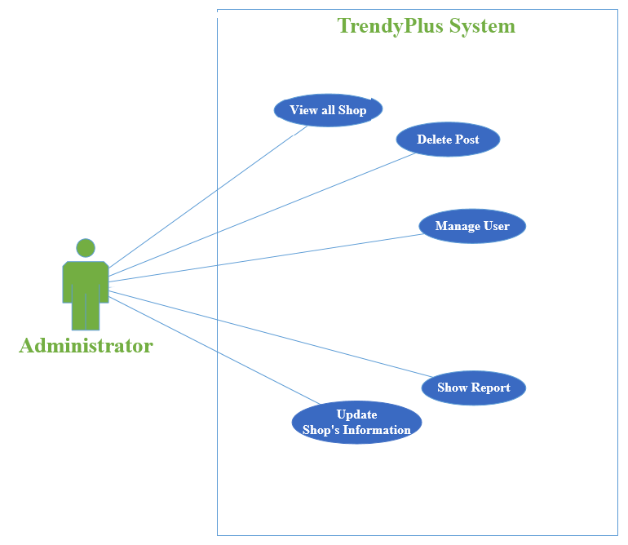

*Figure 3-4: Use case of Administrator*

*Figure 3-4: Use case of Administrator*

##### 3.2.4.3.1. View All User

*Use Case specification*

|  |  |  |  |
| --- | --- | --- | --- |
| UC ID and Name: | **UC-53.0: View All Users** | | |
| Created By: | **CuongDM** | Date Created: | **10/03/2015** |
| Primary Actor: | **Administrator** | Secondary Actors: | N/A |
| Trigger: | Actor indicates that he want to view all users. | | |
| Description: | Actor accesses user management page, list of users is displayed with user’s information. | | |
| Preconditions: | **PRE-53.1:** Actor is logged into TrendyPlus as Administrator on browser via Internet. | | |
| Postconditions: | **POST-53.1:** TrendyPlus displays list of users. | | |
| Normal Flow: | **53.0: View all users**   1. The Actor accesses to the user Administrator page. 2. TrendyPlus displays list of user by pages. | | |
| Alternative Flows: | **53.0** **When actor in manage Shop page/ manage Post page**   1. The actor clicks “*Manage User*”. 2. TrendyPlus displays list of user by page. | | |
| Exceptions: | **53.0-E1 – Cannot communicate with the application server.**   1. TrendyPlus displays error message *“Cannot connect to server”*. 2. Actor clicks on *“Ok”* button and TrendyPlus reload this page. | | |
| Priority: | High. | | |
| Frequency of Use: | Medium. | | |
| Business Rules: | **B12.** | | |
| Other Information: | If user lose network connectivity during loading list of user. There is nothing affected to the system. | | |
| Assumptions: | N/A | | |

##### 3.2.4.3.2. Delete Post

*Use Case specification*

|  |  |  |  |
| --- | --- | --- | --- |
| UC ID and Name: | **UC-54.0: Delete Post** | | |
| Created By: | **CuongDM** | Date Created: | **10/03/2015** |
| Primary Actor: | **Administrator** | Secondary Actors: | N/A |
| Trigger: | The administrator indicates that he wants to delete a Post. | | |
| Description: | If the content of a Post contains some bad data (sexually, racist …), the Administrator wants to delete this Post. | | |
| Preconditions: | **PRE-54.1:** The actor is logged into system as Administrator on browser via Internet. | | |
| Postconditions: | **POST-54.1:** A Post is deleted successfully and information of Post is erased from database. | | |
| Normal Flow: | **54.0: Delete a Post:**   1. The Actor accesses to the Administrator page. 2. The actor chooses “*Manage Post*”. 3. TrendyPlus displays list of Post by pages. 4. The actor can enter caption to search bar and chooses the Post which wants to delete. 5. Actor clicks *“Delete”* button. 6. TrendyPlus shows a pop up with question *“Are you sure?”* with two options *“Yes”* and *“No”.* 7. Actor chooses *“Yes”.* 8. The Post will be deleted from database and no longer being displayed. | | |
| Alternative Flows: | **54.1 Choose *“No”*(Step 7)**   1. Actor chooses *“No”* instead of *“Yes”.* 2. Post is not deleted. | | |
| Exceptions: | **54.0-E1 – Cannot communicate with the application server.**   1. TrendyPlus displays error message *“Cannot connect to server”*. 2. Actor clicks on *“Ok”* button and TrendyPlus reload this page. | | |
| Priority: | High. | | |
| Frequency of Use: | Medium. | | |
| Business Rules: | **B12.** | | |
| Other Information: | If Administrator is lost network connectivity during deleting Post, a Post will not be changed. There is nothing affected to the system. | | |
| Assumptions: | N/A | | |

##### 3.2.4.3.3. View All Shop

*Use Case specification*

|  |  |  |  |
| --- | --- | --- | --- |
| UC ID and Name: | **UC-55.0: View All Shop** | | |
| Created By: | **CuongDM** | Date Created: | **10/03/2015** |
| Primary Actor: | **Administrator** | Secondary Actors: | N/A |
| Trigger: | The actor indicates that he want to view all Shops. | | |
| Description: | The Actor accesses Administrator page, list of Shop is displayed with Shop’s basic information. | | |
| Preconditions: | **PRE-55.1:** The actor is logged into system as Administrator on browns via Internet. | | |
| Postconditions: | **POST-55.1:** TrendyPlus displays list of Shop. | | |
| Normal Flow: | **55.0: View all Shop**   1. The Actor accesses Administrator page on browns via Internet. 2. The actor chooses “*Manage Shop*”. 3. TrendyPlus displays list of Shop by pages. | | |
| Alternative Flows: | N/A | | |
| Exceptions: | **55.0-E1 – Cannot communicate with the application server.**   1. TrendyPlus displays error message *“Cannot connect to server”*. 2. Actor clicks on *“Ok”* button and TrendyPlus reload this page. | | |
| Priority: | High. | | |
| Frequency of Use: | Medium. | | |
| Business Rules: | **B12.** | | |
| Other Information: | If administrator is lost network connectivity during loading list of user. There is nothing affected to the system. | | |
| Assumptions: | N/A | | |

##### 3.2.4.3.4. Update Information Shop

*Use Case specification*

|  |  |  |  |
| --- | --- | --- | --- |
| UC ID and Name: | **UC-56.0: Update Information Shop** | | |
| Created By: | **CuongDM** | Date Created: | **10/03/2015** |
| Primary Actor: | **Administrator** | Secondary Actors: | N/A |
| Trigger: | Administrator indicates that he wants to edit the detail information of a Shop. | | |
| Description: | For some reasons, the Shop saved into TrendyPlus database was wrong, so Actor want to change and update it to be correct. | | |
| Preconditions: | **PRE-56.1:** The actor is logged into system as Administrator on browns via Internet. | | |
| Postconditions: | **POST-56.1:** TrendyPlus displays the Information Shop selected. | | |
| Normal Flow: | **56.0: Update Information Shop:**   1. The Actor accesses to the management page. 2. TrendyPlus displays list of Shop by pages. 3. Actor chooses the Shop which want to change information. 4. TrendyPlus displays list of suggest information Shop. 5. Actor chooses any information Shop and click *“APPROVE”* button. 6. Action *“APPROVE”* change “*UNAPPROVE*”. 7. TrendyPlus update shop’s information and save to database. | | |
| Alternative Flows: | N/A | | |
| Exception | **56.0-E1 – Cannot communicate with the application server.**   1. TrendyPlus displays error message *“Cannot connect to server”*. 2. TrendyPlus reserves the information filled in the destination edited form.   **56.0-E2 – Cannot update information Shop**   1. TrendyPlus displays error message after save information is unsuccessful. 2. TrendyPlus reserves the information filled in the Shop edited form. | | |
| Priority: | High. | | |
| Frequency of Use: | Medium. | | |
| Business Rules: | **B12** | | |
| Other Information: | 1. Actor is able to cancel after re-input all information on field on screen.  2. If Actor is lost network connectivity during editing information Shop, information will not be changed. There is nothing affected to the system. | | |
| Assumptions: | N/A | | |

##### 3.2.4.3.5. Ban User

*Use Case specification*

|  |  |  |  |
| --- | --- | --- | --- |
| UC ID and Name: | **UC-57.0: Ban User** | | |
| Created By: | **CuongDM** | Date Created: | **10/03/2015** |
| Primary Actor: | **Administrator** | Secondary Actors: | N/A |
| Trigger: | The actor indicates that he want to ban user. | | |
| Description: | The Actor accesses to user management page, chose user who violated terms of service by entered information, ban user. | | |
| Preconditions: | **PRE-57.1:** The actor is logged into system as Administrator on browns via Internet.  **PRE-57.2:** Target user is active. | | |
| Postconditions: | **POST-57.1:** TrendyPlus updates user state into database. | | |
| Normal Flow: | **57.0 Ban User**   1. The Actor accesses to the user management page. 2. The actor enters username to search user who violates terms of services. 3. The actor chooses any user that actor wants to ban. 4. The actor clicks on to *“BAN”* button. 5. Action *“BAN”* change *“UNBAN”* and status *“LIVE”* change *“BANNED”.* 6. TrendyPlus update user’s status information. | | |
| Alternative Flows: | N/A | | |
| Exceptions: | **57.0-E1 – Cannot communicate with the application server.**   1. TrendyPlus displays error message *“Cannot connect to server”*. 2. TrendyPlus reserves the information filled in the destination edited form. | | |
| Priority: | High. | | |
| Frequency of Use: | Medium. | | |
| Business Rules: | **B9, B12.** | | |
| Other Information: | N/A | | |
| Assumptions: | N/A | | |

##### 3.2.4.3.6. Unban User

*Use Case specification*

|  |  |  |  |
| --- | --- | --- | --- |
| UC ID and Name: | **UC-58.0: Unban User** | | |
| Created By: | **CuongDM** | Date Created: | **10/03/2015** |
| Primary Actor: | **Administrator** | Secondary Actors: | N/A |
| Trigger: | The actor indicates that he want to unban a user. | | |
| Description: | The Actor accesses to user management page, chose user by unban. | | |
| Preconditions: | **PRE-58.1:** The actor is logged into system as Administrator.  **PRE-58.2:** Target user was banned. | | |
| Postconditions: | **POST-58.1:** TrendyPlus updates user state into database. | | |
| Normal Flow: | **58.0 Unban User**   1. The Actor accesses to the user management page. 2. The actor enters username to search user who violates terms of services. 3. The actor chooses any user that actor wants to ban. 4. The actor clicks on to *“UNBAN”* button. 5. Action *“UNBAN”* change *“BAN”* and status *“BANNED”* change *“LIVE”.* 6. TrendyPlus update user’s status information. | | |
| Alternative Flows: | N/A | | |
| Exceptions: | **58.0-E1 – Cannot communicate with the application server.**   1. TrendyPlus displays error message *“Cannot connect to server”*. 2. TrendyPlus reserves the information filled in the destination edited form. | | |
| Priority: | High. | | |
| Frequency of Use: | Medium. | | |
| Business Rules: | **B9, B12.** | | |
| Other Information: | N/A | | |
| Assumptions: | N/A | | |

##### 3.2.4.3.7. Show Report

*Use Case specification*

|  |  |  |  |
| --- | --- | --- | --- |
| UC ID and Name: | **UC-59.0: Show Report** | | |
| Created By: | **AnhLT** | Date Created: | **17/03/2015** |
| Primary Actor: | **Administrator** | Secondary Actors: | N/A |
| Trigger: | The actor views report about statistics user’s account, like quantity, comment quantity and favorite quantity. | | |
| Description: | The actor accesses to administrator page, chose *“Report”* tab. | | |
| Preconditions: | **PRE-59.1:** The actor is logged into system as Administrator. | | |
| Postconditions: | **POST-59.1:** TrendyPlus show report about statistics user’s account, like quantity, comment quantity and favorite quantity. | | |
| Normal Flow: | **59.0 Show Report.**   1. The actor accesses to the user management page. 2. The actor chooses *“Report”* tab. 3. TrendyPlus will display report about statistics user’s account with three accounts social network: Facebook, Google+ and Twitter, like quantity, comment quantity and favorite quantity of post. | | |
| Alternative Flows: | N/A | | |
| Exceptions: | **59.0-E1 – Cannot communicate with the application server.**   1. TrendyPlus displays error message *“Cannot connect to server.”* | | |
| Priority: | High. | | |
| Frequency of Use: | Medium. | | |
| Business Rules: | **B9, B12.** | | |
| Other Information: | N/A | | |
| Assumptions: | N/A | | |

## 3.3. Non-functional Requirement

### 3.3.1. Usability

* The user interface should be elegant, simple easy to use.

### 3.3.2. Security

* Apply social network (Facebook, Google and Twitter) token to restrict user access.
* The security matrix is as the following table:

|  |  |  |  |
| --- | --- | --- | --- |
| **Function** | **Guest** | **Register User** | **Administrator** |
| Login | **√** | **√** |  |
| View Trendy | **√** | **√** |  |
| View Newsfeed | **√** | **√** |  |
| View User page | **√** | **√** |  |
| View Shop page | **√** | **√** |  |
| View Around Here | **√** | **√** |  |
| My Location | **√** | **√** |  |
| View Album | **√** | **√** |  |
| View Post | **√** | **√** |  |
| View Shop on map | **√** | **√** |  |
| Get all Album of user | **√** | **√** |  |
| Suggest related user | **√** | **√** |  |
| Create Album |  | **√** |  |
| Delete Album |  | **√** |  |
| Edit Album |  | **√** |  |
| Add Post’s comment |  | **√** |  |
| Edit Post’s comment |  | **√** |  |
| Delete Post’s comment |  | **√** |  |
| View Post’s comment | **√** | **√** |  |
| Add Shop’s comment |  | **√** |  |
| Edit Shop’s comment |  | **√** |  |
| Delete Shop’s comment |  | **√** |  |
| View Shop’s comment | **√** | **√** |  |
| Add Post |  | **√** |  |
| Editor Image |  | **√** |  |
| Image tagging |  | **√** |  |
| Content tagging |  | **√** |  |
| Delete Post |  | **√** |  |
| Edit Post |  | **√** |  |
| Like Post |  | **√** |  |
| Unlike Post |  | **√** |  |
| Share Post |  | **√** |  |
| Create Shop |  | **√** |  |
| Suggest Shop | **√** | **√** |  |
| Suggest Shop’s Information |  | **√** |  |
| View Shop Detail |  | **√** |  |
| Like Shop |  | **√** |  |
| Unlike Shop |  | **√** |  |
| View Following |  | **√** |  |
| View Follower |  | **√** |  |
| Add Follow |  | **√** |  |
| Remove Follow |  | **√** |  |
| Add Favorite |  | **√** |  |
| Remove Favorite |  | **√** |  |
| Subscribe Notification |  | **√** |  |
| View Notification |  | **√** |  |
| Change Cover |  | **√** |  |
| Logout |  | **√** |  |
| General Search | **√** | **√** | **√** |
| Search User |  |  | **√** |
| Search Shop |  |  | **√** |
| Search on Map | **√** | **√** | **√** |
| View All User |  |  | **√** |
| Delete Post |  |  | **√** |
| View All Shop |  |  | **√** |
| Update Information Shop |  |  | **√** |
| Ban User |  |  | **√** |
| Unban User |  |  | **√** |

### 3.3.3. Maintainability & Extensibility

* Strictly follow the coding convention to help improve readability of source code and make the website more maintainable.
* Develop Web Service based on Object Oriented Programming paradigm, RESTful API in order to increase maintainability and extendibility.
* Develop client based on AngularJS with MVW design pattern make coding life easier, readable and funny.
* Follow layered architecture, modular software and component-based development.
* Apply popular design patterns (Dependency Injection…) to ease future development.

### 3.3.4. Performance

* Database in 3NF.
* Use AngularJS with lazy loading help improve website’s load.
* Use MySQL - one in best databases for performance.

## 3.4. Entity Relationship Diagram

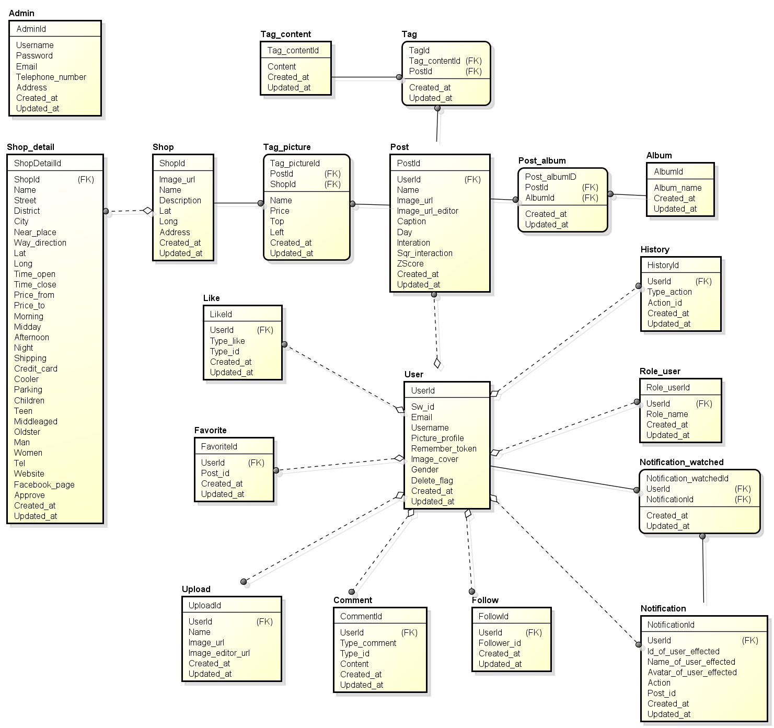

*Figure 3-5: Entity Relationship Diagram of TrendyPlus*

*Figure 3-4: Use case of Administrator*

# CHAPTER 4: SOFTWARE DESIGN

## 4.1. Purpose

This chapter is to give the developer team a guidance of what the system’s architecture is, and how they should be implemented. This chapter consists of:

* Architecture overview
* Component diagram
* Detailed design
* Detailed description of components
* Database design

## 4.2. Architecture Overview

### 4.2.1. System Architecture

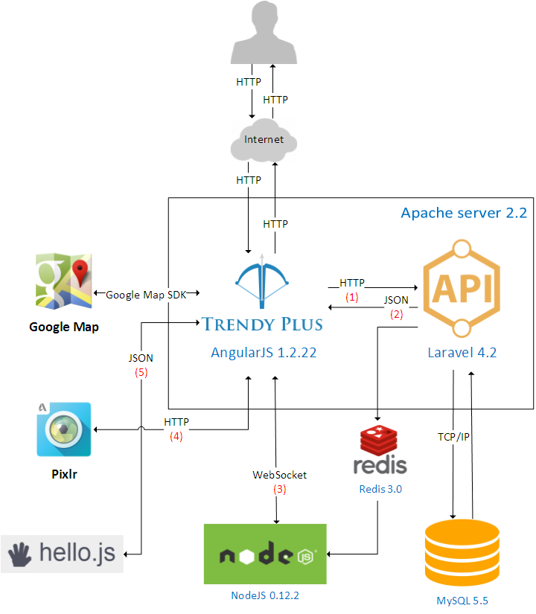

*Figure 4-1: TrendyPlus System Architecture*

#### *Explanation*

##### 1. TrendyPlus request to RESTful API:

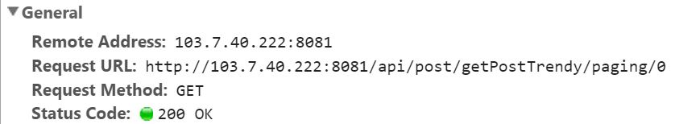

*Figure 4-2: TrendyPlus request to RESTful API*

##### 2. RESTful API response to TrendyPlus:

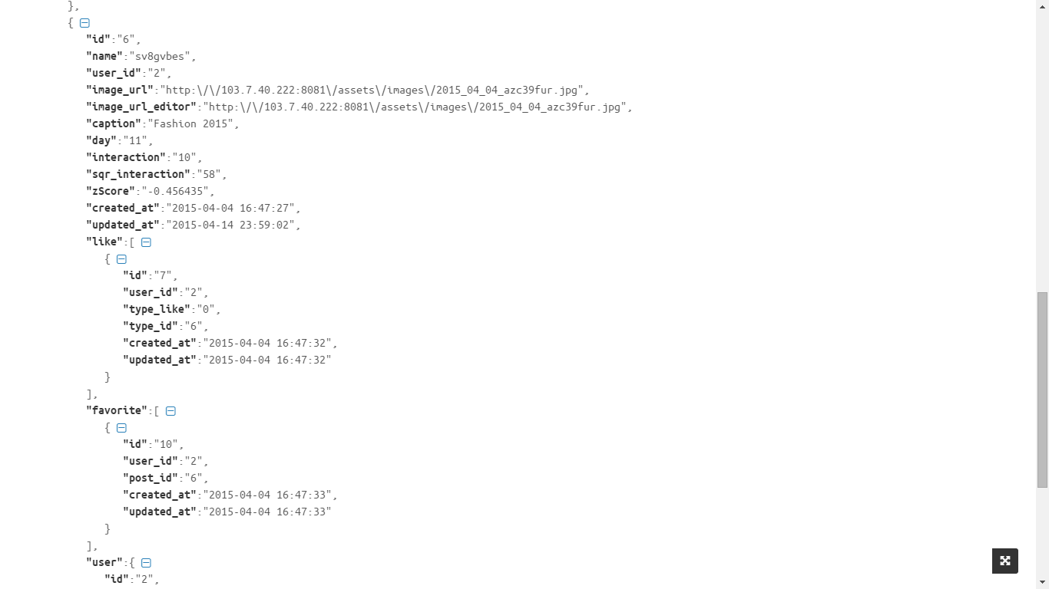

*Figure 4-3: RESTful API response to TrendyPlus*

##### 3. Node.js open a WebSockets to TrendyPlus:

* Connect to WebSocket to server over port 3000

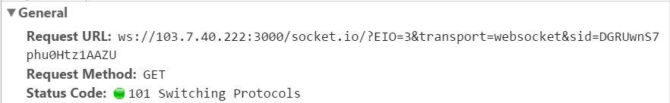

*Figure 4-4: Connect to WebSocket*

* Timing

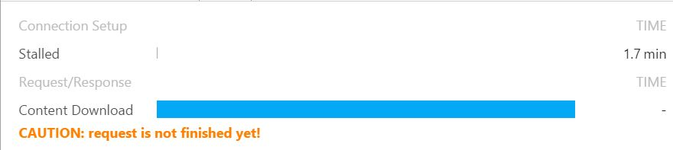

*Figure 4-5: Timing*

##### 4. TrendyPlus send a request to Pixlr

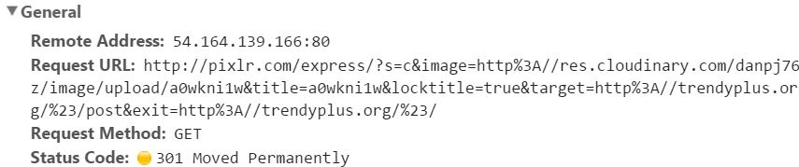

*Figure 4-6: TrendyPlus send request to Pixlr*

##### 5. TrendyPlus Authentication with Hello.js

* TrendyPlus use Hello.js library to Authentication Facebook, Google+ and Twitter and get user’s information.

### 4.2.2. System Architecture Explanation

#### *RESTful API*



*Figure 4-7: RESTful API*

RESTful API application built on top of Laravel 4.2 (PHP Framework) – It is elegance, simplicity, and readability with amazing ORM, powerful Route (support RESTful route), besides that COMPOSER – Dependency with many package help us building powerful API application. **We use it to receive request from Trendyplus application then interactive with database and response results, run-over algorithm to find Trendy, publish data to Redis.**

#### *TrendyPlus*



*Figure 4-8: TrendyPlus Application*

TrendyPlus application built on top of AngularJS v1.2.22 - It is built and maintained by dedicated Google engineers. Communicating with RESTful API become easier, structure your application better with MVVM (Model – View – ViewModel), extend HTML’s syntax, automatically synchronizes data from your View to Model through 2-way data binding. **We use it to take action from user then request to RESTful API application, connect to Node.js application by Websocket to bring Real-Time experience.**

#### *MySQL*



*Figure 4-9: MySQL*

MySQL 5.5 – **We use it to store data.**

#### *Node.js*



*Figure 4-10: NodeJS*

Node.js v0.12.1 with ExpressJS (Node.js framework) built on top of Chrome’s Javascript runtime, uses event-driven, non-blocking I/O make it lightweight and efficient Real-Time application. **We use it to subscribe channel and get data from Redis then push data to TrendyPlus application by Websocket.**

#### *Redis*



*Figure 4-11: Redis*

Redis v3.0 – it is a “NoSQL” in-memory (RAM) key-value store, make it very fast access and retrieve data**. We use it to Publish/Subscribe channel**.

## 4.3. Design of TrendyPlus system

### 4.3.1. Architecture Layers Design

#### *RESTful API*

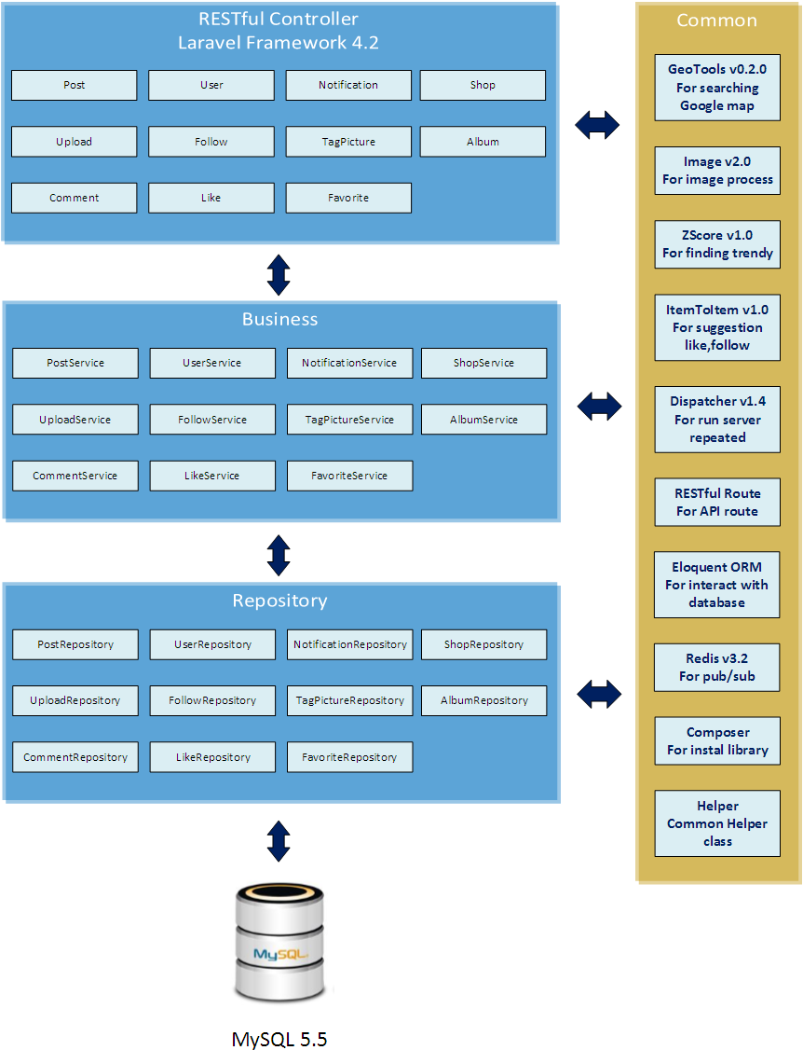

*Figure 4-12: TrendyPlus Layer Design*

|  |  |  |  |
| --- | --- | --- | --- |
| **No** | **Namespace/Directory** | **Description** | **Convention** |
| 1 | app/config | Configure your application’s runtime rules, database, session and more. Contains a number of config files for changing various aspects of the framework. Most of the config files return associative PHP arrays of options. |  |
| 2 | app/config/app.php | Configuration for various application level settings, i.e. time zone, locale, debug mode and unique encryption key. |  |
| 3 | app/config/database.php | Contains relevant configuration information for the database, i.e. default database engine and connection information. |  |
| 4 | app/controllers | Contains the RESTful controllers classes that are used to retrieve request then interact with services. | **xxxController** |
| 5 | app/Services | Contain implementation Services classes for Business Layer. | **xxxService** |
| 6 | app/Repositories | Contain implementation Repositories classes for using Eloquent ORM to query model. | **xxxRepository** |
| 7 | app/models | Contain models class which each table in your database will correspond to one model. |  |
| 8 | app/start/ | Contains custom settings related to the artisan tool as well as global and local context. |  |
| 9 | app/routes.php | Contains routing file which holds routing rules that tells Laravel how to connect incoming requests to route handler closure functions, controllers and actions. |  |
| 10 | app/listeners.php | Contains config mapping event to a Event Handler class. |  |
| 11 | app/events | Contain Event Handler class, which get data and publish to Redis. |  |
| 12 | app/commands | Contain Commands class, which execute command lines. Ex: ZscoreCommand.php. | **xxxCommand** |
| 13 | app/Core | Contain helper, special, main classes. Execute many times in application. |  |

*Table 4-1: Namespace Explanation*

#### *TrendyPlus Application*

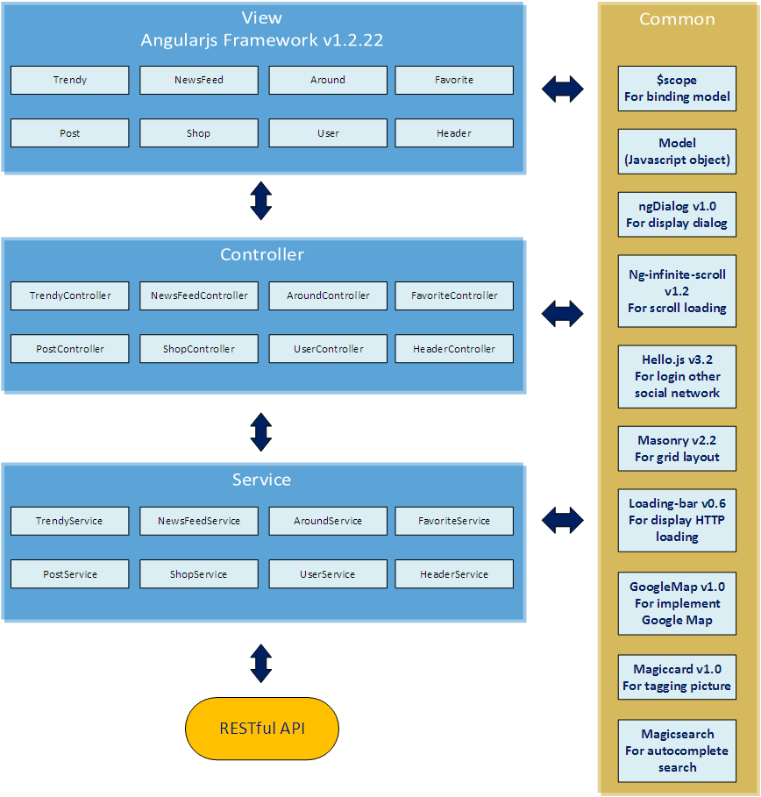

*Figure 4-13: TrendyPlus Layer Design*

|  |  |  |  |
| --- | --- | --- | --- |
| **No** | **Namespace/Directory** | **Description** | **Convention** |
| **1** | app/around | Contains aroundController.js, aroundService.js those are used to execute event, request to API in Around pages. |  |
| **2** | app/around/templates | Contains all html file about Around pages. |  |
| **3** | app/trendy | Contains trendyController.js, trendyService.js those are used to execute event, request to API in Trendy pages. |  |
| **4** | app/trendy/templates | Contains all html file about Trendy pages. |  |
| **5** | app/newsfeed | Contains newsfeedController.js, newsfeedService.js those are used to execute event, request to API in Newsfeed pages. |  |
| **6** | app/newsfeed/templates | Contains all html file about Newsfeed pages. |  |
| **7** | app/favorite | Contains favoriteController.js, favoriteService.js those are used to execute event, request to API in Favorite pages. |  |
| **8** | app/favorite/templates | Contains all html file about Favorite pages. |  |
| **9** | app/header | Contains headerController.js, headerService.js those are used to execute event, request to API in Headerpages. |  |
| **10** | app/header/templates | Contains all html file about Header pages. |  |
| **11** | app/post | Contains postController.js, postService.js that are used to execute event, request to API in Post pages. |  |
| **12** | app/post/templates | Contains all html file about Post pages. |  |
| **13** | app/user | Contains userController.js, userService.js that are used to execute event, request to API in User pages. |  |
| **14** | app/user/templates | Contains all html file about User pages. |  |
| **15** | app/shop | Contains shopController.js, shopService.js that are used to execute event, request to API in Shop pages. |  |
| **16** | app/user/templates | Contains all html file about Shop pages. |  |

*Table 4-2: Namespace Explanation*

### 4.3.2. Database Design

#### 4.3.1 Database Diagram

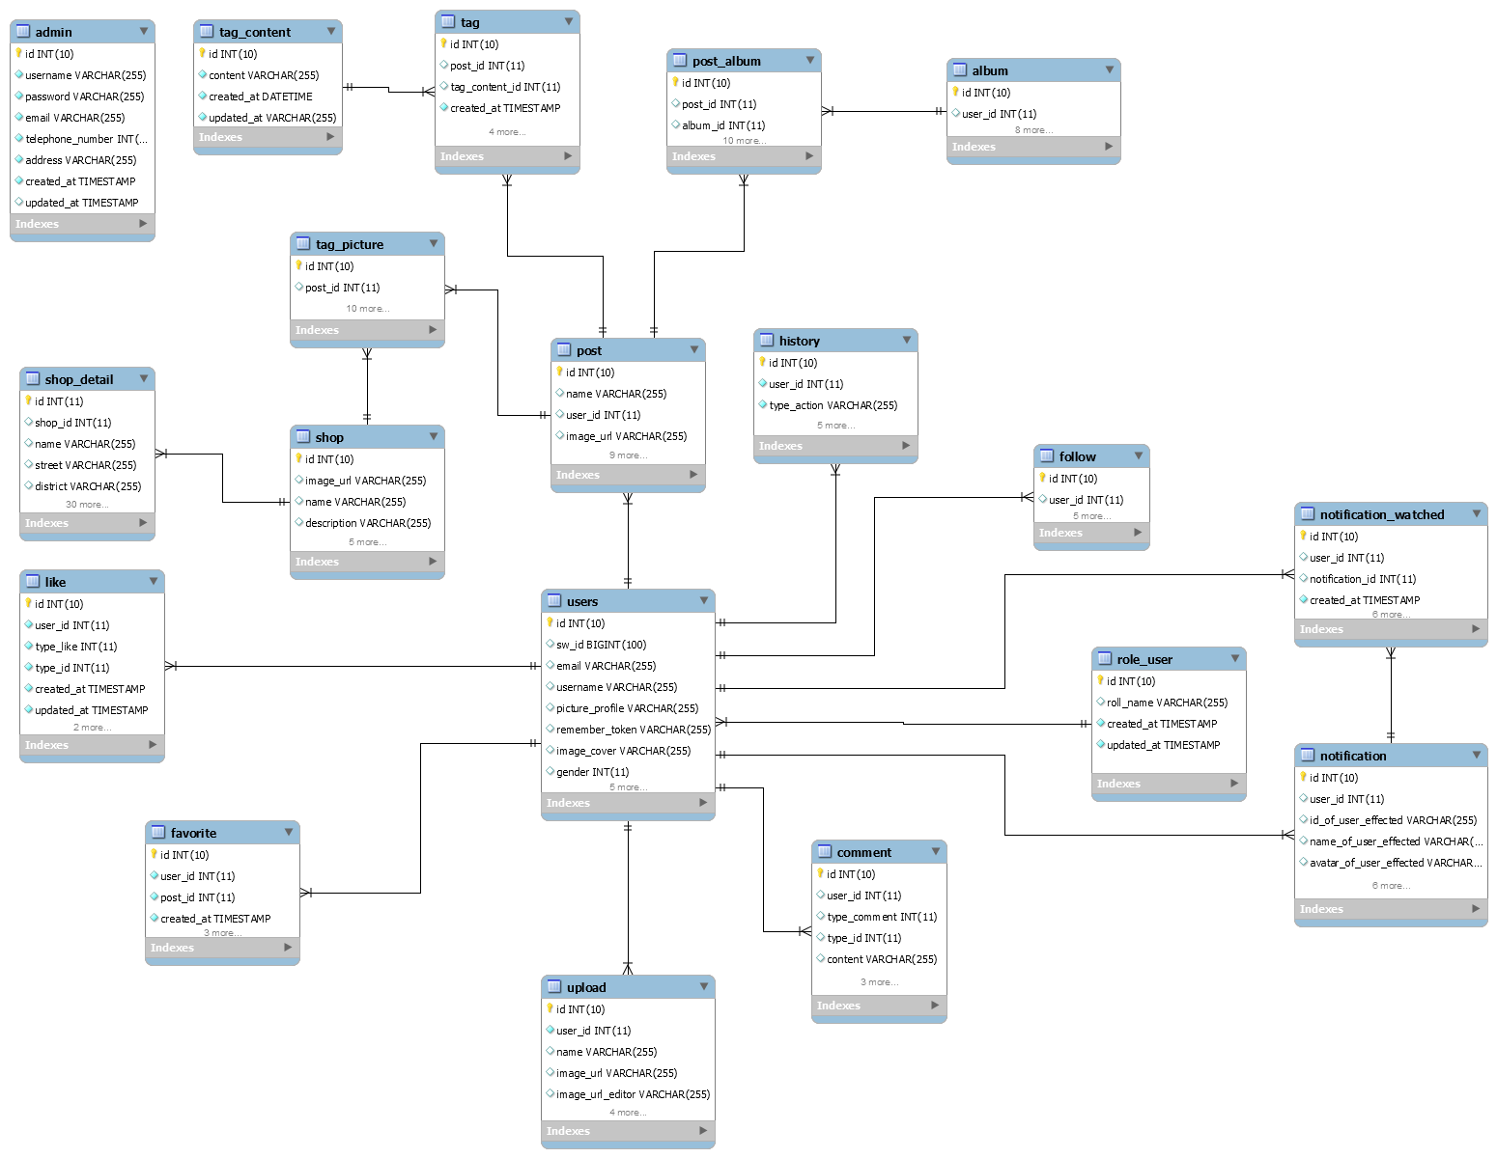

*Figure 4-14: Entity Relationship Diagram*

#### 4.3.2 Table Admin

|  |  |  |  |  |  |
| --- | --- | --- | --- | --- | --- |
| Admin: store all personal data of admin | | | | | |
| **No.** | **Field** | **Type** | **Key** | **Description** | **Null** |
| 1 | id | INT(10) | PK | The id of admin | No |
| 2 | username | VARCHAR(255) |  | Username of user | No |
| 3 | password | VARCHAR(255) |  | Password of user (encrypt by …) | No |
| 4 | email | VARCHAR(320) |  | Email of user | No |
| 5 | telephone_number | INT(11) |  | Password of user (encrypt by …) | No |
| 6 | address | VARCHAR(255) |  | Address of user | No |
| 7 | created_at | TIMESTAMP |  | Time admin data created | No |
| 8 | updated_at | TIMESTAMP |  | Time admin data updated | No |

#### 4.3.3 Table Album

|  |  |  |  |  |  |
| --- | --- | --- | --- | --- | --- |
| album: store data about album | | | | | |
| **No** | **Field** | **Type** | **Key** | **Description** | **Null** |
| 1 | id | INT(10) | PK | Id of album | No |
| 2 | user_id | INT(11) | FK (reference to users) | Id of user who created the album | No |
| 3 | album_name | VARCHAR(255) |  | Name of the album | Yes |
| 4 | created_at | TIMESTAMP |  | Time album data created | No |
| 5 | updated_at | TIMESTAMP |  | Time album data updated | No |

#### 4.3.4 Table Comment

|  |  |  |  |  |  |
| --- | --- | --- | --- | --- | --- |
| comment: store data about comment | | | | | |
| **No** | **Field** | **Type** | **Key** | **Description** | **Null** |
| 1 | id | INT(10) | PK | Id of comment | No |
| 2 | user_id | INT(11) | FK (reference to users) | Id of user who posted comment | No |
| 3 | type_comment | INT(11) |  | Title of job (See **COMMENT-1.1**). | No |
| 4 | type_id | INT(11) |  | Description of job | Yes |
| 5 | content | VARCHAR(255) |  | Minimum salary of job | Yes |
| 6 | created_at | TIMESTAMP |  | Time comment data created | No |
| 7 | updated_at | TIMESTAMP |  | Time comment data updated | No |

|  |
| --- |
| **Note** |
| **COMMENT -1.1:** The type of the comment must be one of the values below:  “0”: The comment in Shop on TrendyPlus system.  “1”: The comment in Post on TrendyPlus system. |

#### 4.3.5 Table [Favorite](http://localhost/phpmyadmin/sql.php?server=1&db=socialnw&table=favorite&pos=0&token=0aaa7e0765272e5cf27716cc755706a8)

|  |  |  |  |  |  |
| --- | --- | --- | --- | --- | --- |
| favorite: store data about favorite | | | | | |
| **No** | **Field** | **Type** | **Key** | **Description** | **Null** |
| 1 | id | INT(10) | PK | Id of favorite | No |
| 2 | user_id | INT(11) | FK (reference to users) | Id of user who favorite Post | No |
| 3 | post_id | INT(11) | FK (reference to Post) | Id of Post which was favorited | No |
| 4 | created_at | TIMESTAMP |  | Time favorite data updated | No |
| 5 | updated_at | TIMESTAMP |  | Time favorite data deleted | No |

#### 4.3.6 Table [Follow](http://localhost/phpmyadmin/sql.php?server=1&db=socialnw&table=follow&pos=0&token=0aaa7e0765272e5cf27716cc755706a8)

|  |  |  |  |  |  |
| --- | --- | --- | --- | --- | --- |
| [follow](http://localhost/phpmyadmin/sql.php?server=1&db=socialnw&table=follow&pos=0&token=0aaa7e0765272e5cf27716cc755706a8): store data about [follow](http://localhost/phpmyadmin/sql.php?server=1&db=socialnw&table=follow&pos=0&token=0aaa7e0765272e5cf27716cc755706a8) | | | | | |
| **No** | **Field** | **Type** | **Key** | **Description** | **Null** |
| 1 | id | INT(10) | PK | Id of follow | No |
| 2 | user_id | INT(11) | FK (reference to users) | Id of user who was followed | No |
| 3 | follower_id | INT(11) |  | Id of user who following | No |
| 4 | created_at | TIMESTAMP |  | Time [follow](http://localhost/phpmyadmin/sql.php?server=1&db=socialnw&table=follow&pos=0&token=0aaa7e0765272e5cf27716cc755706a8) data created | No |
| 5 | updated_at | TIMESTAMP |  | Time [follow](http://localhost/phpmyadmin/sql.php?server=1&db=socialnw&table=follow&pos=0&token=0aaa7e0765272e5cf27716cc755706a8) data updated | No |

#### 4.3.7 Table History

|  |  |  |  |  |  |
| --- | --- | --- | --- | --- | --- |
| history: store data about activity of user | | | | | |
| **No** | **Field** | **Type** | **Key** | **Description** | **Null** |
| 1 | id | INT(10) | PK | Id of history | No |
| 2 | user_id | INT(11) | FK (reference to users) | Id of user who have activity | No |
| 3 | type_action | VARCHAR(255) |  | Type of action (See **HISTORY-1.1**). | No |
| 4 | action_id | INT(11) | FK (reference to Post) | Id of post | No |
| 5 | created_at | TIMESTAMP |  | Time history data created | No |
| 6 | updated_at | TIMESTAMP |  | Time history data updated | No |

|  |
| --- |
| **Note** |
| **HISTORY -1.1:** The type of the action must be one of the values below:  “comment”: The activity of user is comment on TrendyPlus system.  “like”: The activity of user is like on TrendyPlus system.  “favorite”: The activity of user is favorite on TrendyPlus system. |

#### 4.3.8 Table Like

|  |  |  |  |  |  |
| --- | --- | --- | --- | --- | --- |
| like: store data about like | | | | | |
| **No** | **Field** | **Type** | **Key** | **Description** | **Null** |
| 1 | id | INT(10) | PK | Id of like | No |
| 2 | user_id | INT(11) | FK (reference to users) | Id of user who liked | No |
| 3 | type_like | INT(11) |  | Type of like (See **LIKE-1.1**) | No |
| 4 | type_id | INT(11) |  | Id of shop (or post) | No |
| 5 | created_at | TIMESTAMP |  | Time like data created | No |
| 6 | updated_at | TIMESTAMP |  | Time like data updated | No |

|  |
| --- |
| **Note** |
| **LIKE -1.1:** The type of the like must be one of the values below:  “0”: The like for Post on TrendyPlus system.  “1”: The like for Shop on TrendyPlus system. |

#### 4.3.9 Table Notification

|  |  |  |  |  |  |
| --- | --- | --- | --- | --- | --- |
| notification: store data about notification | | | | | |
| **No** | **Field** | **Type** | **Key** | **Description** | **Null** |
| 1 | id | INT(10) | PK | The id of notification | No |
| 2 | user_id | INT(11) | FK (reference to users) | Id of user who has action | No |
| 3 | id_of_user_effected | VARCHAR(255) |  | Id of user who has effected | No |
| 4 | name_of_user_effected | VARCHAR(255) |  | Name of user who has effected | Yes |
| 5 | avatar_of_user_effected | VARCHAR(255) |  | Avatar of user who has effected | Yes |
| 6 | action | VARCHAR(255) |  | Action of user (See **NOTIFICATION-1.1**) | Yes |
| 7 | post_id | INT(11) | FK (reference to post) | Id of Post | No |
| 8 | created_at | TIMESTAMP |  | Time like data created | No |
| 9 | updated_at | TIMESTAMP |  | Time like data updated | No |

|  |
| --- |
| **Note** |
| **NOTIFICATION -1.1:** The type of the action must be one of the values below:  “comment”: The activity of user is comment on TrendyPlus system.  “like”: The activity of user is like on TrendyPlus system.  “favorite”: The activity of user is favorite on TrendyPlus system. |

#### 4.3.10 Table [Notification Watched](http://localhost/phpmyadmin/sql.php?server=1&db=socialnw&table=notification_watched&pos=0&token=0aaa7e0765272e5cf27716cc755706a8)

|  |  |  |  |  |  |
| --- | --- | --- | --- | --- | --- |
| [notification_watched](http://localhost/phpmyadmin/sql.php?server=1&db=socialnw&table=notification_watched&pos=0&token=0aaa7e0765272e5cf27716cc755706a8): store data about notification which was watched | | | | | |
| **No** | **Field** | **Type** | **Key** | **Description** | **Null** |
| 1 | Id | INT(10) | PK | The id of notification which was watched | No |
| 2 | user_id | INT(11) | FK (reference to users) | Id of user who watched notification | No |
| 3 | notification_id | INT(11) | FK (reference to notification) | Id of notification | No |
| 4 | created_at | TIMESTAMP |  | Time notification_watched data created | No |
| 5 | updated_at | TIMESTAMP |  | Time notification_watched data updated | No |

#### 4.3.11 Table Post

|  |  |  |  |  |  |
| --- | --- | --- | --- | --- | --- |
| short_urls: store data of short URL | | | | | |
| **No** | **Field** | **Type** | **Key** | **Description** | **Null** |
| 1 | id | INT(10) | PK | Id of Post | No |
| 2 | name | VARCHAR(255) |  | Name of Post | Yes |
| 3 | user_id | INT(11) | FK (reference to users) | Id of user who posted | No |
| 4 | image_url | VARCHAR(255) |  | Url of image | No |
| 5 | image_url_editor | VARCHAR(255) |  | Url of image which was edited | No |
| 6 | caption | VARCHAR(255) |  | Caption of Post | No |
| 7 | day | INT(11) |  | Day of Post | No |
| 8 | interaction | INT(11) |  | Interaction of Post | No |
| 9 | sqr_interaction | INT(11) |  | Sqr of interaction | No |
| 10 | zScore | Float |  | zScore of Post | No |
| 11 | created_at | TIMESTAMP |  | Time Post data created | No |
| 12 | updated_at | TIMESTAMP |  | Time Post data updated | No |

#### 4.3.12 Table Post_Album

|  |  |  |  |  |  |
| --- | --- | --- | --- | --- | --- |
| post_album: store data of post_album | | | | | |
| **No** | **Field** | **Type** | **Key** | **Description** | **Null** |
| 1 | id | INT(10) | PK | Id of the post_album | No |
| 2 | post_id | INT(11) | FK (reference to post) | Id of the post | No |
| 3 | album_id | INT(11) | FK (reference to album) | Id of the album | No |
| 4 | created_at | TIMESTAMP |  | Time about data created | No |
| 5 | updated_at | TIMESTAMP |  | Time about data updated | No |

#### 4.3.13 Table [Role User](http://localhost/phpmyadmin/sql.php?server=1&db=socialnw&table=role_user&pos=0&token=0aaa7e0765272e5cf27716cc755706a8)

|  |  |  |  |  |  |
| --- | --- | --- | --- | --- | --- |
| role_user: store data of role_user | | | | | |
| **No** | **Field** | **Type** | **Key** | **Description** | **Null** |
| 1 | id | INT(10) | PK | ID of role | No |
| 2 | Role_name | VARCHAR(255) |  | Name of role | Yes |
| 3 | created_at | TIMESTAMP |  | Time about data created | No |
| 4 | updated_at | TIMESTAMP |  | Time about data updated | No |

#### 4.3.14 Table Shop

|  |  |  |  |  |  |
| --- | --- | --- | --- | --- | --- |
| shop: store data of shop | | | | | |
| **No** | **Field** | **Type** | **Key** | **Description** | **Null** |
| 1 | id | INT(10) | PK | ID of the shop | No |
| 2 | image_url | VARCHAR(255) |  | url of Shop’s image | No |
| 3 | name | VARCHAR(255) |  | Name of the shop | No |
| 4 | description | VARCHAR(255) |  | Description of the shop | No |
| 5 | lat | VARCHAR(255) |  | The latitude of this shop. | No |
| 6 | long | VARCHAR(255) |  | The longitude of this shop. | No |
| 7 | address | VARCHAR(255) |  | Address of the shop | No |
| 8 | created_at | TIMESTAMP |  | Time about data created | No |
| 9 | updated_at | TIMESTAMP |  | Time about data updated | No |

#### 4.3.15 Table [Shop Detail](http://localhost/phpmyadmin/sql.php?server=1&db=socialnw&table=shop_detail&pos=0&token=0aaa7e0765272e5cf27716cc755706a8)

|  |  |  |  |  |  |
| --- | --- | --- | --- | --- | --- |
| shop_detail: store data of shop_detail | | | | | |
| **No** | **Field** | **Type** | **Key** | **Description** | **Null** |
| 1 | id | INT(11) | PK | ID of the employment | No |
| 2 | shop_id | INT(11) | FK (reference to shop) | ID of the user who create the article | No |
| 3 | name | VARCHAR(255) |  | Name of the company | No |
| 4 | street | VARCHAR(255) |  | The street of the Shop | No |
| 5 | district | VARCHAR(255) |  | The district of the Shop | No |
| 6 | city | VARCHAR(255) |  | The city of the Shop | No |
| 7 | near_place | VARCHAR(255) |  | The place near the Shop | No |
| 8 | way_direction | VARCHAR(255) |  | The way of the Shop | No |
| 9 | lat | VARCHAR(45) |  | The latitude of this shop. | No |
| 10 | long | VARCHAR(45) |  | The longitude of this shop. | No |
| 11 | time_open | VARCHAR(45) |  | The time open the shop | No |
| 12 | time_close | VARCHAR(45) |  | The time close the shop | No |
| 13 | price_from | VARCHAR(45) |  | The minimum of price | No |
| 14 | price_to | VARCHAR(45) |  | The maximum of price | No |
| 15 | morning | INT(11) |  | Shop services on the morning | No |
| 16 | midday | INT(11) |  | Shop services midday | No |
| 17 | afternoon | INT(11) |  | Shop services in the afternoon | No |
| 18 | night | INT(11) |  | Shop services at night | No |
| 19 | shipping | INT(11) |  | Shop has shipper | No |
| 20 | credit_card | INT(11) |  | Shop has using credit card | No |
| 21 | cooler | INT(11) |  | Shop has using air conditioning | No |
| 22 | parking | INT(11) |  | Shop has parking | No |
| 23 | children | INT(11) |  | Shop services children | No |
| 24 | teen | INT(11) |  | Shop services teen-age | No |
| 25 | middleaged | INT(11) |  | Shop services Middle-aged | No |
| 26 | oldster | INT(11) |  | Shop services Oldster | No |
| 27 | men | INT(11) |  | Shop services man | No |
| 28 | women | INT(11) |  | Shop services woman | No |
| 29 | tel | VARCHAR(45) |  | Shop’s telephone | No |
| 30 | website | VARCHAR(45) |  | Shop’s website | No |
| 31 | facebook_page | VARCHAR(45) |  | Shop’s facebook page | No |
| 32 | approve | INT(11) |  | Approve of user | No |
| 33 | created_at | TIMESTAMP |  | Time about data created | No |
| 34 | updated_at | TIMESTAMP |  | Time about data updated | No |

#### 4.3.16 Table Tag

|  |  |  |  |  |  |
| --- | --- | --- | --- | --- | --- |
| tag: store data of tag | | | | | |
| **No** | **Field** | **Type** | **Key** | **Description** | **Null** |
| 1 | id | INT(10) | PK | Id of the tag | No |
| 2 | post_id | INT(11) | FK (reference to post) | Id of the post | No |
| 3 | tag_content_id | INT(11) | FK (reference to tag content) | Id of the tag content | No |
| 4 | created_at | TIMESTAMP |  | Time about data created | No |
| 5 | updated_at | TIMESTAMP |  | Time about data updated | No |

#### 4.3.17 Table Tag Content

|  |  |  |  |  |  |
| --- | --- | --- | --- | --- | --- |
| [tag_content](http://localhost/phpmyadmin/sql.php?server=1&db=socialnw&table=tag_content&pos=0&token=0aaa7e0765272e5cf27716cc755706a8): store data of [tag_content](http://localhost/phpmyadmin/sql.php?server=1&db=socialnw&table=tag_content&pos=0&token=0aaa7e0765272e5cf27716cc755706a8) | | | | | |
| **No** | **Field** | **Type** | **Key** | **Description** | **Null** |
| 1 | id | INT(10) | PK | ID of the tag content | No |
| 2 | content | VARCHAR(255) |  | Content of tag | No |
| 3 | created_at | TIMESTAMP |  | Time about data created | No |
| 4 | updated_at | TIMESTAMP |  | Time about data updated | No |

#### 4.3.18 Table Tag Picture

|  |  |  |  |  |  |
| --- | --- | --- | --- | --- | --- |
| tag_picture: store data of tag_picture | | | | | |
| **No** | **Field** | **Type** | **Key** | **Description** | **Null** |
| 1 | id | INT(10) | PK | Id of tag picture | No |
| 2 | post_id | INT(11) | FK (reference to post) | Id of the post which was tagged | No |
| 3 | shop_id | INT(11) | FK (reference to shop) | Id of the shop which was tagged | No |
| 4 | name | VARCHAR(255) |  | Name of tag | No |
| 5 | price | VARCHAR(255) |  | Price of tag | No |
| 6 | top | INT(11) |  |  | No |
| 7 | left | INT(11) |  | Time about data created | No |
| 8 | created_at | TIMESTAMP |  | Time about data created | No |
| 9 | updated_at | TIMESTAMP |  | Time about data updated | No |

#### 4.3.19 Table Upload

|  |  |  |  |  |  |
| --- | --- | --- | --- | --- | --- |
| upload: store data of upload | | | | | |
| **No** | **Field** | **Type** | **Key** | **Description** | **Null** |
| 1 | id | INT(10) | PK | Id of upload | No |
| 2 | user_id | INT(11) | FK (reference to user) | Id of the user | No |
| 3 | name | INT(11) | FK (reference to shop) | Name of user | No |
| 4 | image_url | VARCHAR(255) |  | Url of image | No |
| 5 | image_url_editor | VARCHAR(255) |  | Url of image which was edited | No |
| 6 | created_at | TIMESTAMP |  | Time about data created | No |
| 7 | updated_at | TIMESTAMP |  | Time about data updated | No |

#### 4.3.20. Table Users

|  |  |  |  |  |  |
| --- | --- | --- | --- | --- | --- |
| [user](http://localhost/phpmyadmin/sql.php?server=1&db=socialnw&table=tag_picture&pos=0&token=0aaa7e0765272e5cf27716cc755706a8): store data of [user](http://localhost/phpmyadmin/sql.php?server=1&db=socialnw&table=tag_picture&pos=0&token=0aaa7e0765272e5cf27716cc755706a8) | | | | | |
| **No** | **Field** | **Type** | **Key** | **Description** | **Null** |
| 1 | id | INT(10) | PK | Id of user | No |
| 2 | sw_id | VARCHAR(255) |  | Id of the post which was tagged | No |
| 3 | email | VARCHAR(255) |  | Id of the shop which was tagged | No |
| 4 | username | VARCHAR(255) |  | Name of tag | No |
| 5 | picture_profile | VARCHAR(255) |  | Price of tag | No |
| 6 | remember_token | VARCHAR(255) |  |  | No |
| 7 | image_cover | VARCHAR(255) |  | Time about data created | No |
|  | gender | INT(11) |  |  |  |
|  | delete_flag | INT(11) |  |  |  |
| 8 | created_at | TIMESTAMP |  | Time about data created | No |
| 9 | updated_at | TIMESTAMP |  | Time about data updated | No |
| 10 | role_id | INT(11) |  |  | No |

#### REFERENCES

1. http://era.nih.gov/docs/rup_fundamentals.htm
2. http://laravel.com/docs/quick
3. http://api.jquery.com/
4. http://plugins.jquery.com/
5. http://jqueryui.com/
6. http://getbootstrap.com/
7. http://wkhtmltopdf.org/
8. http://students.mimuw.edu.pl/~zbyszek/posi/ibm/RUP_Eval/process/modguide/md_tstcs.htm
9. http://www.istqb.org/downloads/practice-exam-downloads.html
10. http://www.istqb.org/certification-path-root/foundation-level/foundation-level-in-a-nutshell.html
11. http://www.istqb.org/downloads/e-books.html

### 4.3.3. Common Design

#### 4.3.3.1. Zscore Algorithm and Dispatcher

##### 4.3.3.1.1. Purpose

* Zscore algorithm use to analyze data to finding trending post’s fashion.
* Dispatcher help use rune Zscore algorithm everyday at 23h59’.

##### 4.3.3.1.2. Version

* Zscore algorithm: Version 1.0 for server Linux (Ubuntu 14.04 Trusty Tahr) 64-bit.
* Dispatcher: Version 1.4 for server Linux (Ubuntu 14.04 Trusty Tahr) 64-bit.

##### 4.3.3.1.3. Physical path

* Zscore algorithm: app/Core/, app/Command
* “A trend simply reflects what seems to be going around at any given time”
* <http://www.vocabulary.com/dictionary/trend>
* “A new development in clothing, make-up, etc…”
* <http://dictionary.cambridge.org/dictionary/british/trend>
* **Zscore concept**
* **Zscore** are also called Standard score, z-value…
* “In statistics, the standard score is the (signed) number of standard deviations an observation or datum is above the mean”
* [http://en.wikipedia.org/wiki/Standard_score](http://en.wikipedia.org/wiki/Standard_score))
* Zscore’s formula:

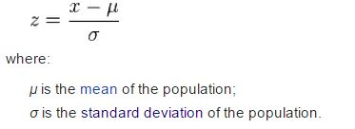

*Figure 4-15: Zscore’s Formula*

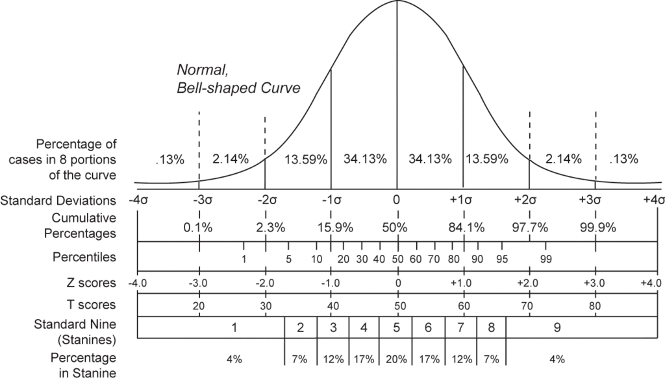

*Figure 4-16: Zscore’s Chart*

* “The standard score (more commonly referred to as a z-score) is a very useful statistic because it (a) allows us to calculate the probability of a score occurring within our normal distribution and (b) enables us to compare two scores that are from different normal distributions.”
* <https://statistics.laerd.com/statistical-guides/standard-score.php>
* In my situation, we use function (b) because we want to finding trendy, finding top trendy so we use Zscore to analyze data and compare all of them to my purpose***.***
* “Most educational and psychological test results are reported in standard scores. Standard scores are derived from z scores.”
* The George Washington University (http://home.gwu.edu/~kkid/sscore.htm
* In Education, they use Zscore for finding how well did a student development their skill, finding top 10% student of class, top 10% student of school….
* Because one student take many exams, and sometime they take different exam. Using average of score you can see how they develop their skill. Same as finding trendy, we can’t use interaction to find which one is the most development (trendy).
* We use Zscore algorithm to analyze data in posts and calculate Zscore which present how fast they development then compare all post’s Zscore, which is the best large Zscore is trendy now.
* **Apply math concept in our project**

|  |  |  |
| --- | --- | --- |
| **Concept** | **In our project** | **Class we implement** |
| Zscore’s formula: | Base on this formula, we use this to build Zscore class, to analyze data and calculate Zscore for each post | Zscore.php |
| “Enables us to compare two scores that are from different normal distributions.” | Base on this concept, we use this to build ZscoreCommand to query all data for Zscore class | ZscoreCommand.php |

* **Implement Zscore combine with database**
* First, for each post we add 4 fields data in database
* Day
* Interaction
* Sqr_interaction (square of interaction)
* Zscore
* The plan is every day at 23h59’, for each post we analyze all interaction data, calculate Zscore in this day (0h to 23h59’), and update to database.
* Flowchart:

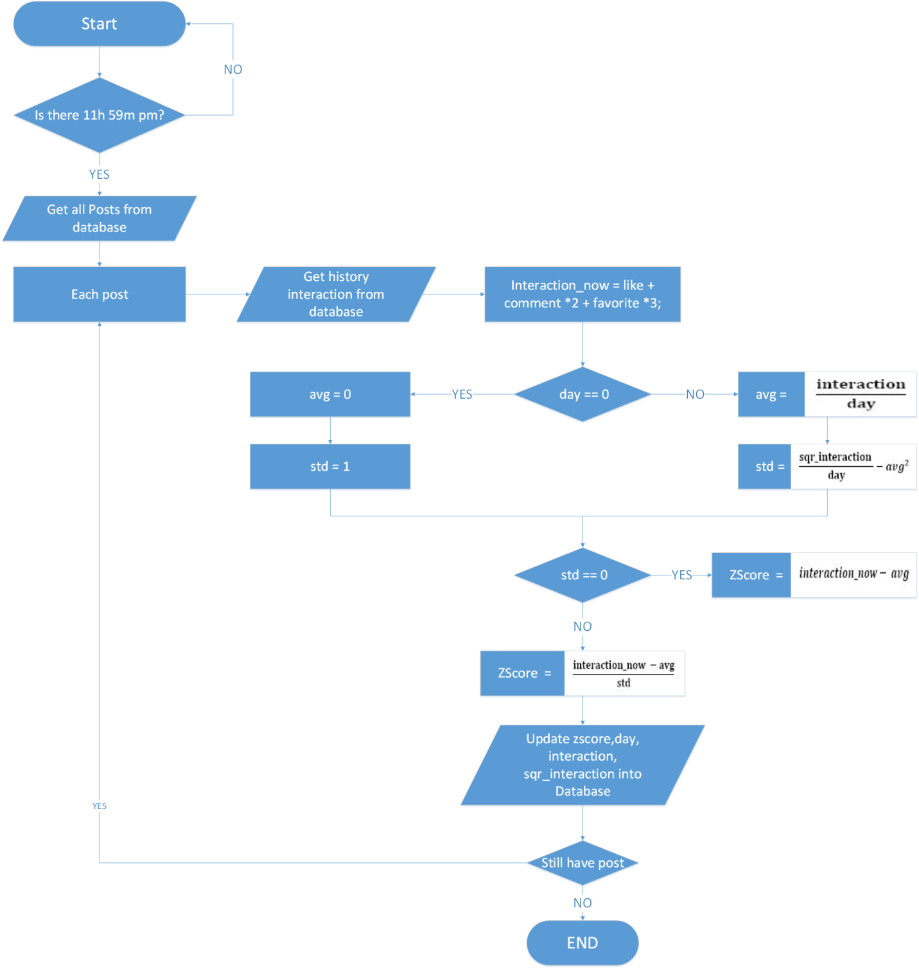

*Figure 4-17: Flowchart of Zscore’s work*

###### **Zscore class:**

**Method_construct($day, $interaction, $sqr_interaction)**

|  |  |  |  |  |
| --- | --- | --- | --- | --- |
| **Purpose** | Initiation day, interaction, sqr_interaction | | | |
| **Return** | **Type** | | | **Description** |
| N/A | | | N/A |
| **Parameter** | **No** | **Name** | **Type** | **Description** |
| 1 | day | Integer | Present how many day from when post is posting. |
| 2 | interaction | Integer | Present how many interaction from when post is posting. |
| 3 | Sqr_interaction | Integer | Present how many square interaction from when post is posting. |

**Method avg()**

|  |  |  |
| --- | --- | --- |
| **Purpose** | Calculate average(mean) | |
| **Return** | **Type** | **Description** |
| float | Present average of data. |

**Method std()**

|  |  |  |
| --- | --- | --- |
| **Purpose** | Calculate standard deviation | |
| **Return** | **Type** | **Description** |
| float | Present standard deviation of data. |

**Method Zscore($interaction_now)**

|  |  |  |  |  |
| --- | --- | --- | --- | --- |
| **Purpose** | Calculate Zscore | | | |
| **Return** | **Type** | | | **Description** |
| float | | | Present Zscore. |
| **Parameter** | **No** | **Name** | **Type** | **Description** |
| 1 | interaction_now | integer | Present how many interaction in a day (present). |

###### **ZscoreCommand Class**

**Method schedule (Schedulable $scheduler)**

|  |  |  |  |  |
| --- | --- | --- | --- | --- |
| **Purpose** | Schedule time when run Zscore. | | | |
| **Return** | **Type** | | | **Description** |
| Schedulable | | | Return config of Schedule. |
| **Parameter** | **No** | **Name** | **Type** | **Description** |
| 1 | scheduler | Schedulable | Inject schedulable to set time. |

**Method fire()**

|  |  |  |  |  |
| --- | --- | --- | --- | --- |
| **Purpose** | Fire code when time coming | | | |
| **Return** | **Type** | | | **Description** |
| N/A | | | N/A |
| **Parameter** | **No** | **Name** | **Type** | **Description** |
| N/A | N/A | N/A | N/A |

#### **4**.3.3.2. Real – time

* **Real-time in our website**
* In our website, we use real-time concept to help user easier to interact with other user, you don’t need to wait, to refresh.
* For details:
* We implement notification real-time: it mean you can get notification when other
* Comment, like, favorite your post
* Comment in your post which your commented
* We implement real-time comment: it means you don’t need to refresh page to see new comment, it automatically appear immediately.
* Technology stack
* First we use there technology stack:
* NodeJS
* Redis
* AngularJS
* NodeJS and Redis
* Node.js® is a platform built on Chrome's JavaScript runtime for easily building fast, scalable network applications. Node.js uses an event-driven, non-blocking I/O model that makes it lightweight and efficient, perfect for data-intensive real-time applications that run across distributed devices.
* [https://Node.js.org/](https://nodejs.org/)
* “Redis is a data structure server. It is open-source, networked, in-memory, and stores keys with optional durability. Redis is the most popular key-value store.”
* <http://en.wikipedia.org/wiki/Redis>
* Redis has many situation using for
* **Pub/Sub**
* **Queues**
* **Caching**
* **Deletion and filtering**
* But in my scope of my website, we use Pub/sub (publisher/subscribe) to interact with Node.js to make real-time web application.
* Notification’s flowchart

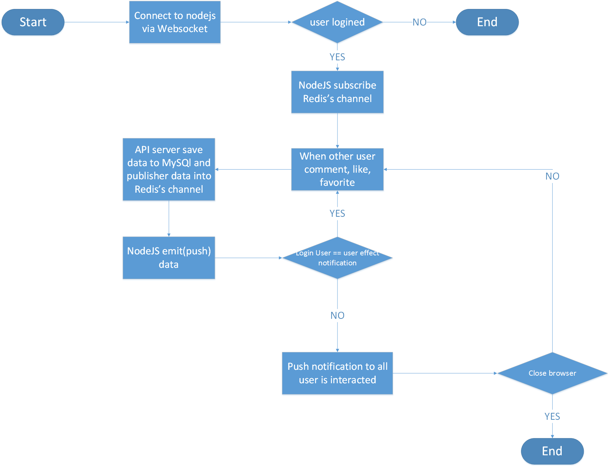

*Figure 4-18: Flowchart of Notification’s work*

* Comment’s flowchart

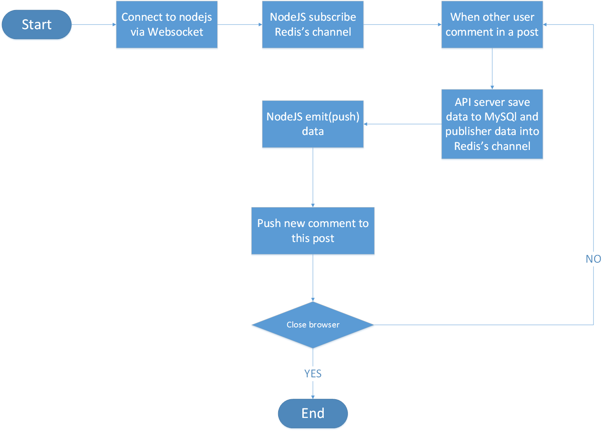

*Figure 4-19: Flowchart of Comment’s work*

* Connect to Node.js Server via Socket

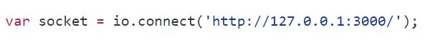

* Node.js Subscribe Redis channel

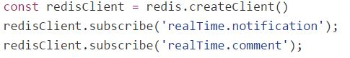

* Fire to Notification Event Handler when new notification coming

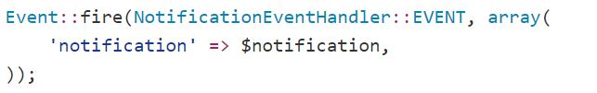

* Publisher data to Redis channel

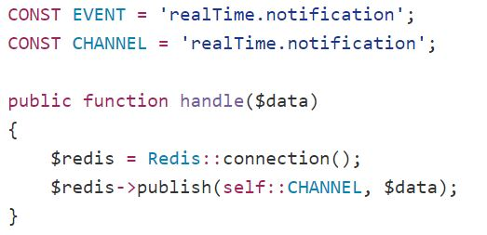

* Node.js emit data to Client

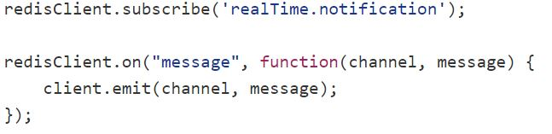

* Example notification data:

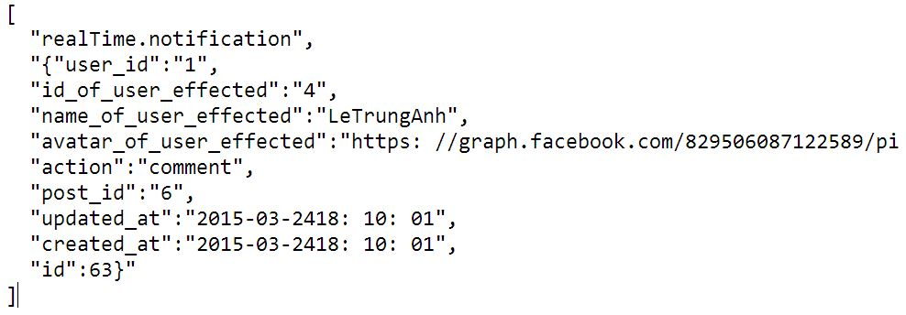

#### 4.3.3.3. **Item-to-Item Suggestion** algorithm

##### 4.3.3.3.1. Purpose

We use Item-to-item algorithm to suggest user follow other users, like shop which they may like.

##### 4.3.3.3.2. Version

Item-to-item algorithm: Version 1.0 for server Linux (Ubuntu 14.04 Trusty Tahr) 64-bit.

##### 4.3.3.3.3. Physical path

Item-to-item algorithm: app/Core/

* **Item-to-Item Suggestion Algorithm Concept**
* Item-to-Item suggestion which we build based on Amazon suggestion’s system :
* Item-to-item collaborative filtering.
* This algorithm works when user interact with a item then it will find related item based on all user’s interaction.
* **Item-to-Item in our project**
* In our project, our **Item-to-Item algorithm** matches each of user to user (or shop) then combine them in a matrix. After that, we calculated cousin of angle between 2 user (or shop) using:

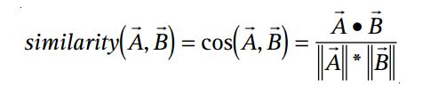

*Figure 4-20: Suggestion Algorithm’s Formula*

* Example we have 3 user and 4 shop:
* User1
* User2
* User3
* Shop1
* Shop2
* Shop3
* Shop4
* First we match all user to all shop

|  |  |  |  |  |
| --- | --- | --- | --- | --- |
|  | Shop1 | Shop2 | Shop3 | Shop4 |
| User1 | 1 | 1 | 0 | 0 |
| User2 | 0 | 1 | 1 | 0 |
| User3 | 1 | 1 | 1 | 0 |

(1: Shop which liked by User, 0: Shop which don’t liked by User)

* After that we calculated cousin of angle between 2 shops for each shop.

**Shop1:**

Cousin between shop1 and shop2

Cousin between shop1 and shop3

Cousin between shop1 and shop4

Hence, a user visit shop1 would receive shop2 as first recommendation, then shop 3 and shop 4…

Keep doing that with shop2, shop3, shop4 we will find list of recommendation shop for each shop.

So if user access to shop1, it will see shop2, shop3… is suggestion.

* **Suggestion shop flowchart**

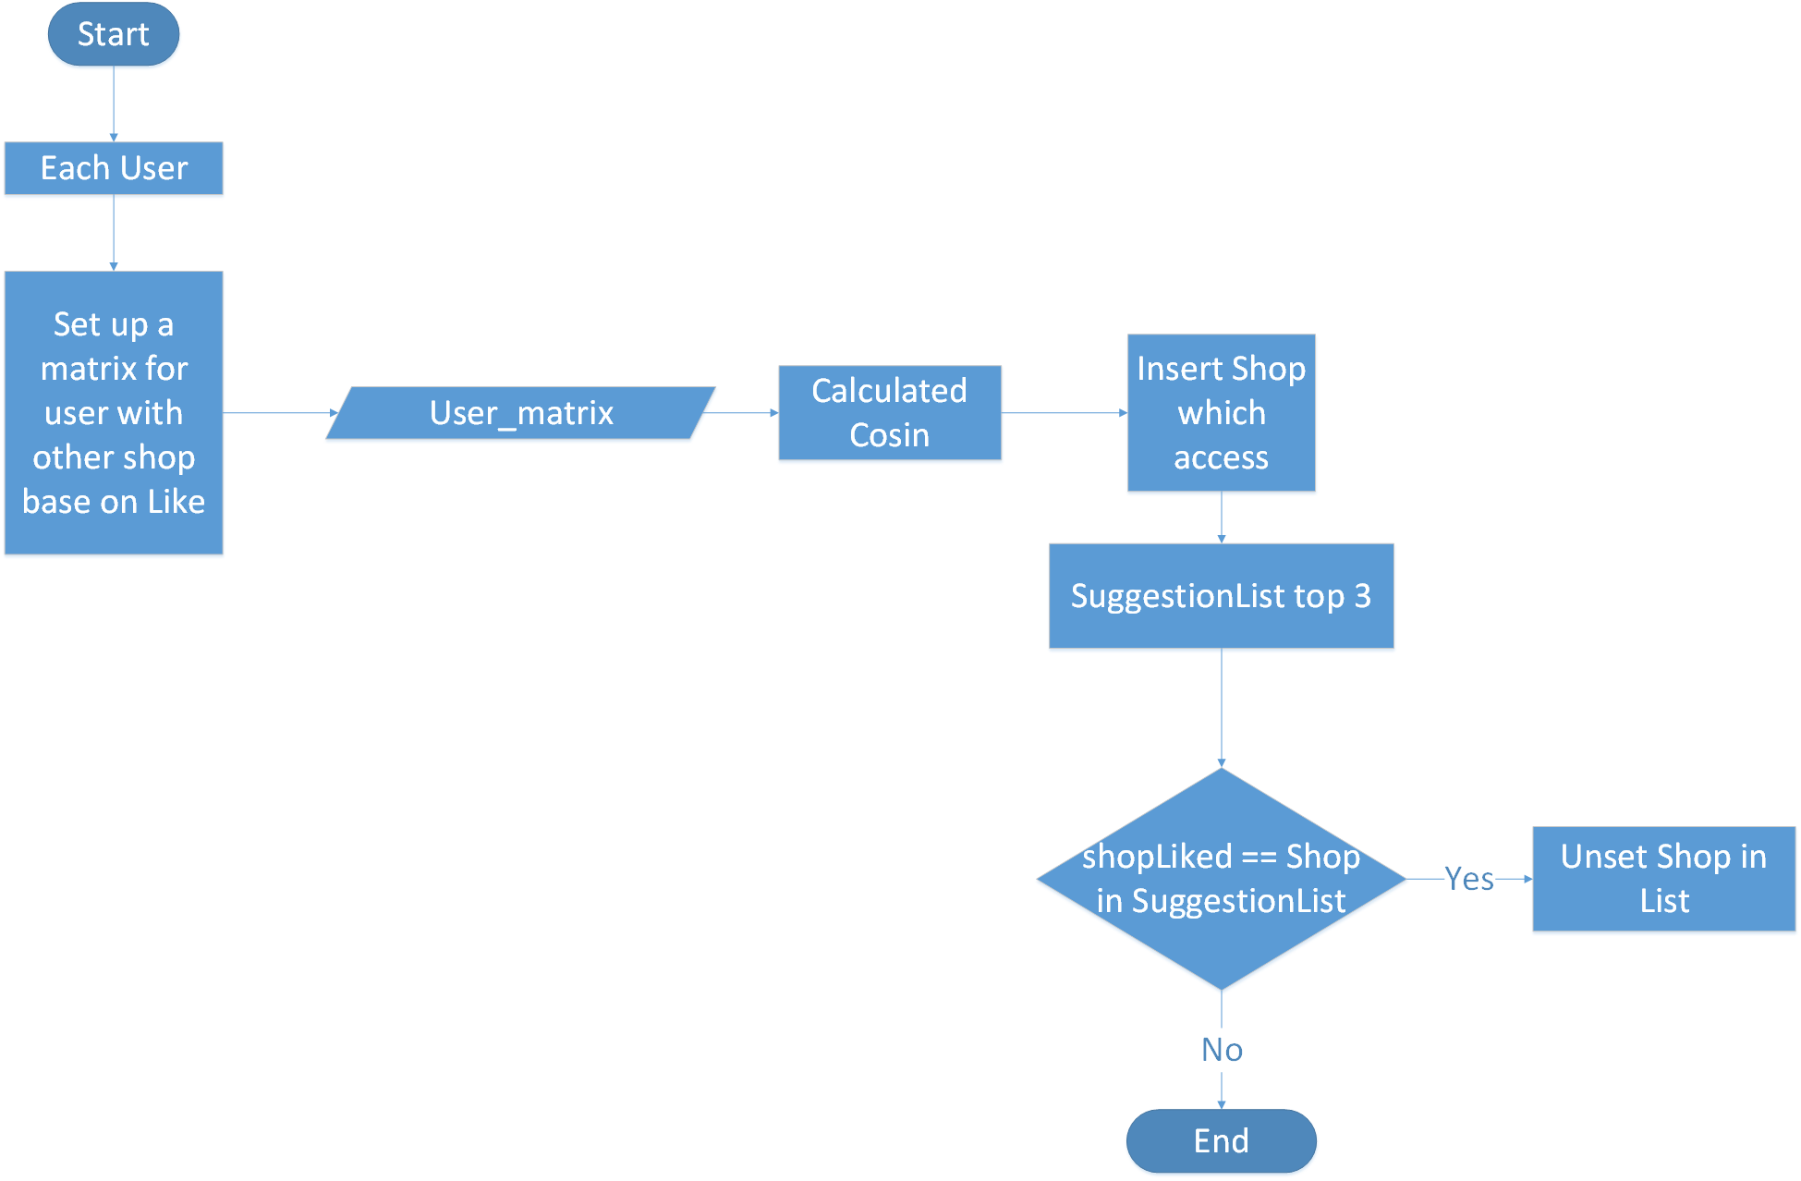

*Figure 4-21: Flowchart of Suggestion shop*

* **Suggestion Follow’s flowchart**

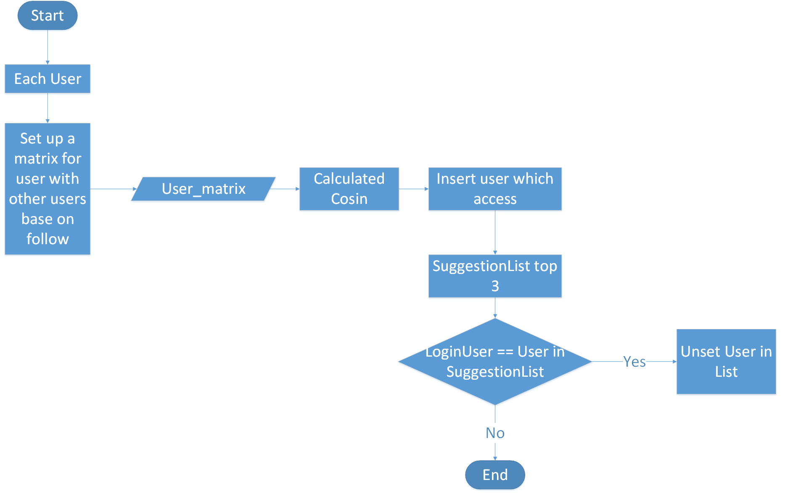

*Figure 4-22: Flowchart of Suggestion follow*

###### ItemtoItem class:

Method insert($matrix)

|  |  |  |  |  |
| --- | --- | --- | --- | --- |
| **Purpose** | Calculate cousin for each user in matrix | | | |
| **Return** | **Type** | | | **Description** |
| N/A | | | N/A |
| **Parameter** | **No** | **Name** | **Type** | **Description** |
| 1 | matrix | array | Loop in matrix array to Calculate cousin |

Method predict ($name)

|  |  |  |  |  |
| --- | --- | --- | --- | --- |
| **Purpose** | Return suggestion base on name input | | | |
| **Return** | **Type** | | | **Description** |
| array | | | List of suggestion |
| **Parameter** | **No** | **Name** | **Type** | **Description** |
| 1 | name | String | Name of user(or shop) accessed |

### 4.3.4. Detail Design

#### 4.3.4.1. Guest

##### 4.3.4.1.1. Login

###### Description

* Actor logins into TrendyPlus.

###### Class Diagram

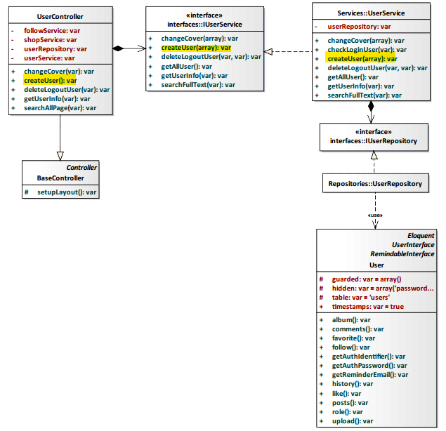

*Figure 4-23: Login Class Diagram*

###### Class Specification

UserController class

Physical Address: Trendy-Server\app\controllers*UserController.php*

Attribute

|  |  |  |  |
| --- | --- | --- | --- |
| No | Name | Type | Description |
| 1 | followService | var | Instance of interface using to call methods in IFollowService. |
| 2 | shopService | var | Instance of interface using to call methods in IShopService. |
| 3 | userRepository | var | Instance of interface using to call methods in IUserRepository. |
| 4 | userService | var | Instance of interface using to call methods in IUserService. |

Method: createUser()

|  |  |  |
| --- | --- | --- |
| Purpose | Create actor’s account after actor logins into system. | |
| Return | **Type** | **Description** |
| var | Return actor’s account. |

UserService class

Physical Address: Trendy-Server\app\Services*UserService.php*

Attribute

|  |  |  |  |
| --- | --- | --- | --- |
| No | Name | Type | Description |
| 1 | userRepository | var | Instance of interface using to call methods in IUserRepository. |

Method: createUser(var $array)

|  |  |  |  |  |
| --- | --- | --- | --- | --- |
| Purpose | Process to creat actor’s account after actor logins into system. | | | |
| Return | **Type** | | | **Description** |
| var | | | Return actor’s account. |
| Parameter | **No** | **Name** | **Type** | **Description** |
| 1 | array | var | Array contains actor’s information. |

###### Sequence Diagram

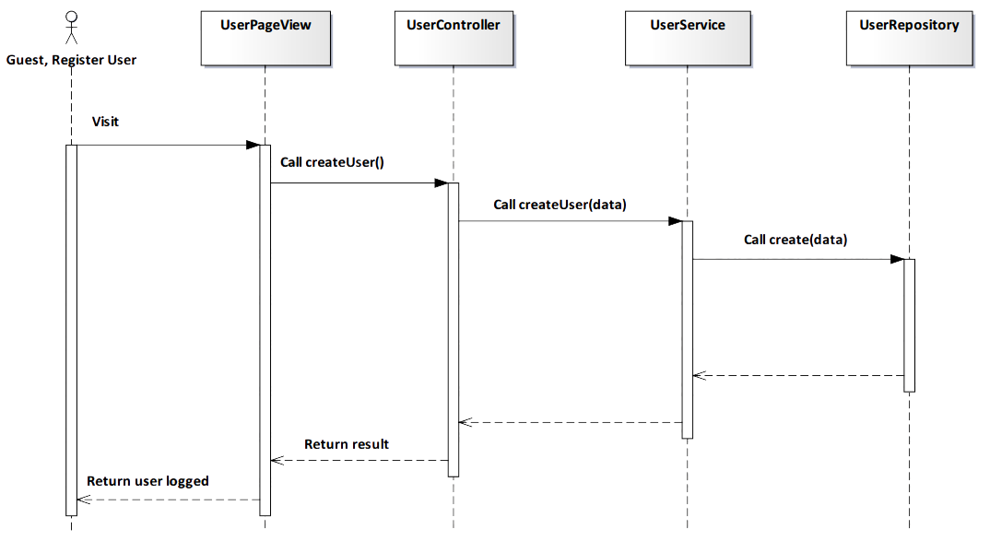

*Figure 4-24: Login Sequence Diagram*

###### Screen Design

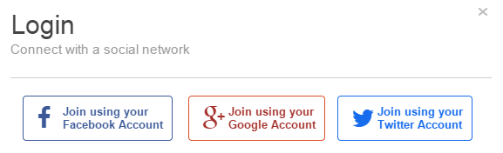

*Figure 4-25: Login Screen*

|  |  |  |
| --- | --- | --- |
| **Element** | **Type** | **Description** |
| **Join using your Facebook Account** | Button | Click to login by Facebook account. |
| **Join using your Google Account** | Button | Click to login by Google account. |
| **Join using your Twitter Account** | Button | Click to login by Twitter account. |

##### 4.3.4.1.2. View Trendy

###### Description

* User view fashion Trendy in website.

###### Class Diagram

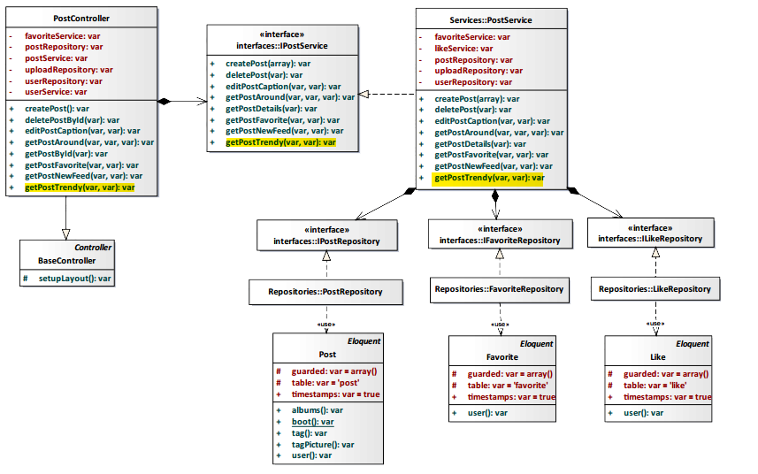

*Figure 4-26: View Trendy Class Diagram*

###### Class Specification

PostController class

Physical Address: Trendy-Server\app\Controller*PostController.php*

Attribute

|  |  |  |  |
| --- | --- | --- | --- |
| No | Name | Type | Description |
| 1 | favoriteService | var | Instance of interface using to call methods in IFavoriteService. |
| 2 | postRepository | var | Instance of interface using to call methods in IPostRepository. |
| 3 | postService | var | Instance of interface using to call methods in IPostService. |
| 4 | uploadRepository | var | Instance of interface using to call methods in IUploadRepository. |
| 6 | userRepository | var | Instance of interface using to call methods in IUserRepository. |
| 7 | userService | var | Instance of interface using to call methods in IUserService. |
| 8 | postRepository | var | Instance of interface using to call methods in IPostRepository. |

Method: getPostTrendy($id, $tag)

|  |  |  |  |  |
| --- | --- | --- | --- | --- |
| Purpose | Display trendy post | | | |
| Return | **Type** | | | **Description** |
| var | | | All trendy of post. |
| Parameter | **No** | **Name** | **Type** | **Description** |
| 1 | id | var | id of post. |
| 2 | tag | var | tag of post. |

PostService class

Physical Address: Trendy-Server\app\Services*PostService.php*

Attribute

|  |  |  |  |
| --- | --- | --- | --- |
| No | Name | Type | Description |
| 1 | favoriteRepository | var | Instance of interface using to call methods in IFavoriteRepository. |
| 2 | likeService | var | Instance of interface using to call methods in ILikeService. |
| 3 | postRepository | var | Instance of interface using to call methods in IPostRepository. |
| 4 | uploadRepository | var | Instance of interface using to call methods in IUploadRepository. |
| 5 | userRepository | var | Instance of interface using to call methods in IUserRepository. |

Method: getPostTrendy($id, $tag)

|  |  |  |  |  |
| --- | --- | --- | --- | --- |
| Purpose | Display trendy post | | | |
| Return | **Type** | | | **Description** |
| var | | | All trendy of post. |
| Parameter | **No** | **Name** | **Type** | **Description** |
| 1 | id | var | id of post. |
| 2 | tag | var | tag of post. |

###### Sequence Diagram

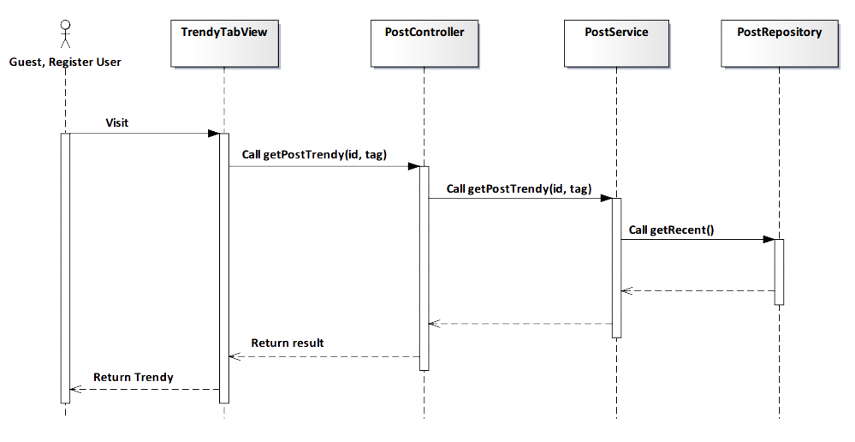

*Figure 4-27: View Trendy Sequence Diagram*

###### Screen Design

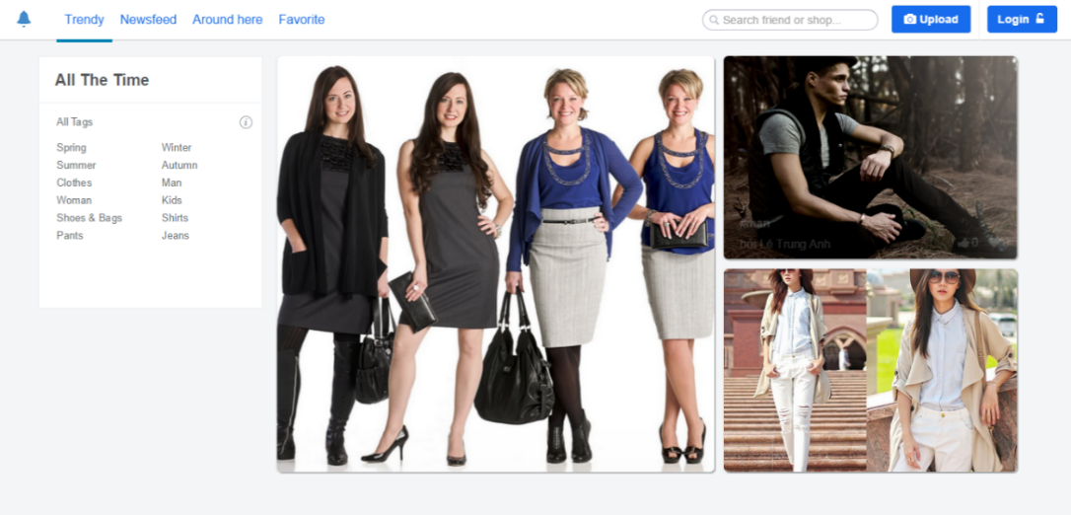

*Figure 4-28: View Trendy Screen*

|  |  |  |
| --- | --- | --- |
| **Element** | **Type** | **Description** |
| **All tag** | Button | Click to view Trendy order by content. |
| **Scroll** | Button | Scroll down to get more trend. |

##### 4.3.4.1.3. View Newsfeed

###### Description

* User see new posts which user’s following posting.

###### Class Diagram

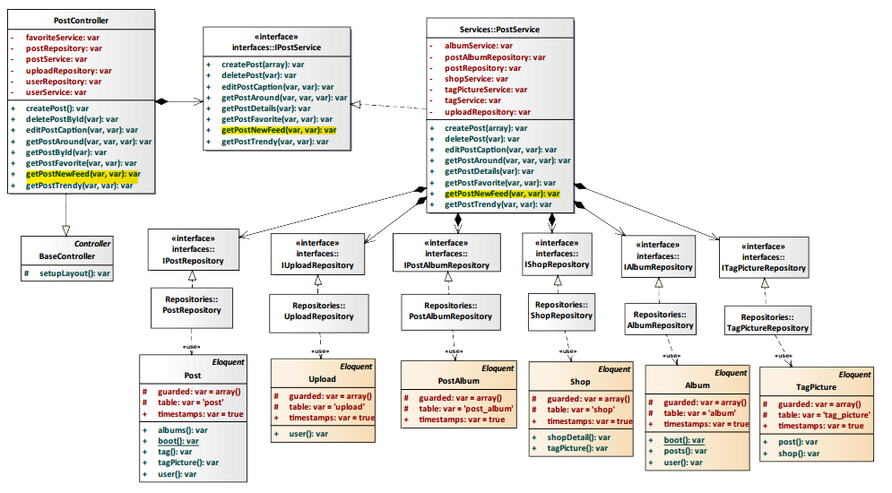

*Figure 4-29: View Newsfeed Class Diagram*

###### Class Specification

PostController class

Physical Address: Trendy-Server\app\Controller*PostController.php*

Attribute

|  |  |  |  |
| --- | --- | --- | --- |
| No | Name | Type | Description |
| 1 | favoriteService | var | Instance of interface using to call methods in IFavoriteService. |
| 2 | postRepository | var | Instance of interface using to call methods in IPostRepository. |
| 3 | postService | var | Instance of interface using to call methods in IPostService. |
| 4 | uploadRepository | var | Instance of interface using to call methods in IUploadRepository. |
| 6 | userRepository | var | Instance of interface using to call methods in IUserRepository. |
| 7 | userService | var | Instance of interface using to call methods in IUserService. |

Method: getPostNewFeed($id, $user_id)

|  |  |  |  |  |
| --- | --- | --- | --- | --- |
| Purpose | Display new post which user’s following posting | | | |
| Return | **Type** | | | **Description** |
| var | | | All new post which user’s following posting. |
| Parameter | **No** | **Name** | **Type** | **Description** |
| 1 | id | var | id of post which actor’s following posting. |
| 2 | user_id | var | id of user who actor’s following. |

PostService class

Physical Address: Trendy-Server\app\Services*PostService.php*

Attribute

|  |  |  |  |
| --- | --- | --- | --- |
| No | Name | Type | Description |
| 1 | albumService | var | Instance of interface using to call methods in IAlbumService. |
| 2 | postAlbumRepository | var | Instance of interface using to call methods in IPostAlbumRepository. |
| 3 | postRepository | var | Instance of interface using to call methods in IPostRepository. |
| 4 | shopService | var | Instance of interface using to call methods in IShopService. |
| 5 | tagPictureService | var | Instance of interface using to call methods in ITagPictureService. |
| 6 | tagService | var | Instance of interface using to call methods in ITagService. |
| 7 | uploadRepository | var | Instance of interface using to call methods in IUploadRepository. |

Method: getPostNewFeed($id, $user_id)

|  |  |  |  |  |
| --- | --- | --- | --- | --- |
| Purpose | Display new post which user’s following posting | | | |
| Return | **Type** | | | **Description** |
| var | | | All new post which user’s following posting. |
| Parameter | **No** | **Name** | **Type** | **Description** |
| 1 | id | var | id of post which actor’s following posting. |
| 2 | user_id | var | id of user who actor’s following. |

###### Sequence Diagram

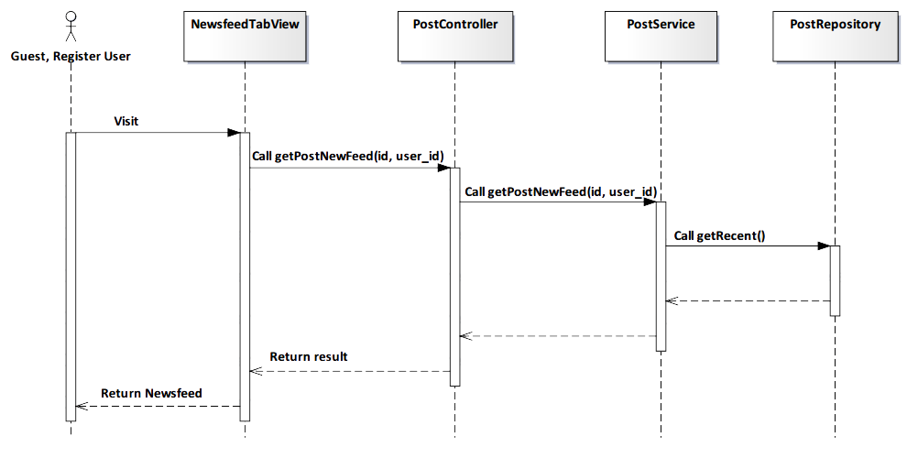

*Figure 4-30: View Newsfeed Sequence Diagram*

###### Screen Design

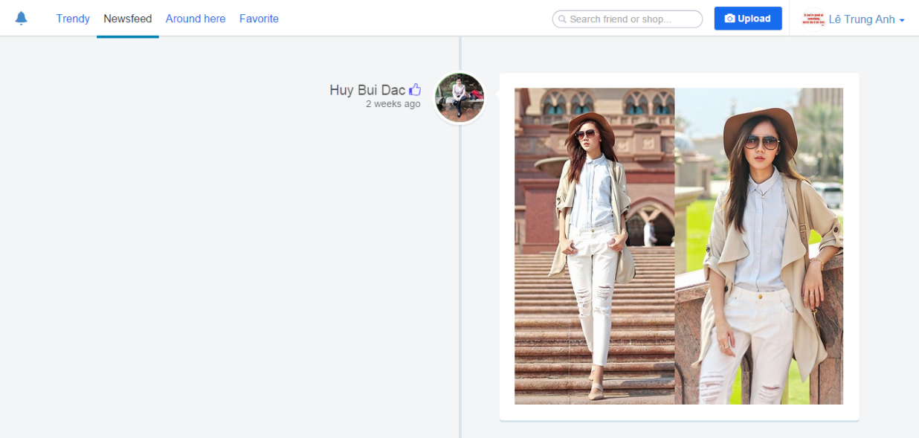

*Figure 4-31: View Newsfeed Screen*

|  |  |  |
| --- | --- | --- |
| **Element** | **Type** | **Description** |
| **Scroll** | Button | Scroll down to get more newsfeed. |

##### 4.3.4.1.4. View User page

###### Description

* User view User page.

###### Class Diagram

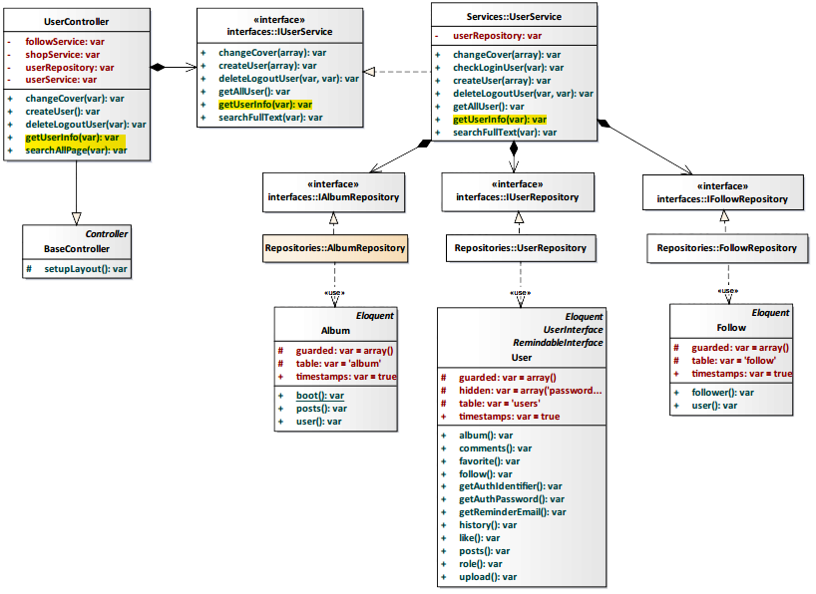

*Figure 4-32: View User page Class Diagram*

###### Class Specification

UserController class

Physical Address: Trendy-Server\app\Controller*UserController.php*

Attribute

|  |  |  |  |
| --- | --- | --- | --- |
| No | Name | Type | Description |
| 1 | followService | var | Instance of interface using to call methods in IFollowService. |
| 2 | shopService | var | Instance of interface using to call methods in IShopService. |
| 3 | userRepository | var | Instance of interface using to call methods in IUserRepository. |
| 4 | userService | var | Instance of interface using to call methods in IUserService. |

Method: getUserInfo($id)

|  |  |  |  |  |
| --- | --- | --- | --- | --- |
| Purpose | Display the user page. | | | |
| Return | **Type** | | | **Description** |
| var | | | Return information about user page. |
| Parameter | **No** | **Name** | **Type** | **Description** |
| 1 | id | var | id of the user that want to view page. |

UserService class

Physical Address: Trendy-Server\app\Services*UserService.php*

Attribute

|  |  |  |  |
| --- | --- | --- | --- |
| No | Name | Type | Description |
| 1 | userRepository | var | Instance of interface using to call methods in IUserRepository. |

Method: getUserInfo($id)

|  |  |  |  |  |
| --- | --- | --- | --- | --- |
| Purpose | Process to get information user page. | | | |
| Return | **Type** | | | **Description** |
| var | | | Return information about user page. |
| Parameter | **No** | **Name** | **Type** | **Description** |
| 1 | id | var | id of the user that want to view user page. |

###### Sequence Diagram

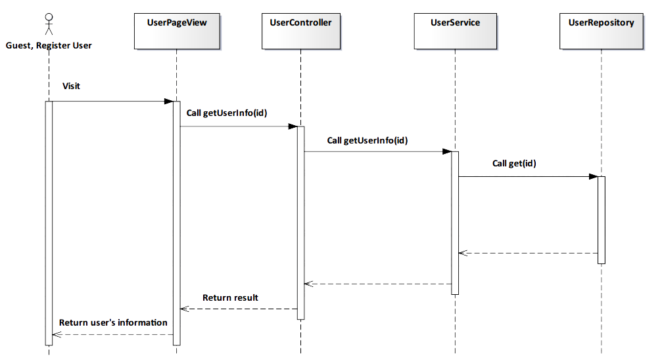

*Figure 4-33: View User page Sequence Diagram*

###### Screen Design

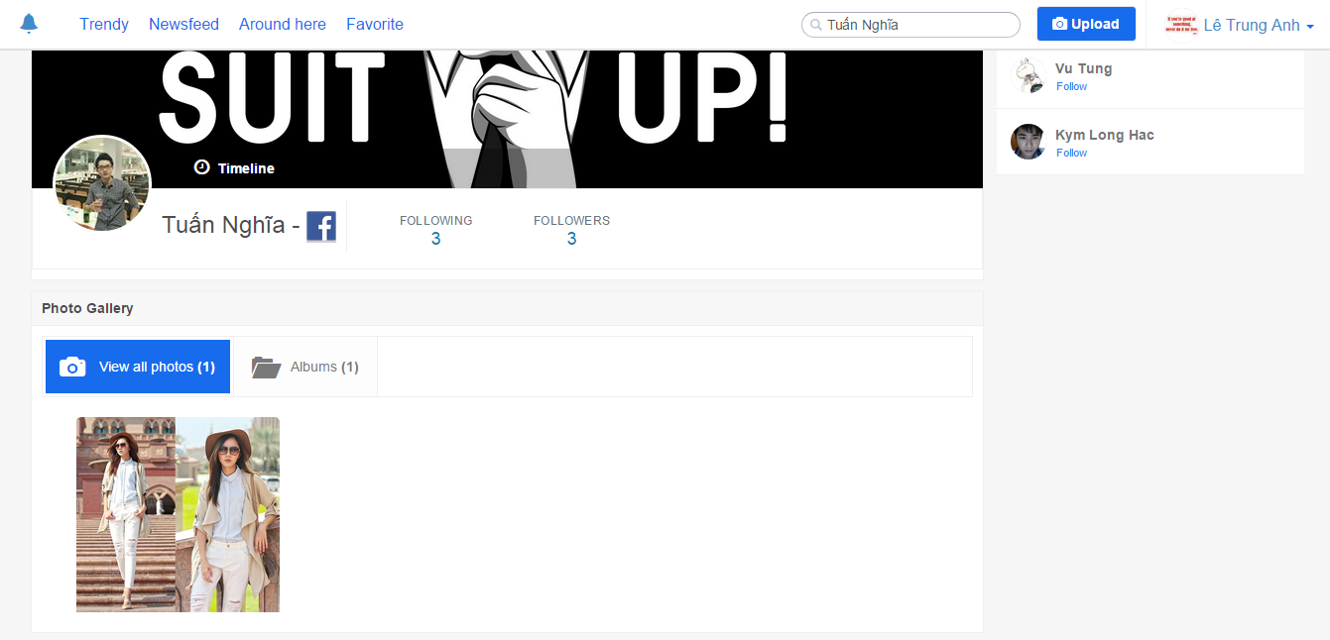

*Figure 4-34: View User page Screen*

##### 4.3.4.1.5. View Shop page

###### Description

* User browses the shop page of a specific shop.

###### Class Diagram

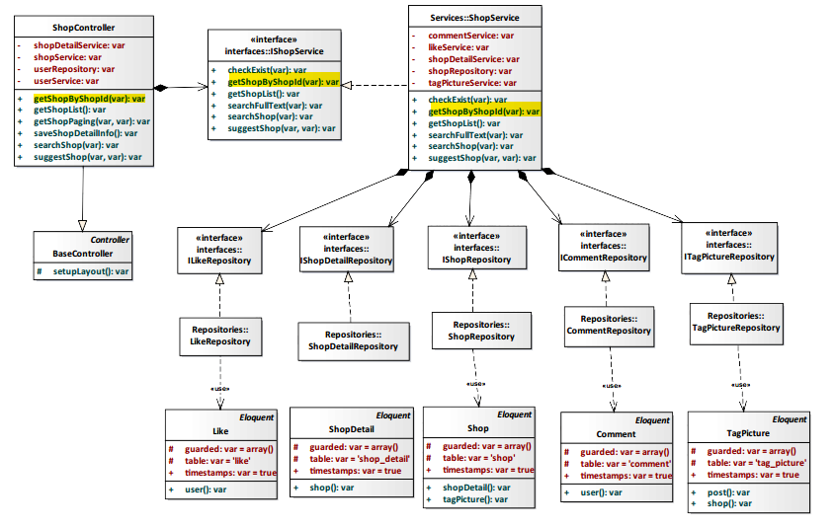

*Figure 4-35: View Shop page Class Diagram*

###### Class Specification

ShopController class

Physical Address: Trendy-Server\app\controllers*ShopController.php*

Attribute

|  |  |  |  |
| --- | --- | --- | --- |
| No | Name | Type | Description |
| 1 | shopDetailService | var | Instance of interface using to call methods in IShopDetailService. |
| 2 | shopService | var | Instance of interface using to call methods in IShopService. |
| 3 | userRepository | var | Instance of interface using to call methods in IUserRepository. |
| 4 | userService | var | Instance of interface using to call methods in IUserService. |

Method: getShopByShopId($id)

|  |  |  |  |  |
| --- | --- | --- | --- | --- |
| Purpose | Display all shop’s information to client. | | | |
| Return | **Type** | | | **Description** |
| var | | | Return shop information. |
| Parameter | **No** | **Name** | **Type** | **Description** |
| 1 | id | var | id of the shop that want to view. |

ShopService class

Physical Address: Trendy-Server\app\Services*ShopService.php*

Attribute

|  |  |  |  |
| --- | --- | --- | --- |
| No | Name | Type | Description |
| 1 | commentService | var | Instance of interface using to call methods in ICommentService. |
| 2 | likeService | var | Instance of interface using to call methods in ILikeService. |
| 3 | shopDetailService | var | Instance of interface using to call methods in IShopDetailService. |
| 4 | shopRepository | var | Instance of interface using to call methods in IshopRepository. |
| 5 | tagPictureService | var | Instance of interface using to call methods in ITagPictureService. |

Method: getShopByShopId($id)

|  |  |  |  |  |
| --- | --- | --- | --- | --- |
| Purpose | Process to get all shop’s information. | | | |
| Return | **Type** | | | **Description** |
| var | | | Return shop information. |
| Parameter | **No** | **Name** | **Type** | **Description** |
| 1 | id | var | Id of the shop that want to view. |

###### Sequence Diagram

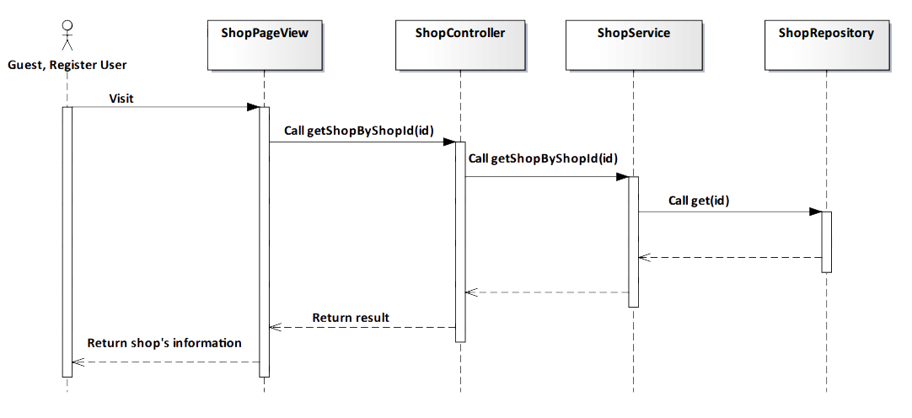

*Figure 4-36: View Shop page Sequence Diagram*

###### Screen Design

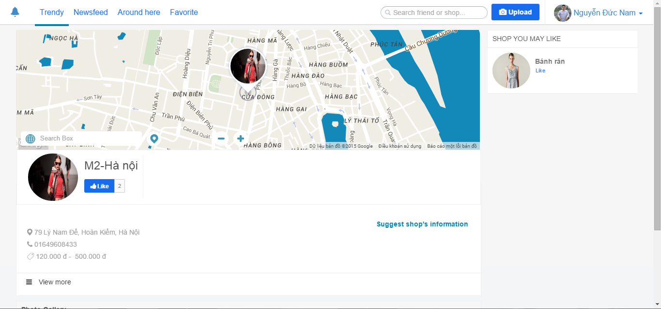

*Figure 4-37: View Shop page Screen*

|  |  |  |
| --- | --- | --- |
| **Element** | **Type** | **Description** |
| **View more** | Button | Click to view more about shop. |

##### 4.3.4.1.6. View Around here

###### Description

* User views Fashion Post near user location.

###### Class Diagram

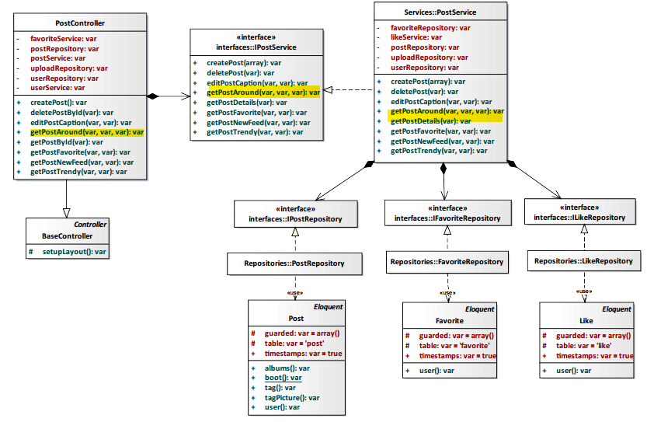

*Figure 4-38: View Around here Class Diagram*

###### Class Specification

PostController class

Physical Address: Trendy-Server\app\Controller*PostController.php*

Attribute

|  |  |  |  |
| --- | --- | --- | --- |
| No | Name | Type | Description |
| 1 | favoriteService | var | Instance of interface using to call methods in IFavoriteService. |
| 2 | postRepository | var | Instance of interface using to call methods in IPostRepository. |
| 3 | postService | var | Instance of interface using to call methods in IPostService. |
| 4 | uploadRepository | var | Instance of interface using to call methods in IUploadRepository. |
| 6 | userRepository | var | Instance of interface using to call methods in IUserRepository. |
| 7 | userService | var | Instance of interface using to call methods in IUserService. |

Method: getPostAround($id, $lat, $long)

|  |  |  |  |  |
| --- | --- | --- | --- | --- |
| Purpose | User view fashion posts around user’s location. | | | |
| Return | **Type** | | | **Description** |
| var | | | All fashion near post. |
| Parameter | **No** | **Name** | **Type** | **Description** |
| 1 | id | var | id of post. |
| 2 | lat | var | lat of post. |
| 3 | long | var | long of post. |

PostService class

Physical Address: Trendy-Server\app\Services*PostService.php*

Attribute

|  |  |  |  |
| --- | --- | --- | --- |
| No | Name | Type | Description |
| 1 | favoriteRepository | var | Instance of interface using to call methods in IFavoriteRepository. |
| 2 | likeService | var | Instance of interface using to call methods in ILikeService. |
| 3 | postRepository | var | Instance of interface using to call methods in IPostRepository. |
| 4 | uploadRepository | var | Instance of interface using to call methods in IUploadRepository. |
| 5 | userRepository | var | Instance of interface using to call methods in IUserRepository. |

Method: getPostAround ($id, $lat, $long)

|  |  |  |  |  |
| --- | --- | --- | --- | --- |
| Purpose | User view fashion posts around user’s location. | | | |
| Return | **Type** | | | **Description** |
| var | | | Display all fashion post nearly user’s location. |
| Parameter | **No** | **Name** | **Type** | **Description** |
| 1 | id | var | id of post. |
| 2 | lat | var | lat of post. |
| 3 | long | var | long of post. |

###### Sequence Diagram

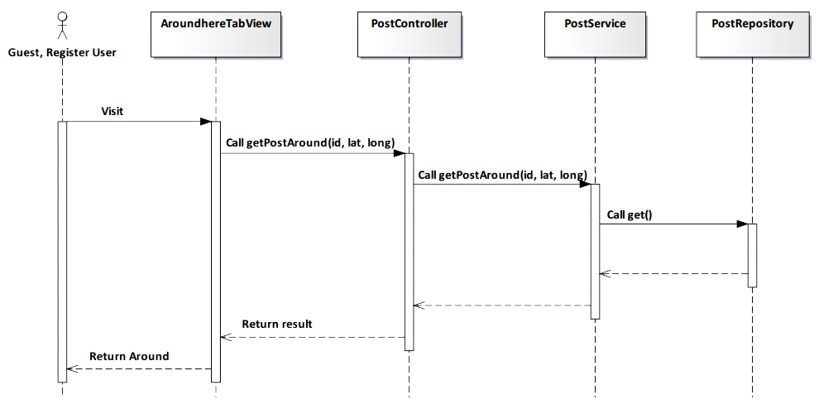

*Figure 4-39: View Around here Sequence Diagram*

###### Screen Design

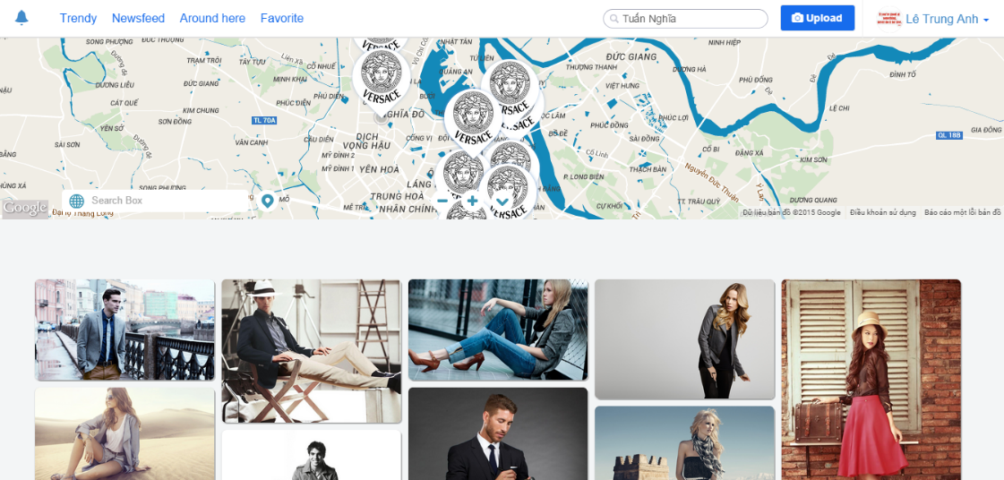

*Figure 4-40: View Around here Screen*

|  |  |  |
| --- | --- | --- |
| **Element** | **Type** | **Description** |
| **Scroll** | Button | Scroll down to view more post around. |
| **Pin** | Button | Click to get position on map. |

##### 4.3.4.1.7. View Album

###### Description

* Actor views album of user.

###### Class Diagram

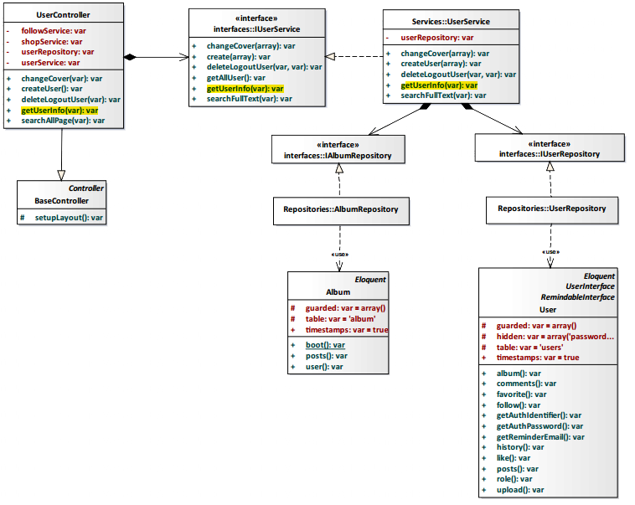

*Figure 4-41: View Album Class Diagram*

###### Class Specification

UserController class

Physical Address: Trendy-Server\app\controllers*UserController.php*

Attribute

|  |  |  |  |
| --- | --- | --- | --- |
| No | Name | Type | Description |
| 1 | followService | var | Instance of interface using to call methods in IFollowService. |
| 2 | shopService | var | Instance of interface using to call methods in IShopService. |
| 3 | userRepository | var | Instance of interface using to call methods in IUserRepostiory. |
| 4 | userService | var | Instance of interface using to call methods in IUserService. |

Method: getUserInfo(var $id)

|  |  |  |  |  |
| --- | --- | --- | --- | --- |
| Purpose | Show user’s album for actor. | | | |
| Return | **Type** | | | **Description** |
| var | | | Return user’s album. |
| Parameter | **No** | **Name** | **Type** | **Description** |
| 1 | id | var | id of the user that want to view album. |

UserService class

Physical Address: Trendy-Server\app\Services*UserService.php*

Attribute

|  |  |  |  |
| --- | --- | --- | --- |
| No | Name | Type | Description |
| 1 | userRepository | var | Instance of interface using to call methods in IUserRepository. |

Method: getUserInfo(var $id)

|  |  |  |  |  |
| --- | --- | --- | --- | --- |
| Purpose | Process to show user’s album. | | | |
| Return | **Type** | | | **Description** |
| var | | | Return user’s album. |
| Parameter | **No** | **Name** | **Type** | **Description** |
| 1 | id | var | id of the user that want to view album. |

###### Sequence Diagram

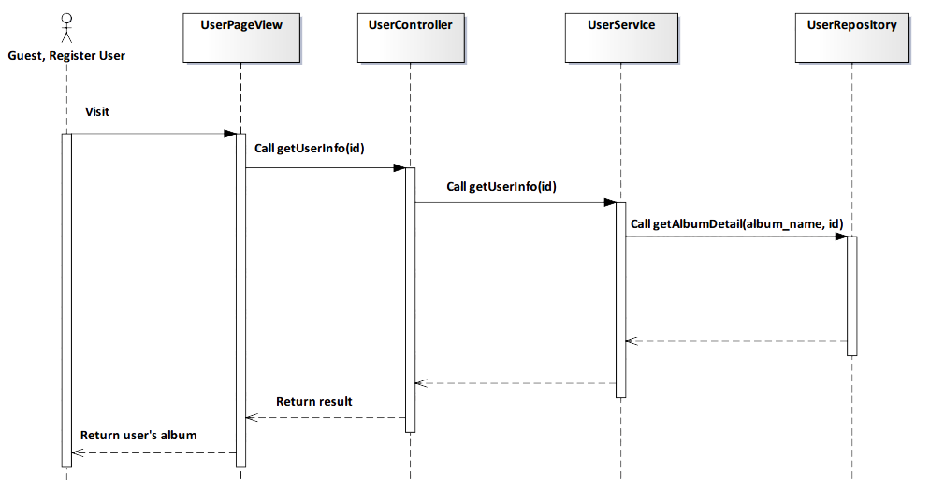

*Figure 4-42: View Album Sequence Diagram*

###### Screen Design

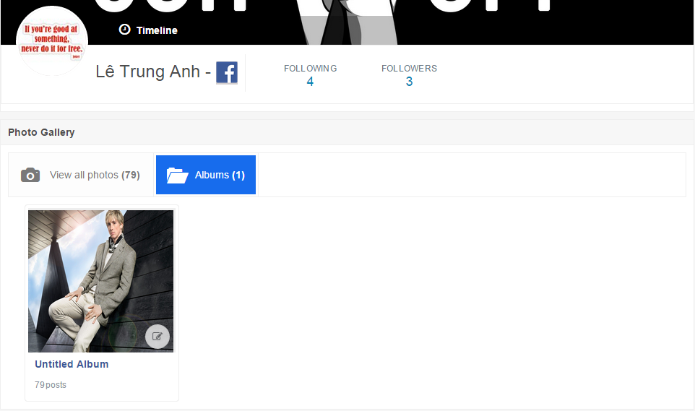

*Figure 4-43: View Album Screen*

##### 4.3.4.1.8. View Post

###### Description

* Actor views a post on TrendyPlus that they want.

###### Class Diagram

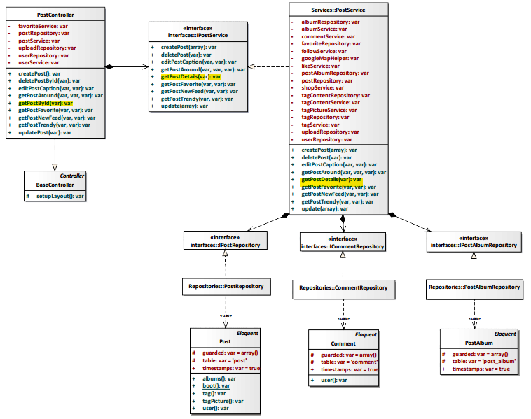

*Figure 4-44: View Post Class Diagram*

###### Class Specification

PostController class

Physical Address: Trendy-Server\app\controllers*PostController.php*

Attribute

|  |  |  |  |
| --- | --- | --- | --- |
| No | Name | Type | Description |
| 1 | favoriteService | var | Instance of interface using to call methods in IFavoriteService. |
| 2 | postRepository | var | Instance of interface using to call methods in IPostRepository. |
| 3 | postService | var | Instance of interface using to call methods in IPostService. |
| 4 | uploadRepository | var | Instance of interface using to call methods in IUploadRepostiory. |
| 5 | userRepository | var | Instance of interface using to call methods in IUserRepostiory. |
| 6 | userService | var | Instance of interface using to call methods in IUserService. |

Method: getPostById(var $id)

|  |  |  |  |  |
| --- | --- | --- | --- | --- |
| Purpose | Display post to client. | | | |
| Return | **Type** | | | **Description** |
| var | | | Return to a post. |
| Parameter | **No** | **Name** | **Type** | **Description** |
| 1 | id | var | id of the post that want to view post details. |

PostService class

Physical Address: Trendy-Server\app\Services*PostService.php*

Attribute

|  |  |  |  |
| --- | --- | --- | --- |
| No | Name | Type | Description |
| 1 | albumRepository | var | Instance of interface using to call methods in IAlbumRepository. |
| 2 | albumService | var | Instance of interface using to call methods in IAlbumService. |
| 3 | commentService | var | Instance of interface using to call methods in ICommentService. |
| 4 | favoriteRepository | var | Instance of interface using to call methods in IFavoriteRepository. |
| 5 | followService | var | Instance of interface using to call methods in IFollowSerivce. |
| 6 | googleMapHelper | var | Instance of interface using to call methods in IGoogleMapHelper. |
| 7 | likeService | var | Instance of interface using to call methods in ILikeSerivce. |
| 8 | postAlbumRepository | var | Instance of interface using to call methods in IAlbumRepository. |
| 9 | postRepository | var | Instance of interface using to call methods in IPostRepository. |
| 10 | shopService | var | Instance of interface using to call methods in IShopSerivce. |
| 11 | tagContentRepository | var | Instance of interface using to call methods in ITagContentRepository. |
| 12 | tagContentService | var | Instance of interface using to call methods in ITagContentSerivce. |
| 13 | tagPictureService | var | Instance of interface using to call methods in ITagPictureSerivce. |
| 14 | tagRepository | var | Instance of interface using to call methods in ITagRepository. |
| 15 | tagService | var | Instance of interface using to call methods in ITagSerivce. |
| 16 | uploadRepository | var | Instance of interface using to call methods in IUploadRepository. |
| 17 | userRepository | var | Instance of interface using to call methods in IUserRepository. |

Method: getPostDetails(var $id)

|  |  |  |  |  |
| --- | --- | --- | --- | --- |
| Purpose | Process to show all information details of a post. | | | |
| Return | **Type** | | | **Description** |
| var | | | Return to a post. |
| Parameter | **No** | **Name** | **Type** | **Description** |
| 1 | id | var | id of the post that want to view post details. |

###### Sequence Diagram

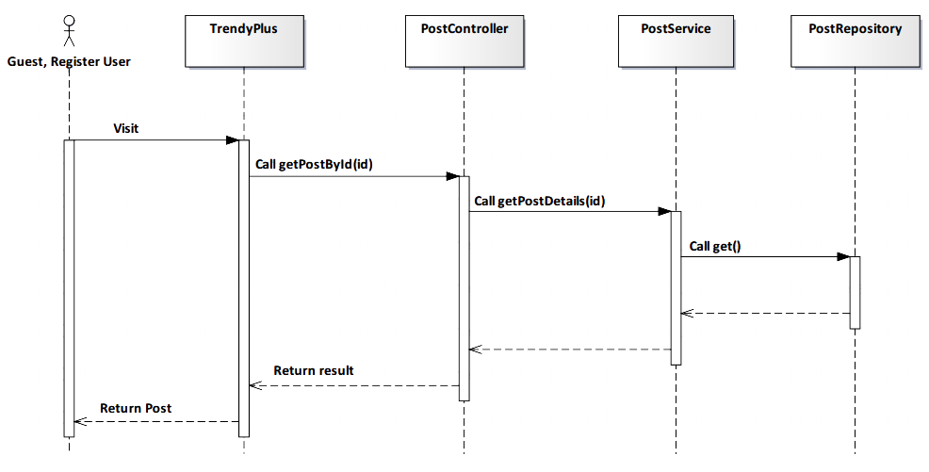

*Figure 4-45: View Post Sequence Diagram*

###### Screen Design

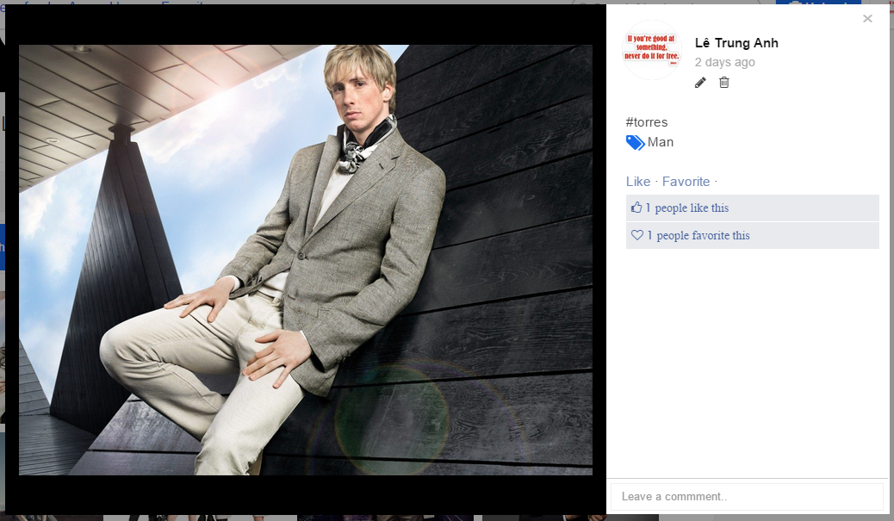

*Figure 4-46: View Post Screen Diagram*

|  |  |  |
| --- | --- | --- |
| **Element** | **Type** | **Description** |
| **Leave a comment** | Input text | Text field for entering comment. |
| **Like** | Button | Click to like post. |
| **Favorite** | Button | Click to add favorite. |
| **Edit** | Button | Click to edit post’s caption. |
| **Delete** | Button | Click to delete post’s caption. |

##### 4.3.4.1.9. View Shop on map

###### Description

* Actor views address of shop on map.

###### Class Diagram

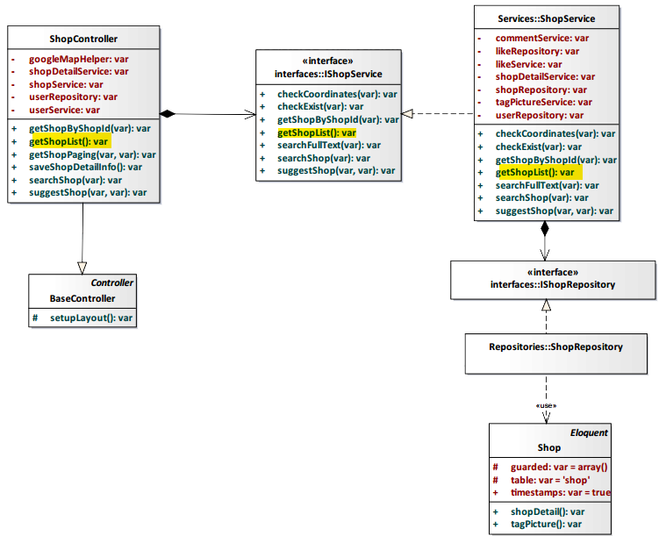

*Figure 4-47: View Shop on map Class Diagram*

###### Class Specification

ShopController class

Physical Address: Trendy-Server\app\controllers*ShopController.php*

Attribute

|  |  |  |  |
| --- | --- | --- | --- |
| No | Name | Type | Description |
| 1 | googleMapHelper | var | Instance of interface using to call methods in IGoogleMapHelper. |
| 2 | shopDetailService | var | Instance of interface using to call methods in IShopDetailService. |
| 3 | shopService | var | Instance of interface using to call methods in IShopService. |
| 4 | userRepository | var | Instance of interface using to call methods in IUserRepository. |
| 5 | userService | var | Instance of interface using to call methods in IUserService. |

Method: getShopList()

|  |  |  |
| --- | --- | --- |
| Purpose | Display all shop on map to client. | |
| Return | **Type** | **Description** |
| var | Return shop’s address. |

ShopService class

Physical Address: Trendy-Server\app\Services*ShopService.php*

Attribute

|  |  |  |  |
| --- | --- | --- | --- |
| No | Name | Type | Description |
| 1 | commentService | var | Instance of interface using to call methods in ITagCommentService. |
| 2 | likeRepository | var | Instance of interface using to call methods in ILikeRepository. |
| 3 | likeSerivce | var | Instance of interface using to call methods in ILikeService. |
| 4 | shopDetailService | var | Instance of interface using to call methods in IShopDetailService. |
| 5 | shopRepository | var | Instance of interface using to call methods in IShopRepository. |
| 6 | tagPictureService | var | Instance of interface using to call methods in ITagPictureService. |
| 7 | userRepository | var | Instance of interface using to call methods in IUserRepository. |

Method: getShopList()

|  |  |  |
| --- | --- | --- |
| Purpose | Process to show all shop on map. | |
| Return | **Type** | **Description** |
| var | Return shop’s address. |

###### Sequence Diagram

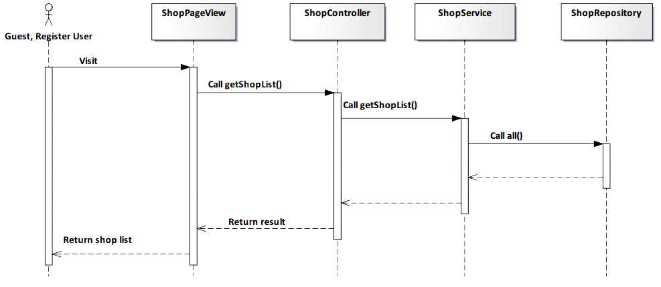

*Figure 4-48: View Shop on map Sequence Diagram*

###### Screen Design

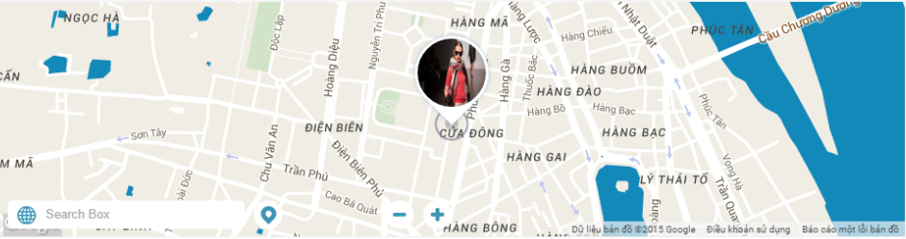

*Figure 4-49: View Shop Screen*

|  |  |  |
| --- | --- | --- |
| **Element** | **Type** | **Description** |
| **Pin** | Button | Click to get position on map. |

##### 4.3.4.1.10. Get all Album of user

###### Description

* Actor gets all album of a user.

###### Class Diagram



*Figure 4-50: Get all Album of user Class Diagram*

###### Class Specification

UserController class

Physical Address: Trendy-Server\app\controllers*UserController.php*

Attribute

|  |  |  |  |
| --- | --- | --- | --- |
| No | Name | Type | Description |
| 1 | followService | var | Instance of interface using to call methods in IFollowService. |
| 2 | shopService | var | Instance of interface using to call methods in IShopService. |
| 3 | userRepository | var | Instance of interface using to call methods in IUserRepostiory. |
| 4 | userService | var | Instance of interface using to call methods in IUserService. |

Method: getUserInfo(var $id)

|  |  |  |  |  |
| --- | --- | --- | --- | --- |
| Purpose | Get all album of user. | | | |
| Return | **Type** | | | **Description** |
| var | | | Return user’s information. |
| Parameter | **No** | **Name** | **Type** | **Description** |
| 1 | id | var | id of the user that want to get all album. |

UserService class

Physical Address: Trendy-Server\app\Services*UserService.php*

Attribute

|  |  |  |  |
| --- | --- | --- | --- |
| No | Name | Type | Description |
| 1 | userRepository | var | Instance of interface using to call methods in IUserRepository. |

Method: getUserInfo(var $id)

|  |  |  |  |  |
| --- | --- | --- | --- | --- |
| Purpose | Process to get all album of user. | | | |
| Return | **Type** | | | **Description** |
| var | | | Return user’s information. |
| Parameter | **No** | **Name** | **Type** | **Description** |
| 1 | id | var | id of the user that want to get all album. |

###### Sequence Diagram

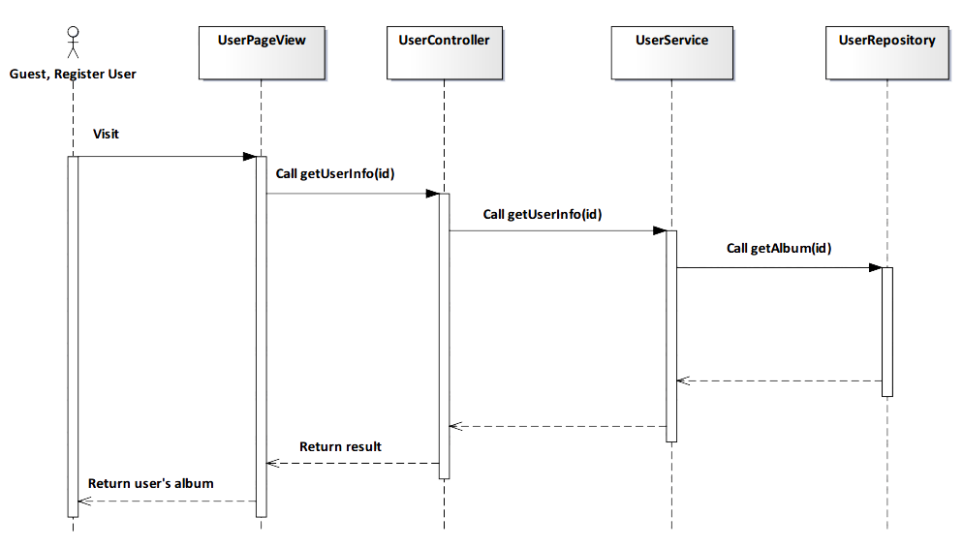

*Figure 4-51: Get all Album of user Sequence Diagram*

###### Screen Design

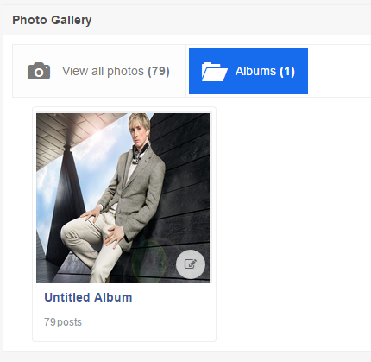

*Figure 4-52: Get all Album of user Screen*

##### 4.3.4.1.11. Suggest related user

###### Description

* User see related user to following.

###### Class Diagram

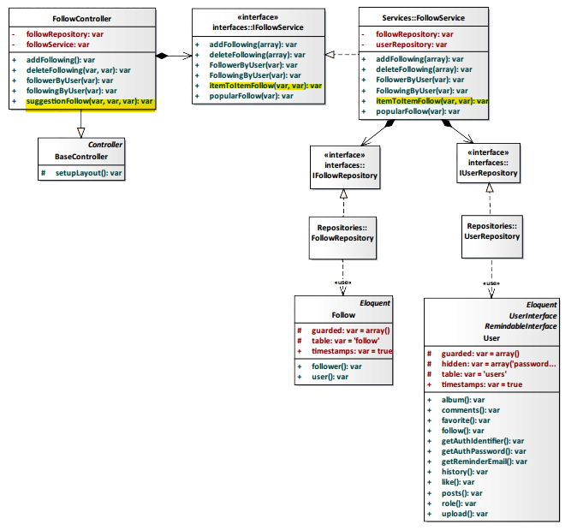

*Figure 4-53: Suggest related user Class Diagram*

###### Class Specification

FollowController class

Physical Address: Trendy-Server\app\Controller*FollowController.php*

Attribute

|  |  |  |  |
| --- | --- | --- | --- |
| No | Name | Type | Description |
| 1 | followService | var | Instance of interface using to call methods in IFollowService. |
| 2 | followRepository | var | Instance of interface using to call methods in IFollowRepository. |

Method: suggestionFollow($id, $type, $userId)

|  |  |  |  |  |
| --- | --- | --- | --- | --- |
| Purpose | Display the like number of shop to client. | | | |
| Return | **Type** | | | **Description** |
| var | | | Return list suggestion follow. |
| Parameter | **No** | **Name** | **Type** | **Description** |
| 1 | id | var | id of user who received suggestion. |
| 2 | type | var | type of follow. |
| 3 | user_id | var | id of user who is suggested other people. |

FollowService class

Physical Address: Trendy-Server\app\Services*FollowService.php*

Attribute

|  |  |  |  |
| --- | --- | --- | --- |
| No | Name | Type | Description |
| 1 | userRepository | var | Instance of interface using to call methods in IUserRepository. |
| 2 | followRepository | var | Instance of interface using to call methods in IFollowRepository. |

Method: itemToItemFollow($loginId, $user_id)

|  |  |  |  |  |
| --- | --- | --- | --- | --- |
| Purpose | User see related user to following. | | | |
| Return | **Type** | | | **Description** |
| var | | | Return list following people. |
| Parameter | **No** | **Name** | **Type** | **Description** |
| 1 | loginId | var | id of the user that want to view list following. |
| 2 | user_id | var | id of user who is suggested other people. |

###### Sequence Diagram

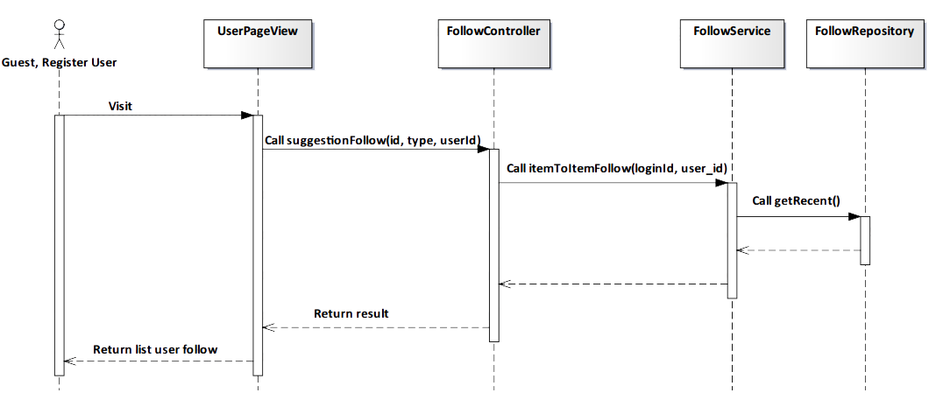

*Figure 4-54: Suggest related user Sequence Diagram*

###### Screen Design

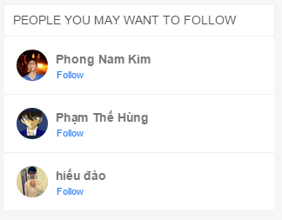

*Figure 4-55: Suggest related user Screen*

|  |  |  |
| --- | --- | --- |
| **Element** | **Type** | **Description** |
| **Follow** | Hyperlink | Click to follow user. |

#### 4.3.4.2. Register User

##### 4.3.4.2.1. Delete Album

###### Description

* Actor deletes actor‘s album.

###### Class Diagram

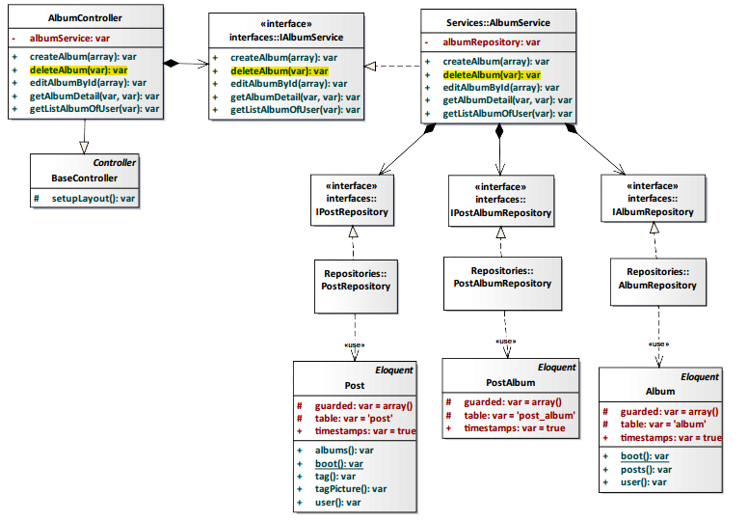

*Figure 4-56: Delete Album Class Diagram*

###### Class Specification

AlbumController class

Physical Address: Trendy-Server\app\controllers*AlbumController.php*

Attribute

|  |  |  |  |
| --- | --- | --- | --- |
| No | Name | Type | Description |
| 1 | albumService | var | Instance of interface using to call methods in IAlbumService. |

Method: deleteAlbumByName($album_name)

|  |  |  |  |  |
| --- | --- | --- | --- | --- |
| Purpose | Delete album of actor. | | | |
| Return | **Type** | | | **Description** |
| var | | | Return successful or error. |
| Parameter | **No** | **Name** | **Type** | **Description** |
| 1 | album_name | var | Name of album need delete. |

AlbumService class

Physical Address: Trendy-Server\app\Services*AlbumService.php*

Attribute

|  |  |  |  |
| --- | --- | --- | --- |
| No | Name | Type | Description |
| 1 | AlbumRepository | var | Instance of interface using to call methods in IAlbumRepository. |

Method: deleteAlbum($album_name)

|  |  |  |  |  |
| --- | --- | --- | --- | --- |
| Purpose | Delete album of actor. | | | |
| Return | **Type** | | | **Description** |
| var | | | Return successful or error. |
| Parameter | **No** | **Name** | **Type** | **Description** |
| 1 | album_name | var | Name of album need delete. |

###### Sequence Diagram

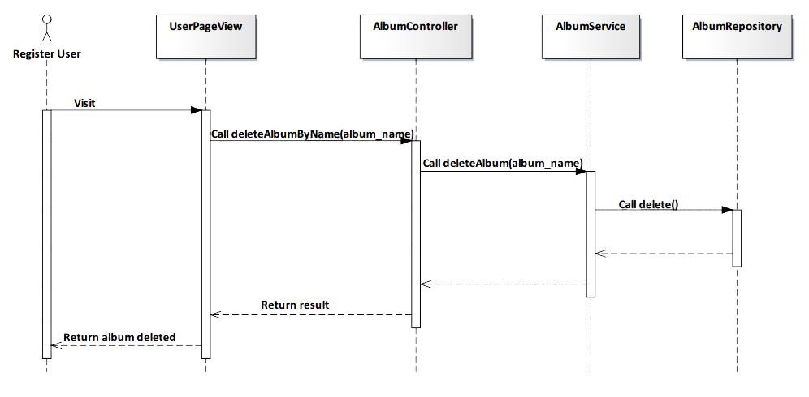

*Figure 4-57: Delete Album Sequence Diagram*

###### Screen Design

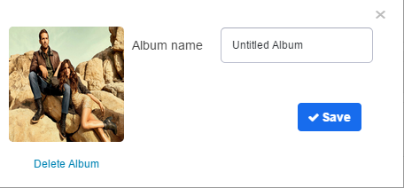

*Figure 4-58: Delete Album Screen*

|  |  |  |
| --- | --- | --- |
| **Element** | **Type** | **Description** |
| **Delete Album** | Hyperlink | Click to delete album. |
| **Save** | Button | Click to save changes. |

##### 4.3.4.2.2. Edit Album

###### Description

* Actor edits actor‘s album.

###### Class Diagram

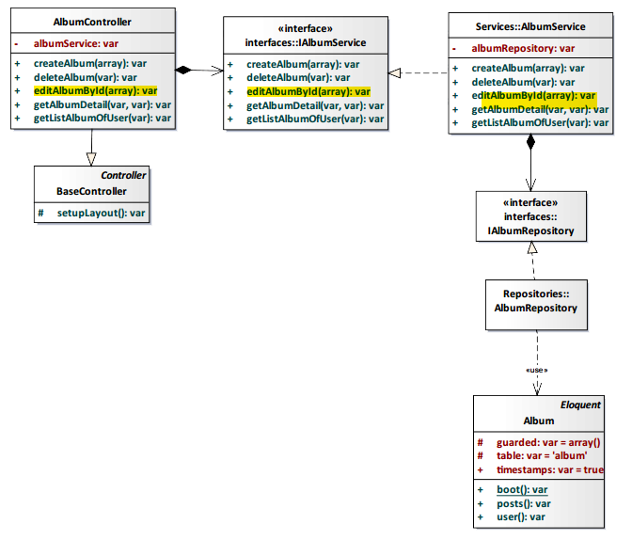

*Figure 4-59: Edit Album Class Diagram*

###### Class Specification

AlbumController class

Physical Address: Trendy-Server\app\controllers*AlbumController.php*

Attribute

|  |  |  |  |
| --- | --- | --- | --- |
| No | Name | Type | Description |
| 1 | albumService | var | Instance of interface using to call methods in IAlbumService. |

Method: editAlbumById($data)

|  |  |  |  |  |
| --- | --- | --- | --- | --- |
| Purpose | Edit content album of actor. | | | |
| Return | **Type** | | | **Description** |
| var | | | Return successful or error. |
| Parameter | **No** | **Name** | **Type** | **Description** |
| 1 | data | var | Album’s data need edit. |

AlbumService class

Physical Address: Trendy-Server\app\Services*AlbumService.php*

Attribute

|  |  |  |  |
| --- | --- | --- | --- |
| No | Name | Type | Description |
| 1 | AlbumRepository | var | Instance of interface using to call methods in IAlbumRepository. |

Method: editAlbumById($data)

|  |  |  |  |  |
| --- | --- | --- | --- | --- |
| Purpose | Edit content album of actor. | | | |
| Return | **Type** | | | **Description** |
| var | | | Return successful or error. |
| Parameter | **No** | **Name** | **Type** | **Description** |
| 1 | data | var | Album’s data need edit. |

###### Sequence Diagram

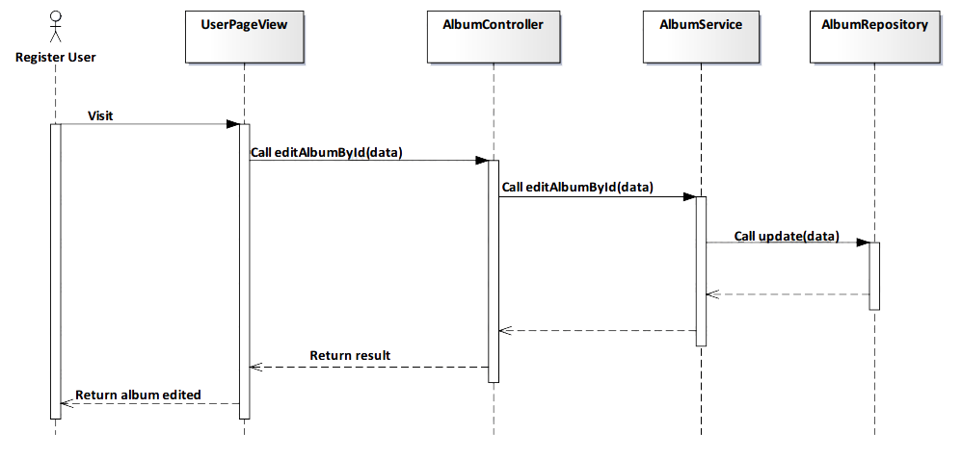

*Figure 4-60: Edit Album Sequence Diagram*

###### Screen Design



*Figure 4-60: Edit Album Class Diagram*

|  |  |  |
| --- | --- | --- |
| **Element** | **Type** | **Description** |
| **Delete Album** | Hyperlink | Click to delete album. |
| **Save** | Button | Click to save changes. |

##### 4.3.4.2.3. Add Post’s comment

###### Description

* Actor adds comment of actor in post

###### Class Diagram

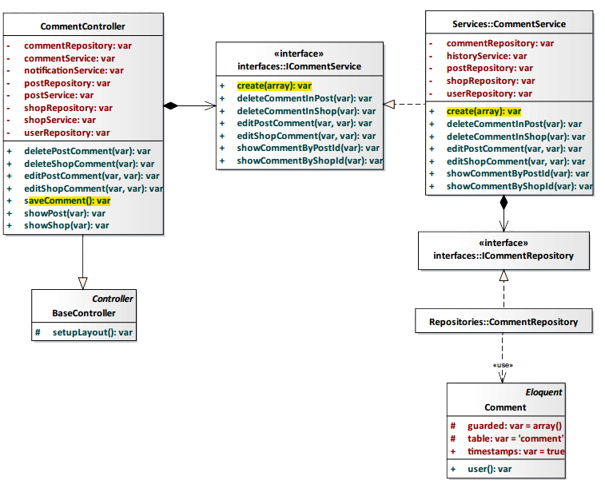

*Figure 4-61: Add Post’s comment Class Diagram*

###### Class Specification

CommentController class

Physical Address: Trendy-Server\app\controllers*CommentController.php*

Attribute

|  |  |  |  |
| --- | --- | --- | --- |
| No | Name | Type | Description |
| 1 | commentRepository | var | Instance of interface using to call methods in ICommentRepository. |
| 2 | commentService | var | Instance of interface using to call methods in ICommentService. |
| 3 | notificationService | var | Instance of interface using to call methods in INotificationService. |
| 4 | postRepository | var | Instance of interface using to call methods in IPostRepository. |
| 5 | postService | var | Instance of interface using to call methods in IPostService. |
| 6 | shopRepository | var | Instance of interface using to call methods in IShopRepository. |
| 7 | shopService | var | Instance of interface using to call methods in IShopService. |
| 8 | userRepository | var | Instance of interface using to call methods in IUserRepostiory. |

Method: saveComment()

|  |  |  |
| --- | --- | --- |
| Purpose | Add comment of actor in post. | |
| Return | **Type** | **Description** |
| var | Return successful or error. |

CommentService class

Physical Address: Trendy-Server\app\Services*CommentService.php*

Attribute

|  |  |  |  |
| --- | --- | --- | --- |
| No | Name | Type | Description |
| 1 | commentRepository | var | Instance of interface using to call methods in ICommentRepository. |
| 2 | historyService | var | Instance of interface using to call methods in IHistoryService. |
| 3 | postRepository | var | Instance of interface using to call methods in IPostRepository. |
| 4 | shopRepository | var | Instance of interface using to call methods in IShopRepository. |
| 5 | userRepository | var | Instance of interface using to call methods in IUserRepository. |

Method: create($data)

|  |  |  |  |  |
| --- | --- | --- | --- | --- |
| Purpose | Add comment of actor in post. | | | |
| Return | **Type** | | | **Description** |
| var | | | Return successful or error. |
| Parameter | **No** | **Name** | **Type** | **Description** |
| 1 | data | var | Content of comment and information insert to database. |

###### Sequence Diagram

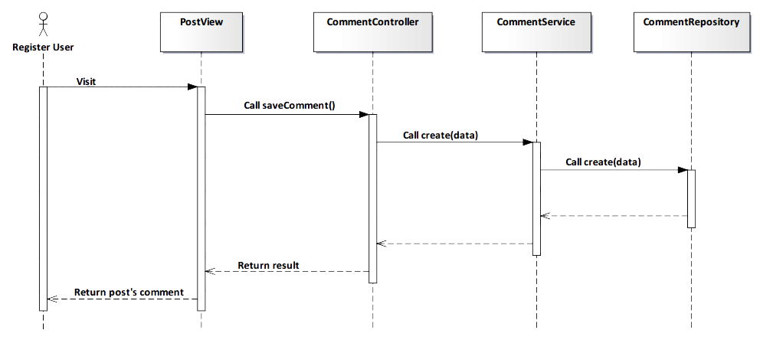

*Figure 4-62: Add Post’s comment Sequence Diagram*

###### Screen Design

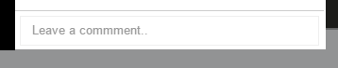

*Figure 4-63: Add Post’s comment Screen*

|  |  |  |
| --- | --- | --- |
| **Element** | **Type** | **Description** |
| **Leave a comment** | Input text | Text field for entering comment. |

##### 4.3.4.2.4. Edit Post’s comment

###### Description

* Actor edits comment of actor in post

###### Class Diagram

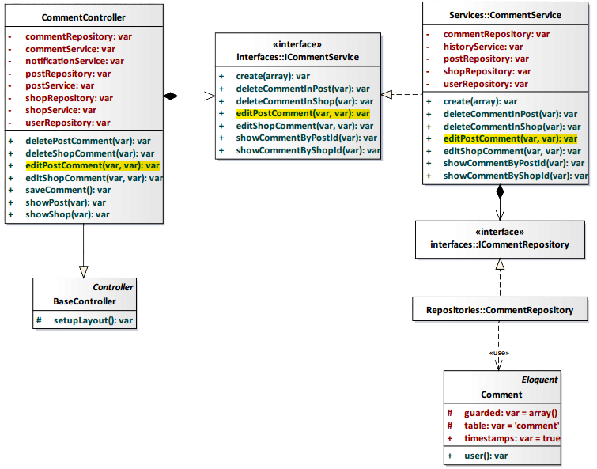

*Figure 4-64: Edit Post’s comment Class Diagram*

###### Class Specification

CommentController class

Physical Address: Trendy-Server\app\controllers*CommentController.php*

Attribute

|  |  |  |  |
| --- | --- | --- | --- |
| No | Name | Type | Description |
| 1 | commentRepository | var | Instance of interface using to call methods in ICommentRepository. |
| 2 | commentService | var | Instance of interface using to call methods in ICommentService. |
| 3 | notificationService | var | Instance of interface using to call methods in INotificationService. |
| 4 | postRepository | var | Instance of interface using to call methods in IPostRepository. |
| 5 | postService | var | Instance of interface using to call methods in IPostService. |
| 6 | shopRepository | var | Instance of interface using to call methods in IShopRepository. |
| 7 | shopService | var | Instance of interface using to call methods in IShopService. |
| 8 | userRepository | var | Instance of interface using to call methods in IUserRepostiory. |

Method: editPostComment($id)

|  |  |  |  |  |
| --- | --- | --- | --- | --- |
| Purpose | Edit comment of actor in post. | | | |
| Return | **Type** | | | **Description** |
| var | | | Return successful or error. |
| Parameter | **No** | **Name** | **Type** | **Description** |
| 1 | id | var | id comment need edit. |

CommentService class

Physical Address: Trendy-Server\app\Services*CommentService.php*

Attribute

|  |  |  |  |
| --- | --- | --- | --- |
| No | Name | Type | Description |
| 1 | commentRepository | var | Instance of interface using to call methods in ICommentRepository. |
| 2 | historyService | var | Instance of interface using to call methods in IHistoryService. |
| 3 | postRepository | var | Instance of interface using to call methods in IPostRepository. |
| 4 | shopRepository | var | Instance of interface using to call methods in IShopRepository. |
| 5 | userRepository | var | Instance of interface using to call methods in IUserRepository. |

Method: editPostComment($id)

|  |  |  |  |  |
| --- | --- | --- | --- | --- |
| Purpose | Edit comment of actor in post. | | | |
| Return | **Type** | | | **Description** |
| var | | | Return successful or error. |
| Parameter | **No** | **Name** | **Type** | **Description** |
| 1 | id | var | id comment need edit. |

###### Sequence Diagram

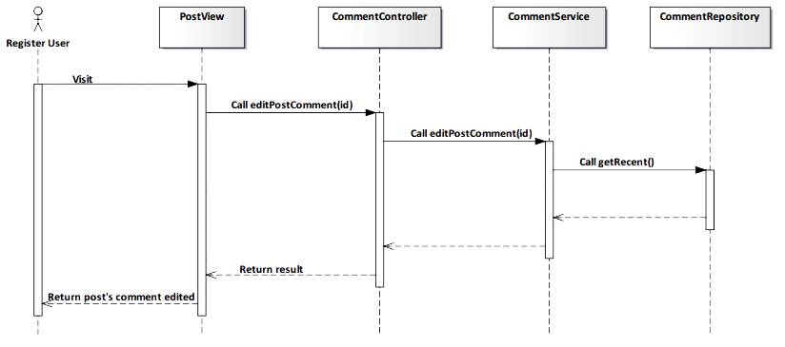

*Figure 4-65: Edit Post’s comment Sequence Diagram*

###### Screen Design

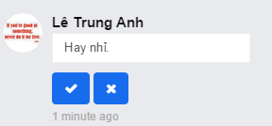

*Figure 4-66: Edit Post’s comment Screen*

##### 4.3.4.2.5. Delete Post’s comment

###### Description

* Actor deletes comment of actor in post

###### Class Diagram

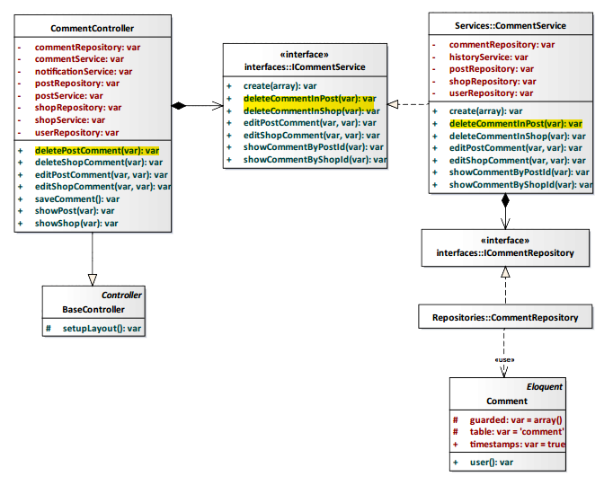

*Figure 4-67: Delete Post’s comment Class Diagram*

###### Class Specification

CommentController class

Physical Address: Trendy-Server\app\controllers*CommentController.php*

Attribute

|  |  |  |  |
| --- | --- | --- | --- |
| No | Name | Type | Description |
| 1 | commentRepository | var | Instance of interface using to call methods in ICommentRepository. |
| 2 | commentService | var | Instance of interface using to call methods in ICommentService. |
| 3 | notificationService | var | Instance of interface using to call methods in INotificationService. |
| 4 | postRepository | var | Instance of interface using to call methods in IPostRepository. |
| 5 | postService | var | Instance of interface using to call methods in IPostService. |
| 6 | shopRepository | var | Instance of interface using to call methods in IShopRepository. |
| 7 | shopService | var | Instance of interface using to call methods in IShopService. |
| 8 | userRepository | var | Instance of interface using to call methods in IUserRepostiory. |

Method: deletePostComment($id)

|  |  |  |  |  |
| --- | --- | --- | --- | --- |
| Purpose | Delete comment of actor in post. | | | |
| Return | **Type** | | | **Description** |
| var | | | Return successful or error. |
| Parameter | **No** | **Name** | **Type** | **Description** |
| 1 | id | var | id comment need delete. |

CommentService class

Physical Address: Trendy-Server\app\Services*CommentService.php*

Attribute

|  |  |  |  |
| --- | --- | --- | --- |
| No | Name | Type | Description |
| 1 | commentRepository | var | Instance of interface using to call methods in ICommentRepository. |
| 2 | historyService | var | Instance of interface using to call methods in IHistoryService. |
| 3 | postRepository | var | Instance of interface using to call methods in IPostRepository. |
| 4 | shopRepository | var | Instance of interface using to call methods in IShopRepository. |
| 5 | userRepository | var | Instance of interface using to call methods in IUserRepository. |

Method: deleteCommentInPost($id)

|  |  |  |  |  |
| --- | --- | --- | --- | --- |
| Purpose | Delete comment of actor in post. | | | |
| Return | **Type** | | | **Description** |
| var | | | Return successful or error. |
| Parameter | **No** | **Name** | **Type** | **Description** |
| 1 | id | var | id comment need delete. |

###### Sequence Diagram

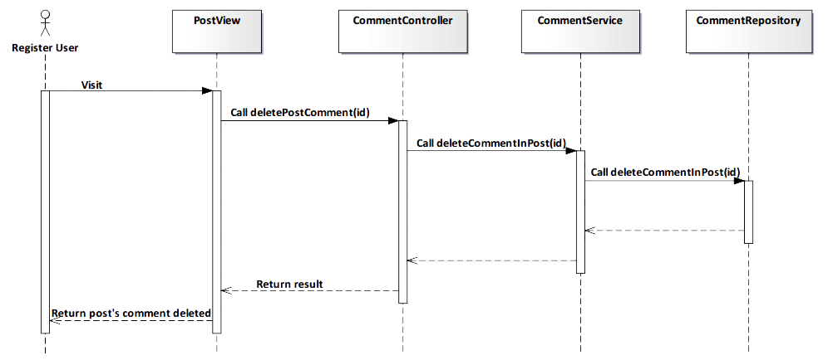

*Figure 4-68: Delete Post’s comment Sequence Diagram*

###### Screen Design

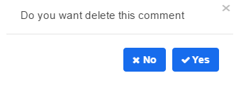

*Figure 4-69: Delete Post’s comment Screen*

|  |  |  |
| --- | --- | --- |
| **Element** | **Type** | **Description** |
| **No** | Button | Click to undelete comment. |
| **Yes** | Button | Click to delete comment. |

##### 4.3.4.2.6. View Post’s comment

###### Description

* Actor views all comments of a post.

###### Class Diagram

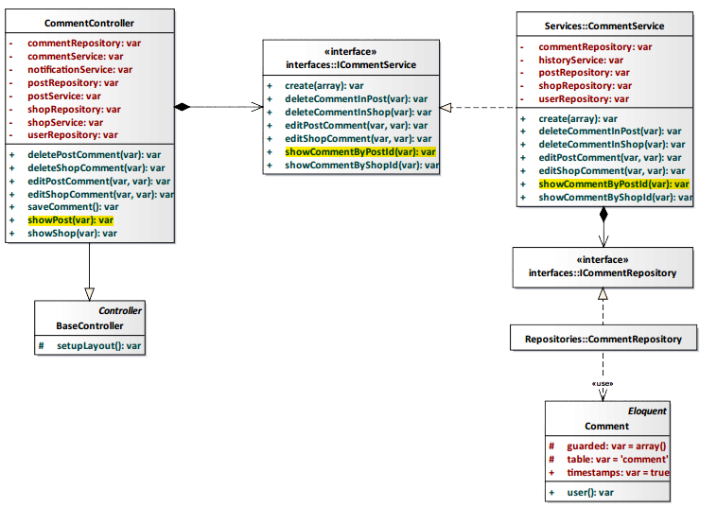

*Figure 4-70: View Post’s comment Class Diagram*

###### Class Specification

CommentController class

Physical Address: Trendy-Server\app\controllers*\CommentController.php*

Attribute

|  |  |  |  |
| --- | --- | --- | --- |
| No | Name | Type | Description |
| 1 | commentRepository | var | Instance of interface using to call methods in ICommentRepository. |
| 2 | commentService | var | Instance of interface using to call methods in ICommentService. |
| 3 | notificationService | var | Instance of interface using to call methods in INotificationService. |
| 4 | postRepository | var | Instance of interface using to call methods in IPostRepository. |
| 5 | postService | var | Instance of interface using to call methods in IPostService. |
| 6 | shopRepository | var | Instance of interface using to call methods in IShopRepository. |
| 7 | shopService | var | Instance of interface using to call methods in IShopService. |
| 8 | userRepository | var | Instance of interface using to call methods in IUserRepostiory. |

Method: showPost(var $id)

|  |  |  |  |  |
| --- | --- | --- | --- | --- |
| Purpose | Display all post’s comment to client. | | | |
| Return | **Type** | | | **Description** |
| var | | | Return post’s comment. |
| Parameter | **No** | **Name** | **Type** | **Description** |
| 1 | id | var | id of the post that want to view post’s comment. |

CommentService class

Physical Address: Trendy-Server\app\Services*CommentService.php*

Attribute

|  |  |  |  |
| --- | --- | --- | --- |
| No | Name | Type | Description |
| 1 | commentRepository | var | Instance of interface using to call methods in ICommentRepository. |
| 2 | historyService | var | Instance of interface using to call methods in IHistoryService. |
| 3 | postRepository | var | Instance of interface using to call methods in IPostRepository. |
| 4 | shopRepository | var | Instance of interface using to call methods in IShopRepository. |
| 5 | userRepository | var | Instance of interface using to call methods in IUserRepository. |

Method: showCommentByPostId(var $id)

|  |  |  |  |  |
| --- | --- | --- | --- | --- |
| Purpose | Process to show all comments of a post. | | | |
| Return | **Type** | | | **Description** |
| var | | | Return post’s comment. |
| Parameter | **No** | **Name** | **Type** | **Description** |
| 1 | id | var | id of the post that want to view post’s comment. |

###### Sequence Diagram

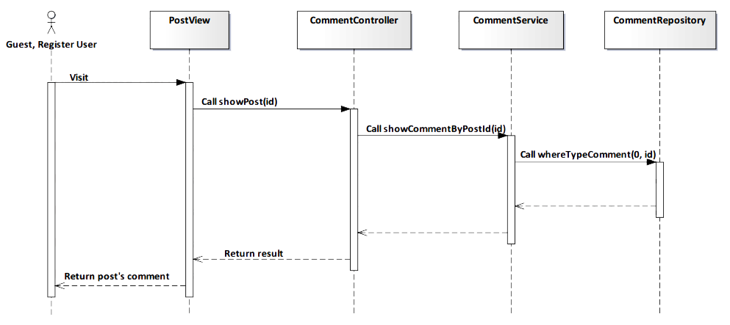

*Figure 4-71: View Post’s comment Sequence Diagram*

###### Screen Design

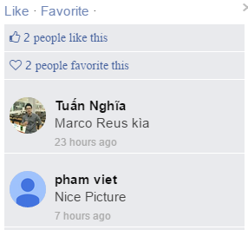

*Figure 4-72: View Post’s comment Screen*

##### 4.3.4.2.7. Add Shop’s comment

###### Description

* Actor writes content that they want comment to a shop.

###### Class Diagram

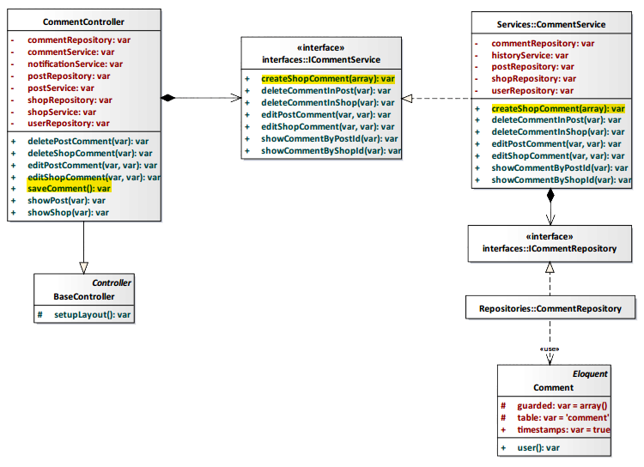

*Figure 4-73: Add Shop’s comment Class Diagram*

###### Class Specification

CommentController class

Physical Address: Trendy-Server\app\controllers*CommentController.php*

Attribute

|  |  |  |  |
| --- | --- | --- | --- |
| No | Name | Type | Description |
| 1 | commentRepository | var | Instance of interface using to call methods in ICommentRepository. |
| 2 | commentService | var | Instance of interface using to call methods in ICommentService. |
| 3 | notificationService | var | Instance of interface using to call methods in INotificationService. |
| 4 | postRepository | var | Instance of interface using to call methods in IPostRepository. |
| 5 | postService | var | Instance of interface using to call methods in IPostService. |
| 6 | shopRepository | var | Instance of interface using to call methods in IShopRepository. |
| 7 | shopService | var | Instance of interface using to call methods in IShopService. |
| 8 | userRepository | var | Instance of interface using to call methods in IUserRepostiory. |

Method: saveComment()

|  |  |  |
| --- | --- | --- |
| Purpose | Save content that actor comment to database. | |
| Return | **Type** | **Description** |
| var | Save content when actor comments to shop. |

CommentService class

Physical Address: Trendy-Server\app\Services*CommentService.php*

Attribute

|  |  |  |  |
| --- | --- | --- | --- |
| No | Name | Type | Description |
| 1 | commentRepository | var | Instance of interface using to call methods in ICommentRepository. |
| 2 | historyService | var | Instance of interface using to call methods in IHistoryService. |
| 3 | postRepository | var | Instance of interface using to call methods in IPostRepository. |
| 4 | shopRepository | var | Instance of interface using to call methods in IShopRepository. |
| 5 | userRepository | var | Instance of interface using to call methods in IUserRepository. |

Method: createShopComment(array $data)

|  |  |  |  |  |
| --- | --- | --- | --- | --- |
| Purpose | Save content that actor comments to database. | | | |
| Return | **Type** | | | **Description** |
| var | | | Save content when actor comments to shop. |
| Parameter | **No** | **Name** | **Type** | **Description** |
| 1 | data | array | Array contains content of comment will be saved to database. |

###### Sequence Diagram

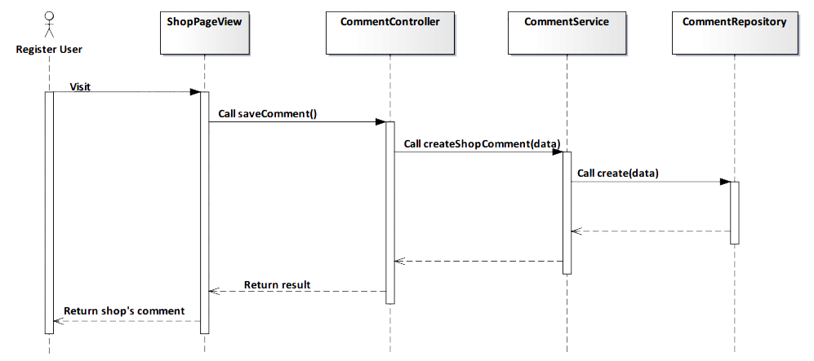

*Figure 4-74: Add Shop’s comment Sequence Diagram*

###### Screen Design



*Figure 4-75: Add Shop’s comment Screen*

|  |  |  |
| --- | --- | --- |
| **Element** | **Type** | **Description** |
| **Write your message** | Input text | Text field for entering comment. |

##### 4.3.4.2.8. Edit Shop’s comment

###### Description

* Actor edits content that they commented to a shop.

###### Class Diagram

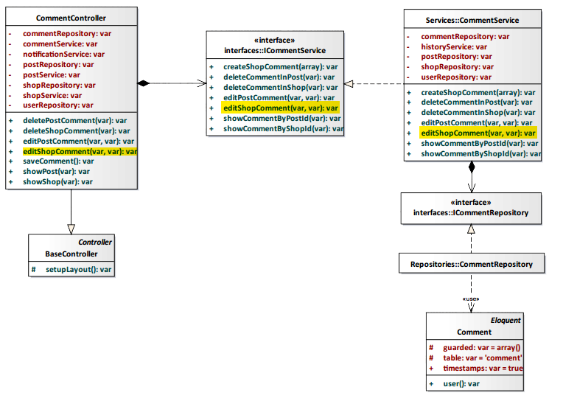

*Figure 4-76: Edit Shop’s comment Class Diagram*

###### Class Specification

CommentController class

Physical Address: Trendy-Server\app\controllers*CommentController.php*

Attribute

|  |  |  |  |
| --- | --- | --- | --- |
| No | Name | Type | Description |
| 1 | commentRepository | var | Instance of interface using to call methods in ICommentRepository. |
| 2 | commentService | var | Instance of interface using to call methods in ICommentService. |
| 3 | notificationService | var | Instance of interface using to call methods in INotificationService. |
| 4 | postRepository | var | Instance of interface using to call methods in IPostRepository. |
| 5 | postService | var | Instance of interface using to call methods in IPostService. |
| 6 | shopRepository | var | Instance of interface using to call methods in IShopRepository. |
| 7 | shopService | var | Instance of interface using to call methods in IShopService. |
| 8 | userRepository | var | Instance of interface using to call methods in IUserRepostiory. |

Method: editShopComment(var $id, var $content)

|  |  |  |  |  |
| --- | --- | --- | --- | --- |
| Purpose | Process to edit comment of a shop. | | | |
| Return | **Type** | | | **Description** |
| var | | | Edit comment when actor want edit content that they commented in shop. |
| Parameter | **No** | **Name** | **Type** | **Description** |
| 1 | id | var | id of comment will be edited. |
| 2 | content | var | Content of comment after editing will be saved to database. |

CommentService class

Physical Address: Trendy-Server\app\Services*CommentService.php*

Attribute

|  |  |  |  |
| --- | --- | --- | --- |
| No | Name | Type | Description |
| 1 | commentRepository | var | Instance of interface using to call methods in ICommentRepository. |
| 2 | historyService | var | Instance of interface using to call methods in IHistoryService. |
| 3 | postRepository | var | Instance of interface using to call methods in IPostRepository. |
| 4 | shopRepository | var | Instance of interface using to call methods in IShopRepository. |
| 5 | userRepository | var | Instance of interface using to call methods in IUserRepository. |

Method: editShopComment(var $id, var $content)

|  |  |  |  |  |
| --- | --- | --- | --- | --- |
| Purpose | Process to edit comment of a shop. | | | |
| Return | **Type** | | | **Description** |
| var | | | Edit comment when actor want edit content that they commented in shop. |
| Parameter | **No** | **Name** | **Type** | **Description** |
| 1 | id | var | id of comment will be edited. |
| 2 | content | var | Content of comment after editing will be saved to database. |

###### Sequence Diagram

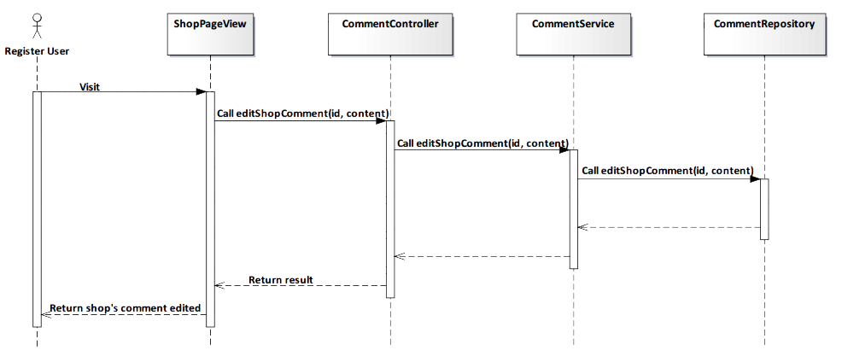

*Figure 4-77: Edit Shop’s comment Sequence Diagram*

###### Screen Design

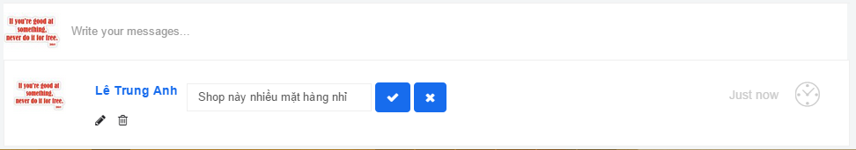

*Figure 4-78: Edit Shop’s comment Screen*

##### 4.3.4.2.9. Delete Shop’s comment

###### Description

* Actor deletes comment that they commented to a shop.

###### Class Diagram

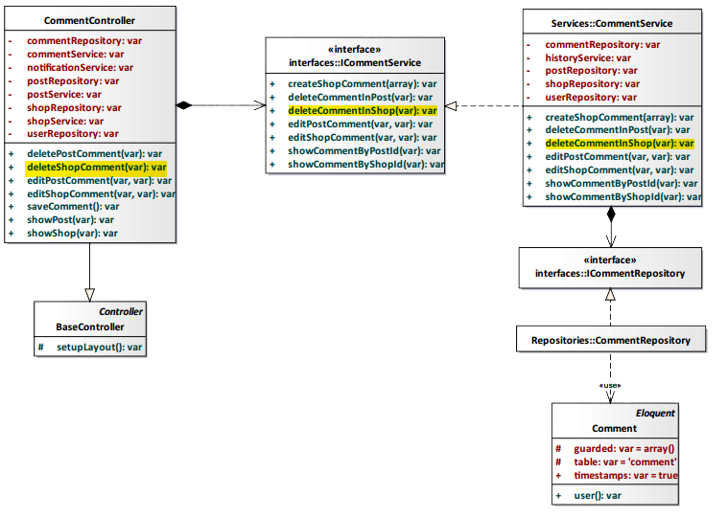

*Figure 4-79: Delete Shop’s comment Class Diagram*

###### Class Specification

CommentController class

Physical Address: Trendy-Server\app\controllers*CommentController.php*

Attribute

|  |  |  |  |
| --- | --- | --- | --- |
| No | Name | Type | Description |
| 1 | commentRepository | var | Instance of interface using to call methods in ICommentRepository. |
| 2 | commentService | var | Instance of interface using to call methods in ICommentService. |
| 3 | notificationService | var | Instance of interface using to call methods in INotificationService. |
| 4 | postRepository | var | Instance of interface using to call methods in IPostRepository. |
| 5 | postService | var | Instance of interface using to call methods in IPostService. |
| 6 | shopRepository | var | Instance of interface using to call methods in IShopRepository. |
| 7 | shopService | var | Instance of interface using to call methods in IShopService. |
| 8 | userRepository | var | Instance of interface using to call methods in IUserRepostiory. |

Method: deleteShopComment(var $id)

|  |  |  |  |  |
| --- | --- | --- | --- | --- |
| Purpose | Process to delete comment of a shop. | | | |
| Return | **Type** | | | **Description** |
| var | | | Delelete comment when actor want delete content that they commented in shop. |
| Parameter | **No** | **Name** | **Type** | **Description** |
| 1 | id | var | id of comment will be deleted. |

CommentService class

Physical Address: Trendy-Server\app\Services*CommentService.php*

Attribute

|  |  |  |  |
| --- | --- | --- | --- |
| No | Name | Type | Description |
| 1 | commentRepository | var | Instance of interface using to call methods in ICommentRepository. |
| 2 | historyService | var | Instance of interface using to call methods in IHistoryService. |
| 3 | postRepository | var | Instance of interface using to call methods in IPostRepository. |
| 4 | shopRepository | var | Instance of interface using to call methods in IShopRepository. |
| 5 | userRepository | var | Instance of interface using to call methods in IUserRepository. |

Method: deleteCommentInShop(var $id)

|  |  |  |  |  |
| --- | --- | --- | --- | --- |
| Purpose | Process to delete comment of a shop. | | | |
| Return | **Type** | | | **Description** |
| var | | | Delelete comment when actor want delete content that they commented in shop. |
| Parameter | **No** | **Name** | **Type** | **Description** |
| 1 | id | var | id of comment will be deleted. |

###### Sequence Diagram

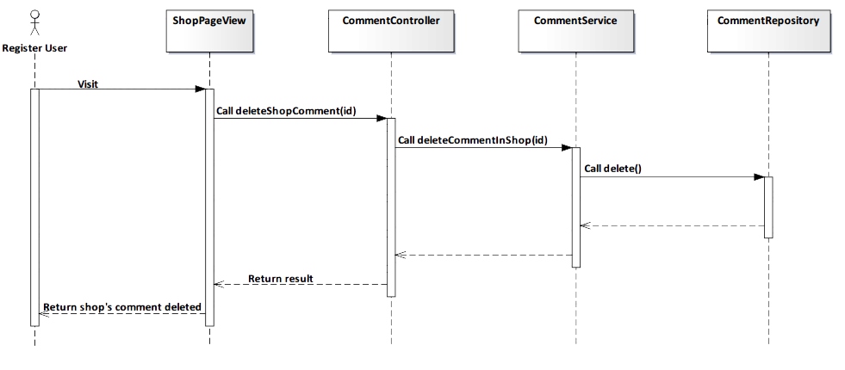

*Figure 4-80: Delete Shop’s comment Sequence Diagram*

###### Screen Design



*Figure 4-81: Delete Shop’s comment Screen*

|  |  |  |
| --- | --- | --- |
| **Element** | **Type** | **Description** |
| **No** | Button | Click to undelete comment. |
| **Yes** | Button | Click to delete comment. |

##### 4.3.4.2.10. View Shop’s comment

###### Description

* Actor views all comments of a shop.

Class Diagram

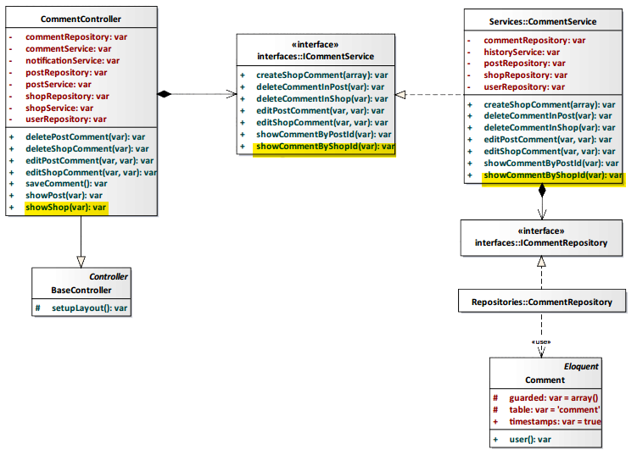

*Figure 4-82: View Shop’s comment Class Diagram*

###### Class Specification

CommentController class

Physical Address: Trendy-Server\app\controllers*CommentController.php*

Attribute

|  |  |  |  |
| --- | --- | --- | --- |
| No | Name | Type | Description |
| 1 | commentRepository | var | Instance of interface using to call methods in ICommentRepository. |
| 2 | commentService | var | Instance of interface using to call methods in ICommentService. |
| 3 | notificationService | var | Instance of interface using to call methods in INotificationService. |
| 4 | postRepository | var | Instance of interface using to call methods in IPostRepository. |
| 5 | postService | var | Instance of interface using to call methods in IPostService. |
| 6 | shopRepository | var | Instance of interface using to call methods in IShopRepository. |
| 7 | shopService | var | Instance of interface using to call methods in IShopService. |
| 8 | userRepository | var | Instance of interface using to call methods in IUserRepostiory. |

Method: showShop(var $id)

|  |  |  |  |  |
| --- | --- | --- | --- | --- |
| Purpose | Display all shop’s comment to client. | | | |
| Return | **Type** | | | **Description** |
| var | | | Return shop’s comment. |
| Parameter | **No** | **Name** | **Type** | **Description** |
| 1 | id | var | id of the shop that want to view shop’s comment. |

CommentService class

Physical Address: Trendy-Server\app\Services*CommentService.php*

Attribute

|  |  |  |  |
| --- | --- | --- | --- |
| No | Name | Type | Description |
| 1 | commentRepository | var | Instance of interface using to call methods in ICommentRepository. |
| 2 | historyService | var | Instance of interface using to call methods in IHistoryService. |
| 3 | postRepository | var | Instance of interface using to call methods in IPostRepository. |
| 4 | shopRepository | var | Instance of interface using to call methods in IShopRepository. |
| 5 | userRepository | var | Instance of interface using to call methods in IUserRepository. |

Method: showCommentByShopId(var $id)

|  |  |  |  |  |
| --- | --- | --- | --- | --- |
| Purpose | Process to show all comments of a shop. | | | |
| Return | **Type** | | | **Description** |
| var | | | Return shop’s comment. |
| Parameter | **No** | **Name** | **Type** | **Description** |
| 1 | id | var | id of the post that want to view shop’s comment. |

###### Sequence Diagram

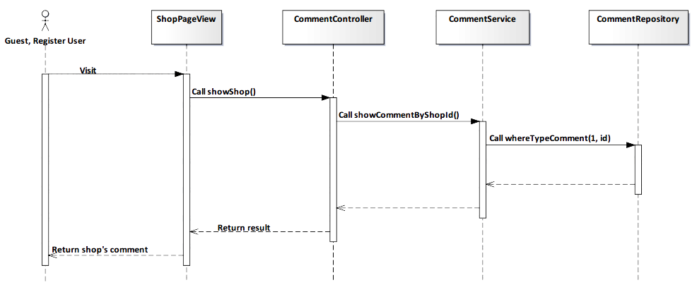

*Figure 4-83: View Shop’s comment Sequence Diagram*

###### Screen Design

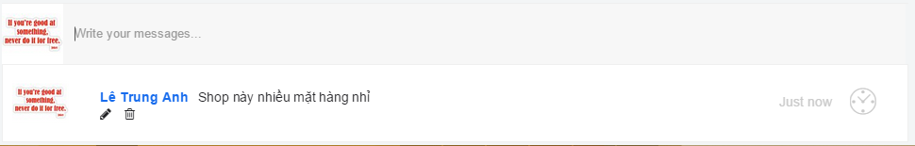

*Figure 4-84: View Shop’s comment Screen*

|  |  |  |
| --- | --- | --- |
| **Element** | **Type** | **Description** |
| **Edit** | Button | Click to edit comment. |
| **Delete** | Button | Click to delete comment. |

##### 4.3.4.2.11. Add Post

###### Description

* Actor adds a post to TrendyPlus.

###### Class Diagram

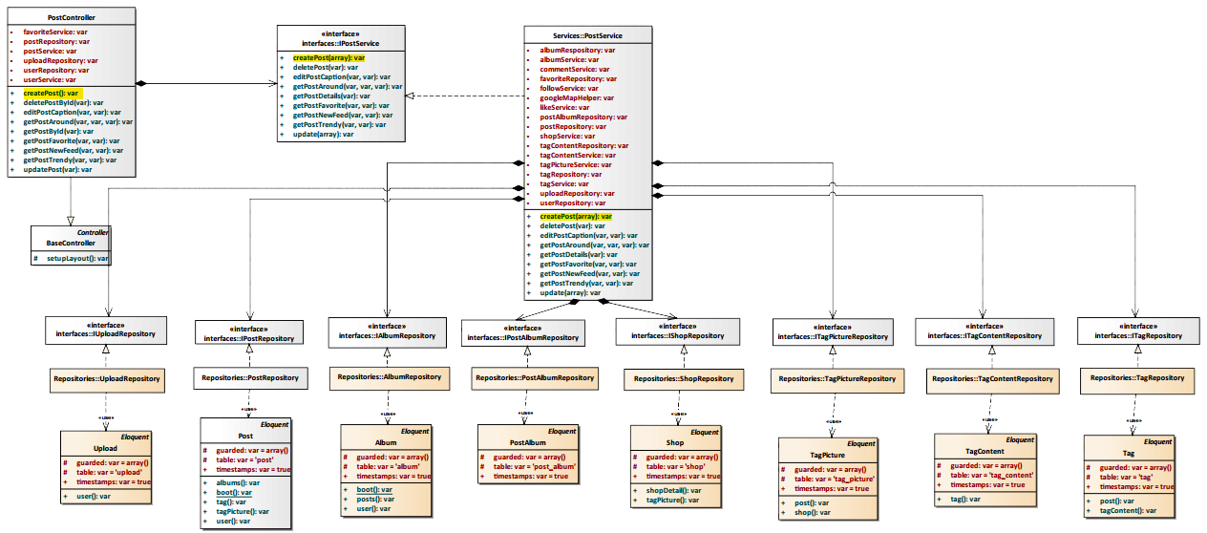

*Figure 4-85: Add Post Class Diagram*

###### Class Specification

PostController class

Physical Address: Trendy-Server\app\controllers*PostController.php*

Attribute

|  |  |  |  |
| --- | --- | --- | --- |
| No | Name | Type | Description |
| 1 | favoriteService | var | Instance of interface using to call methods in IFavoriteService. |
| 2 | postRepository | var | Instance of interface using to call methods in IPostRepository. |
| 3 | postService | var | Instance of interface using to call methods in IPostService. |
| 4 | uploadRepository | var | Instance of interface using to call methods in IUploadRepostiory. |
| 5 | userRepository | var | Instance of interface using to call methods in IUserRepostiory. |
| 6 | userService | var | Instance of interface using to call methods in IUserService. |

Method: createPost()

|  |  |  |
| --- | --- | --- |
| Purpose | Process to create post will be display to TrendyPlus. | |
| Return | **Type** | **Description** |
| var | Post after creating will be display to TrendyPlus. |

PostService class

Physical Address: Trendy-Server\app\Services*PostService.php*

Attribute

|  |  |  |  |
| --- | --- | --- | --- |
| No | Name | Type | Description |
| 1 | albumRepository | var | Instance of interface using to call methods in IAlbumRepository. |
| 2 | albumService | var | Instance of interface using to call methods in IAlbumService. |
| 3 | commentService | var | Instance of interface using to call methods in ICommentService. |
| 4 | favoriteRepository | var | Instance of interface using to call methods in IFavoriteRepository. |
| 5 | followService | var | Instance of interface using to call methods in IFollowSerivce. |
| 6 | googleMapHelper | var | Instance of interface using to call methods in IGoogleMapHelper. |
| 7 | likeService | var | Instance of interface using to call methods in ILikeSerivce. |
| 8 | postAlbumRepository | var | Instance of interface using to call methods in IAlbumRepository. |
| 9 | postRepository | var | Instance of interface using to call methods in IPostRepository. |
| 10 | shopService | var | Instance of interface using to call methods in IShopSerivce. |
| 11 | tagContentRepository | var | Instance of interface using to call methods in ITagContentRepository. |
| 12 | tagContentService | var | Instance of interface using to call methods in ITagContentSerivce. |
| 13 | tagPictureService | var | Instance of interface using to call methods in ITagPictureSerivce. |
| 14 | tagRepository | var | Instance of interface using to call methods in ITagRepository. |
| 15 | tagService | var | Instance of interface using to call methods in ITagSerivce. |
| 16 | uploadRepository | var | Instance of interface using to call methods in IUploadRepository. |
| 17 | userRepository | var | Instance of interface using to call methods in IUserRepository. |

Method: createPost(array $data)

|  |  |  |  |  |
| --- | --- | --- | --- | --- |
| Purpose | Process to create post will be display to TrendyPlus. | | | |
| Return | **Type** | | | **Description** |
| var | | | Post after creating will be display to TrendyPlus. |
| Parameter | **No** | **Name** | **Type** | **Description** |
| 1 | data | array | Array contains content of post will be saved to database. |

###### Sequence Diagram

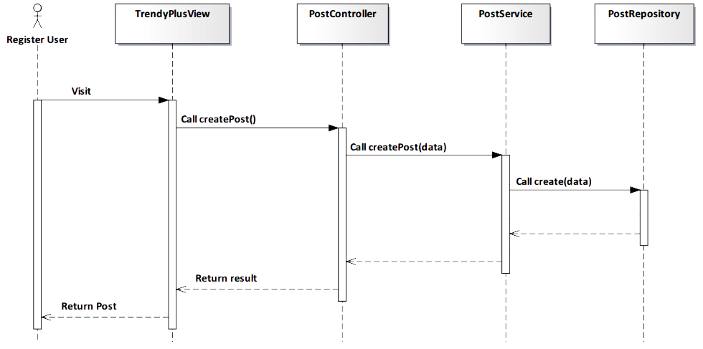

*Figure 4-86: Add Post Sequence Diagram*

###### Screen Design

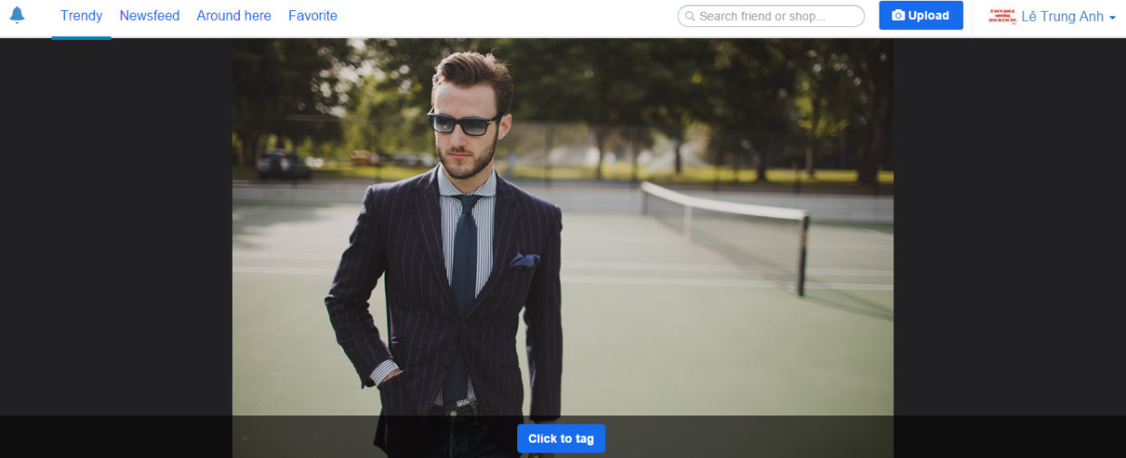

*Figure 4-87: Add Post Screen*

|  |  |  |
| --- | --- | --- |
| **Element** | **Type** | **Description** |
| **Click to tag** | Button | Click to tag product on image. |

##### 4.3.4.2.12. Editor Image

###### Description

* Actor edits image that they want post to TrendyPlus.

###### Class Diagram

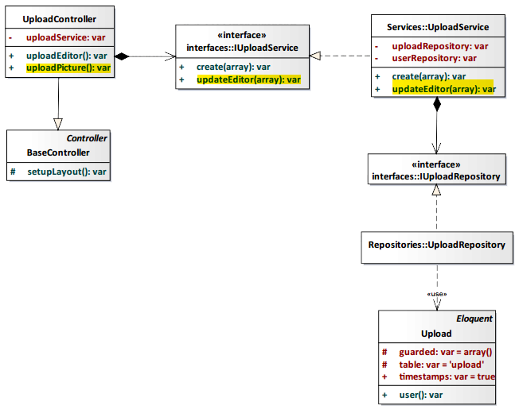

*Figure 4-88: Editor Image Class Diagram*

###### Class Specification

UploadController class

Physical Address: Trendy-Server\app\controllers*UploadController.php*

Attribute

|  |  |  |  |
| --- | --- | --- | --- |
| No | Name | Type | Description |
| 1 | uploadService | var | Instance of interface using to call methods in IUploadService. |

Method: uploadEditor()

|  |  |  |
| --- | --- | --- |
| Purpose | Process to edit image that displayed to TrendyPlus. | |
| Return | **Type** | **Description** |
| var | Image after editing will be move to create post page. |

UploadService class

Physical Address: Trendy-Server\app\Services*UploadService.php*

Attribute

|  |  |  |  |
| --- | --- | --- | --- |
| No | Name | Type | Description |
| 1 | uploadRepository | var | Instance of interface using to call methods in IUploadRepository. |
| 2 | userRepository | var | Instance of interface using to call methods in IUserRepository. |

Method: updateEditor(array $data)

|  |  |  |  |  |
| --- | --- | --- | --- | --- |
| Purpose | Process to create post will be display to TrendyPlus. | | | |
| Return | **Type** | | | **Description** |
| var | | | Post after creating will be display to TrendyPlus. |
| Parameter | **No** | **Name** | **Type** | **Description** |
| 1 | data | array | Array contains content of image after editing will be saved to database. |

###### Sequence Diagram

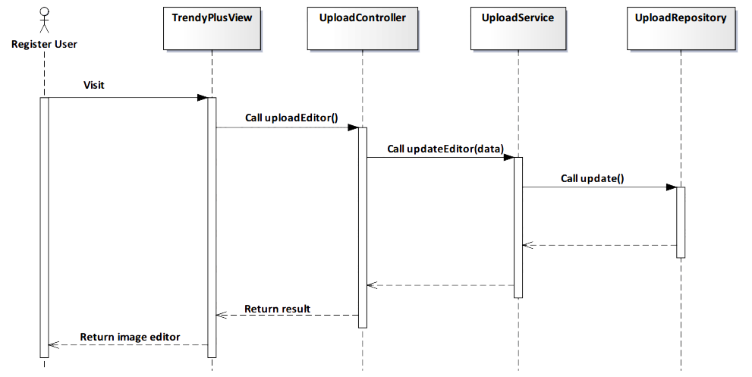

*Figure 4-89: Editor Image Sequence Diagram*

###### Screen Design

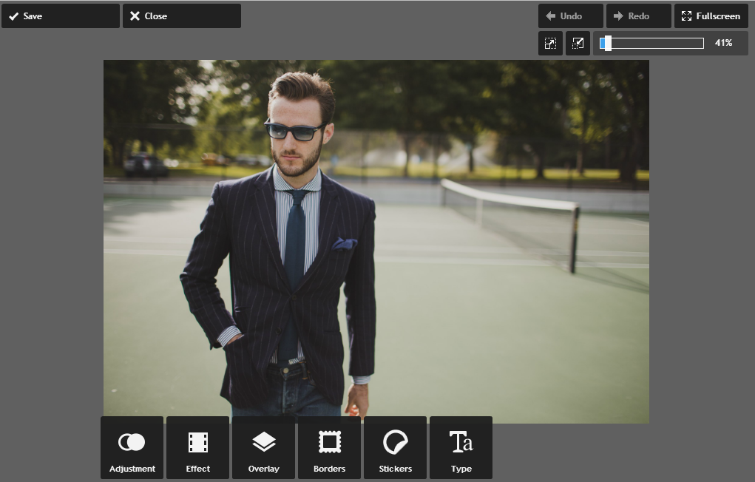

*Figure 4-90: Editor Image Screen*

|  |  |  |
| --- | --- | --- |
| **Element** | **Type** | **Description** |
| **Save** | Button | Click to save image after image edited. |
| **Close** | Button | Click to leave this page. |

##### 4.3.4.2.13. Image tagging

###### Description

* Actor tags image that they want post to TrendyPlus. Tag information will display *“Name”, “Price”, “Address”* of product in image.

###### Class Diagram

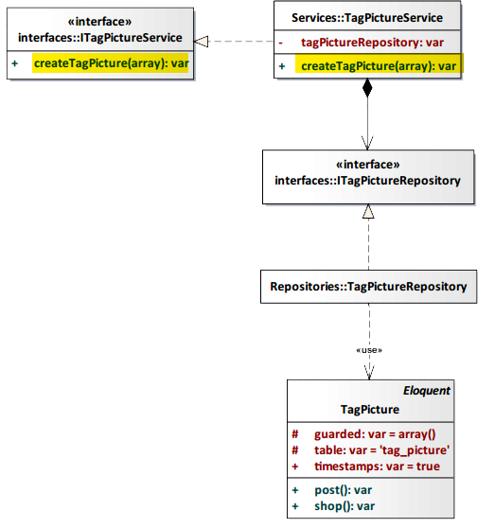

*Figure 4-91: Image Tagging Class Diagram*

###### Class Specification

TagPictureService class

Physical Address: Trendy-Server\app\Services*TagPictureService.php*

Attribute

|  |  |  |  |
| --- | --- | --- | --- |
| No | Name | Type | Description |
| 1 | tagPictureRepository | var | Instance of interface using to call methods in ITagPictureRepository. |

Method: createTagPicture(array $data)

|  |  |  |  |  |
| --- | --- | --- | --- | --- |
| Purpose | Process to create tag picture that displayed in post. | | | |
| Return | **Type** | | | **Description** |
| var | | | Image after tagging will be displayed in post on TrendyPlus. |
| Parameter | **No** | **Name** | **Type** | **Description** |
| 1 | data | array | Array contains content of image after tagging will be saved to database. |

###### Sequence Diagram

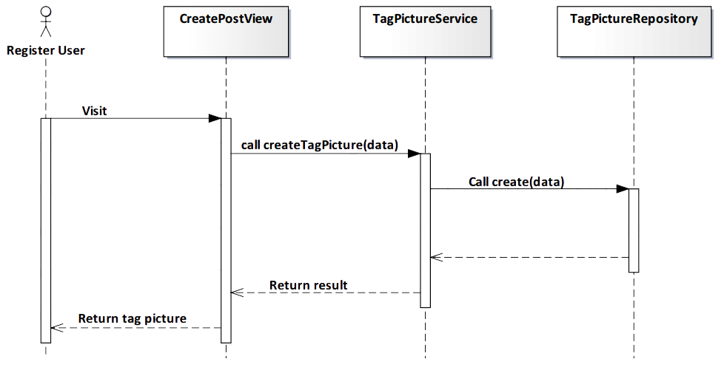

*Figure 4-92: Image Tagging Sequence Diagram*

###### Screen Design

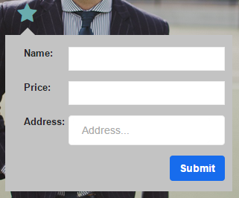

*Figure 4-93: Image Tagging Screen*

|  |  |  |
| --- | --- | --- |
| **Element** | **Type** | **Description** |
| **Name** | Input text | Text field for entering name of product. |
| **Price** | Input text | Text field for entering price of product. |
| **Address** | Input text | Text field for entering address of product. |
| **Submit** | Button | Click to submit. |

##### 4.3.4.2.14. Content tagging

###### Description

* Actor uses this function to classify product in image that they post.

###### Class Diagram

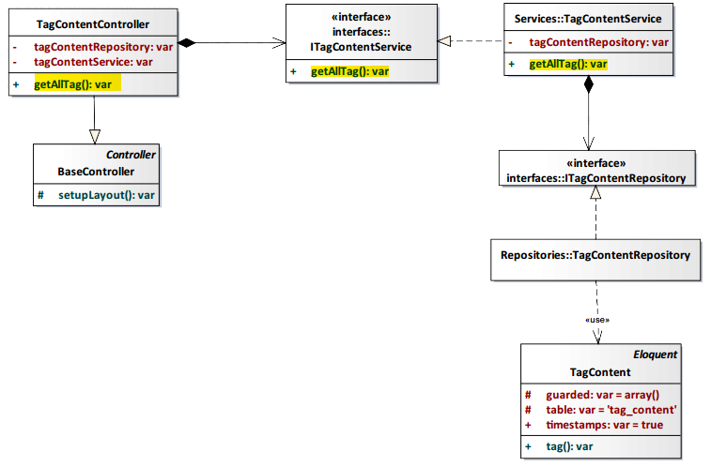

*Figure 4-94: Content Tagging Class Diagram*

###### Class Specification

TagContentController class

Physical Address: Trendy-Server\app\controllers*TagContentController.php*

Attribute

|  |  |  |  |
| --- | --- | --- | --- |
| No | Name | Type | Description |
| 1 | tagContentRepository | var | Instance of interface using to call methods in ITagContentRepository. |
| 2 | tagContentService | var | Instance of interface using to call methods in ITagContentRepository. |

Method: getAllTag()

|  |  |  |
| --- | --- | --- |
| Purpose | Get all tag content of system for actor chooses. | |
| Return | **Type** | **Description** |
| var | Content of tag after choosing will be displayed on post. |

TagContentService class

Physical Address: Trendy-Server\app\Services*TagContentService.php*

Attribute

|  |  |  |  |
| --- | --- | --- | --- |
| No | Name | Type | Description |
| 1 | tagContentRepository | var | Instance of interface using to call methods in ITagContentRepository. |

Method: getAllTag()

|  |  |  |
| --- | --- | --- |
| Purpose | Get all tag content of system for actor chooses. | |
| Return | **Type** | **Description** |
| var | Content of tag after choosing will be displayed on post. |

###### Sequence Diagram

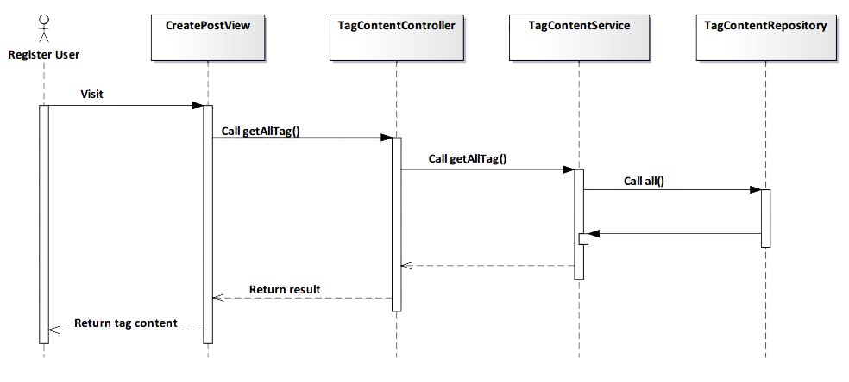

*Figure 4-95: Content Tagging Sequence Diagram*

###### Screen Design

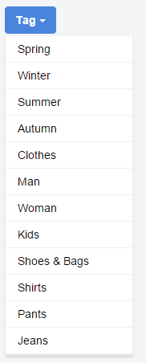

*Figure 4-96: Content Tagging Screen*

|  |  |  |
| --- | --- | --- |
| **Element** | **Type** | **Description** |
| **Tag** | Button | Click to show all list tag order by content. |

##### 4.3.4.2.15. Delete Post

###### Description

* Actor deletes a post that they shared.

###### Class Diagram

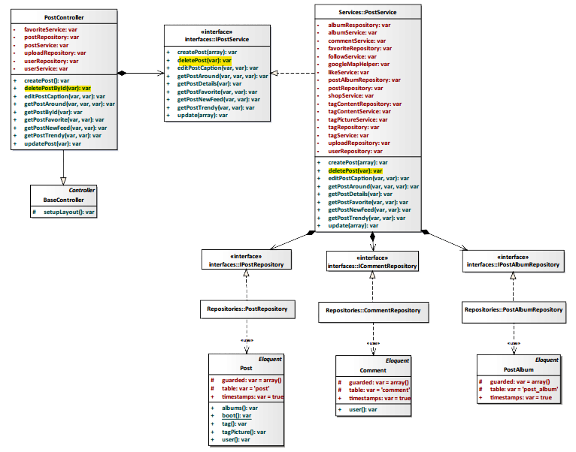

*Figure 4-97: Delete Post Class Diagram*

###### Class Specification

PostController class

Physical Address: Trendy-Server\app\controllers*PostController.php*

Attribute

|  |  |  |  |
| --- | --- | --- | --- |
| No | Name | Type | Description |
| 1 | favoriteService | var | Instance of interface using to call methods in IFavoriteService. |
| 2 | postRepository | var | Instance of interface using to call methods in IPostRepository. |
| 3 | postService | var | Instance of interface using to call methods in IPostService. |
| 4 | uploadRepository | var | Instance of interface using to call methods in IUploadRepostiory. |
| 5 | userRepository | var | Instance of interface using to call methods in IUserRepostiory. |
| 6 | userService | var | Instance of interface using to call methods in IUserService. |

Method: deletePostById(var $id)

|  |  |  |  |  |
| --- | --- | --- | --- | --- |
| Purpose | Delete post to client. | | | |
| Return | **Type** | | | **Description** |
| var | | | Post deleted will will no longer exist. |
| Parameter | **No** | **Name** | **Type** | **Description** |
| 1 | id | var | id of the post that want to delete post. |

PostService class

Physical Address: Trendy-Server\app\Services*PostService.php*

Attribute

|  |  |  |  |
| --- | --- | --- | --- |
| No | Name | Type | Description |
| 1 | albumRepository | var | Instance of interface using to call methods in IAlbumRepository. |
| 2 | albumService | var | Instance of interface using to call methods in IAlbumService. |
| 3 | commentService | var | Instance of interface using to call methods in ICommentService. |
| 4 | favoriteRepository | var | Instance of interface using to call methods in IFavoriteRepository. |
| 5 | followService | var | Instance of interface using to call methods in IFollowSerivce. |
| 6 | googleMapHelper | var | Instance of interface using to call methods in IGoogleMapHelper. |
| 7 | likeService | var | Instance of interface using to call methods in ILikeSerivce. |
| 8 | postAlbumRepository | var | Instance of interface using to call methods in IAlbumRepository. |
| 9 | postRepository | var | Instance of interface using to call methods in IPostRepository. |
| 10 | shopService | var | Instance of interface using to call methods in IShopSerivce. |
| 11 | tagContentRepository | var | Instance of interface using to call methods in ITagContentRepository. |
| 12 | tagContentService | var | Instance of interface using to call methods in ITagContentSerivce. |
| 13 | tagPictureService | var | Instance of interface using to call methods in ITagPictureSerivce. |
| 14 | tagRepository | var | Instance of interface using to call methods in ITagRepository. |
| 15 | tagService | var | Instance of interface using to call methods in ITagSerivce. |
| 16 | uploadRepository | var | Instance of interface using to call methods in IUploadRepository. |
| 17 | userRepository | var | Instance of interface using to call methods in IUserRepository. |

Method: deletePost(var $id)

|  |  |  |  |  |
| --- | --- | --- | --- | --- |
| Purpose | Process to delete post on TrendyPlus. | | | |
| Return | **Type** | | | **Description** |
| var | | | Post deleted will will no longer exist. |
| Parameter | **No** | **Name** | **Type** | **Description** |
| 1 | id | var | id of the post that want to delete post. |

###### Sequence Diagram

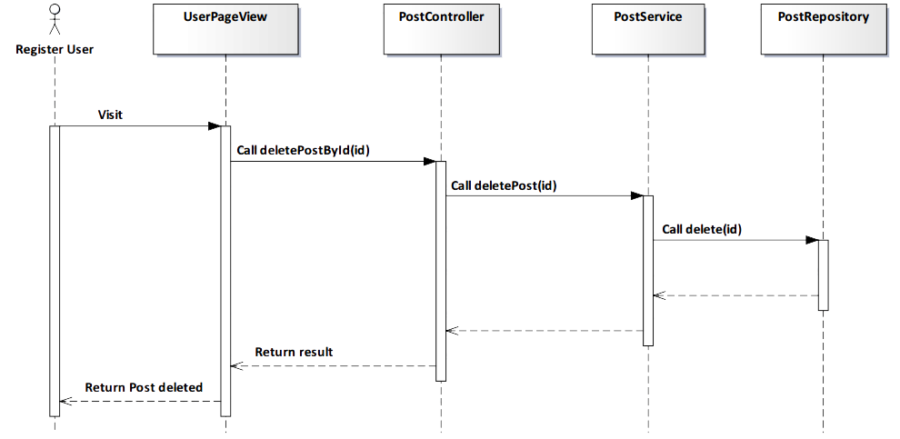

*Figure 4-98: Delete Post Sequence Diagram*

###### Screen Design

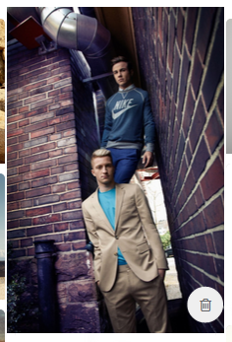

*Figure 4-99: Delete Post Screen*

|  |  |  |
| --- | --- | --- |
| **Element** | **Type** | **Description** |
| **Delelte** | Button | Click to delete post. |

##### 4.3.4.2.16. Edit Post

###### Description

* Actor edits a post that they shared.

###### Class Diagram

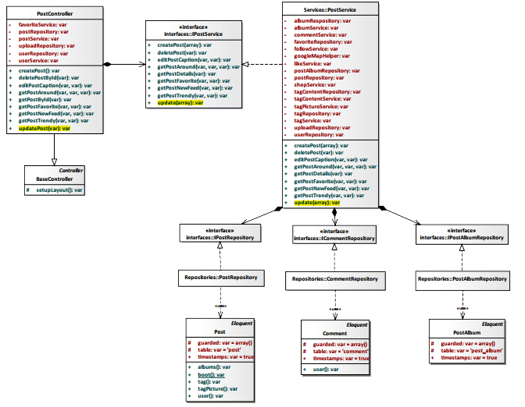

*Figure 4-100: Edit Post Class Diagram*

###### Class Specification

PostController class

Physical Address: Trendy-Server\app\controllers*PostController.php*

Attribute

|  |  |  |  |
| --- | --- | --- | --- |
| No | Name | Type | Description |
| 1 | favoriteService | var | Instance of interface using to call methods in IFavoriteService. |
| 2 | postRepository | var | Instance of interface using to call methods in IPostRepository. |
| 3 | postService | var | Instance of interface using to call methods in IPostService. |
| 4 | uploadRepository | var | Instance of interface using to call methods in IUploadRepostiory. |
| 5 | userRepository | var | Instance of interface using to call methods in IUserRepostiory. |
| 6 | userService | var | Instance of interface using to call methods in IUserService. |

Method: updatePost(var $id)

|  |  |  |  |  |
| --- | --- | --- | --- | --- |
| Purpose | Display all informations of post after editing to client. | | | |
| Return | **Type** | | | **Description** |
| var | | | Return post’s new information. |
| Parameter | **No** | **Name** | **Type** | **Description** |
| 1 | id | var | id of the post that want to edit post. |

PostService class

Physical Address: Trendy-Server\app\Services*PostService.php*

Attribute

|  |  |  |  |
| --- | --- | --- | --- |
| No | Name | Type | Description |
| 1 | albumRepository | var | Instance of interface using to call methods in IAlbumRepository. |
| 2 | albumService | var | Instance of interface using to call methods in IAlbumService. |
| 3 | commentService | var | Instance of interface using to call methods in ICommentService. |
| 4 | favoriteRepository | var | Instance of interface using to call methods in IFavoriteRepository. |
| 5 | followService | var | Instance of interface using to call methods in IFollowSerivce. |
| 6 | googleMapHelper | var | Instance of interface using to call methods in IGoogleMapHelper. |
| 7 | likeService | var | Instance of interface using to call methods in ILikeSerivce. |
| 8 | postAlbumRepository | var | Instance of interface using to call methods in IAlbumRepository. |
| 9 | postRepository | var | Instance of interface using to call methods in IPostRepository. |
| 10 | shopService | var | Instance of interface using to call methods in IShopSerivce. |
| 11 | tagContentRepository | var | Instance of interface using to call methods in ITagContentRepository. |
| 12 | tagContentService | var | Instance of interface using to call methods in ITagContentSerivce. |
| 13 | tagPictureService | var | Instance of interface using to call methods in ITagPictureSerivce. |
| 14 | tagRepository | var | Instance of interface using to call methods in ITagRepository. |
| 15 | tagService | var | Instance of interface using to call methods in ITagSerivce. |
| 16 | uploadRepository | var | Instance of interface using to call methods in IUploadRepository. |
| 17 | userRepository | var | Instance of interface using to call methods in IUserRepository. |

Method: updatePost(array $**data**)

|  |  |  |  |  |
| --- | --- | --- | --- | --- |
| Purpose | Process to edit information of a post. | | | |
| Return | **Type** | | | **Description** |
| var | | | Return post’s new information. |
| Parameter | **No** | **Name** | **Type** | **Description** |
| 1 | id | var | id of the post that want to edit post. |

###### Sequence Diagram

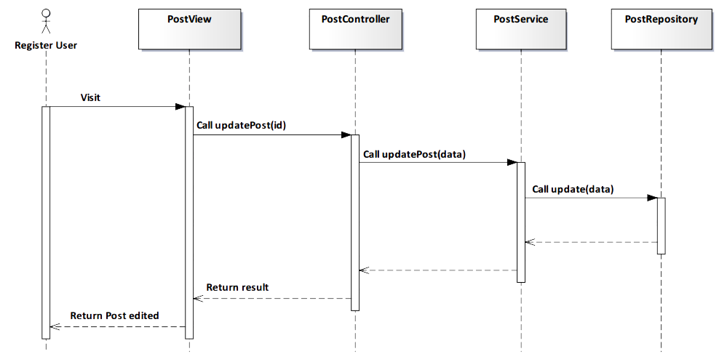

*Figure 4-101: Edit Post Squence Diagram*

###### Screen Design

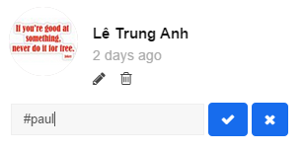

*Figure 4-102: Edit Post Screen*

|  |  |  |
| --- | --- | --- |
| **Element** | **Type** | **Description** |
| **Edit** | Button | Click to edit post’s caption. |
| **Delete** | Button | Click to delete post’s caption. |

##### 4.3.4.2.17. Like Post

###### Description

* Actor likes a post that they want on TrendyPlus.

###### Class Diagram

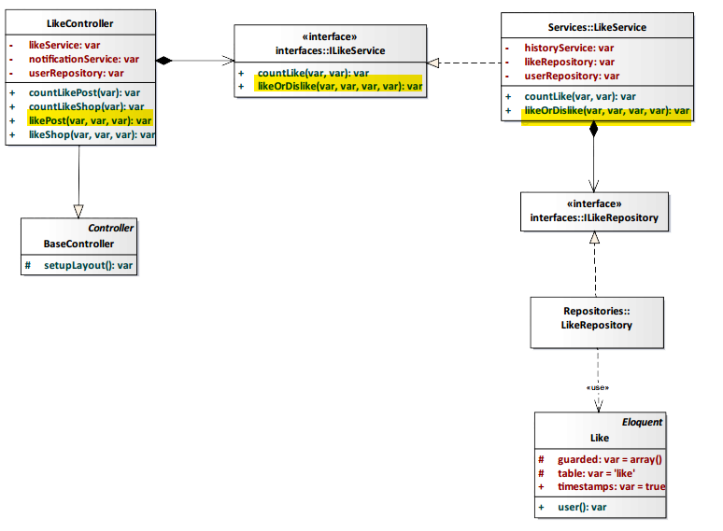

*Figure 4-103: Like Post Class Diagram*

###### Class Specification

LikeController class

Physical Address: Trendy-Server\app\controllers*LikeController.php*

Attribute

|  |  |  |  |
| --- | --- | --- | --- |
| No | Name | Type | Description |
| 1 | likeService | var | Instance of interface using to call methods in ILikeService. |
| 2 | notificationService | var | Instance of interface using to call methods in INotificationService. |
| 3 | userRepository | var | Instance of interface using to call methods in IUserRepository. |

Method: likePost(var $id, var $type, var $user_id)

|  |  |  |  |  |
| --- | --- | --- | --- | --- |
| Purpose | Display post was liked to client. | | | |
| Return | **Type** | | | **Description** |
| var | | | Return status *“Liked”* of post. |
| Parameter | **No** | **Name** | **Type** | **Description** |
| 1 | id | var | id of the post that want to unlike. |
| 2 | type | var | type of action (in this case: like). |
| 3 | user_id | var | id of user liked post. |

LikeService class

Physical Address: Trendy-Server\app\Services*LikeService.php*

Attribute

|  |  |  |  |
| --- | --- | --- | --- |
| No | Name | Type | Description |
| 1 | tagPictureRepository | var | Instance of interface using to call methods in ITagPictureRepository. |
| 2 | historyService | var | Instance of interface using to call methods in IHistoryService. |
| 3 | likeRepository | var | Instance of interface using to call methods in ILikeRepository. |

Method: likeOrDislike (var $type_like, var $type_id, var $type, var $user_id)

|  |  |  |  |  |
| --- | --- | --- | --- | --- |
| Purpose | Process to show post was liked. | | | |
| Return | **Type** | | | **Description** |
| var | | | Return status *“Liked”* of post. |
| Parameter | **No** | **Name** | **Type** | **Description** |
| 1 | type_like | var | With post will have type like is *“0”*. With shop will have type like is *“1”.* |
| 2 | type_id | var | id of post. |
| 3 | type | var | type of action (in this case: like) |
| 4 | user_id | var | id of user liked post. |

###### Sequence Diagram

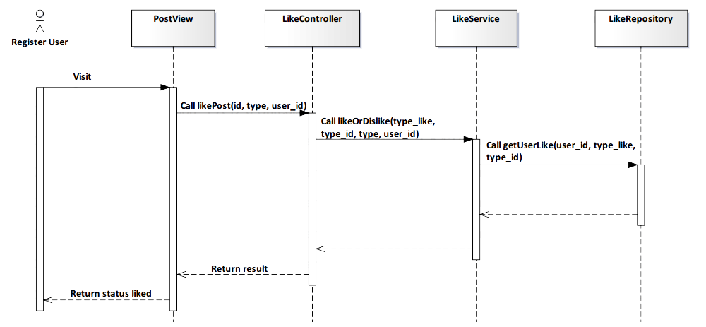

*Figure 4-104: Like Post Sequence Diagram*

###### Screen Design

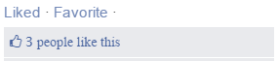

*Figure 4-105: Like Post Screen*

|  |  |  |
| --- | --- | --- |
| **Element** | **Type** | **Description** |
| **Liked** | Button | Click to unlike post. |
| **Favorite** | Button | Click to add favorite. |

##### 4.3.4.2.18. Unlike Post

###### Description

* Actor unlikes a post after they liked.

###### Class Diagram



*Figure 4-106: Unlike Post Class Diagram*

###### Class Specification

LikeController class

Physical Address: Trendy-Server\app\controllers*LikeController.php*

Attribute

|  |  |  |  |
| --- | --- | --- | --- |
| No | Name | Type | Description |
| 1 | likeService | var | Instance of interface using to call methods in ILikeService. |
| 2 | notificationService | var | Instance of interface using to call methods in INotificationService. |
| 3 | userRepository | var | Instance of interface using to call methods in IUserRepository. |

Method: likePost(var $id, var $type, var $user_id)

|  |  |  |  |  |
| --- | --- | --- | --- | --- |
| Purpose | Display post was unliked to client. | | | |
| Return | **Type** | | | **Description** |
| var | | | Return status *“Like”* of post. |
| Parameter | **No** | **Name** | **Type** | **Description** |
| 1 | id | var | id of the post that want to unlike. |
| 2 | type | var | type of action (in this case: like). |
| 3 | user_id | var | id of user unliked post. |

LikeService class

Physical Address: Trendy-Server\app\Services*LikeService.php*

Attribute

|  |  |  |  |
| --- | --- | --- | --- |
| No | Name | Type | Description |
| 1 | tagPictureRepository | var | Instance of interface using to call methods in ITagPictureRepository. |
| 2 | historyService | var | Instance of interface using to call methods in IHistoryService. |
| 3 | likeRepository | var | Instance of interface using to call methods in ILikeRepository. |

Method: likeOrDislike (var $type_like, var $type_id, var $type, var $user_id)

|  |  |  |  |  |
| --- | --- | --- | --- | --- |
| Purpose | Process to show post was unliked. | | | |
| Return | **Type** | | | **Description** |
| var | | | Return status *“Like”* of post. |
| Parameter | **No** | **Name** | **Type** | **Description** |
| 1 | type_like | var | With post will have type like is *“0”*. With shop will have type like is *“1”.* |
| 2 | type_id | var | id of post. |
| 3 | type | var | type of action (in this case: unlike) |
| 4 | user_id | var | id of user unliked post. |

###### Sequence Diagram

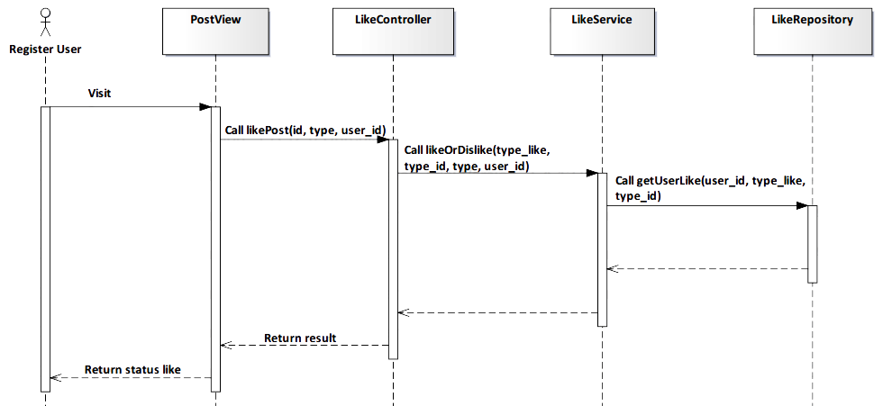

*Figure 4-107: Unlike Post Sequence Diagram*

###### Screen Design

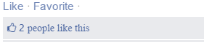

*Figure 4-108: Unlike Post Screen*

|  |  |  |
| --- | --- | --- |
| **Element** | **Type** | **Description** |
| **Like** | Button | Click to like post. |
| **Favorite** | Button | Click to add favorite. |

##### 4.3.4.2.19. Create Shop

###### Description

* User creates a new shop.

###### Class Diagram



*Figure 4-109: Create Shop Class Diagram*

###### Class Specification

PostController class

Physical Address: Trendy-Server\app\Controller*PostController.php*

Attribute

|  |  |  |  |
| --- | --- | --- | --- |
| No | Name | Type | Description |
| 1 | favoriteService | var | Instance of interface using to call methods in IFavoriteService. |
| 2 | postRepository | var | Instance of interface using to call methods in IPostRepository. |
| 3 | postService | var | Instance of interface using to call methods in IPostService. |
| 4 | uploadRepository | var | Instance of interface using to call methods in IUploadRepository. |
| 5 | userRepository | var | Instance of interface using to call methods in IUserRepository. |
| 6 | userService | var | Instance of interface using to call methods in IUserService. |

Method: createPost()

|  |  |  |
| --- | --- | --- |
| Purpose | Save a post to the database | |
| Return | **Type** | **Description** |
| var | Save data to database and response status save success or fail. |

PostService class

Physical Address: Trendy-Server\app\Services*PostService.php*

Attribute

|  |  |  |  |
| --- | --- | --- | --- |
| No | Name | Type | Description |
| 1 | albumRepository | var | Instance of interface using to call methods in IAlbumRepository. |
| 2 | albumService | var | Instance of interface using to call methods in IAlbumService. |
| 3 | commentService | var | Instance of interface using to call methods in ICommentService. |
| 4 | favoriteRepository | var | Instance of interface using to call methods in IFavoriteRepository. |
| 5 | followService | var | Instance of interface using to call methods in IFollowSerivce. |
| 6 | googleMapHelper | var | Instance of interface using to call methods in IGoogleMapHelper. |
| 7 | likeService | var | Instance of interface using to call methods in ILikeSerivce. |
| 8 | postAlbumRepository | var | Instance of interface using to call methods in IAlbumRepository. |
| 9 | postRepository | var | Instance of interface using to call methods in IPostRepository. |
| 10 | shopService | var | Instance of interface using to call methods in IShopSerivce. |
| 11 | tagContentRepository | var | Instance of interface using to call methods in ITagContentRepository. |
| 12 | tagContentService | var | Instance of interface using to call methods in ITagContentSerivce. |
| 13 | tagPictureService | var | Instance of interface using to call methods in ITagPictureSerivce. |
| 14 | tagRepository | var | Instance of interface using to call methods in ITagRepository. |
| 15 | tagService | var | Instance of interface using to call methods in ITagSerivce. |
| 16 | uploadRepository | var | Instance of interface using to call methods in IUploadRepository. |
| 17 | userRepository | var | Instance of interface using to call methods in IUserRepository. |

Method: createPost(array $data)

|  |  |  |  |  |
| --- | --- | --- | --- | --- |
| Purpose | Save a post to the database | | | |
| Return | **Type** | | | **Description** |
| var | | | Save data to database and response status save success or fail. |
| Parameter | **No** | **Name** | **Type** | **Description** |
| 1 | data | array | Array contains shop’ information that save to database. |

###### Sequence Diagram



*Figure 4-110: Create Shop Sequence Diagram*

###### Screen Design

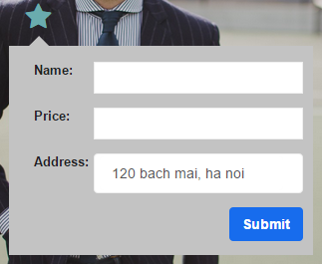

*Figure 4-111: Create Shop Screen*

|  |  |  |
| --- | --- | --- |
| **Element** | **Type** | **Description** |
| **Name** | Input text | Text field for entering name of product. |
| **Price** | Input text | Text field for entering price of product. |
| **Address** | Input text | Text field for entering address of product. |
| **Submit** | Button | Click to submit. |

##### 4.3.4.2.20. Suggest Shop

###### Description

* System suggest shops for user.

###### Class Diagram

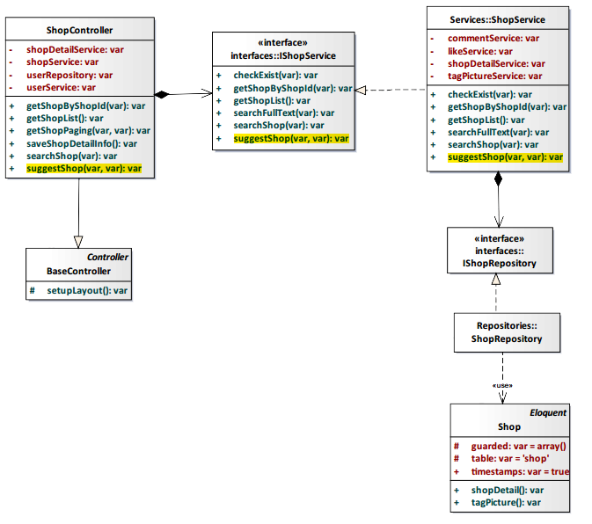

*Figure 4-112: Suggest Shop Class Diagram*

###### Class Specification

ShopController class

Physical Address: Trendy-Server\app\Controller*ShopController.php*

Attribute

|  |  |  |  |
| --- | --- | --- | --- |
| No | Name | Type | Description |
| 1 | shopDetailService | var | Instance of interface using to call methods in IShopDetailService. |
| 2 | shopService | var | Instance of interface using to call methods in IShopService. |
| 3 | userService | var | Instance of interface using to call methods in IUserService. |
| 4 | userRepository | var | Instance of interface using to call methods in IUserRepository. |

Method: suggestShop($loginId, $shopId)

|  |  |  |  |  |
| --- | --- | --- | --- | --- |
| Purpose | System suggest shop for user. | | | |
| Return | **Type** | | | **Description** |
| var | | | Show list shop that for user. |
| Parameter | **No** | **Name** | **Type** | **Description** |
| 1 | loginId | var | id of status system. |
| 2 | shopId | var | id of shop. |

ShopService class

Physical Address: Trendy-Server\app\Services*ShopService.php*

Attribute

|  |  |  |  |
| --- | --- | --- | --- |
| No | Name | Type | Description |
| 1 | commentService | var | Instance of interface using to call methods in ICommentService. |
| 2 | likeService | var | Instance of interface using to call methods in ILikeService. |
| 3 | shopDetailRepository | var | Instance of interface using to call methods in IshopDetailRepository. |
| 4 | tagPictureService | var | Instance of interface using to call methods in ITagPictureService. |

Method: suggestShop($loginId, $shopId)

|  |  |  |  |  |
| --- | --- | --- | --- | --- |
| Purpose | System suggest shop for user. | | | |
| Return | **Type** | | | **Description** |
| var | | | Show list shop that for user. |
| Parameter | **No** | **Name** | **Type** | **Description** |
| 1 | loginId | var | id of status syste. |
| 2 | shopId | var | id of shop. |

###### Sequence Diagram

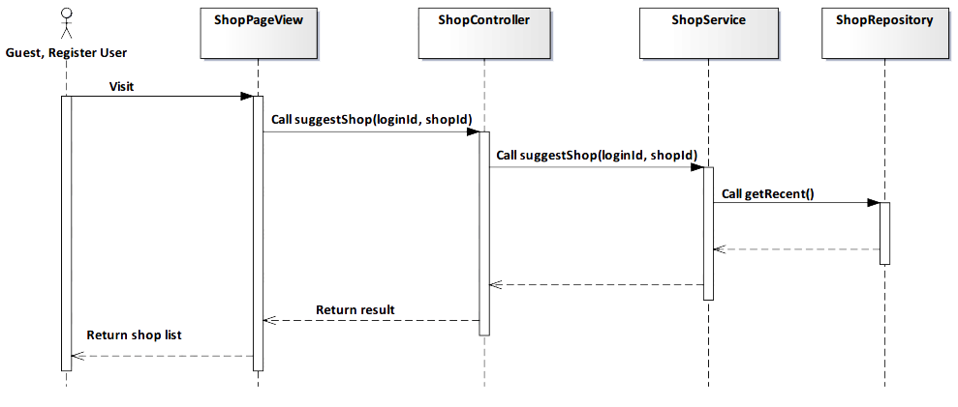

*Figure 4-112: Suggest Shop Squence Diagram*

###### Screen Design

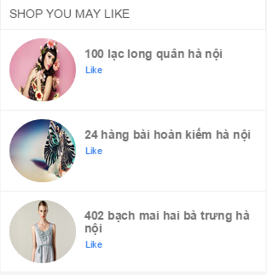

*Figure 4-113: Suggest Shop Screen*

|  |  |  |
| --- | --- | --- |
| **Element** | **Type** | **Description** |
| **Like** | Button | Click to like shop. |

##### 4.3.4.2.21. Suggest Shop’s Information

###### Description

* User suggest shop’s information.

###### Class Diagram

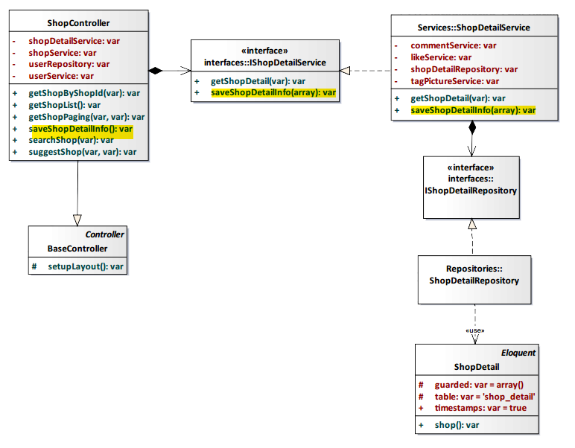

*Figure 4-114: Suggest Shop’s Information Class Diagram*

###### Class Specification

ShopController class

Physical Address: Trendy-Server\app\Controller*ShopController.php*

Attribute

|  |  |  |  |
| --- | --- | --- | --- |
| No | Name | Type | Description |
| 1 | shopDetailService | var | Instance of interface using to call methods in IShopDetailService. |
| 2 | shopService | var | Instance of interface using to call methods in IShopService. |
| 3 | userService | var | Instance of interface using to call methods in IUserService. |
| 4 | userRepository | var | Instance of interface using to call methods in IUserRepository. |

Method: saveShopDetailInfo()

|  |  |  |
| --- | --- | --- |
| Purpose | Save the suggestion shop’s information to the database. | |
| Return | **Type** | **Description** |
| var | Save data to database and response status save success or fail. |

ShopDetailService class

Physical Address: Trendy-Server\app\Services*ShopDetailService.php*

Attribute

|  |  |  |  |
| --- | --- | --- | --- |
| No | Name | Type | Description |
| 1 | commentService | var | Instance of interface using to call methods in ICommentService. |
| 2 | likeService | var | Instance of interface using to call methods in ILikeService. |
| 3 | shopDetailRepository | var | Instance of interface using to call methods in IshopDetailRepository. |
| 4 | tagPictureService | var | Instance of interface using to call methods in ITagPictureService. |

Method: saveShopDetailInfo(array $data)

|  |  |  |  |  |
| --- | --- | --- | --- | --- |
| Purpose | Save the suggestion shop’s information to the database. | | | |
| Return | **Type** | | | **Description** |
| var | | | Save data to database and response status save success or fail. |
| Parameter | **No** | **Name** | **Type** | **Description** |
| 1 | data | array | Array contains suggestion shop’ information that save to database. |

###### Sequence Diagram

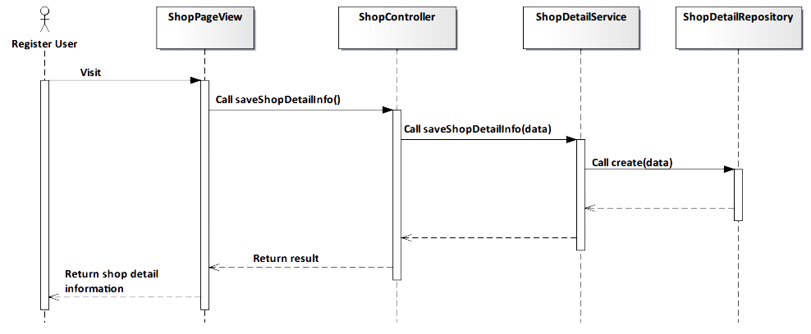

*Figure 4-115: Suggest Shop’s Information Sequence Diagram*

###### Screen Design

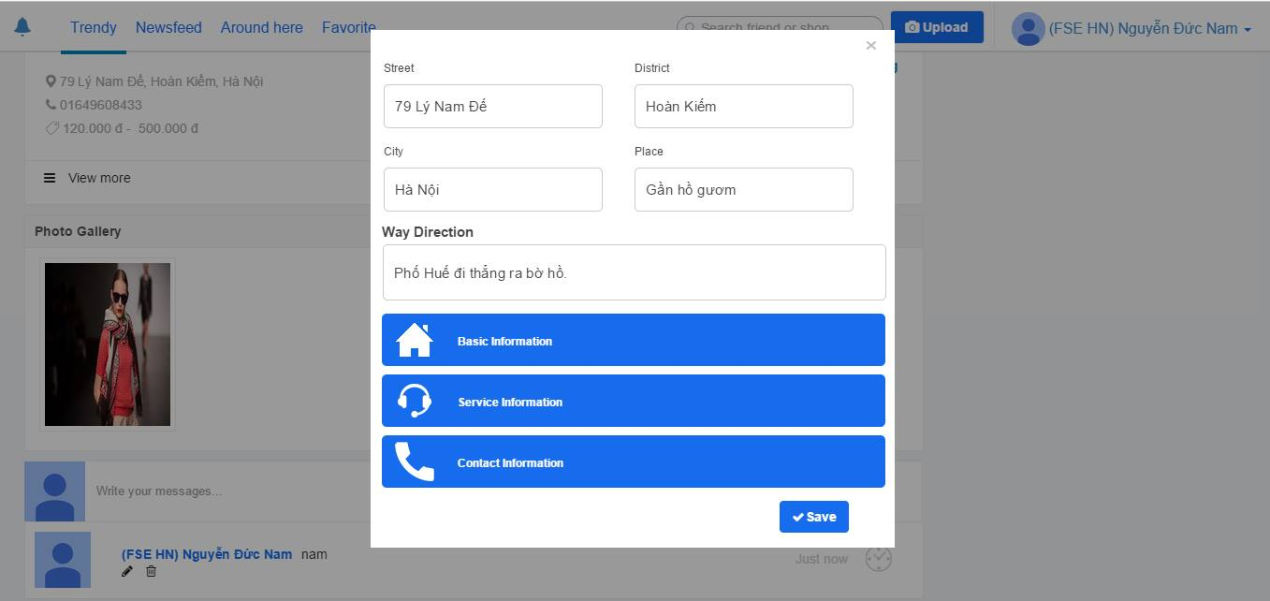

*Figure 4-116: Suggest Shop’s Information Screen*

##### 4.3.4.2.22. View Shop Detail

###### Description

* User view shop detail information.

###### Class Diagram

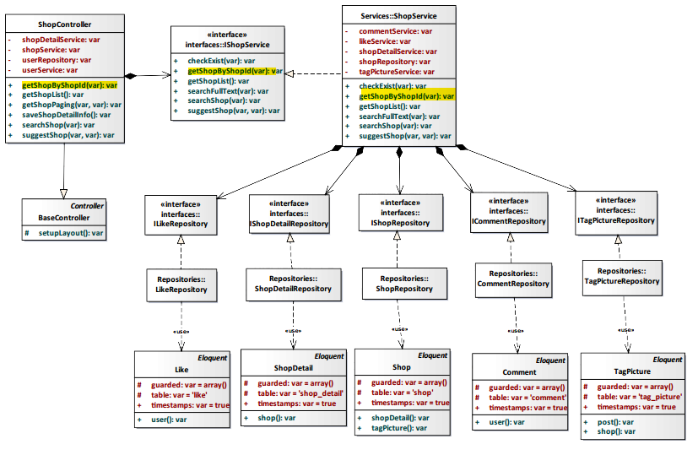

*Figure 4-117: View Shop Detail Class Diagram*

###### Class Specification

ShopController class

Physical Address: Trendy-Server\app\Controller*ShopController.php*

Attribute

|  |  |  |  |
| --- | --- | --- | --- |
| No | Name | Type | Description |
| 1 | shopDetailService | var | Instance of interface using to call methods in IShopDetailService. |
| 2 | shopService | var | Instance of interface using to call methods in IShopService. |
| 3 | userService | var | Instance of interface using to call methods in IUserService. |
| 4 | userRepository | var | Instance of interface using to call methods in IUserRepository. |

Method: getShopByShopId($id)

|  |  |  |  |  |
| --- | --- | --- | --- | --- |
| Purpose | Display all shop’s information to client. | | | |
| Return | **Type** | | | **Description** |
| var | | | Return shop information. |
| Parameter | **No** | **Name** | **Type** | **Description** |
| 1 | id | var | id of the shop that want to view. |

ShopService class

Physical Address: Trendy-Server\app\Services*ShopService.php*

Attribute

|  |  |  |  |
| --- | --- | --- | --- |
| No | Name | Type | Description |
| 1 | commentService | var | Instance of interface using to call methods in ICommentService. |
| 2 | likeService | var | Instance of interface using to call methods in ILikeService. |
| 3 | shopDetailService | var | Instance of interface using to call methods in IShopDetailService. |
| 4 | shopRepository | var | Instance of interface using to call methods in IShopRepository |
| 5 | tagPictureService | var | Instance of interface using to call methods in ITagPictureService. |

Method: getShopByShopId($id)

|  |  |  |  |  |
| --- | --- | --- | --- | --- |
| Purpose | Process to get all shop’s information. | | | |
| Return | **Type** | | | **Description** |
| var | | | Return shop information. |
| Parameter | **No** | **Name** | **Type** | **Description** |
| 1 | Id | var | id of the shop that want to view. |

###### Sequence Diagram

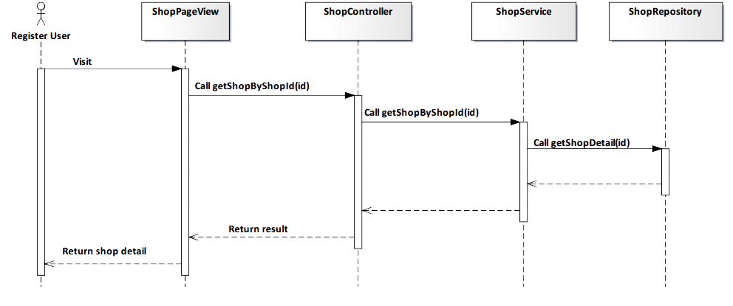

*Figure 4-118: View Shop Detail Sequence Diagram*

###### Screen Design

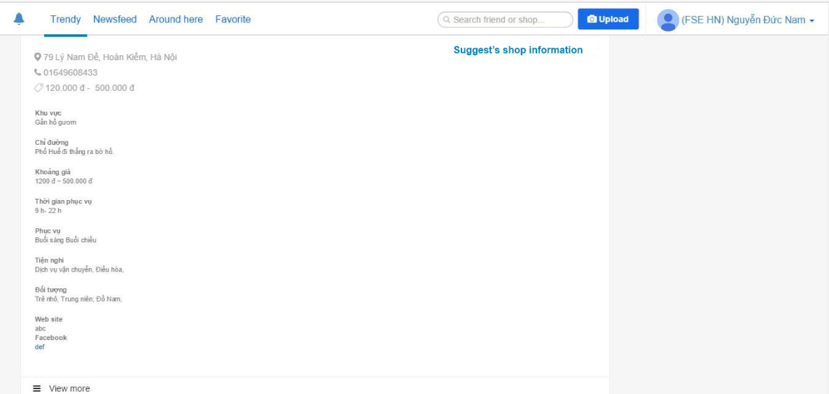

*Figure 4-119: View Shop Detail Screen*

|  |  |  |
| --- | --- | --- |
| **Element** | **Type** | **Description** |
| **View more** | Button | Click to view more shop’s information |

##### 4.3.4.2.23. Like Shop

###### Description

* User like a shop.

###### Class Diagram

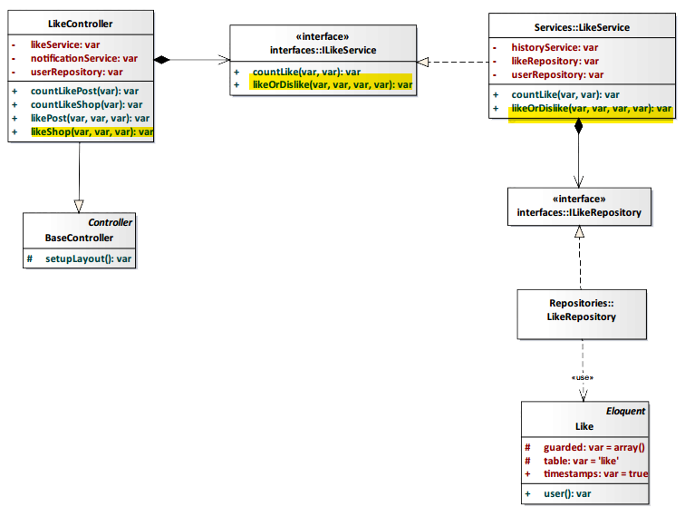

*Figure 4-120: Like Shop Class Diagram*

###### Class Specification

LikeController class

Physical Address: Trendy-Server\app\Controller*LikeController.php*

Attribute

|  |  |  |  |
| --- | --- | --- | --- |
| No | Name | Type | Description |
| 1 | likeService | var | Instance of interface using to call methods in ILikeService. |
| 2 | notificationService | var | Instance of interface using to call methods in INotificationService. |
| 3 | userRepository | var | Instance of interface using to call methods in IUserRepository. |

Method: likeShop($id, $type, $user_id)

|  |  |  |  |  |
| --- | --- | --- | --- | --- |
| Purpose | Display the like number of shop to client. | | | |
| Return | **Type** | | | **Description** |
| var | | | The like number of shop. |
| Parameter | **No** | **Name** | **Type** | **Description** |
| 1 | id | var | id of the shop that want to like. |
| 2 | type | var | type of action (in this case: like). |
| 3 | user_id | var | id of the user that like the shop |

LikeService class

Physical Address: Trendy-Server\app\Services*LikeService.php*

Attribute

|  |  |  |  |
| --- | --- | --- | --- |
| No | Name | Type | Description |
| 1 | userRepository | var | Instance of interface using to call methods in IUserRepository. |
| 2 | likeRepository | var | Instance of interface using to call methods in ILikeRepository. |
| 3 | historyService | var | Instance of interface using to call methods in IHistoryService. |

Method: likeOrDislike($type_like, $type_id, $type, $user_id)

|  |  |  |  |  |
| --- | --- | --- | --- | --- |
| Purpose | Update the number of like shop is incremented by 1 to database. | | | |
| Return | **Type** | | | **Description** |
| var | | | Save data to database and response status success or fail. |
| Parameter | **No** | **Name** | **Type** | **Description** |
| 1 | type_like | var | type of like action. |
| 2 | type_id | var | id of the shop. |
| 3 | type | var | type of action (in this case: like). |
| 4 | user_id | var | id of the user that like the shop. |

###### Sequence Diagram

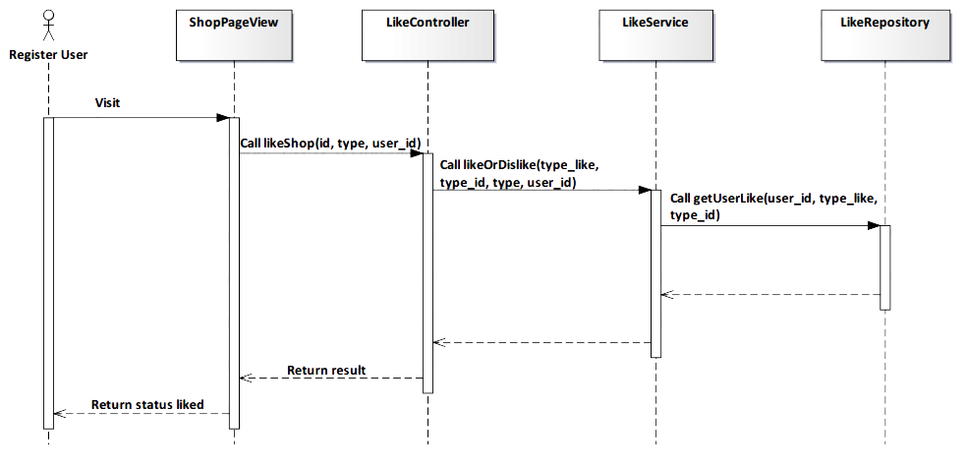

*Figure 4-121: Like Shop Sequence Diagram*

###### Screen Design

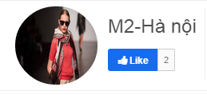

*Figure 4-122: Like Shop Screen*

|  |  |  |
| --- | --- | --- |
| **Element** | **Type** | **Description** |
| **Like** | Button | Click to like shop. |

##### 4.3.4.2.24. Unlike Shop

###### Description

* User unlike a shop that liked before.

###### Class Diagram



*Figure 4-123: Unlike Shop Class Diagram*

###### Class Specification

LikeController class

Physical Address: Trendy-Server\app\Controller*LikeController.php*

Attribute

|  |  |  |  |
| --- | --- | --- | --- |
| No | Name | Type | Description |
| 1 | likeService | var | Instance of interface using to call methods in ILikeService. |
| 2 | notificationService | var | Instance of interface using to call methods in INotificationService. |
| 3 | userRepository | var | Instance of interface using to call methods in IUserRepository. |

Method: likeShop($id, $type, $user_id)

|  |  |  |  |  |
| --- | --- | --- | --- | --- |
| Purpose | Display the like number of shop to client. | | | |
| Return | **Type** | | | **Description** |
| var | | | The like number of shop. |
| Parameter | **No** | **Name** | **Type** | **Description** |
| 1 | id | var | Id of the shop that want to like. |
| 2 | type | var | Type of action (in this case: unlike). |
| 3 | user_id | var | Id of the user that unlike the shop. |

LikeService class

Physical Address: Trendy-Server\app\Services*LikeService.php*

Attribute

|  |  |  |  |
| --- | --- | --- | --- |
| No | Name | Type | Description |
| 1 | userRepository | var | Instance of interface using to call methods in IUserRepository. |
| 2 | likeRepository | var | Instance of interface using to call methods in ILikeRepository. |
| 3 | historyService | var | Instance of interface using to call methods in IHistoryService. |

Method: likeOrDislike($type_like, $type_id, $type, $user_id)

|  |  |  |  |  |
| --- | --- | --- | --- | --- |
| Purpose | Update the number of like shop is decremented by 1 to database. | | | |
| Return | **Type** | | | **Description** |
| var | | | Save data to database and response status success or fail. |
| Parameter | **No** | **Name** | **Type** | **Description** |
| 1 | type_like | var | Type of like action. |
| 2 | type_id | var | Id of the shop. |
| 3 | type | var | Type of action (in this case: unlike). |
| 4 | user_id | var | Id of the user that unlike the shop. |

###### Sequence Diagram

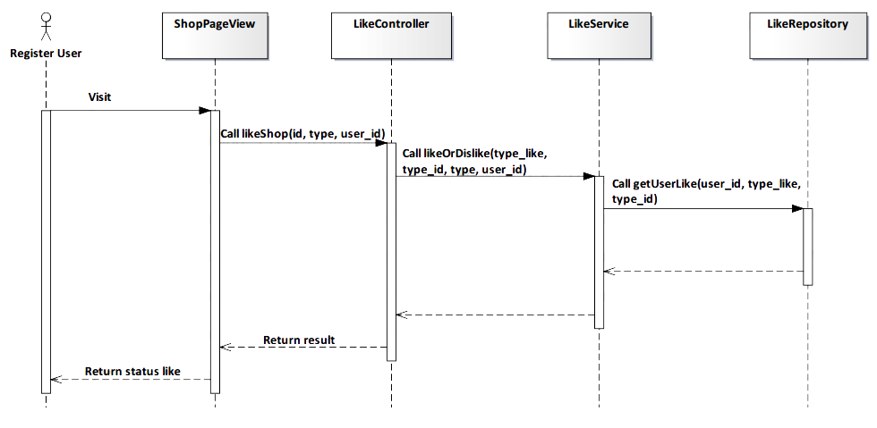

*Figure 4-124: Unlike Shop Sequence Diagram*

###### Screen Design

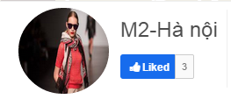

*Figure 4-125: Unlike Shop Screen*

|  |  |  |
| --- | --- | --- |
| **Element** | **Type** | **Description** |
| **Liked** | Button | Click to unlike shop. |

##### 4.3.4.2.25. View Following

###### Description

* User view the following people.

###### Class Diagram

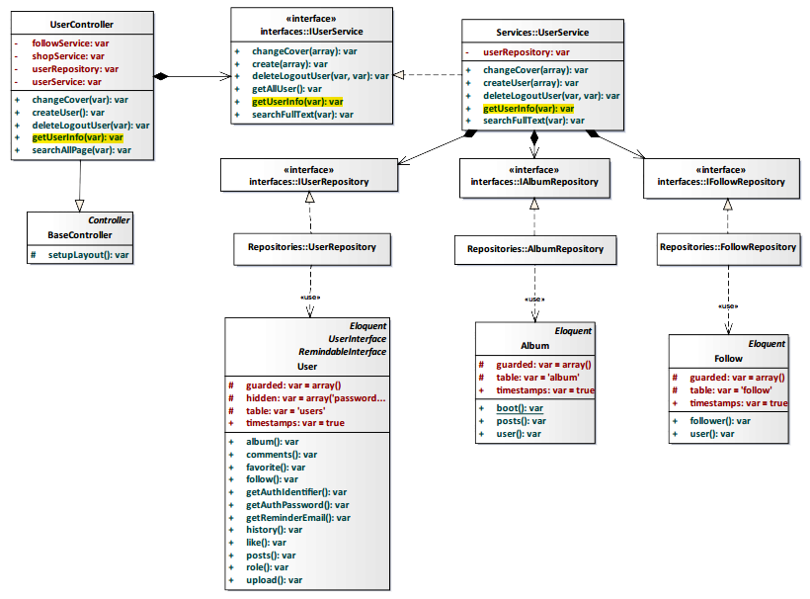

*Figure 4-126: View Following Class Diagram*

###### Class Specification

UserController class

Physical Address: Trendy-Server\app\Controller*UserController.php*

Attribute

|  |  |  |  |
| --- | --- | --- | --- |
| No | Name | Type | Description |
| 1 | followService | var | Instance of interface using to call methods in IFollowService. |
| 2 | shopService | var | Instance of interface using to call methods in IShopService. |
| 3 | userRepository | var | Instance of interface using to call methods in IUserRepository. |
| 4 | userService | var | Instance of interface using to call methods in IUserService. |

Method: getUserInfo($id)

|  |  |  |  |  |
| --- | --- | --- | --- | --- |
| Purpose | Display the following people to client | | | |
| Return | **Type** | | | **Description** |
| var | | | Return list following people. |
| Parameter | **No** | **Name** | **Type** | **Description** |
| 1 | id | var | id of the user that want to view list following. |

UserService class

Physical Address: Trendy-Server\app\Services*UserService.php*

Attribute

|  |  |  |  |
| --- | --- | --- | --- |
| No | Name | Type | Description |
| 1 | userRepository | var | Instance of interface using to call methods in IUserRepository. |

Method: getUserInfo($id)

|  |  |  |  |  |
| --- | --- | --- | --- | --- |
| Purpose | Process to get list following people | | | |
| Return | **Type** | | | **Description** |
| var | | | Return list following people. |
| Parameter | **No** | **Name** | **Type** | **Description** |
| 1 | id | var | id of the user that want to view list following. |

###### Sequence Diagram

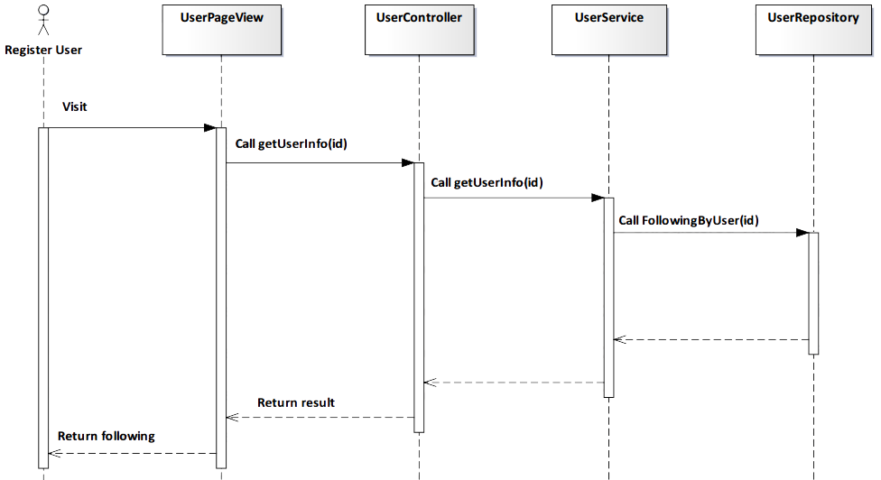

*Figure 4-127: View Following Sequence Diagram*

###### Screen Design

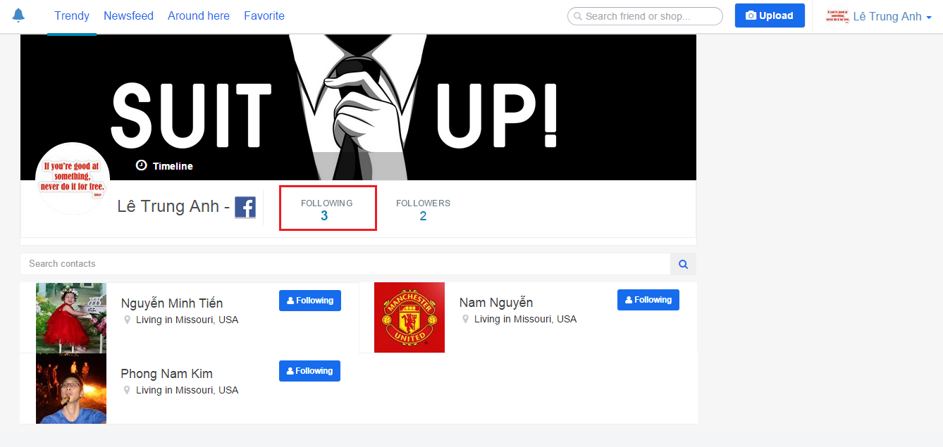

*Figure 4-128: View Following Screen*

|  |  |  |
| --- | --- | --- |
| **Element** | **Type** | **Description** |
| **Following** | Button | Click to unfollow user. |

##### 4.3.4.2.26. View Follower

###### Description

* User view list follower people.

###### Class Diagram



*Figure 4-129: View Follower Class Diagram*

###### Class Specification

UserController class

Physical Address: Trendy-Server\app\Controller*UserController.php*

Attribute

|  |  |  |  |
| --- | --- | --- | --- |
| No | Name | Type | Description |
| 1 | followService | var | Instance of interface using to call methods in IFollowService. |
| 2 | shopService | var | Instance of interface using to call methods in IShopService. |
| 3 | userRepository | var | Instance of interface using to call methods in IUserRepository. |
| 4 | userService | var | Instance of interface using to call methods in IUserService. |

Method: getUserInfo($id)

|  |  |  |  |  |
| --- | --- | --- | --- | --- |
| Purpose | Display the list follower people to client. | | | |
| Return | **Type** | | | **Description** |
| var | | | Return list follower people. |
| Parameter | **No** | **Name** | **Type** | **Description** |
| 1 | Id | var | Id of the user that want to view list follower. |

UserService class

Physical Address: Trendy-Server\app\Services*UserService.php*

Attribute

|  |  |  |  |
| --- | --- | --- | --- |
| No | Name | Type | Description |
| 1 | userRepository | var | Instance of interface using to call methods in IUserRepository. |

Method: getUserInfo($id)

|  |  |  |  |  |
| --- | --- | --- | --- | --- |
| Purpose | Process to get list follower people. | | | |
| Return | **Type** | | | **Description** |
| var | | | Return list follower people. |
| Parameter | **No** | **Name** | **Type** | **Description** |
| 1 | Id | var | Id of the user that want to view list follower. |

###### Sequence Diagram

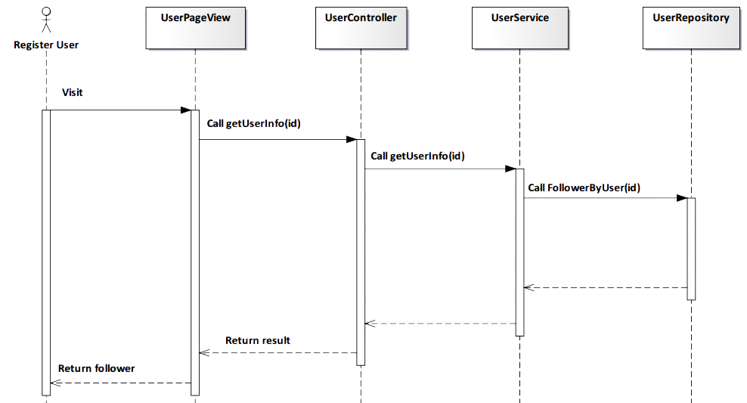

*Figure 4-130: View Follower Sequence Diagram*

###### Screen Design

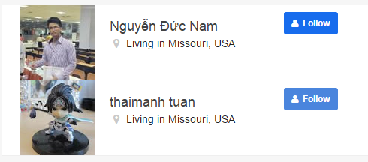

*Figure 4-131: View Follower Screen*

|  |  |  |
| --- | --- | --- |
| **Element** | **Type** | **Description** |
| **Follow** | Button | Click to follow user. |

##### 4.3.4.2.27. Add Follow

###### Description

* User add follow other people.

###### Class Diagram

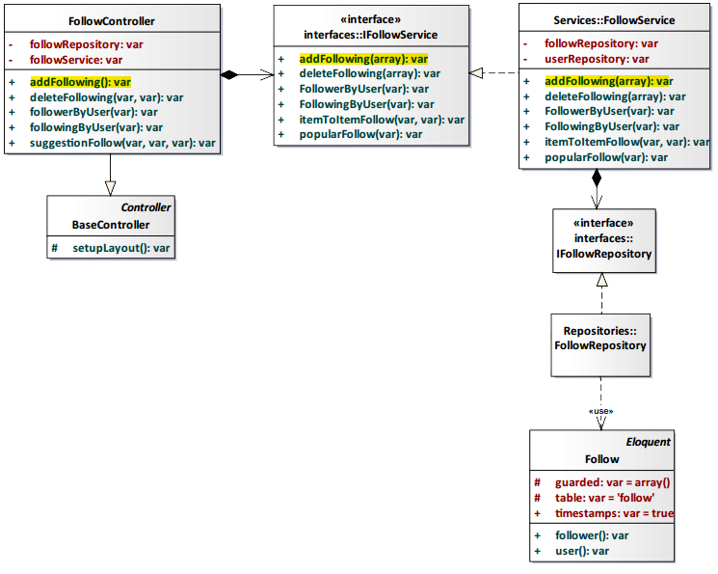

*Figure 4-132: Add Follow Class Diagram*

###### Class Specification

FollowController class

Physical Address: Trendy-Server\app\Controller*FollowController.php*

Attribute

|  |  |  |  |
| --- | --- | --- | --- |
| No | Name | Type | Description |
| 1 | followService | var | Instance of interface using to call methods in IFollowService. |
| 2 | followRepository | var | Instance of interface using to call methods in IFollowRepository. |

Method: addFollowing()

|  |  |  |
| --- | --- | --- |
| Purpose | Add following other people. | |
| Return | **Type** | **Description** |
| var | Save data to database and response status success or fail. |

FollowService class

Physical Address: Trendy-Server\app\Services*FollowService.php*

Attribute

|  |  |  |  |
| --- | --- | --- | --- |
| No | Name | Type | Description |
| 1 | userRepository | var | Instance of interface using to call methods in IUserRepository. |
| 2 | followRepository | var | Instance of interface using to call methods in IFollowRepository. |

Method: addFollowing(array $data)

|  |  |  |  |  |
| --- | --- | --- | --- | --- |
| Purpose | Process add following other people. | | | |
| Return | **Type** | | | **Description** |
| var | | | Save data to database and response status success or fail. |
| Parameter | **No** | **Name** | **Type** | **Description** |
| 1 | data | array | Array contains following user’s information that save to database. |

###### Sequence Diagram

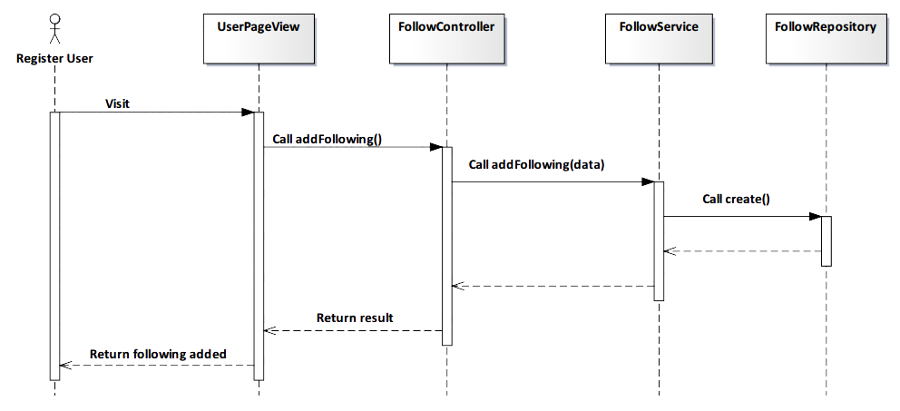

*Figure 4-133: Add Follow Sequence Diagram*

###### Screen Design



*Figure 4-134: Add Follow Screen*

##### 4.3.4.2.28. Remove Follow

###### Description

* User remove follow other people.

###### Class Diagram

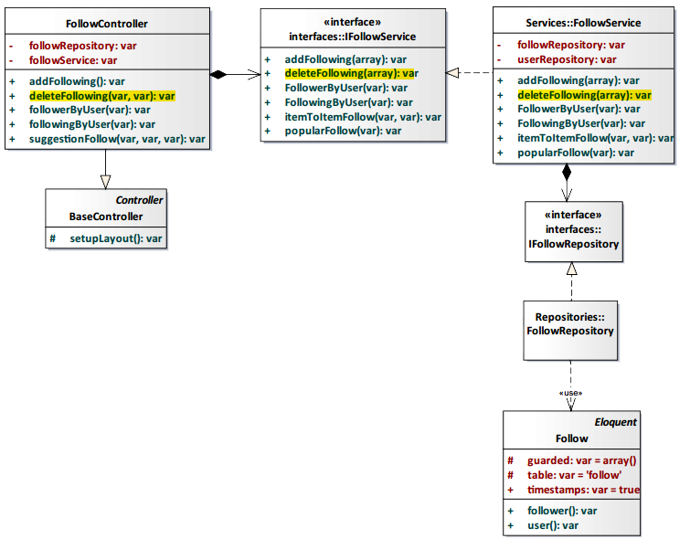

*Figure 4-135: Remove Follow Class Diagram*

###### Class Specification

FollowController class

Physical Address: Trendy-Server\app\Controller*FollowController.php*

Attribute

|  |  |  |  |
| --- | --- | --- | --- |
| No | Name | Type | Description |
| 1 | followService | var | Instance of interface using to call methods in IFollowService. |
| 2 | followRepository | var | Instance of interface using to call methods in IFollowRepository. |

Method: deleteFollowing($user_id, $follower_id)

|  |  |  |  |  |
| --- | --- | --- | --- | --- |
| Purpose | Delete following other people. | | | |
| Return | **Type** | | | **Description** |
| var | | | Save data to database and response status success or fail. |
| Parameter | **No** | **Name** | **Type** | **Description** |
| 1 | User_id | var | Id of the user that delete following other people. |
| 2 | Follower_id | var | Id of the user that is deleted from following user list. |

FollowService class

Physical Address: Trendy-Server\app\Services*FollowService.php*

Attribute

|  |  |  |  |
| --- | --- | --- | --- |
| No | Name | Type | Description |
| 1 | userRepository | var | Instance of interface using to call methods in IUserRepository. |
| 2 | followRepository | var | Instance of interface using to call methods in IFollowRepository. |

Method: deleteFollowing(array $data)

|  |  |  |  |  |
| --- | --- | --- | --- | --- |
| Purpose | Process delete following other people. | | | |
| Return | **Type** | | | **Description** |
| var | | | Save data to database and response status success or fail. |
| Parameter | **No** | **Name** | **Type** | **Description** |
| 1 | Data | Array | Array contains following user’s information that delete from database. |

###### Sequence Diagram

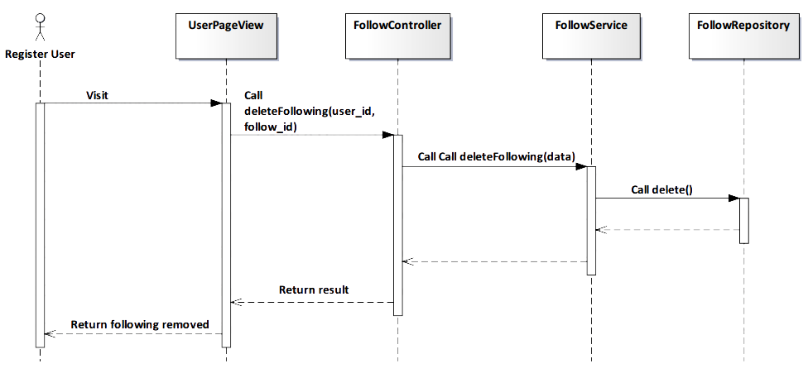

*Figure 4-136: Remove Follow Sequence Diagram*

###### Screen Design

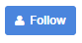

*Figure 4-137: Remove Follow Screen*

##### 4.3.4.2.29. Add Favorite

###### Description

* User add favorite post.

###### Class Diagram

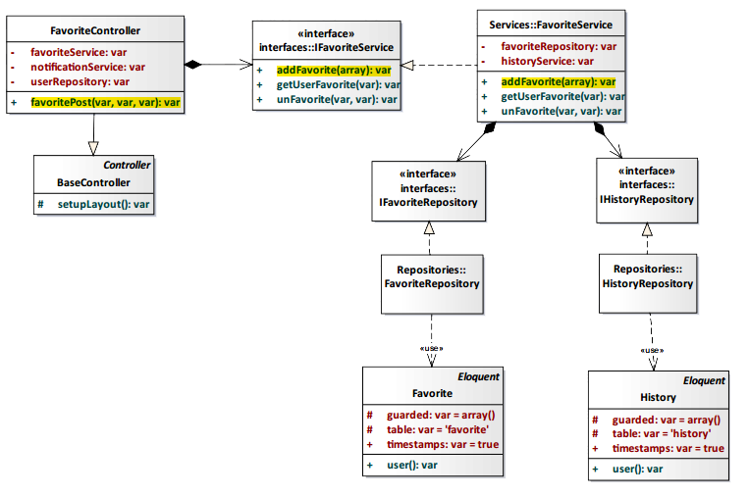

*Figure 4-138: Add Favorite Class Diagram*

###### Class Specification

FavoriteController class

Physical Address: Trendy-Server\app\Controller*FavoriteController.php*

Attribute

|  |  |  |  |
| --- | --- | --- | --- |
| No | Name | Type | Description |
| 1 | favoriteService | var | Instance of interface using to call methods in IFavoriteService. |
| 2 | notificationService | var | Instance of interface using to call methods in INotificationService. |
| 3 | userRepository | var | Instance of interface using to call methods in IUserRepository. |

Method: favoritePost($user_id, $post_id, $type)

|  |  |  |  |  |
| --- | --- | --- | --- | --- |
| Purpose | Display the favorite number of post to client. | | | |
| Return | **Type** | | | **Description** |
| var | | | The favorite number of post. |
| Parameter | **No** | **Name** | **Type** | **Description** |
| 1 | user_id | var | id of the user that add favorite post. |
| 2 | post_id | var | id of the post. |
| 3 | type | var | type of action (in this case: favorite). |

FavoriteService class

Physical Address: Trendy-Server\app\Services*FavoriteService.php*

Attribute

|  |  |  |  |
| --- | --- | --- | --- |
| No | Name | Type | Description |
| 1 | favoriteRepository | var | Instance of interface using to call methods in IFavoriteRepository. |
| 2 | historyService | var | Instance of interface using to call methods in IHistoryService. |

Method: addFavorite(array $data)

|  |  |  |  |  |
| --- | --- | --- | --- | --- |
| Purpose | Update the number of favorite post is incremented by 1 to database | | | |
| Return | **Type** | | | **Description** |
| var | | | Save data to database and response status success or fail. |
| Parameter | **No** | **Name** | **Type** | **Description** |
| 1 | data | array | Array contains userId and postId that save to database. |

###### Sequence Diagram

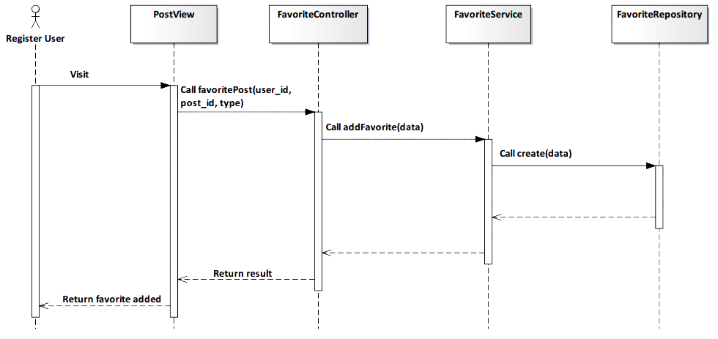

*Figure 4-139: Add Favorite Sequence Diagram*

###### Screen Design

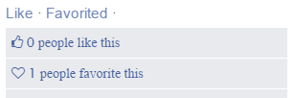

*Figure 4-140: Add Favorite Screen*

|  |  |  |
| --- | --- | --- |
| **Element** | **Type** | **Description** |
| **Like** | Button | Click to like post. |
| **Favorited** | Button | Click to unfavorite post. |

##### 4.3.4.2.30. Remove Favorite

###### Description

* User remove favorite post that added before.

###### Class Diagram



*Figure 4-141: Remove Favorite Class Diagram*

###### Class Specification

FavoriteController class

Physical Address: Trendy-Server\app\Controller*FavoriteController.php*

Attribute

|  |  |  |  |
| --- | --- | --- | --- |
| No | Name | Type | Description |
| 1 | favoriteService | var | Instance of interface using to call methods in IFavoriteService. |
| 2 | notificationService | var | Instance of interface using to call methods in INotificationService. |
| 3 | userRepository | var | Instance of interface using to call methods in IUserRepository. |

Method: favoritePost($user_id, $post_id, $type)

|  |  |  |  |  |
| --- | --- | --- | --- | --- |
| Purpose | Display the favorite number of post to client. | | | |
| Return | **Type** | | | **Description** |
| var | | | The favorite number of post. |
| Parameter | **No** | **Name** | **Type** | **Description** |
| 1 | user_id | var | id of the user that add favorite post. |
| 2 | post_id | var | id of the post. |
| 3 | type | var | type of action (in this case: unfavorite). |

FavoriteService class

Physical Address: Trendy-Server\app\Services*FavoriteService.php*

Attribute

|  |  |  |  |
| --- | --- | --- | --- |
| No | Name | Type | Description |
| 1 | favoriteRepository | var | Instance of interface using to call methods in IFavoriteRepository. |
| 2 | historyService | var | Instance of interface using to call methods in IHistoryService. |

Method: unFavorite($user_id, $post_id)

|  |  |  |  |  |
| --- | --- | --- | --- | --- |
| Purpose | Update the number of favorite post is decremented by 1 to database. | | | |
| Return | **Type** | | | **Description** |
| var | | | Save data to database and response status success or fail. |
| Parameter | **No** | **Name** | **Type** | **Description** |
| 1 | user_id | var | id of the user that remove favorite post. |
| 2 | post_id | var | id of the post. |

###### Sequence Diagram

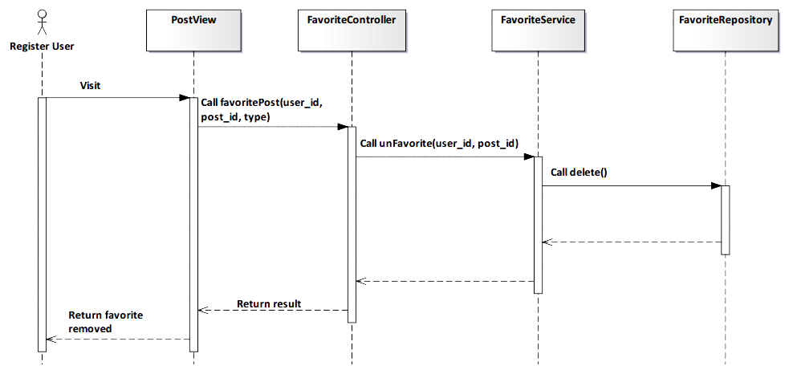

*Figure 4-142: Remove Favorite Sequence Diagram*

###### Screen Design

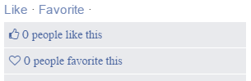

*Figure 4-143: Remove Favorite Screen*

|  |  |  |
| --- | --- | --- |
| **Element** | **Type** | **Description** |
| **Like** | Button | Click to like post. |
| **Favorite** | Button | Click to favorite post. |

##### 4.3.4.2.31. Subscribe Notification

###### Description

* Actor receives notify from TrendyPlus when another user liked/favorited/commented image of actor follows.

###### Class Diagram

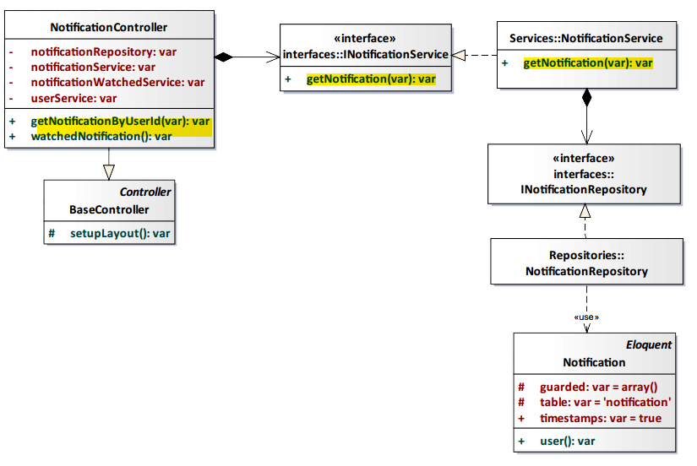

*Figure 4-144: Subscribe Notification Class Diagram*

###### Class Specification

NotificationController class

Physical Address: Trendy-Server\app\controllers*NotificationController.php*

Attribute

|  |  |  |  |
| --- | --- | --- | --- |
| No | Name | Type | Description |
| 1 | notificationService | var | Instance of interface using to call methods in INotificationService. |
| 2 | notificationWatchedService | var | Instance of interface using to call methods in INotificationWatchedService. |
| 3 | notificationRepository | var | Instance of interface using to call methods in INotificationRepository. |
| 4 | userService | var | Instance of interface using to call methods in IUserService. |

Method: getNotificationByUserId($id)

|  |  |  |  |  |
| --- | --- | --- | --- | --- |
| Purpose | Get notification of user. | | | |
| Return | **Type** | | | **Description** |
| var | | | Return list notification. |
| Parameter | **No** | **Name** | **Type** | **Description** |
| 1 | id | var | User id had being login. |

NotificationService class

Physical Address: Trendy-Server\app\Services*NotificationService.php*

Attribute

|  |  |  |  |
| --- | --- | --- | --- |
| No | Name | Type | Description |
| 1 | notificationRepository | var | Instance of interface using to call methods in INotificationRepository. |

Method: getNotification($user_id)

|  |  |  |  |  |
| --- | --- | --- | --- | --- |
| Purpose | Get notification of user. | | | |
| Return | **Type** | | | **Description** |
| var | | | Return list notification. |
| Parameter | **No** | **Name** | **Type** | **Description** |
| 1 | id | var | User id had being login. |

###### Sequence Diagram

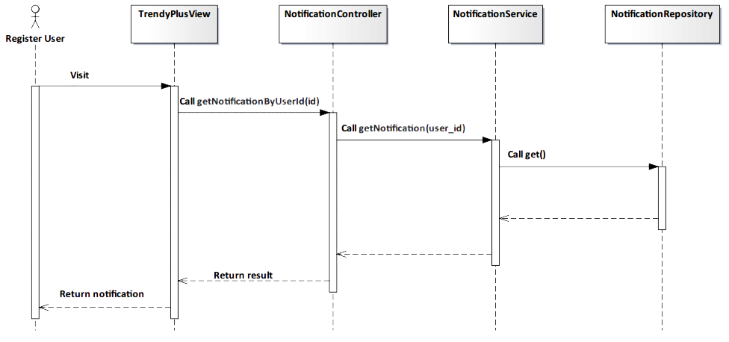

*Figure 4-145: Subscribe Notification Sequence Diagram*

###### Screen Design

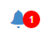

*Figure 4-146: Subscribe Notification Screen*

##### 4.3.4.2.32. View Notification

###### Description

* Actor will view notification when actor clicks to one notice

###### Class Diagram

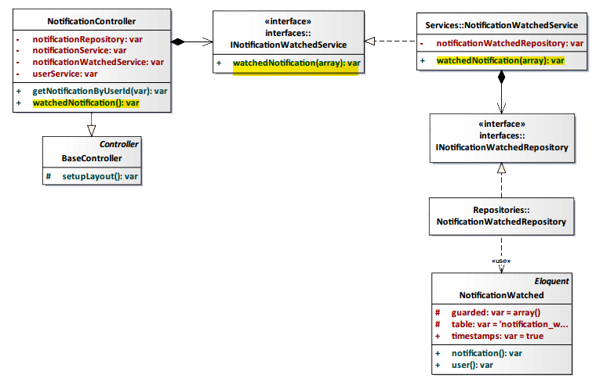

*Figure 4-147: View Notification Class Diagram*

###### Class Specification

NotificationController class

Physical Address: Trendy-Server\app\controllers*NotificationController.php*

Attribute

|  |  |  |  |
| --- | --- | --- | --- |
| No | Name | Type | Description |
| 1 | notificationService | var | Instance of interface using to call methods in INotificationService. |
| 2 | notificationWatchedService | var | Instance of interface using to call methods in INotificationWatchedService. |
| 3 | notificationRepository | var | Instance of interface using to call methods in INotificationRepository. |
| 4 | userService | var | Instance of interface using to call methods in IUserService. |

Method: watchedNotification()

|  |  |  |
| --- | --- | --- |
| Purpose | Watch content of notification. | |
| Return | **Type** | **Description** |
| var | Return address need notice. |

NotificationWatchedService Class

Physical Address: Trendy-Server\app\Services\ *NotificationWatchedService.php*

Attribute

|  |  |  |  |
| --- | --- | --- | --- |
| No | Name | Type | Description |
| 1 | notificationWatchedRepository | var | Instance of interface using to call methods in INotificationWatchedRepository. |

Method: watchedNotification($data)

|  |  |  |  |  |
| --- | --- | --- | --- | --- |
| Purpose | Watch content of notification. | | | |
| Return | **Type** | | | **Description** |
| var | | | Return address need notice. |
| Parameter | **No** | **Name** | **Type** | **Description** |
| 1 | data | array | Include user_id and notification_id. |

###### Sequence Diagram

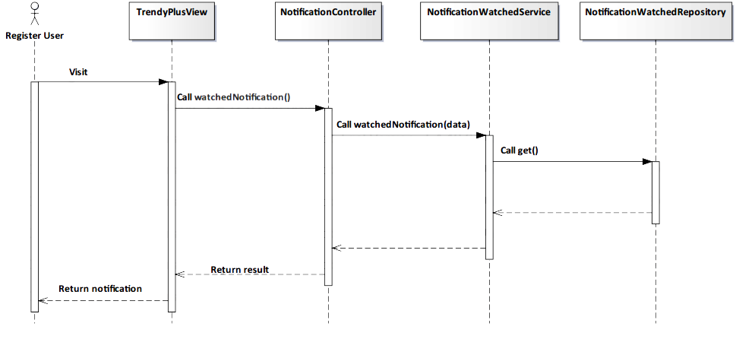

*Figure 4-148: View Notification Sequence Diagram*

###### Screen Design

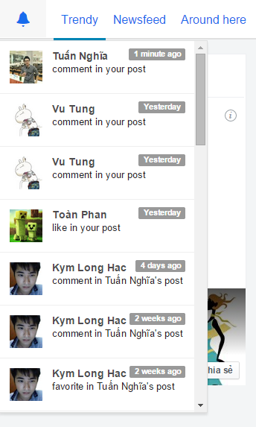

*Figure 4-149: View Notification Screen*

##### 4.3.4.2.33. Change Cover

###### Description

* User can change cover in their profile page.

###### Class Diagram

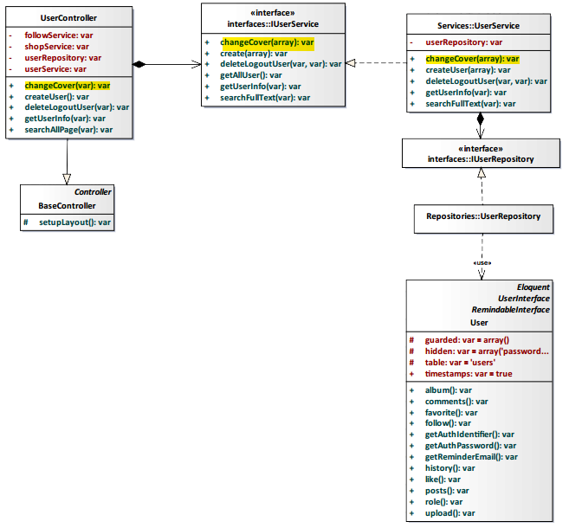

*Figure 4-150: Change Cover Class Diagram*

###### Class Specification

UserController class

Physical Address: Trendy-Server\app\Controller*UserController.php*

Attribute

|  |  |  |  |
| --- | --- | --- | --- |
| No | Name | Type | Description |
| 1 | followService | var | Instance of interface using to call methods in IFollowService. |
| 2 | shopService | var | Instance of interface using to call methods in IShopService. |
| 3 | userRepository | var | Instance of interface using to call methods in IUserRepository. |
| 4 | userService | var | Instance of interface using to call methods in IUserService. |

Method: changeCover($id)

|  |  |  |  |  |
| --- | --- | --- | --- | --- |
| Purpose | Update image to be new cover profile page. | | | |
| Return | **Type** | | | **Description** |
| boolean | | | Return true if successful. |
| Parameter | **No.** | **Name** | **Type** | **Description** |
| 1 | id | var | id of the user. |

UserService class

Physical Address: Trendy-Server\app\Services*UserService.php*

Attribute

|  |  |  |  |
| --- | --- | --- | --- |
| No | Name | Type | Description |
| 1 | userRepository | var | Instance of interface using to call methods in IUserRepository. |

Method: changeCover ($data)

|  |  |  |  |  |
| --- | --- | --- | --- | --- |
| Purpose | Process to change user’s cover. | | | |
| Return | **Type** | | | **Description** |
| var | | | Return user’s cover. |
| Parameter | **No** | **Name** | **Type** | **Description** |
| 1 | data | array | Array contains information update user’s cover. |

###### Sequence Diagram

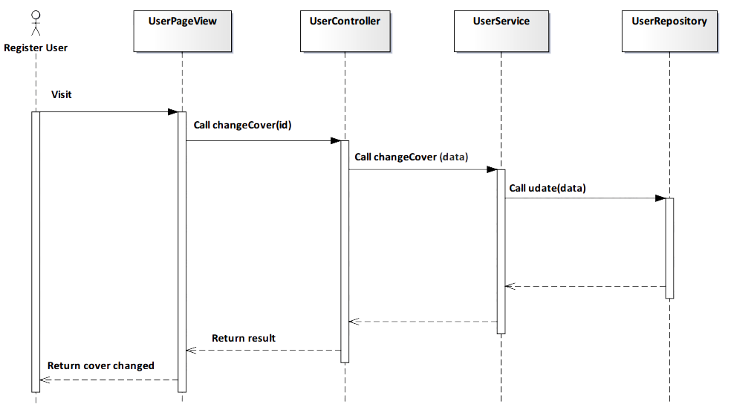

*Figure 4-151: Change Cover Sequence Diagram*

###### Screen Design



*Figure 4-152: Change Cover Screen*

##### 4.3.4.2.34. Logout

###### Description

* Actor logouts TrendyPlus.

###### Class Diagram

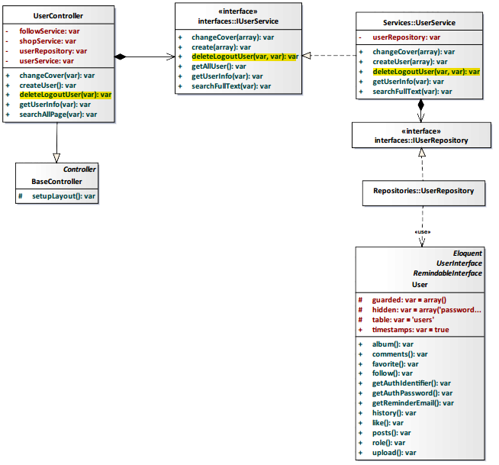

*Figure 4-153: Logout Class Diagram*

###### Class Specification

UserController class

Physical Address: Trendy-Server\app\controllers*UserController.php*

Attribute

|  |  |  |  |
| --- | --- | --- | --- |
| No | Name | Type | Description |
| 1 | followService | var | Instance of interface using to call methods in IFollowService. |
| 2 | shopService | var | Instance of interface using to call methods in IShopService. |
| 3 | userRepository | var | Instance of interface using to call methods in IUserRepository. |
| 4 | userService | var | Instance of interface using to call methods in IUserService. |

Method: deleteLogoutUser($id)

|  |  |  |  |  |
| --- | --- | --- | --- | --- |
| Purpose | User implement logout system. | | | |
| Return | **Type** | | | **Description** |
| var | | | Return status logout system. |
| Parameter | **No** | **Name** | **Type** | **Description** |
| 1 | id | var | id of user. |

UserService class

Physical Address: Trendy-Server\app\Services*UserService.php*

Attribute

|  |  |  |  |
| --- | --- | --- | --- |
| No | Name | Type | Description |
| 1 | userRepository | var | Instance of interface using to call methods in IUserRepository. |

Method: deleteLogoutUser($column, $value)

|  |  |  |  |  |
| --- | --- | --- | --- | --- |
| Purpose | Process user implement logout system. | | | |
| Return | **Type** | | | **Description** |
| var | | | Return status logout system. |
| Parameter | **No** | **Name** | **Type** | **Description** |
| 1 | column | var | column define user. |
| 2 | value | var | value define exactly position of user.. |

###### Sequence Diagram

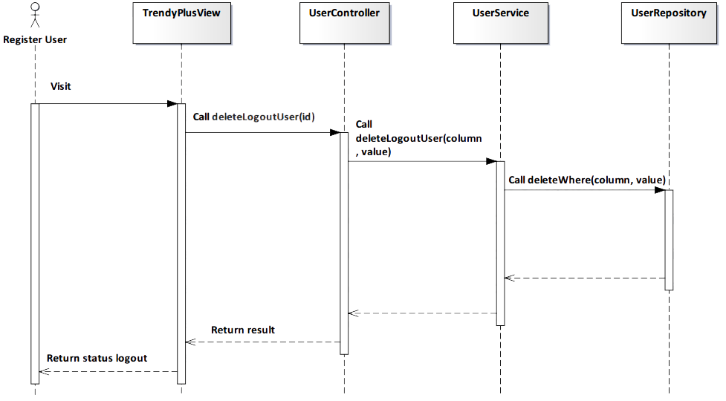

*Figure 4-154: Logout Sequence Diagram*

###### Screen Design

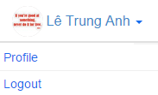

*Figure 4-155: Logout Screen*

|  |  |  |
| --- | --- | --- |
| **Element** | **Type** | **Description** |
| **Profile** | Button | Click to access user’s profile. |
| **Logout** | Button | Click to logout TrendyPlus. |

##### 4.3.4.2.35. General Search

###### Description

* Actor searches users or shops from our system with an input string.

###### Class Diagram

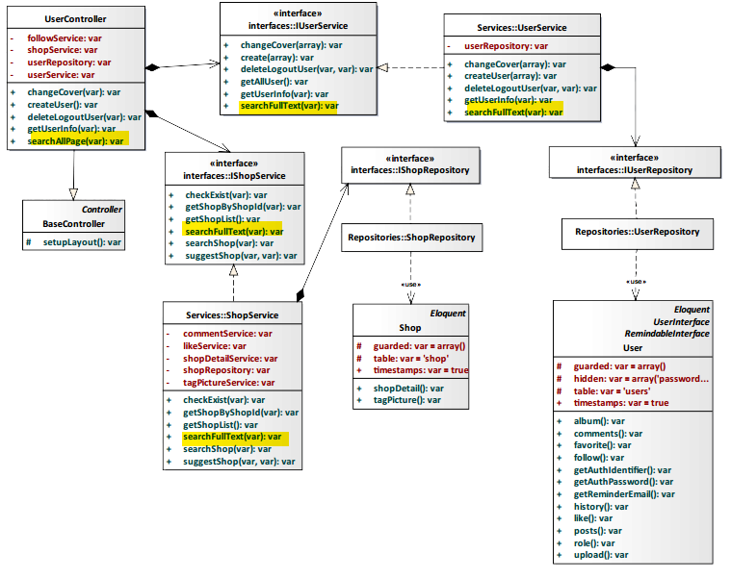

*Figure 4-156: General Search Class Diagram*

###### Class Specification

UserController class

Physical Address: Trendy-Server\app\Controller*UserController.php*

Attribute

|  |  |  |  |
| --- | --- | --- | --- |
| No | Name | Type | Description |
| 1 | followService | var | Instance of interface using to call methods in IFollowService. |
| 2 | shopService | var | Instance of interface using to call methods in IShopService. |
| 3 | userRepository | var | Instance of interface using to call methods in IUserRepository. |
| 4 | userService | var | Instance of interface using to call methods in IUserService. |

Method: searchAllPage($type)

|  |  |  |  |  |
| --- | --- | --- | --- | --- |
| Purpose | Search users and shops had name contain $type. | | | |
| Return | **Type** | | | **Description** |
| array | | | Return list of shop and user result of search. |
| Parameter | **No.** | **Name** | **Type** | **Description** |
| 1 | type | var | String is inputed in textbox search. |

UserService class

Physical Address: Trendy-Server\app\Services*UserService.php*

Attribute

|  |  |  |  |
| --- | --- | --- | --- |
| No | Name | Type | Description |
| 1 | userRepository | var | Instance of interface using to call methods in IUserRepository. |

Method: searchFullText($type)

|  |  |  |  |  |
| --- | --- | --- | --- | --- |
| Purpose | Search users have name contain $type. | | | |
| Return | **Type** | | | **Description** |
| var | | | Return list user. |
| Parameter | **No** | **Name** | **Type** | **Description** |
| 1 | type | var | String is inputed in textbox search. |

ShopService class

Physical Address: Trendy-Server\app\Services*ShopService.php*

Attribute

|  |  |  |  |
| --- | --- | --- | --- |
| No | Name | Type | Description |
| 1 | commentService | var | Instance of interface using to call methods in ICommentService. |
| 2 | likeService | var | Instance of interface using to call methods in ILikeService. |
| 3 | shopDetailService | var | Instance of interface using to call methods in IShopDetailService. |
| 4 | shopRepository | var | Instance of interface using to call methods in IShopRepository. |
| 5 | tagPictureService | var | Instance of interface using to call methods in ITagPictureService. |

Method: searchFullText ($type)

|  |  |  |  |  |
| --- | --- | --- | --- | --- |
| Purpose | Search shops have name contain $type. | | | |
| Return | **Type** | | | **Description** |
| var | | | Return list shop. |
| Parameter | **No** | **Name** | **Type** | **Description** |
| 1 | type | var | String is inputed in textbox search. |

###### Sequence Diagram

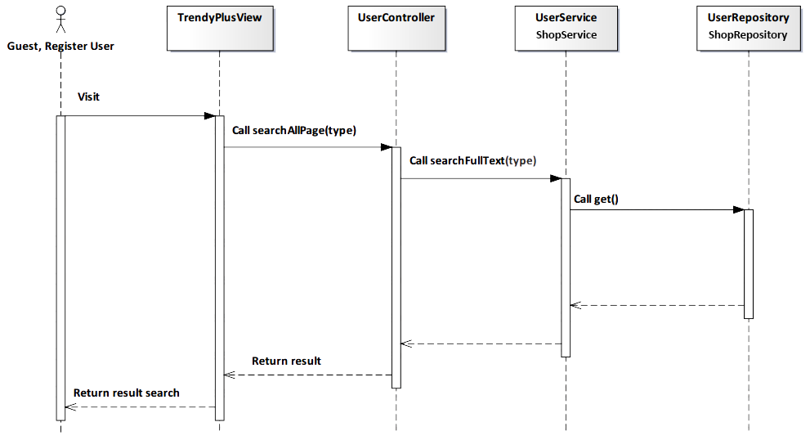

*Figure 4-157: General Search Sequence Diagram*

###### Screen Design

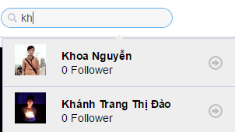

*Figure 4-158: General Search Screen*

|  |  |  |
| --- | --- | --- |
| **Element** | **Type** | **Description** |
| **Search** | Input text | Text field for entering content to search. |

#### 4.3.4.3. Administrator

##### 4.3.4.3.1. Search User

###### Description

* Admin search user to view information of user.

###### Class Diagram

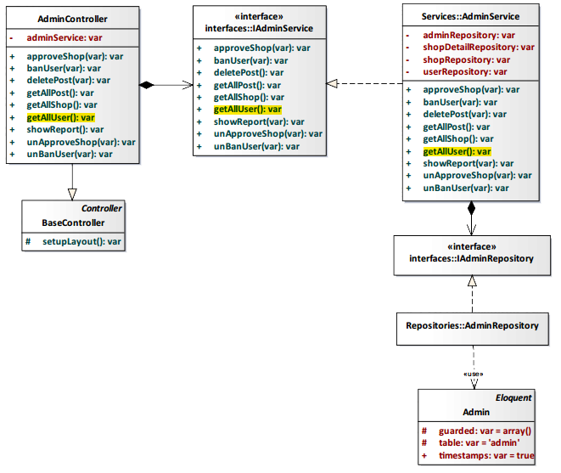

*Figure 4-159: Search User Class Diagram*

###### Class Specification

AdminController class

Physical Address: Trendy-Server\app\Controller*AdminController.php*

Attribute

|  |  |  |  |
| --- | --- | --- | --- |
| No | Name | Type | Description |
| 1 | adminService | var | Instance of interface using to call methods in IAdminService. |

Method: getAllUser()

|  |  |  |
| --- | --- | --- |
| Purpose | Process and display a result search user. | |
| Return | **Type** | **Description** |
| arrayList | Represents the result of an action method. Return list all user. |

AdminService class

Physical Address: Trendy-Server\app\Services*AdminService.php*

Attribute

|  |  |  |  |
| --- | --- | --- | --- |
| No | Name | Type | Description |
| 1 | adminRepository | var | Instance of interface using to call methods in IAdminRepository. |
| 2 | shopDetailRepository | var | Instance of interface using to call methods in IShopDetailRepository. |
| 3 | shopRepository | var | Instance of interface using to call methods in IShopRepository. |
| 4 | userRepository | var | Instance of interface using to call methods in IUserRepository. |

Method: getAllUser()

|  |  |  |
| --- | --- | --- |
| Purpose | Process and display a result search user. | |
| Return | **Type** | **Description** |
| arrayList | Represents the result of an action method. Return list all user. |

###### Sequence Diagram

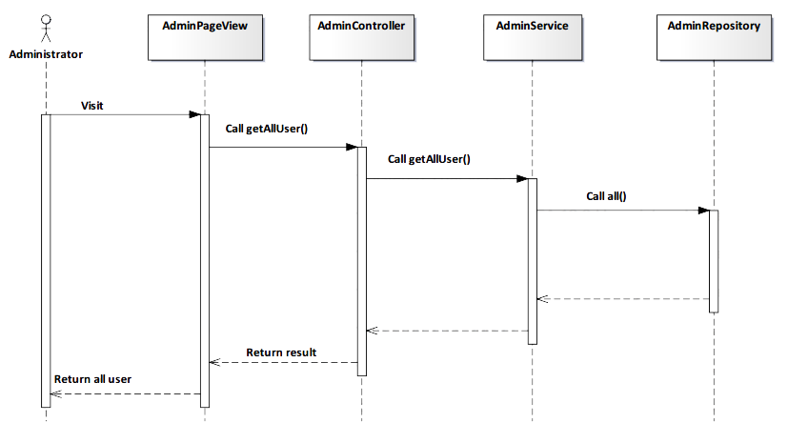

*Figure 4-160: Search User Sequence Diagram*

###### Screen Design

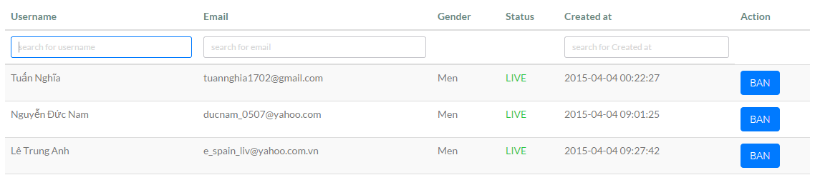

*Figure 4-161: Search User Screen*

|  |  |  |
| --- | --- | --- |
| **Element** | **Type** | **Description** |
| **Username** | Input text | Text field for entering username. |
| **Email** | Input text | Text field for entering email. |
| **Create at** | Input text | Text field for entering create at. |

##### 4.3.4.3.2. Search Shop

###### Description

* Admin search shop to view information of shop.

###### Class Diagram

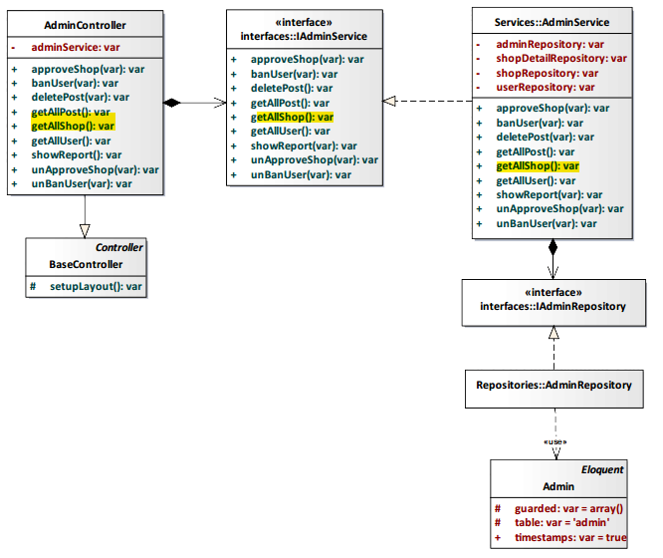

*Figure 4-162: Search Shop Class Diagram*

###### Class Specification

AdminController class

Physical Address: Trendy-Server\app\Controller*AdminController.php*

Attribute

|  |  |  |  |
| --- | --- | --- | --- |
| No | Name | Type | Description |
| 1 | adminService | var | Instance of interface using to call methods in IAdminService. |

Method: getAllShop()

|  |  |  |
| --- | --- | --- |
| Purpose | Process and display a result search shop. | |
| Return | **Type** | **Description** |
| arrayList | Represents the result of an action method. Return list all shop. |

AdminService class

Physical Address: Trendy-Server\app\Services*AdminService.php*

Attribute

|  |  |  |  |
| --- | --- | --- | --- |
| No | Name | Type | Description |
| 1 | adminRepository | var | Instance of interface using to call methods in IAdminRepository. |
| 2 | shopDetailRepository | var | Instance of interface using to call methods in IShopDetailRepository. |
| 3 | shopRepository | var | Instance of interface using to call methods in IShopRepository. |
| 4 | userRepository | var | Instance of interface using to call methods in IUserRepository. |

Method: getAllShop()

|  |  |  |
| --- | --- | --- |
| Purpose | Process and display a result search shop. | |
| Return | **Type** | **Description** |
| arrayList | Represents the result of an action method. Return list all shop. |

###### Sequence Diagram

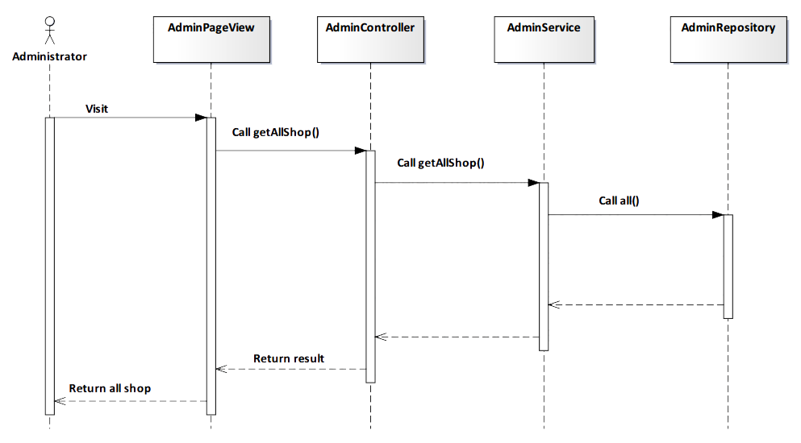

*Figure 4-163: Search Shop Sequence Diagram*

###### Screen Design

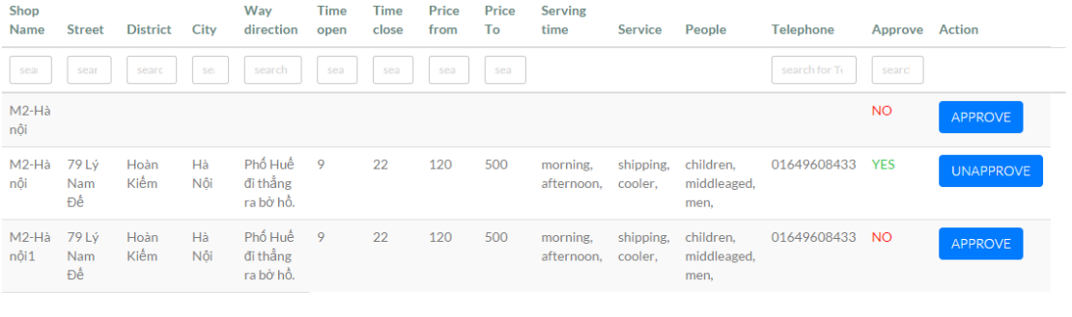

*Figure 4-164: Search Shop Screen*

|  |  |  |
| --- | --- | --- |
| **Element** | **Type** | **Description** |
| **Shop Name** | Input text | Text field for entering shop name. |
| **Street** | Input text | Text field for entering street. |
| **District** | Input text | Text field for entering district. |
| **City** | Input text | Text field for entering city. |
| **Way direction** | Input text | Text field for entering way direction. |
| **Time open** | Input text | Text field for entering time open. |
| **Time close** | Input text | Text field for entering time close. |
| **Price from** | Input text | Text field for entering price from. |
| **Price To** | Input text | Text field for entering price to. |
| **Telephone** | Input text | Text field for entering telephone. |
| **Approve** | Input text | Text field for entering approve. |
| **Approve** | Button | Click to approve information shop. |
| **Unapprove** | Button | Click to unapprove information shop. |

##### 4.3.4.3.3. View All User

###### Description

* Admin view all user.

###### Class Diagram



*Figure 4-165: View All User Class Diagram*

###### Class Specification

AdminController class

Physical Address: Trendy-Server\app\Controller*AdminController.php*

Attribute

|  |  |  |  |
| --- | --- | --- | --- |
| No | Name | Type | Description |
| 1 | adminService | var | Instance of interface using to call methods in IAdminService. |

Method: getAllUser()

|  |  |  |
| --- | --- | --- |
| Purpose | Show all user for administrator. | |
| Return | **Type** | **Description** |
| arrayList | Represents the result of an action method. Return list all user. |

AdminService class

Physical Address: Trendy-Server\app\Services*AdminService.php*

Attribute

|  |  |  |  |
| --- | --- | --- | --- |
| No | Name | Type | Description |
| 1 | adminRepository | var | Instance of interface using to call methods in IAdminRepository. |
| 2 | shopDetailRepository | var | Instance of interface using to call methods in IShopDetailRepository. |
| 3 | shopRepository | var | Instance of interface using to call methods in IShopRepository. |
| 4 | userRepository | var | Instance of interface using to call methods in IUserRepository. |

Method: getAllUser()

|  |  |  |
| --- | --- | --- |
| Purpose | Show all user for administrator. | |
| Return | **Type** | **Description** |
| arrayList | Represents the result of an action method. Return list all user. |

###### Sequence Diagram



*Figure 4-166: View All User Sequence Diagram*

###### Screen Design

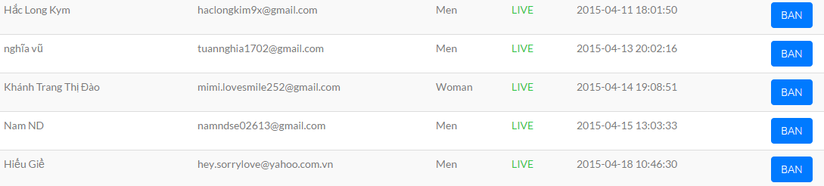

*Figure 4-167: View All User Screen*

|  |  |  |
| --- | --- | --- |
| **Element** | **Type** | **Description** |
| **Scroll** | Button | Scroll down to view more user. |
| **Page** | Button | Next page to view more user. |

##### 4.3.4.3.4. Delete Post

###### Description

* Admin delete post of user.

###### Class Diagram

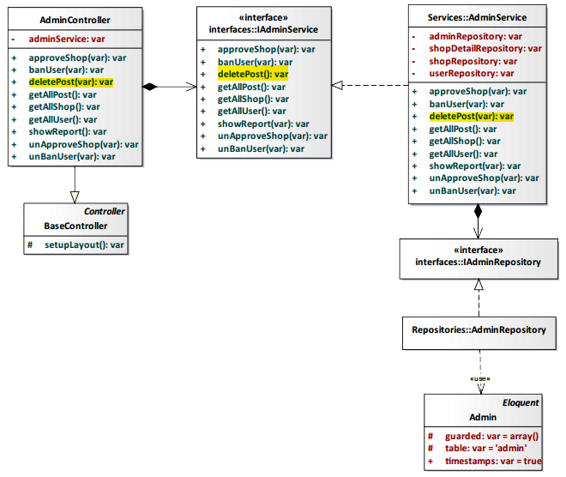

*Figure 4-168: Delete Post Class Diagram*

###### Class Specification

AdminController class

Physical Address: Trendy-Server\app\Controller*AdminController.php*

Attribute

|  |  |  |  |
| --- | --- | --- | --- |
| No | Name | Type | Description |
| 1 | adminService | var | Instance of interface using to call methods in IAdminService. |

Method: deletePost()

|  |  |  |
| --- | --- | --- |
| Purpose | Delete post of user. | |
| Return | **Type** | **Description** |
| boolean | Represents the result of an action method. Return true or false. |

AdminService class

Physical Address: Trendy-Server\app\Services*AdminService.php*

Attribute

|  |  |  |  |
| --- | --- | --- | --- |
| No | Name | Type | Description |
| 1 | adminRepository | var | Instance of interface using to call methods in IAdminRepository. |
| 2 | shopDetailRepository | var | Instance of interface using to call methods in IShopDetailRepository. |
| 3 | shopRepository | var | Instance of interface using to call methods in IShopRepository. |
| 4 | userRepository | var | Instance of interface using to call methods in IUserRepository. |

Method: deletePost()

|  |  |  |
| --- | --- | --- |
| Purpose | Delete post of user. | |
| Return | **Type** | **Description** |
| boolean | Represents the result of an action method. Return true or false. |

###### Sequence Diagram

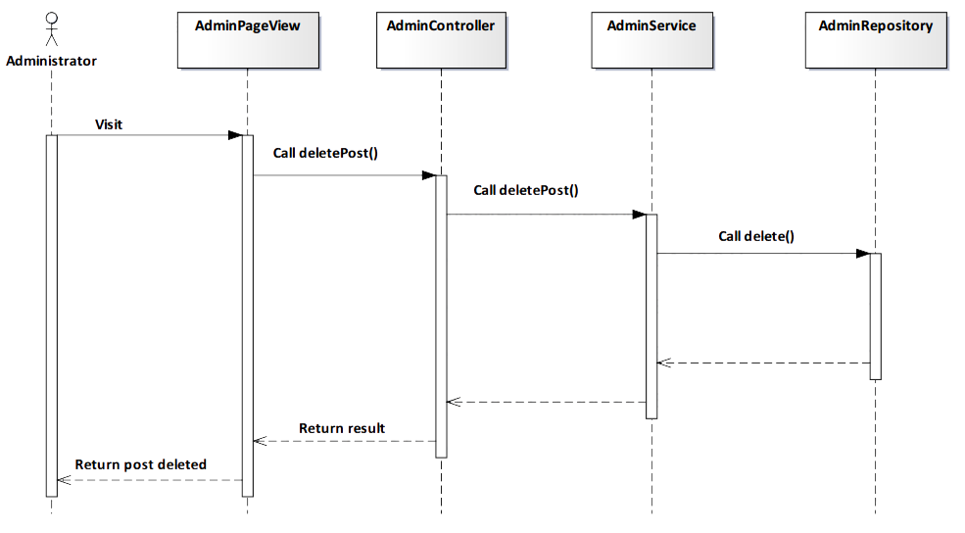

*Figure 4-169: Delete Post Sequence Diagram*

###### Screen Design

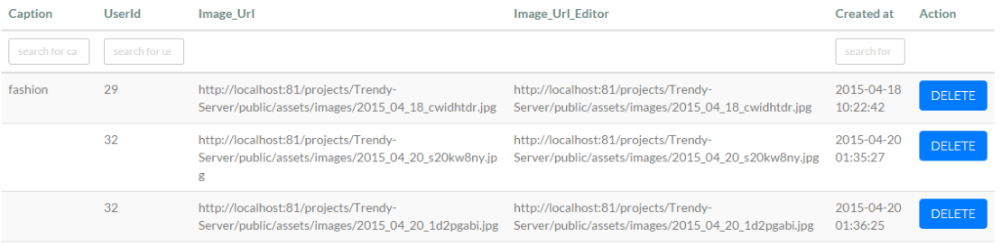

*Figure 4-170: Delete Post Screen*

|  |  |  |
| --- | --- | --- |
| **Element** | **Type** | **Description** |
| **Delete** | Button | Click to delete post. |

##### 4.3.4.3.5. View All Shop

###### Description

* Admin view list all shop.

###### Class Diagram



*Figure 4-171: View All Shop Class Diagram*

###### Class Specification

AdminController class

Physical Address: Trendy-Server\app\Controller*AdminController.php*

Attribute

|  |  |  |  |
| --- | --- | --- | --- |
| No | Name | Type | Description |
| 1 | adminService | var | Instance of interface using to call methods in IAdminService. |

Method: getAllShop()

|  |  |  |
| --- | --- | --- |
| Purpose | Show all shop for administrator. | |
| Return | **Type** | **Description** |
| arrayList | Represents the result of an action method. Return list all shop. |

AdminService class

Physical Address: Trendy-Server\app\Services*AdminService.php*

Attribute

|  |  |  |  |
| --- | --- | --- | --- |
| No | Name | Type | Description |
| 1 | adminRepository | var | Instance of interface using to call methods in IAdminRepository. |
| 2 | shopDetailRepository | var | Instance of interface using to call methods in IShopDetailRepository. |
| 3 | shopRepository | var | Instance of interface using to call methods in IShopRepository. |
| 4 | userRepository | var | Instance of interface using to call methods in IUserRepository. |

Method: getAllShop()

|  |  |  |
| --- | --- | --- |
| Purpose | Show all shop for administrator. | |
| Return | **Type** | **Description** |
| arrayList | Represents the result of an action method. Return list all shop. |

###### Sequence Diagram



*Figure 4-172: View All Shop Sequence Diagram*

###### Screen Design



*Figure 4-173: View All Shop Screen*

|  |  |  |
| --- | --- | --- |
| **Element** | **Type** | **Description** |
| **Next** | Button | Next page to view more shop. |

##### 4.3.4.3.6. Update Information Shop

###### Description

* Admin approve or unapproved request update shop’s information of user.

###### Class Diagram

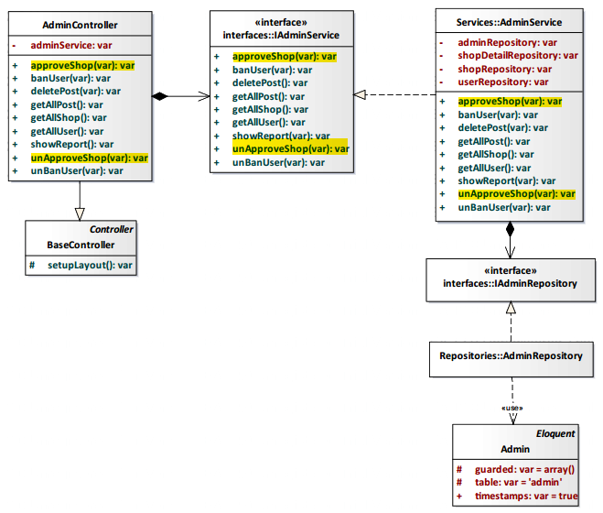

*Figure 4-174: Update Information Shop Class Diagram*

###### Class Specification

AdminController class

Physical Address: Trendy-Server\app\Controller*AdminController.php*

Attribute

|  |  |  |  |
| --- | --- | --- | --- |
| No | Name | Type | Description |
| 1 | adminService | var | Instance of interface using to call methods in IAdminService. |

Method: approveShop()

|  |  |  |
| --- | --- | --- |
| Purpose | Approve request update shop’s information of user. | |
| Return | **Type** | **Description** |
| boolean | Represents the result of an action method. Return true or false. |

Method: unAproveShop()

|  |  |  |
| --- | --- | --- |
| Purpose | Unapproved request update shop’s information of user. | |
| Return | **Type** | **Description** |
| boolean | Represents the result of an action method. Return true or false. |

AdminService class

Physical Address: Trendy-Server\app\Services*AdminService.php*

Attribute

|  |  |  |  |
| --- | --- | --- | --- |
| No | Name | Type | Description |
| 1 | adminRepository | var | Instance of interface using to call methods in IAdminRepository. |
| 2 | shopDetailRepository | var | Instance of interface using to call methods in IShopDetailRepository. |
| 3 | shopRepository | var | Instance of interface using to call methods in IShopRepository. |
| 4 | userRepository | var | Instance of interface using to call methods in IUserRepository. |

Method: approveShop()

|  |  |  |
| --- | --- | --- |
| Purpose | Approve request update shop’s information of user. | |
| Return | **Type** | **Description** |
| boolean | Represents the result of an action method. Return true or false. |

Method: unAproveShop()

|  |  |  |
| --- | --- | --- |
| Purpose | Unapproved request update shop’s information of user. | |
| Return | **Type** | **Description** |
| boolean | Represents the result of an action method. Return true or false. |

###### Sequence Diagram

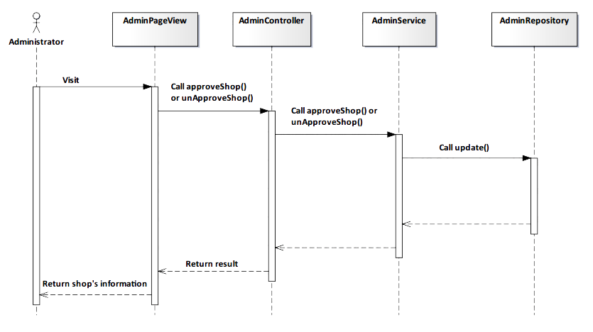

*Figure 4-175: Update Information Shop Sequence Diagram*

###### Screen Design



*Figure 4-176: Update Information Shop Screen*

|  |  |  |
| --- | --- | --- |
| **Element** | **Type** | **Description** |
| **Approve** | Button | Click to approve information shop. |
| **Unapprove** | Button | Click to unapprove information shop. |

##### 4.3.4.3.7. Ban User

###### Description

* Admin ban user in system.

###### Class Diagram

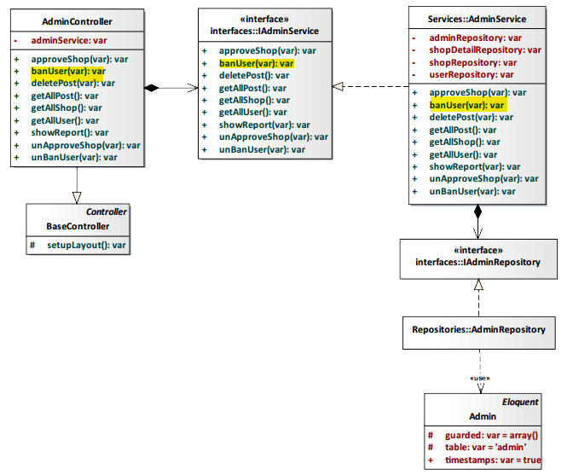

*Figure 4-177: Ban User Class Diagram*

###### Class Specification

AdminController class

Physical Address: Trendy-Server\app\Controller*AdminController.php*

Attribute

|  |  |  |  |
| --- | --- | --- | --- |
| No | Name | Type | Description |
| 1 | adminService | var | Instance of interface using to call methods in IAdminService. |

Method: banUser(var)

|  |  |  |  |  |
| --- | --- | --- | --- | --- |
| Purpose | Implementation progress ban user of administrator. | | | |
| Return | **Type** | | | **Description** |
| boolean | | | Return success or error. |
| Parameter | **No.** | **Name** | **Type** | **Description** |
| 1 | user_id | var | id of user. |

AdminService class

Physical Address: Trendy-Server\app\Services*AdminService.php*

Attribute

|  |  |  |  |
| --- | --- | --- | --- |
| No | Name | Type | Description |
| 1 | adminRepository | var | Instance of interface using to call methods in IAdminRepository. |
| 2 | shopDetailRepository | var | Instance of interface using to call methods in IShopDetailRepository. |
| 3 | shopRepository | var | Instance of interface using to call methods in IShopRepository. |
| 4 | userRepository | var | Instance of interface using to call methods in IUserRepository. |

Method: banUser(var)

|  |  |  |  |  |
| --- | --- | --- | --- | --- |
| Purpose | Implementation progress ban user of administrator. | | | |
| Return | **Type** | | | **Description** |
| boolean | | | Return success or error. |
| Parameter | **No.** | **Name** | **Type** | **Description** |
| 1 | user_id | var | id of user. |

###### Sequence Diagram

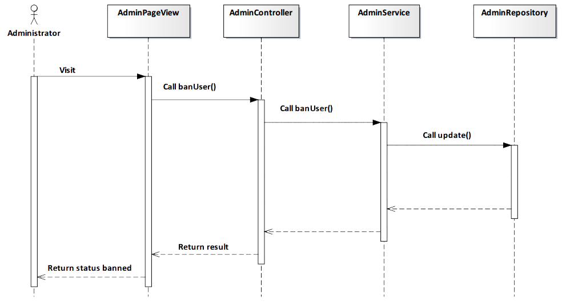

*Figure 4-178: Ban User Sequence Diagram*

###### Screen Design



*Figure 4-179: Ban User Scree*

|  |  |  |
| --- | --- | --- |
| **Element** | **Type** | **Description** |
| **Ban** | Button | Click to ban user. |

##### 4.3.4.3.8. Unban User

###### Description

* Admin unban user in system.

###### Class Diagram

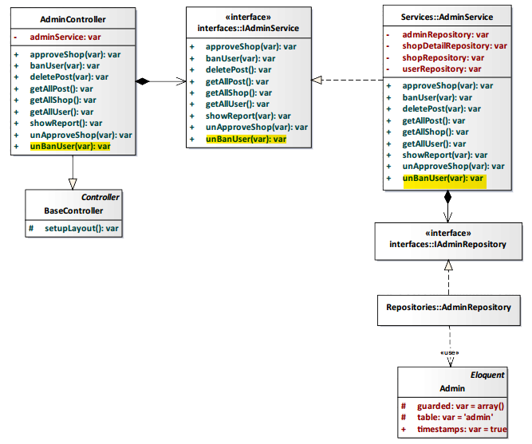

*Figure 4-180: Unban User Class Diagram*

###### Class Specification

AdminController class

Physical Address: Trendy-Server\app\Controller*AdminController.php*

Attribute

|  |  |  |  |
| --- | --- | --- | --- |
| No | Name | Type | Description |
| 1 | adminService | var | Instance of interface using to call methods in IAdminService. |

Method: unBanUser(var)

|  |  |  |  |  |
| --- | --- | --- | --- | --- |
| Purpose | Implementation progress unban user of administrator. | | | |
| Return | **Type** | | | **Description** |
| boolean | | | Return success or error |
| Parameter | **No.** | **Name** | **Type** | **Description** |
| 1 | user_id | var | id of user |

AdminService class

Physical Address: Trendy-Server\app\Services*AdminService.php*

Attribute

|  |  |  |  |
| --- | --- | --- | --- |
| No | Name | Type | Description |
| 1 | adminRepository | var | Instance of interface using to call methods in IAdminRepository. |
| 2 | shopDetailRepository | var | Instance of interface using to call methods in IShopDetailRepository. |
| 3 | shopRepository | var | Instance of interface using to call methods in IShopRepository. |
| 4 | userRepository | var | Instance of interface using to call methods in IUserRepository. |

Method: unBanUser(var)

|  |  |  |  |  |
| --- | --- | --- | --- | --- |
| Purpose | Implementation progress unban user of administrator. | | | |
| Return | **Type** | | | **Description** |
| boolean | | | Return success or error |
| Parameter | **No.** | **Name** | **Type** | **Description** |
| 1 | user_id | var | id of user |

###### Sequence Diagram

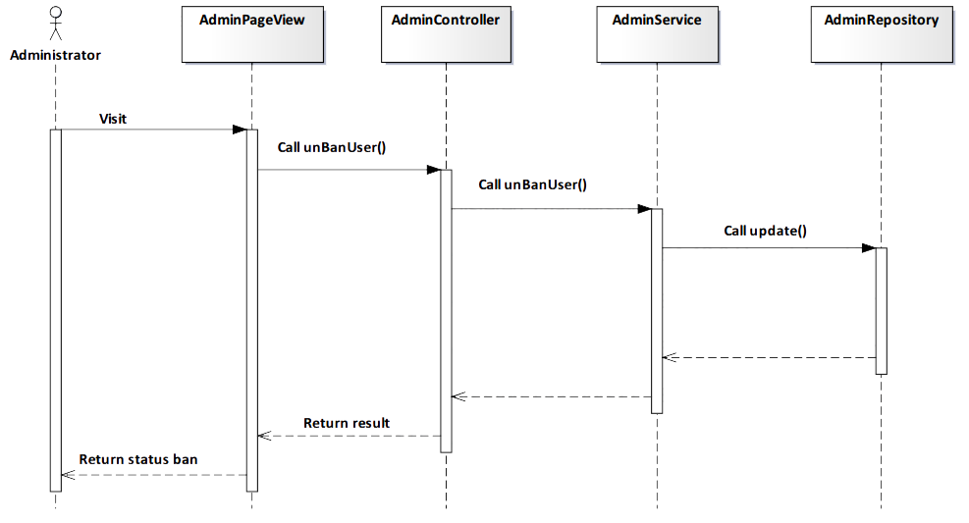

*Figure 4-181: Unban User Sequence Diagram*

###### Screen Design

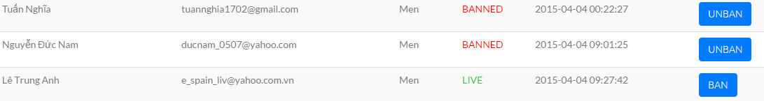

*Figure 4-182: Unban User Screen*

|  |  |  |
| --- | --- | --- |
| **Element** | **Type** | **Description** |
| **Unban** | Button | Click to unban user. |

##### 4.3.4.3.9. Show report

###### Description

* Admin view report about statistics user’s account.

###### Class Diagram

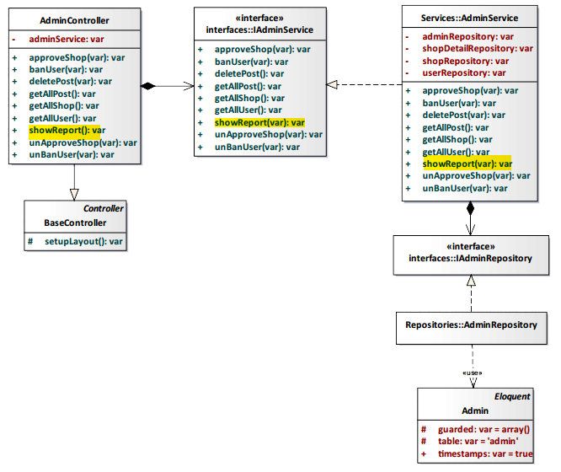

*Figure 4-183: Show Report Class Diagram*

###### Class Specification

AdminController class

Physical Address: Trendy-Server\app\Controller*AdminController.php*

Attribute

|  |  |  |  |
| --- | --- | --- | --- |
| No | Name | Type | Description |
| 1 | adminService | var | Instance of interface using to call methods in IAdminService. |

Method: showReport()

|  |  |  |
| --- | --- | --- |
| Purpose | Process and display report. | |
| Return | **Type** | **Description** |
| boolean | Represents the result of an action method. Return true or false. |

AdminService class

Physical Address: Trendy-Server\app\Services*AdminService.php*

Attribute

|  |  |  |  |
| --- | --- | --- | --- |
| No | Name | Type | Description |
| 1 | userResponsitory | var | Instance of interface using to call methods in IUserResponsitory |
| 2 | shopResponsitory | var | Instance of interface using to call methods in IShopResponsitory |
| 3 | postResponsitory | var | Instance of interface using to call methods in IPostResponsitory |
| 4 | adminResponsitory | var | Instance of interface using to call methods in IAdminResponsitory |
| 5 | postAlbumResponsitory | var | Instance of interface using to call methods in IAdminResponsitory |

Method: showReport()

|  |  |  |
| --- | --- | --- |
| Purpose | Process and display report. | |
| Return | **Type** | **Description** |
| boolean | Represents the result of an action method. Return true or false |

###### Sequence Diagram

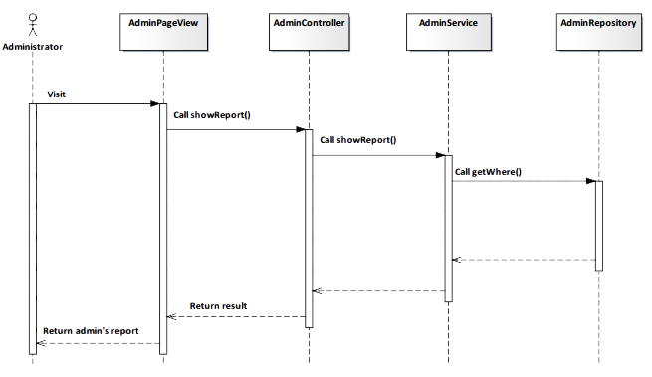

*Figure 4-184: Show Report Sequence Diagram*

###### Screen Design

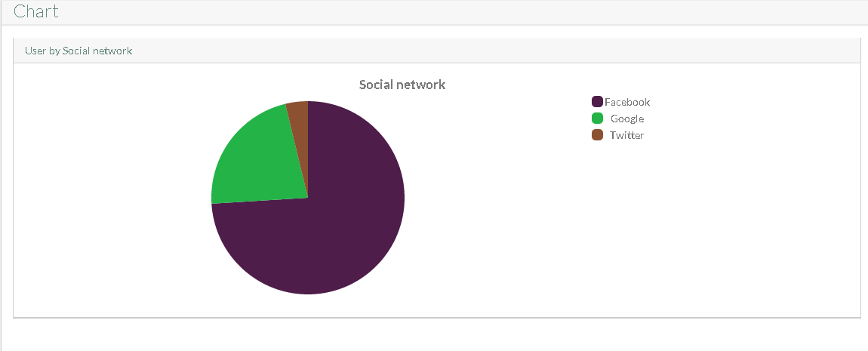

*Figure 4-185: Show Report User’s account Screen*

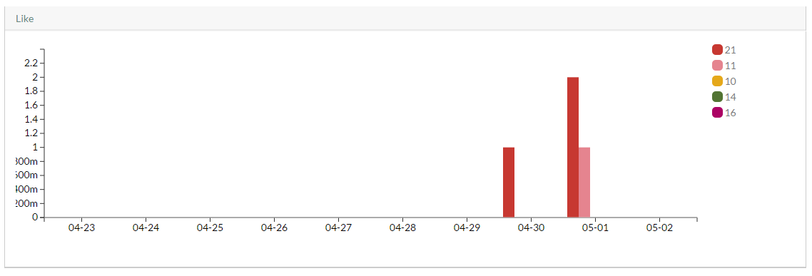

*Figure 4-186: Show Report Like quantity Screen*

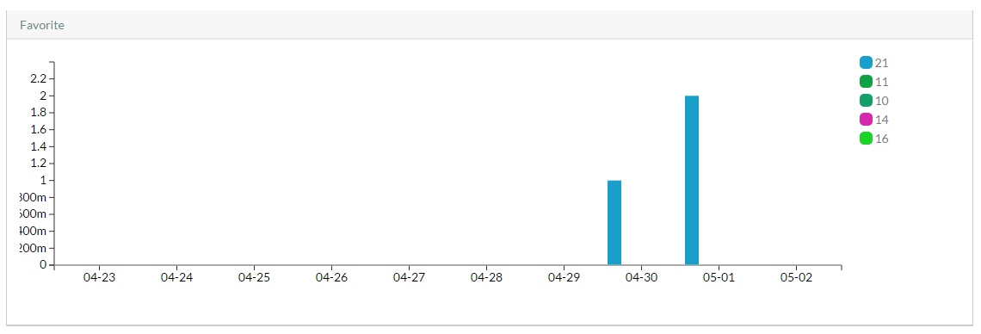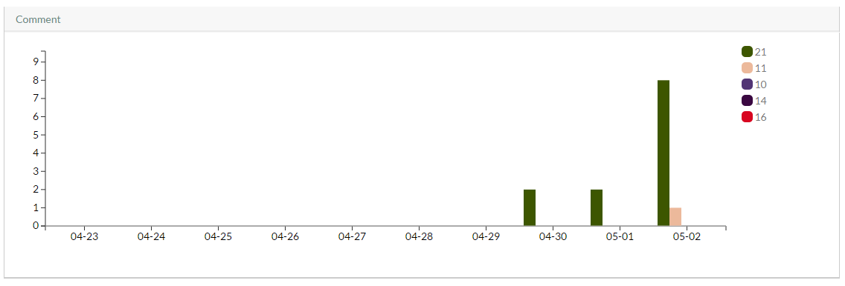

*Figure 4-187: Show Report Favorite quantity Screen*

*Figure 4-187: Show Report Comment quantity Screen*

# CHAPTER 5: SOFTWARE TESTING DOCUMENTATION

## 5.1. Introduction

### 5.1.1. Purpose

The primary purpose of this report is to detect software failures so that defects may be discovered and correct to ensure that our project is thoroughly tested and resulting in a successful implementation of a new social website we are developing. It contains the following sections:

* Scope of Testing.
* Testing Tool and Environment.
* Resources and responsibilities.
* Test strategy: Test approach, test stages.
* Test schedule.
* Feature to be tested.
* Feature not to be tested.
* Defect Log.
* Test report.

### 5.1.2. Scope of testing

#### Stages of testing:

There are 4 phases in Testing Process: Unit testing, Integration testing, System testing and Acceptance testing.

|  |  |  |  |
| --- | --- | --- | --- |
| **ID** | **Test Stages** | **Description** | **The implementation** |
| **1** | **Unit testing** | Unit testing will be done by the developer and approved by the development team leader. | Developer:  - Vu Tuan Nghia.  - Nguyen Duc Nam.  - Do Thanh Luan.  - Le Trung Anh.  (Build by xampp v3.2.1) |
| **2** | **Integration testing** | Integration testing will be performed by testers. Requirements of the system will be tested in functional flow. Starting after unit testing complete for each flow.  Focuses on specific areas of uses case when all requirements are completed, integration test should be performed to ensure all components incorporate well. | All team member.  (Build by xampp v3.2.1) |
| **3** | **System testing** | System Testing will be performed by the tester and development team leader with assistance from the individual developers as required. No specific test tools are available for this project. Programs will enter into System/Integration test after all critical defects have been corrected. |
| **4** | **Acceptance testing** | Acceptance testing consist of Alpha Test and Beta Test will be executed by all team members, stand at end user point of view. Determine whether a system satisfies the requirements specified in the requirements analysis phase. Finding defects is not the main focus in this stage.  Acceptance testing will assess the system’s readiness for deployment and using. | All member and people with internet.  (Build in host with domain trendyplus.org) |

*Tale 5-1: Stages of testing’s*

#### **Types of testing:**

The test team has to test the following type on Google Chrome:

* GUI test
* Function test
* Performance test
* Regression test
* Acceptance test

#### Range of testing:

Team performs all functions defined in the SRS based on the approved version.

## 5.2. Test Plan

### 5.2.1. Testing tool and environment

#### 5.2.1.1. Testing tool

* **Google Chrome v43.0:** Used for test size of web page and size of component on page.



*Figure 5-1: Google Chrome*

* **Color Picker v43.0:** Pixel Perfect Tool from Google Chrome Application used for read color ID of Picture and web page.



*Figure 5-2: Color Picker*

* **HostedRedmine v1.4:** Log bug. ([www.hostedredmine.com](http://www.hostedredmine.com)).



*Figure 5-3: HostedRedmine*

#### 5.2.1.2. Testing Environment

The contents of the Testing Environment is shown in the table below:

|  |  |
| --- | --- |
| **Software** | **Hardware** |
| Testing environment consist:   * Google Chrome v42.0. | Personal computer for developing with the minimum configuration:   * Windows 8 Professional 64-bit, SP 1 * Inter® Core™ i3. * Install memory (RAM): 4.00GB. |

*Tale 5-2: Testing Environment*

### 5.2.2. Resources and responsibilities

This table shows the staffing assumptions for our project:

|  |  |  |
| --- | --- | --- |
| **ID** | **Resources** | **Responsibilities** |
| 1 | Project Manager | * Responsible for Project Schedules and overall success of the project. * Review Test-case and report. |
| 2 | Tester | * Preforming the actual system testing. * Manage test resource and assign test tasks. * Create Test Plan. * Create Test Cases. * Create Test Report. * Execute Test. * Test Log report. |
| 3 | Developer | * Create pUnit Test. * Test API. * Fix bugs. |

*Tale 5-3: Resources and Responsibilities*

### 5.2.3. Test strategy

#### 5.2.3.1. Test Model

This project follows V-Model process to implement testing. The V model takes the bottom half of the waterfall model and bends it upward into the form of a V, so that the activities on the right verify or validate the work products of the activity on the left. Below figure demonstrates the relationships between each phase of the development life cycle and its associated phase of testing.

More specifically, the left side of the V represents the analysis activities that decompose the users’ needs into small, manageable pieces, while the right side of the V shows the corresponding synthesis activities that aggregate (and test) these pieces into a system that need system that meets the users’ needs.

The V-Model demonstrates the relationships between each phase of the development life cycle and its associated phase of testing. The horizontal and vertical axes represent time or project completeness (left-to-right) and level of abstraction. Advances in the production of executable requirements, architectures, and designs enable testing to begin much earlier on the left side of the V so that requirements, architecture, and design defects can be found and fixed early before they can propagate into downstream work products.

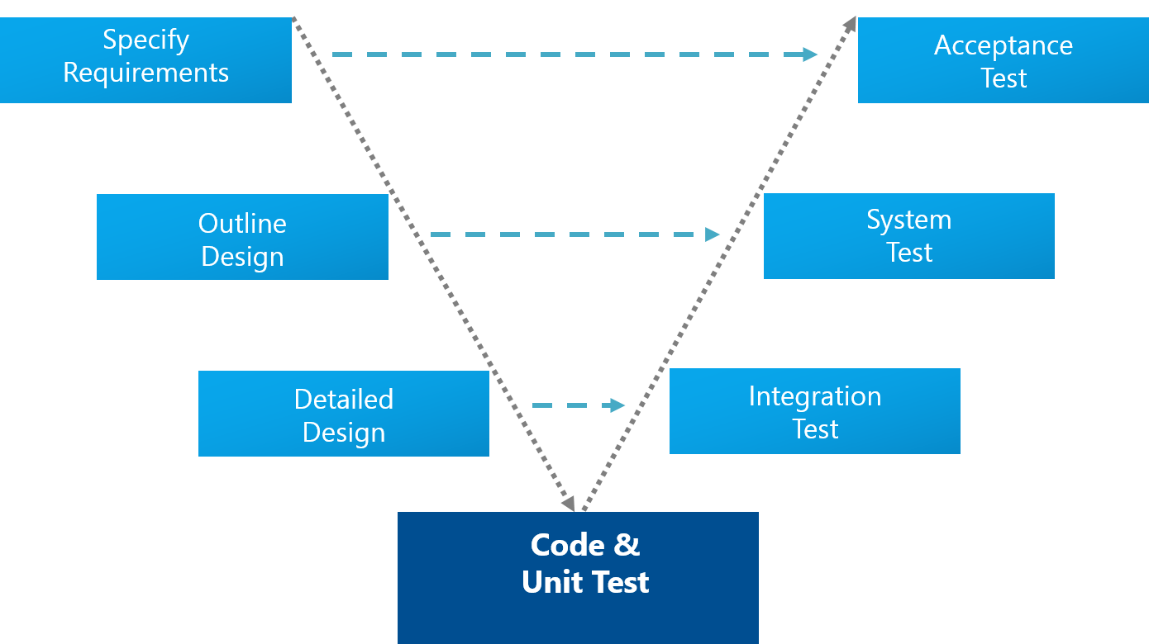

*Figure 5-4: V-Model*

#### 5.2.3.2. Test Types

Testing TrendyPlus project will be carrying out in each release package as defined in project plan and depends on internal delivery by development side. Critical test will be defined as any new or modified test for the TrendyPlus system. Project Manager will decide which closed defects which the test team cannot determine.

The different types of testing that will be carry out this project are.

* **Function Test:**
* Testing of all implemented functions on the TrendyPlus system.
* The testing that will be covered for those functions in function test is verification the validation of the behavior according to requirements.
* Test cases will have to be designed to cover all the above and executed.
* Implemented function’s error message will be included under this test.
* **GUI Test**
* Graphical User Interface (GUI) Testing verifies a user’s interaction with the software. The goal of GUI testing is to ensure that the GUI provides the user with the appropriate access and navigation through the functions of the target-of-test. In addition, GUI testing ensures that the objects within the GUI function as expected and conform to requirement.
* GUI test will be performed fully on all screens.
* This test is targeted to cover the verification of the overall look and feel of the TrendyPlus system including initial position, font, text size, color, focus, initial button, tab order, label, screen sizes and sentences width.
* Check all the GUI elements for size, position, width, length and acceptance of characters or numbers. For instance, it must be able to provide inputs to the input fields.
* Check Error Messages are displayed correctly.
* Check Font used in application is readable.
* Check the alignment of the text is proper.
* Check the Color of the font and warning messages is aesthetically pleasing.
* Check that the images have good clarity.
* Check that the images are properly aligned.
* Check the positioning of GUI elements for different screen resolution.
* **Performance Test:**
* The testing that will be covered for response time for TrendyPlus system.
* **Regression test:**
* The testing is confirmed that the bug was removed including the extent of the impact.
* **Acceptance test:**
* The testing is a test conducted to determine if the requirements of a specification or contract are met.
* It involves alpha testing and beta testing. Alpha testing takes place at developers' sites, and involves testing of the operational system by internal member, before it is released to external users. Beta testing takes place at user’s sites, and involves testing by a group of users who use the system at their own locations and provide feedback, before the system is released to all users.

#### 5.2.3.3. Test Stage

Table below are the stages in which common test are executed:

|  |  |  |  |
| --- | --- | --- | --- |
| **Type of Tests** | **Stage of Test** | | |
| **Unit** | **Integration** | **System** |
| Function Tests | **√** | **√** | **√** |
| API Tests | **√** | **√** | **√** |
| GUI Tests |  | **√** | **√** |
| Regression Tests |  | **√** | **√** |
| Performance Tests |  |  | **√** |
| Acceptance Tests |  |  | **√** |

*Tale 5-4: Test Stage*

#### 5.2.3.4. Test Schedule

Table below are the Test Schedule for TrendyPlus Project. That consist of 4 phases:

|  |  |  |
| --- | --- | --- |
| **Test Schedule** | **Start Date** | **End Date** |
| Phase 1: Pilot project |  |  |
| Unit Testing | 20/03/2015 | 01/04/2015 |
| Phase 2: Main features  (version 1.0) |  |  |
| User Interface Testing | 01/04/2015 | 10/04/2015 |
| Functional Testing | 01/04/2015 | 10/04/2015 |
| Performance Tests | 01/04/2015 | 10/04/2015 |
| Regression Tests | 01/04/2015 | 10/04/2015 |
| Phase 3: Other features and optimization  (version 2.0) |  |  |
| User Interface Testing | 10/04/2015 | 19/04/2015 |
| Functional Testing | 10/04/2015 | 19/04/2015 |
| Performance Tests | 10/04/2015 | 19/04/2015 |
| Scenario Tests | 10/04/2015 | 19/04/2015 |
| Regression Tests | 10/04/2015 | 19/04/2015 |
| Phase 4: Deployment  (version 10.0) |  |  |
| Acceptance testing | 19/04/2015 | 22/04/2015 🡪 then |

#### 5.2.3.5. Deliverables

*Tale 5-5: Test Schedule*

Table below are the Deliverables for TrendyPlus Project:

|  |  |  |
| --- | --- | --- |
| **Deliverables** | **Responsibilities** | **Completion date** |
| Test Plan | Tester | 20/03/2015 |
| Test Cases | Tester | 27/03/2015 |
| Test case review | Tester + PM | 01/04/2015 |
| Test Data (Data Set) | Tester | 14/04/2015 |
| Defect report | All members | 19/04/2015 |
| Final test Summary report | PM | 23/04/2015 |

*Tale 5-6: Deliverables*

### 5.2.4. Feature to be tested

|  |  |  |
| --- | --- | --- |
| **Components** | | **Description** |
| **Group** | Function |
| **Guest** | Login | Login to TrendyPlus |
| View Trendy | View Trendy |
| View Newsfeed | View Newsfeed |
| View User page | View User page |
| View Shop page | View Shop page |
| View Around Here | View Around Here |
| My Location | My Location |
| View Album | View Album |
| View Post | View Post |
| View Shop on map | View Shop on map |
| Get all Album of user | Get all Album of user |
| Suggest related user | Suggest related user |
| **Register User** | Create Album | Create Album |
| Delete Album | Delete Album |
| Edit Album | Edit Album |
| Add Post’s comment | Add Post’s comment |
| Edit Post’s comment | Edit Post’s comment |
| Delete Post’s comment | Delete Post’s comment |
| View Post’s comment | View Post’s comment |
| Add Shop’s comment | Add Shop’s comment |
| Edit Shop’s comment | Edit Shop’s comment |
| Delete Shop’s comment | Delete Shop’s comment |
| View Shop’s comment | View Shop’s comment |
| Add Post | Add Post |
| Editor Image | Editor Image |
| Image tagging | Image tagging |
| Content tagging | Content tagging |
| Delete Post | Delete Post |
| Edit Post | Edit Post |
| Like Post | Like Post |
| Unlike Post | Unlike Post |
| Share Post | Share Post |
| Create Shop | Create Shop |
| Suggest Shop | Suggest Shop |
| Suggest Shop’s Information | Suggest Shop’s Information |
| View Shop Detail | View Shop Detail |
| Like Shop | Like Shop |
| Unlike Shop | Unlike Shop |
| View Following | View Following |
| View Follower | View Follower |
| Add Follow | Add Follow |
| Remove Follow | Remove Follow |
| Add Favorite | Add Favorite |
| Remove Favorite | Remove Favorite |
| Subscribe Notification | Subscribe Notification |
| View Notification | View Notification |
| Change Cover | Change Cover |
| Logout | Logout |
| General Search | General Search |
| Search on Map | Search on Map |
| **Administrator** | Search User | Search User |
| Search Shop | Search Shop |
| View All User | View All User |
| Delete Post | Delete Post |
| View All Shop | View All Shop |
| Update Information Shop | Update Information Shop |
| Ban User | Ban User |
| Unban User | Unban User |

*Tale 5-7: Feature to be tested*

### 5.2.5. Feature not to be tested

* Out of scope features will not to be tested.

## 5.3. Test Approach

### 5.3.1. Unit Test

* Test API:
* Using the REST Client within PHPStorm.

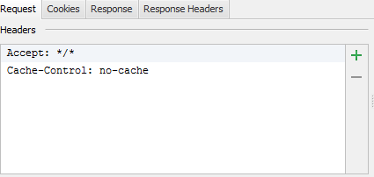

*Figure 5-5: Test API*

When building REST – based web APIs, it’s worth having a tool available to invoke them over HTTP. The current versions PHPStorm 8.0 contain a bundled REST Client plugin which allows us to do just that.

We’ll be using PHPStorm as our IDE, invoking an API built using the Laravel framework. The API we’ll be testing using the REST Client plugin is fairly straightforward: it exposes an array of users through a REST endpoint. The projects/Trendy-Server/public/api/user/ endpoint returns the entire array of users. The projects/Trendy-Server/public/api/user/getUser/:id endpoint returns a specific user when issuing a GET request and writes a user to the array when issuing a POST request.

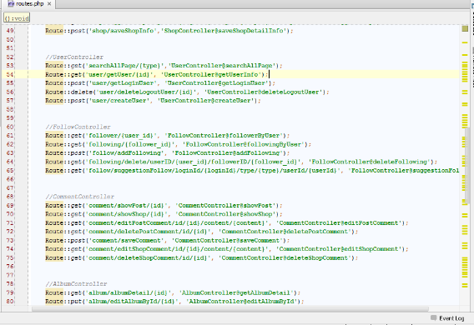

*Figure 5-6: Get Route*

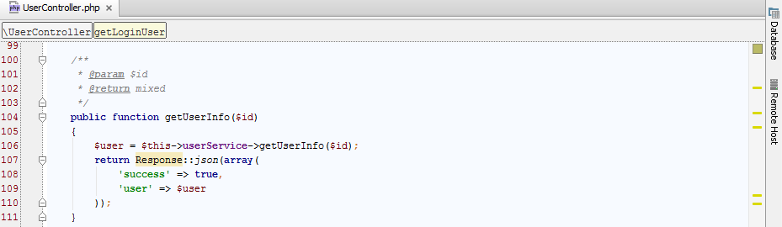

*Figure 5-7: UserController.php*

The REST Client can be found under Tools | Test RESTful Web Service. A new tab will be opened which gives us the possibility to craft an HTTP request which will be invoked against our API. We can specify the HTTP method to be used, the host where our API is located, and the path to be invoked. Other than that, we can add header data as well as query string parameters or a request body to be sent to the API.

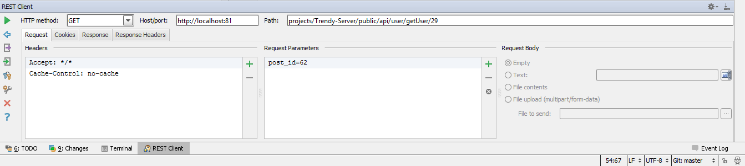

*Figure 5-8: REST Client GET*

Upon invoking the request by clicking the green Run button, the REST Client connects to our API and gathers the response data. We can easily inspect the response body as well as the response headers, each available through their own result tab.

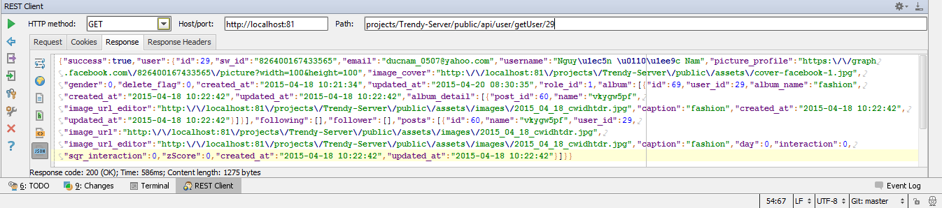

*Figure 5-9: REST Client Response*

To create a user in our API, invoke a POST request providing JSON data in the request parameters.

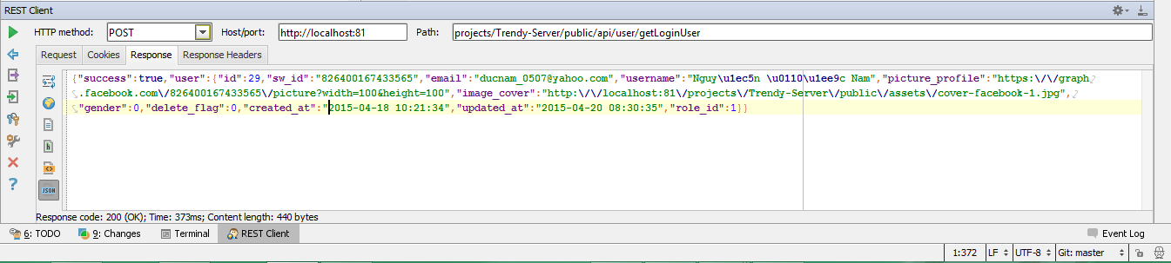

*Figure 5-10: REST Client POST*

### 5.3.2. Integration and System Test

* The detailed Test case will be described in ***TestCase_Final.xlsx***

### 5.3.3. Acceptance Test

* Build website to host with domain name is **trendyplus.org**.
* Invite friends use and comment.
* Fix bug arising when people use.

### 5.3.4. Defect Log

* TrendyPlus project used [www.hostedredmine.com](http://www.hostedredmine.com)to manager bug list.
* Every member of TrendyPlus project created an account in [www.hostedredmine.com](http://www.hostedredmine.com)to get bug and fix bug.
* Processes:
* Tester log bug to hostedredmine.com with status *“Assigned”* and assign developer.
* Developer fix bug and change status bug in hostedredmine.com to *“Resolved”* and assign tester who log bug.
* Tester check bug again:
* If bug fixed, check relating test case and Tester change status to *“Closed”*.
* If bug didn’t fix, Tester change status to *“Open”* and assign again developer.

## 5.4. Test Report

* **Test coverage**: ([number of test cases pass] + [number of test cases Fail] ) / ([number of test cases] - [number of test cases N/A]).
* **Test successful coverage:** [number of test cases pass] / ([number of test cases] - [number of test cases N/A]).

### 5.4.1. Version 1.0

* **Before:**
* This version have not admin page.

|  |  |  |  |  |  |  |
| --- | --- | --- | --- | --- | --- | --- |
| **No** | **Module Test** | **Pass** | **Fail** | **Untested** | **N/A** | **Number of test cases** |
| 1 | Login-1 | 76 | 0 | 0 | 0 | 76 |
| 2 | Login-2 | 0 | 72 | 0 | 0 | 72 |
| 3 | Login-3 | 0 | 0 | 72 | 0 | 72 |
| 4 | Logout | 3 | 0 | 0 | 0 | 3 |
| 5 | Cache Login | 4 | 0 | 0 | 0 | 4 |
| 6 | Time Out | 4 | 0 | 0 | 0 | 4 |
| 7 | Screen | 11 | 40 | 11 | 0 | 62 |
| 8 | Map | 15 | 3 | 0 | 0 | 18 |
| 9 | Shop | 34 | 0 | 0 | 0 | 34 |
| 10 | Post and album | 58 | 25 | 0 | 0 | 83 |
| 11 | Follow | 4 | 15 | 0 | 0 | 19 |
| 12 | Trendy | 3 | 0 | 0 | 0 | 3 |
| 13 | Admin | 0 | 0 | 0 | 30 | 30 |
| 14 | Other | 34 | 2 | 0 | 0 | 36 |
|  | **Sub total** | 246 | 157 | 83 | 30 | 516 |
|  | **Test coverage** | 82.92 | % |  |  |  |
|  | **Test successful coverage** | 50.62 | % |  |  |  |

* **DETECTION:** 24 bug

*Tale 5-8: Version 01 detection*

* **After:**

|  |  |  |  |  |  |  |
| --- | --- | --- | --- | --- | --- | --- |
| **No** | **Module Test** | **Pass** | **Fail** | **Untested** | **N/A** | **Number of test cases** |
| 1 | Login-1 | 76 | 0 | 0 | 0 | 76 |
| 2 | Login-2 | 72 | 0 | 0 | 0 | 72 |
| 3 | Login-3 | 0 | 0 | 72 | 0 | 72 |
| 4 | Logout | 3 | 0 | 0 | 0 | 3 |
| 5 | Cache Login | 4 | 0 | 0 | 0 | 4 |
| 6 | Time Out | 4 | 0 | 0 | 0 | 4 |
| 7 | Screen | 23 | 28 | 11 | 0 | 62 |
| 8 | Map | 15 | 3 | 0 | 0 | 18 |
| 9 | Shop | 34 | 0 | 0 | 0 | 34 |
| 10 | Post and album | 83 | 0 | 0 | 0 | 83 |
| 11 | Follow | 4 | 15 | 0 | 0 | 19 |
| 12 | Trendy | 3 | 0 | 0 | 0 | 3 |
| 13 | Admin | 0 | 0 | 0 | 30 | 30 |
| 14 | Other | 34 | 2 | 0 | 0 | 36 |
|  | **Sub total** | 355 | 48 | 83 | 30 | 516 |
|  | **Test coverage** | 82.92 | % |  |  |  |
|  | **Test successful coverage** | 73.05 | % |  |  |  |

* **FIXED:** 22 bug

*Tale 5-9: Version 01 fixed*

### 5.4.2. Version 2.0

* **Before:**

|  |  |  |  |  |  |  |
| --- | --- | --- | --- | --- | --- | --- |
| **No** | **Module Test** | **Pass** | **Fail** | **Untested** | **N/A** | **Number of test cases** |
| 1 | Login-1 | 76 | 0 | 0 | 0 | 76 |
| 2 | Login-2 | 72 | 0 | 0 | 0 | 72 |
| 3 | Login-3 | 72 | 0 | 0 | 0 | 72 |
| 4 | Logout | 3 | 0 | 0 | 0 | 3 |
| 5 | Cache Login | 4 | 0 | 0 | 0 | 4 |
| 6 | Time Out | 4 | 0 | 0 | 0 | 4 |
| 7 | Screen | 43 | 19 | 0 | 0 | 62 |
| 8 | Map | 18 | 0 | 0 | 0 | 18 |
| 9 | Shop | 26 | 8 | 0 | 0 | 34 |
| 10 | Post and album | 77 | 6 | 0 | 0 | 83 |
| 11 | Follow | 4 | 15 | 0 | 0 | 19 |
| 12 | Trendy | 3 | 0 | 0 | 0 | 3 |
| 13 | Admin | 11 | 19 | 0 | 0 | 30 |
| 14 | Other | 36 | 0 | 0 | 0 | 36 |
|  | **Sub total** | 449 | 67 | 0 | 0 | 516 |
|  | **Test coverage** | 100 | % |  |  |  |
|  | **Test successful coverage** | 87.02 | % |  |  |  |

* **DETECTION:** 30 new bug.

*Tale 5-10: Version 02 detection*

* **After:**

|  |  |  |  |  |  |  |
| --- | --- | --- | --- | --- | --- | --- |
| **No** | **Module Test** | **Pass** | **Fail** | **Untested** | **N/A** | **Number of test cases** |
| 1 | Login-1 | 76 | 0 | 0 | 0 | 76 |
| 2 | Login-2 | 72 | 0 | 0 | 0 | 72 |
| 3 | Login-3 | 72 | 0 | 0 | 0 | 72 |
| 4 | Logout | 3 | 0 | 0 | 0 | 3 |
| 5 | Cache Login | 4 | 0 | 0 | 0 | 4 |
| 6 | Time Out | 4 | 0 | 0 | 0 | 4 |
| 7 | Screen | 62 | 0 | 0 | 0 | 62 |
| 8 | Map | 18 | 0 | 0 | 0 | 18 |
| 9 | Shop | 34 | 0 | 0 | 0 | 34 |
| 10 | Post and album | 83 | 0 | 0 | 0 | 83 |
| 11 | Follow | 19 | 0 | 0 | 0 | 19 |
| 12 | Trendy | 3 | 0 | 0 | 0 | 3 |
| 13 | Admin | 30 | 0 | 0 | 0 | 30 |
| 14 | Other | 36 | 0 | 0 | 0 | 36 |
|  | **Sub total** | 516 | 0 | 0 | 0 | 516 |
|  | **Test coverage** | 100 | % |  |  |  |
|  | **Test successful coverage** | 100 | % |  |  |  |

* **FIXED:** 32 bug (30 new bugs and 2 old bugs from last version).

*Tale 5-11: Version 02 fixed*

### 5.4.3. Version 10.0

* Version is building on host domain trendyplus.org
* When people detect error of system, they can comment and inform to team TrendyPlus

**Then:** TrendyPlus received 2 leakages from end user, and fixed it.

### 5.4.4. Bug list report

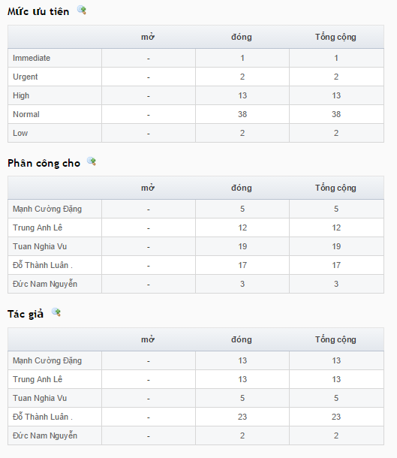

*Figure 5-10: Bug list report*

# CHAPTER 6: INSTALLATION GUIDE & USER MANUAL

## 6.1. Purpose

The purpose of this chapter is:

* Describe the steps to deploy the website and database server to a new system.
* Guide users through the website’s features.

## 6.2. Deployment Guidelines

### 6.1.1. Environment

* Ubuntu 14.04

### 6.1.2. Deployment

#### 6.1.2.1. Install composer

* Official installation guide: https://getcomposer.org/doc/00-intro.md#installation-nix.
* Quick:

$ curl -sS https://getcomposer.org/installer | php

$ sudo mv composer.phar /usr/local/bin/composer

#### 6.1.2.2. Install Apache2, PHP, MySQL

* **Install Apache2**

$ sudo apt-get install apache2

* **Install Lastest stable PHP**

$ sudo apt-get install php5 libapache2-mod-php5

* **Install PHP modules**

$ sudo apt-get install php5-mysql php5-curl php5-gd php5-intl php-pear php5-imagick php5-imap php5-mcrypt php5-memcache php5-ming php5-ps php5-pspell php5-recode php5-snmp php5-sqlite php5-tidy php5-xmlrpc php5-xsl

* **Install MySQL**

$ sudo apt-get install mysql-server mysql-client

* **Enable mod rewrite**

$ sudo a2enmod rewrite

$ sudo service apache2 restart

* **Change php.ini properties**
* Edit file /etc/php5/apache2/php.ini and set these values
* post_max_size = 18M
* upload_max_filesize = 10M

#### 6.1.2.3. Install Git

* $ sudo apt-get update
* $ sudo apt-get install git

#### 6.1.2.4. Install Node.js

* $ sudo apt-get install Node.js
* $ sudo apt-get install npm

#### 6.1.2.5. Install Redis

* $ sudo apt-get update
* $ sudo apt-get install build-essential
* $ sudo apt-get install tcl8.5
* wget <http://download.redis.io/releases/redis-2.8.9.tar.gz>
* $ tar xzf redis-2.8.9.tar.gz
* $ cd redis-2.8.9
* $ sudo make install
* $ cd utils
* $ sudo ./install_server.sh

#### 6.1.2.6. Install server code

##### 6.1.2.6.1. Install API server

* clone source code from git to folder (/Trendy-Server) to server.
* Git clone https://github.com/bonbon1702/Trendy-Server.git
* chmod tmp folder, upload folder, and export folder to 777
* $ sudo chmod -R 777 /var/www/Trendy-Server/
* Create database named socialnw (or any name you want)
* Edit database configurations at /var/www/Trendy-Server /app/config/database.php and edit the db name, user and password
* Dump autoload and migrate database

$ cd /var/www/Trendy-Server/

$ php composer.phar dump-autoload

$ php artisan migrate

* Create virtual host file /etc/apache2/sites-available/trendy-server.conf with these values

<VirtualHost *:8081>

DocumentRoot /var/www/Trendy-Server/public

<Directory /var/www/Trendy-Server/public>

Options Indexes FollowSymLinks

AllowOverride All

Require all granted

</Directory>

</VirtualHost>

* Restart apache

$ sudo service apache2 restart

##### 6.1.2.6.2. Install TrendyPlus website

* Clone source code from git to folder (/TrendyPlus) to server.
  + Git clone <https://github.com/bonbon1702/Trendy-Client>.git
* chmod tmp folder, upload folder, and export folder to 777

$ sudo chmod -R 777 /var/www/TrendyPlus/

* Create virtual host file /etc/apache2/sites-available/trendy-server.conf with these values

<VirtualHost *:80>

DocumentRoot /var/www/TrendyPlus/

<Directory /var/www/TrendyPlus/>

Options Indexes FollowSymLinks

AllowOverride All

Require all granted

</Directory>

</VirtualHost>

* Edit app/app.js: point your ip address, port 8081 /api to $rootScope.url
* Example: $rootScope.url = 'http://103.7.40.222:8081/api/';
* Restart apache

$ sudo service apache2 restart

##### 6.1.2.6.3. Install Node.js server

* clone source code from git to folder (/Node.js) to server.
* Git clone <https://github.com/bonbon1702/Nodejs.git>
* npm install socket.io express redis
* Start server: Node.js server.js

## 6.3. User Guidelines

### Login

1. When actor accesses to TrendyPlus, actor clicks on to *“Login”* button.



*Figure 6-1: Navigation Bar*

1. Actor clicks on one of three buttons: *“Join using for Facebook Account”*, “*Join using for Google Account*”, *“Join using for Twitter Account”* to log in by social networking account.



*Figure 6-2: Login pop-up*

### View Trendy

1. Actor logins.
2. In *“Trendy”* tab, actor clicks on one of multiple tags in *“All The Time”.*
3. TrendyPlus will display trendy order by tag that actor chose.

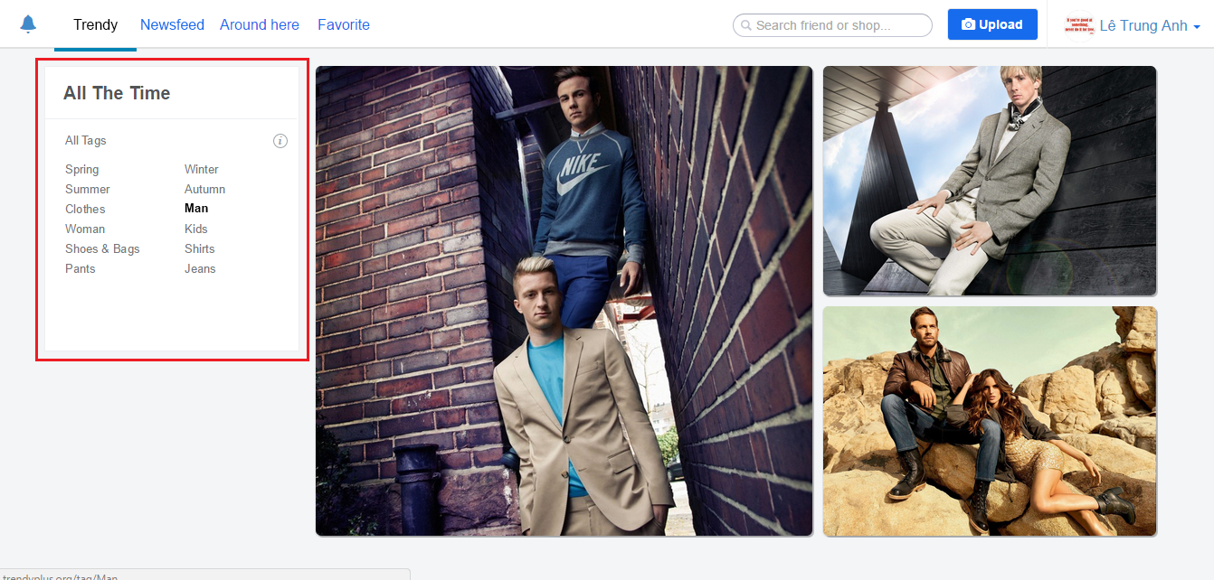

*Figure 6-3: Trendy tab*

### View Newsfeed

1. Actor logins.
2. In *“Newsfeed”* tab, TrendyPlus will displays newsfeed with activities of people that actor is following.

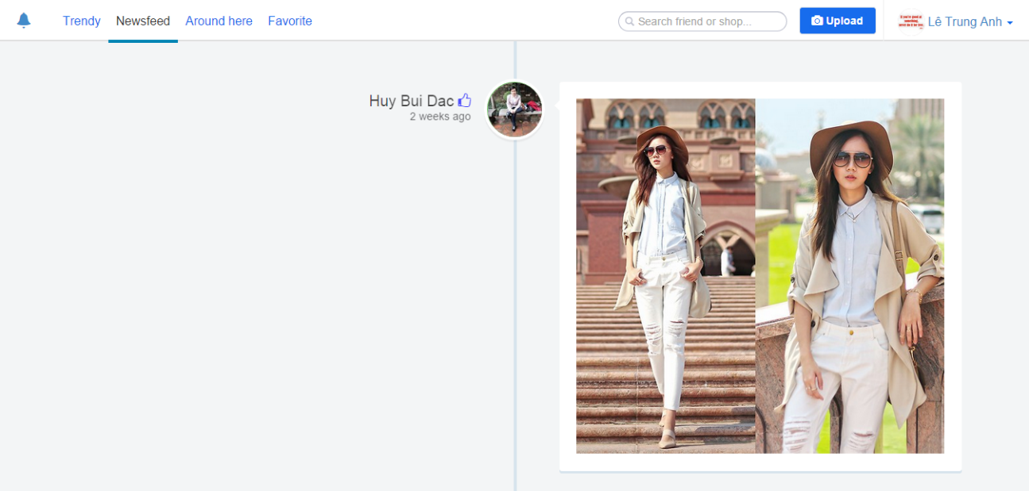

*Figure 6-4: Newsfeed tab*

### Around here

1. Actor clicks on to *“Around here”* tab when actor accesses into TrendyPlus.
2. Actor clicks on to  button.
3. TrendyPlus displays all post near actor.

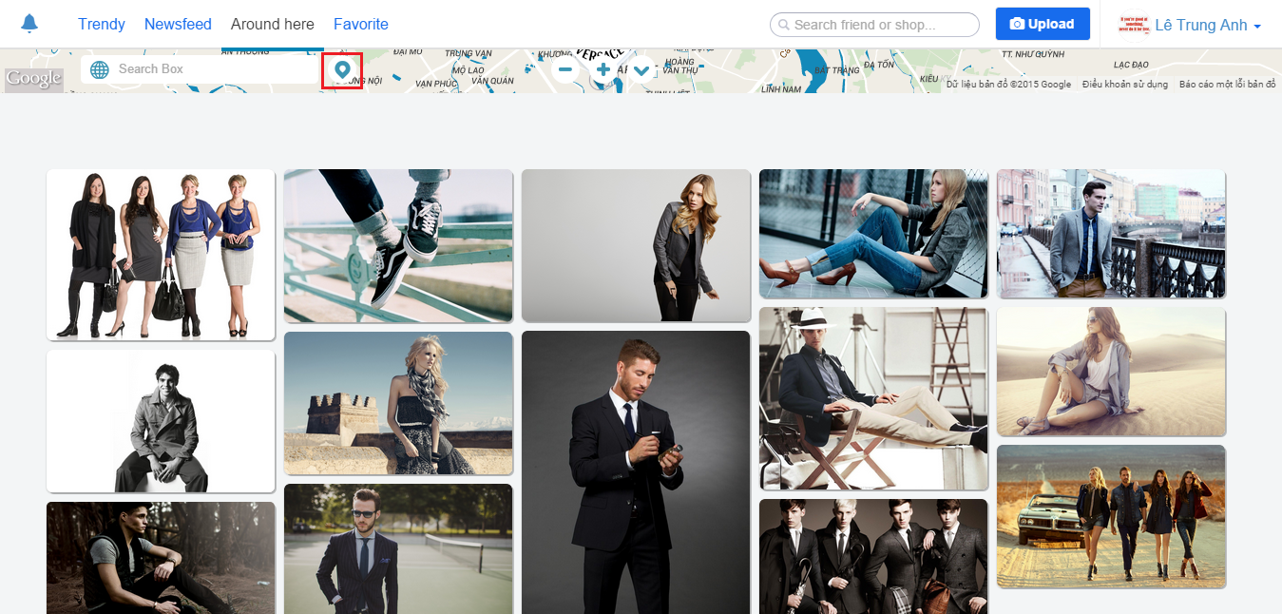

*Figure 6-5: Around here tab*

### My Location

1. In *“Around here”* tab, actors clicks on to  button.

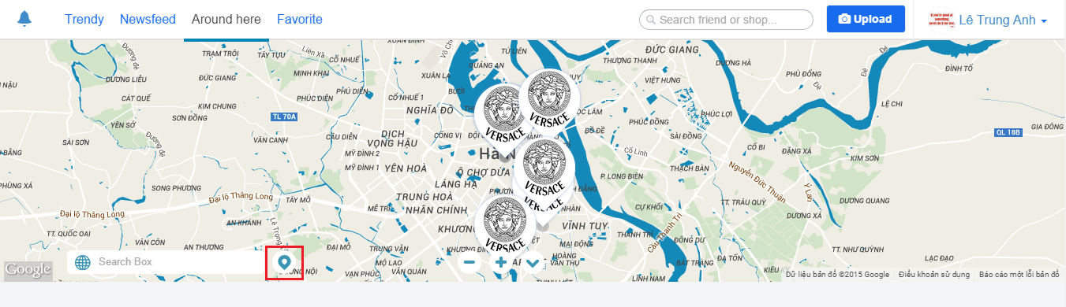

*Figure 6-6: Around here tab*

1. TrendyPlus displays actor’s location on map.

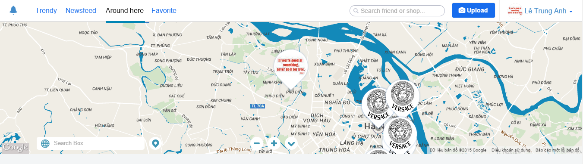

*Figure 6-7: Around here tab*

### Create Post

1. Actor logins.
2. Actor clicks on to *“Upload”* button.



*Figure 6-8: Navigation Bar*

1. TrendyPlus displays a question popup.

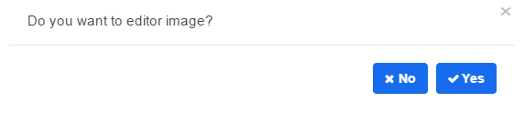

*Figure 6-9: Editor image pop-up*

1. Actor clicks on to *“No”* button if wants to edit image unless click on to *“Yes”* button.
2. TrendyPlus displays create post page.

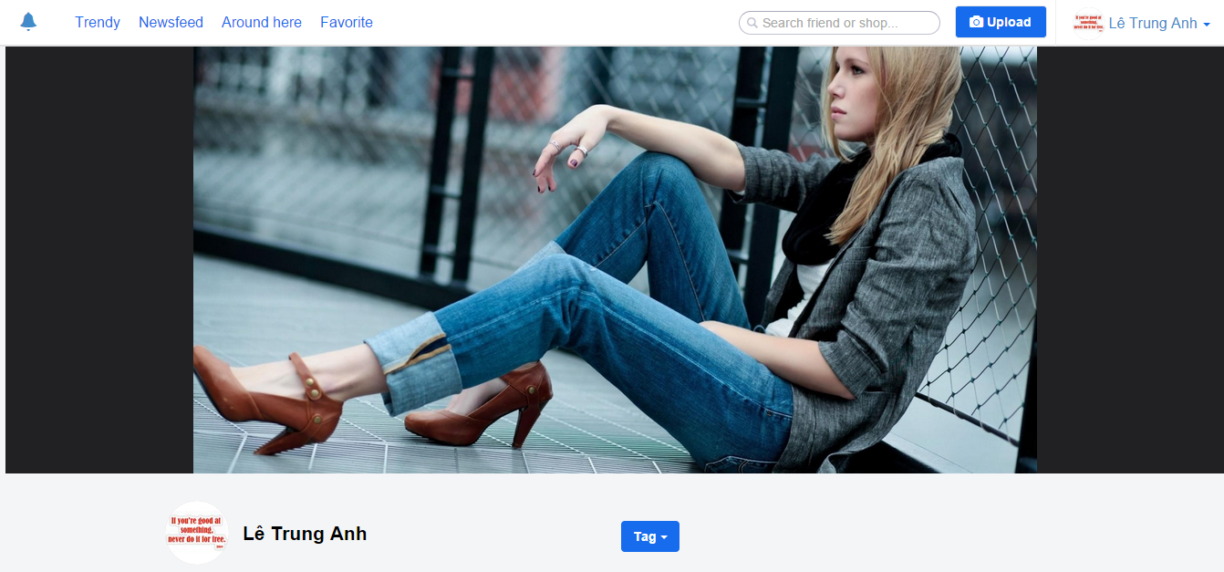

*Figure 6-10: Create post page*

1. Actor fills content about post bellow image.

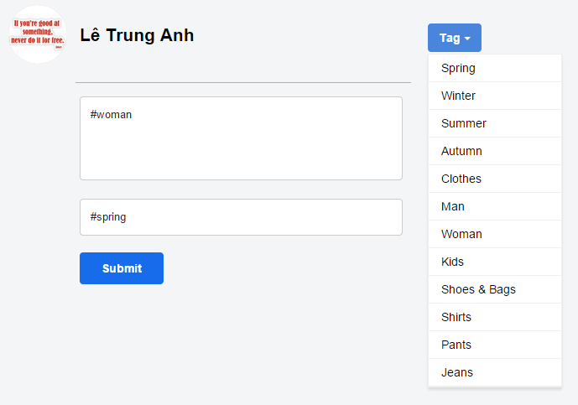

*Figure 6-11: Description post’s information*

1. Actor clicks on to *“Submit”* button.

### Create Shop

1. Actor logins.
2. Actor uploads image and creates post.
3. In create post page, actor hovers to image and clicks on to *“Click to tag”* button.

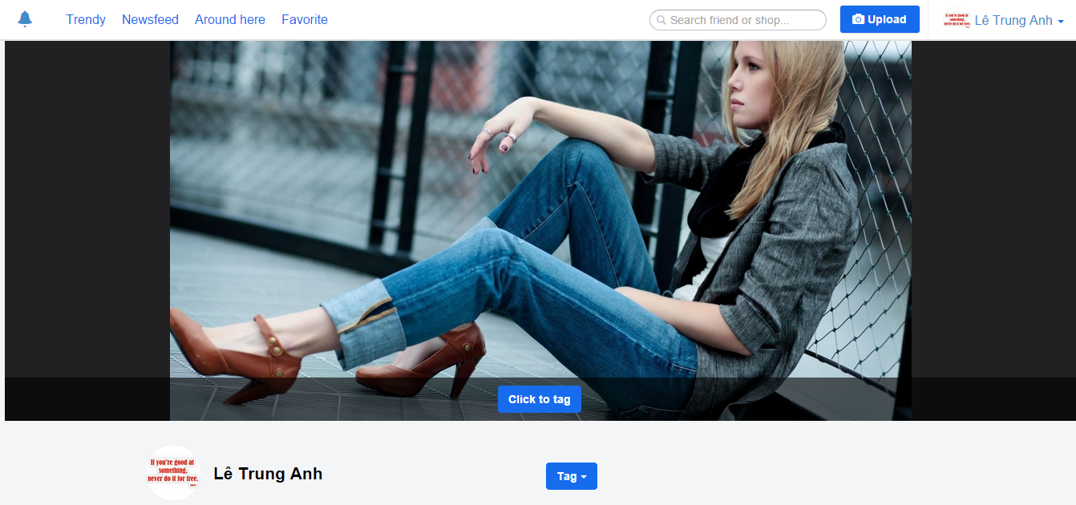

*Figure 6-12: Create post page*

1. Actor clicks on to any position on image.
2. Actor fills content about product on image.

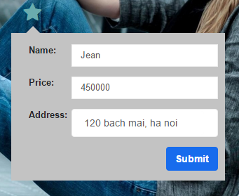

*Figure 6-13: Information tag image’s product*

1. Actor clicks *“Submit”* button.
2. Shop will be created through address that actor inputs.

### User Page

1. Actor logins.
2. On Navigation Bar, actor clicks on user’s avatar and choose “*Profile*” tag.

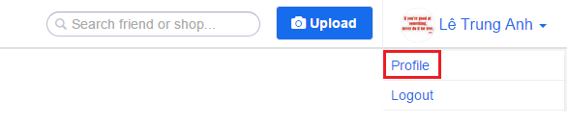

*Figure 6-14: Navigation bar*

1. TrendyPlus displays user page.
2. User can follow other users by clicks “*Follow*” button. After user clicked “*Follow*”, the list of suggest follow will be change.

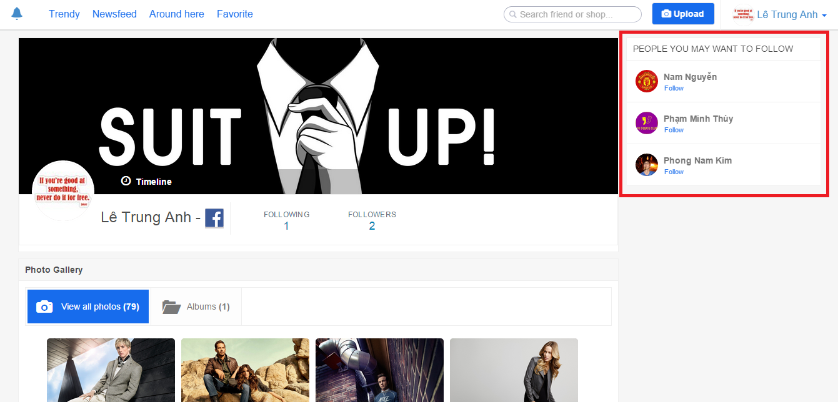

*Figure 6-15: User Page*

1. User can see list of other users who are followed by you by clicks “*Following”* button.



*Figure 6-16: Following tab*

1. User can see list of other users who are following you by clicks “*Follower button*”.

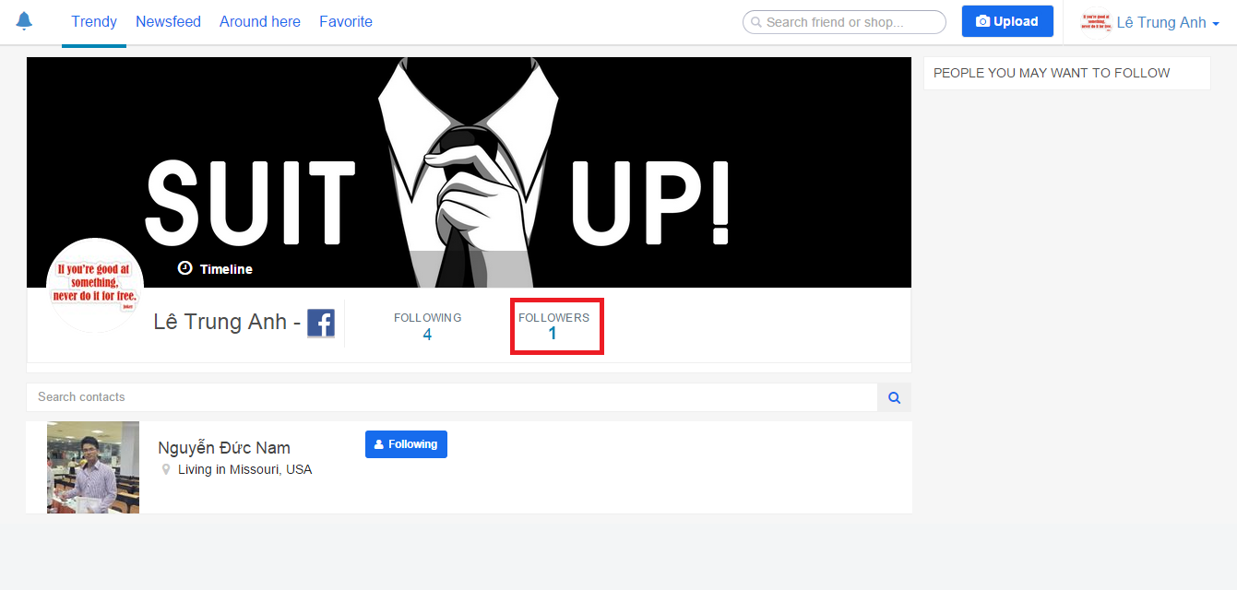

*Figure 6-17: Followers tab*

1. User can go to user’s Facebook by clicks  icon.
2. User can view all album of user by clicks “*Album*” tab.

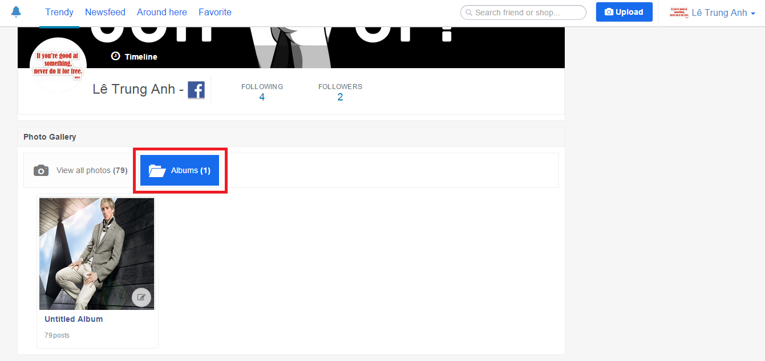

*Figure 6-18: Albums tab*

1. User can change name of Album by click on this icon.

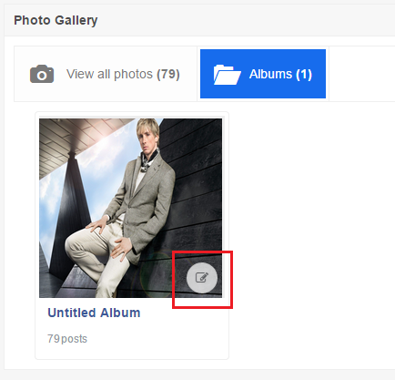

*Figure 6-19: Albums tab*

1. TrendyPlus displays popup and user can change name of album and clicks *“Save”* button.

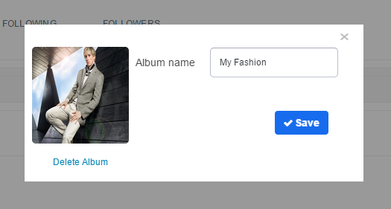

*Figure 6-20: Edit alum pop-up*

### Shop Page

1. User can view all information about Shop in Shop Page.
2. User can suggest Shop’s information by click *“Suggest shop’s information”* hyperlink.

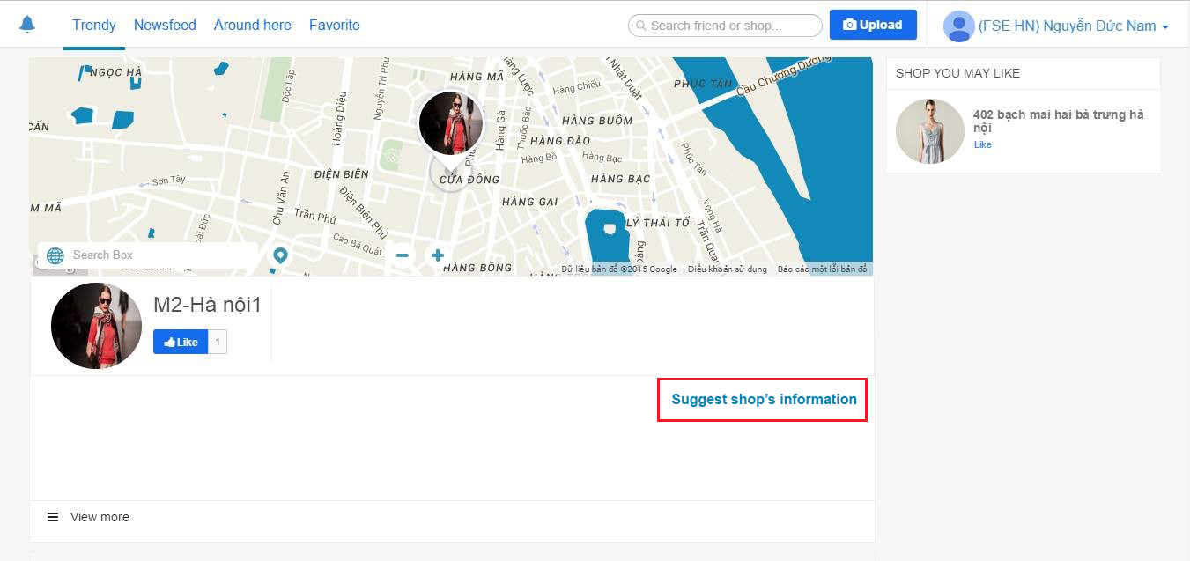

*Figure 6-21: Shop page*

1. User can input information about shop.



*Figure 6-22: Shop’s information pop-up*

1. User click *“Basic Information”* button to input basic shop’s information.

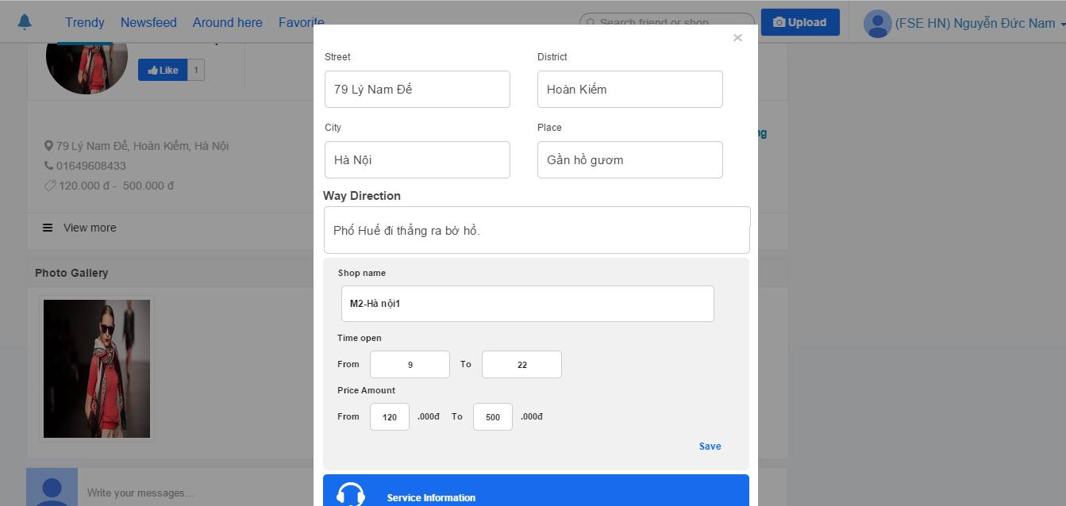

*Figure 6-23: Shop’s information pop-up*

1. User clicks *“Save”* button.
2. User clicks *“Services Information”* button to input information about service.

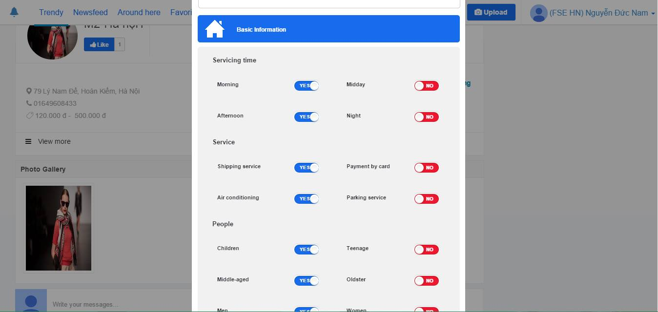

*Figure 6-24: Shop’s information pop-up*

1. User clicks *“Save”* button.
2. User clicks *“Contact Information”* to input information about contact shop.

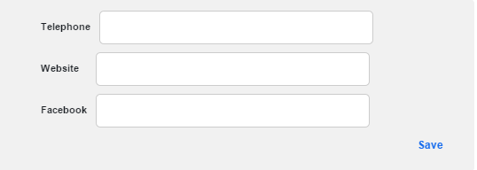

*Figure 6-25: Contac information*

1. User clicks *“Save”* button.
2. User clicks *“Save”* button to save all information about shop.

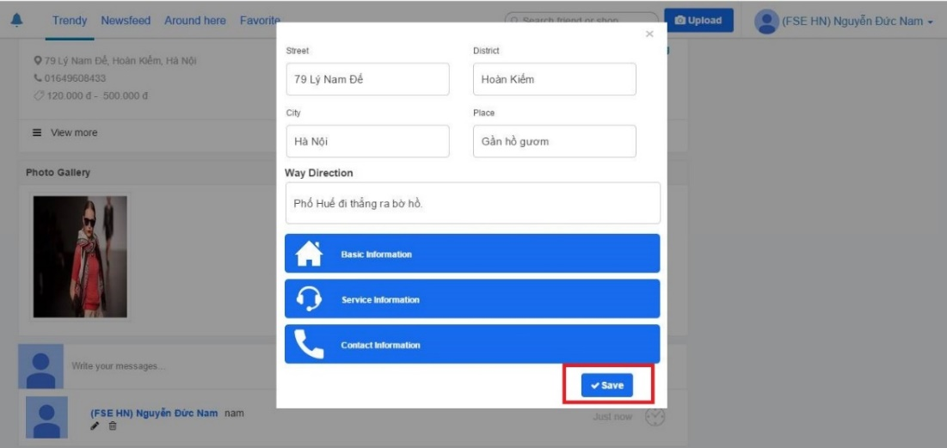

*Figure 6-26: Shop’s information pop-up*

1. User can view detail information shop by click *“View more”* button.

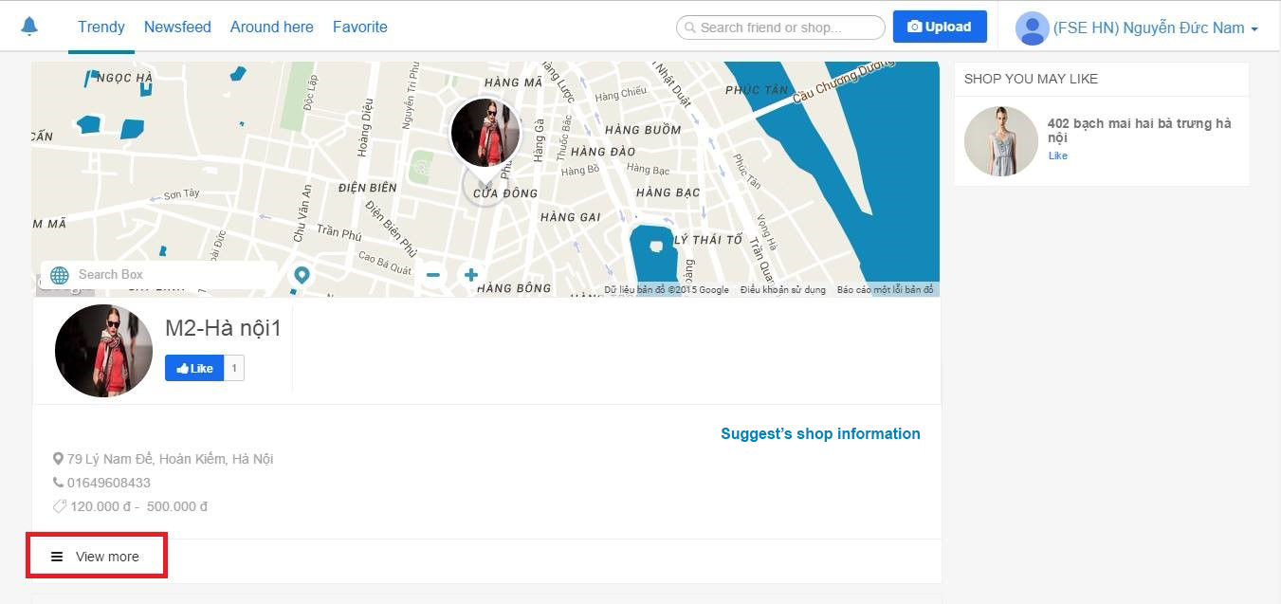

*Figure 6-27: Shop page*

1. TrendyPlus displays more shop’s information.



*Figure 6-28: View shop’s information*

1. User can like some suggest shop which user may be wants to like.

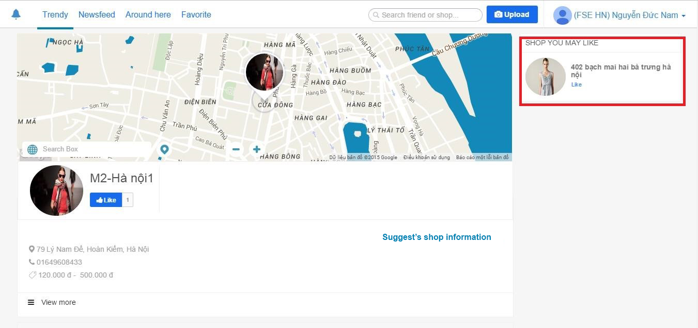

*Figure 6-29: Shop page*

1. User can comment, edit comment and delete comment.

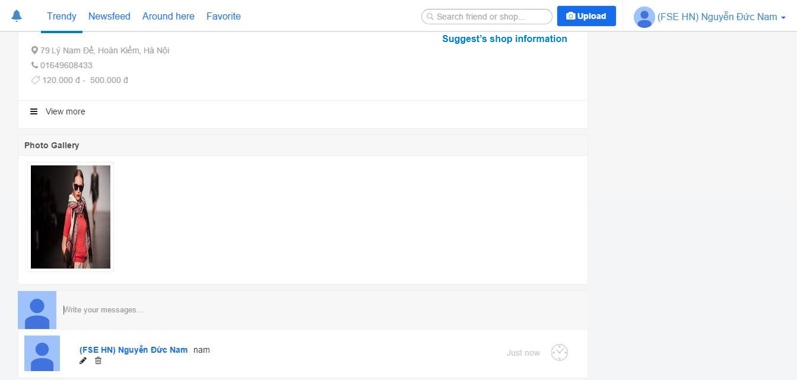

*Figure 6-30: Shop page*

### Notification

1. Actor logins.
2. If owner’s post has like, comment, favorite by other user or the Post which is not user’s but user comments, favorites, has comment, favorite by other user, user will be received notification.



*Figure 6-31: Navigation bar*

1. User clicks  icon
2. TrendyPlus displays new notification.



*Figure 6-32: Notification*

### Admin Login

1. Admin access to admin’s website.
2. Admin click on to *“Login”* button to log in system.

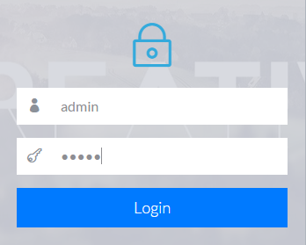

*Figure 6-33: Login form of admin*

### Manage User

1. Admin login.
2. TrendyPlus redirects admin to *“Manage User”* tab.

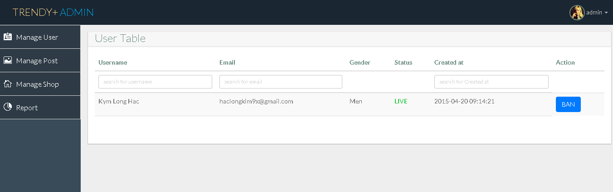

*Figure 6-34: Admin’s manage*

1. Admin input text field to search user.
2. Admin click to *“BAN”* button to ban or unban user.

### Manage Post

1. Admin login.
2. Admin choose *“Manage Post”* tab.

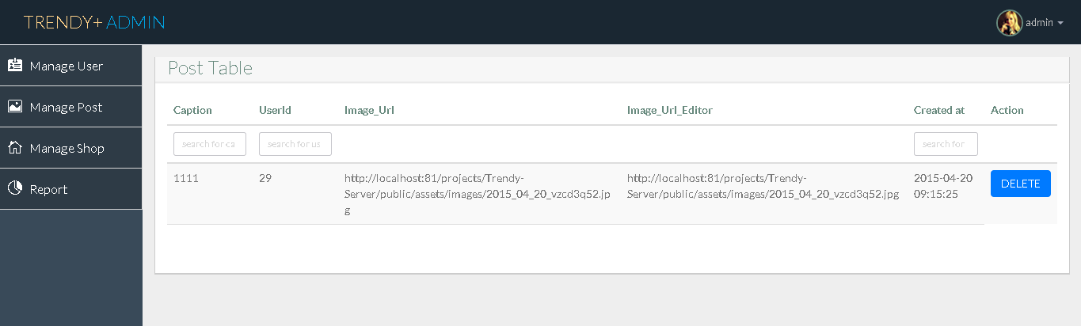

*Figure 6-34: Admin’s manage*

1. Admin input text field to search post.
2. Admin click on to *“DELETE”* button to delete post.

### Manage Shop

1. Admin login.
2. Admin choose *“Manage Shop”* tab.

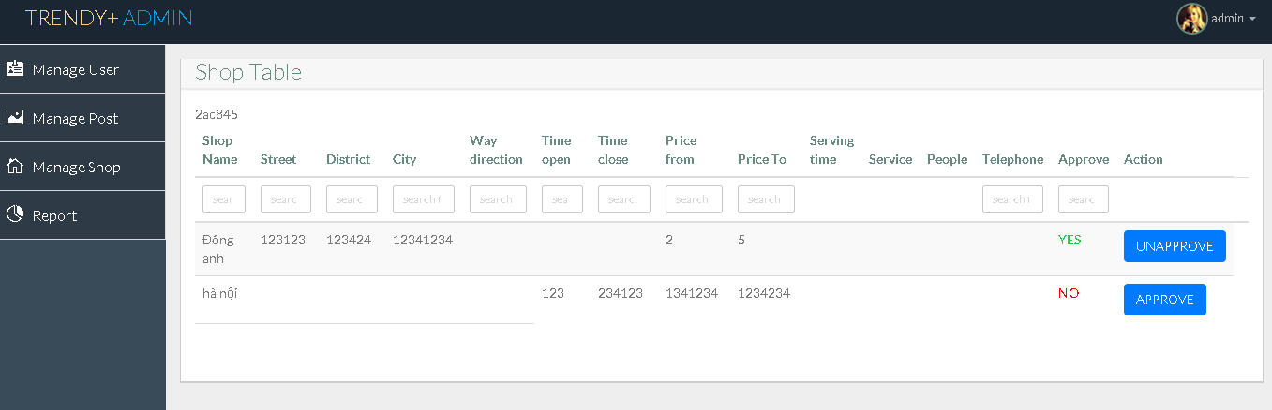

*Figure 6-34: Admin’s manage*

1. Admin input text field to search shop.
2. Admin click on to *“APPROVE”* button to approve suggestion shop’s information.
3. Admin click on to *“UNAPPROVE”* button to unapproved suggestion shop’s information.

### Show Report

1. Admin login.
2. Admin choose *“Report”* tab.
3. TrendyPlus show report about statistics user’s account.



*Figure 6-34: Admin’s report*

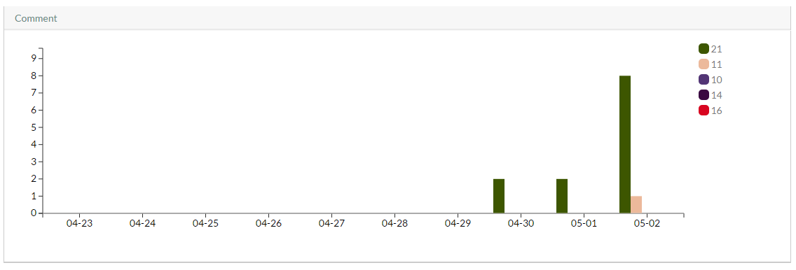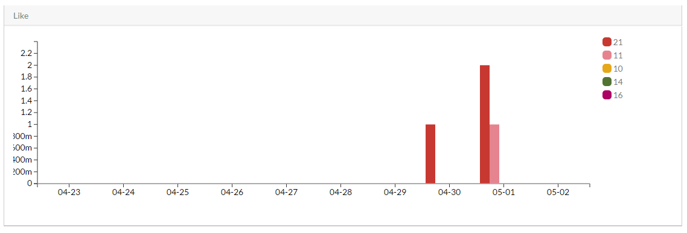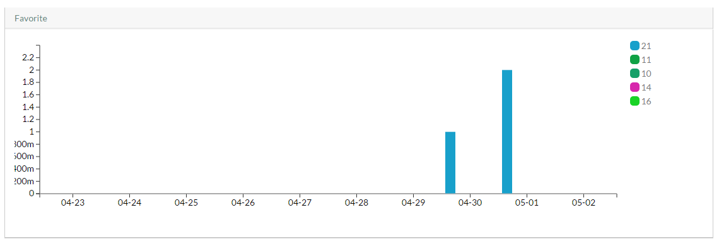

*Figure 6-37: Admin’s report*

*Figure 6-36: Admin’s report*

*Figure 6-35: Admin’s report*

1. <http://www.statista.com/statistics/278414/number-of-worldwide-social-network-users/>
2. <http://www.socialmediatoday.com/content/top-7-anticipated-social-media-trends-2015>